What is Cloud Computing?

**Cloud computing** is an internet-based computing service in which large groups of remote servers are networked to allow centralized data storage, and online access to computer services or resources.

Using cloud computing, organizations can use shared computing and storage resources rather than building, operating, and improving infrastructure on their own.

Cloud computing is a model that enables the following features.

* Users can provision and release resources on-demand.
* Resources can be scaled up or down automatically, depending on the load.
* Resources are accessible over a network with proper security.
* Cloud service providers can enable a pay-as-you-go model, where customers are charged based on the type of resources and per usage.

Types of Clouds

There are three types of clouds − Public, Private, and Hybrid cloud.

Public Cloud

In public cloud, the third-party service providers make resources and services available to their customers via Internet. Customer’s data and related security is with the service providers’ owned infrastructure.

Private Cloud

A private cloud also provides almost similar features as public cloud, but the data and services are managed by the organization or by the third party only for the customer’s organization. In this type of cloud, major control is over the infrastructure so security related issues are minimized.

Hybrid Cloud

A hybrid cloud is the combination of both private and public cloud. The decision to run on private or public cloud usually depends on various parameters like sensitivity of data and applications, industry certifications and required standards, regulations, etc.

**What is AWS?**

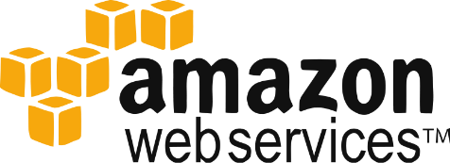

Amazon Web Services(AWS) is a Amazon.com subsidiary which offers**cloud-computing services**at very affordable rates, therefore making its customer base strong from small scale companies like Pinterest (which has just 5 employees) to big enterprises like D-Link.

**What is Cloud Computing?**

It is the use of remote servers on the internet to store, manage and process data rather than a local server or personal computer.

There are basically 3 categories in cloud computing:

* **SaaS (Software as a Service)**
  + It allows companies to use software without having to purchase them, which reduces the expenditure of the company drastically, since they are already installed on the cloud server they can be quickly deployed and therefore saves time.
* **PaaS (Platform as a Service)**
  + It allows developers to build applications, collaborate on projects without having to purchase or maintain infrastructure.
* **IaaS (Infrastructure as a Service)**
  + It allows companies to rent servers, storage space, etc. from a cloud provider.

When we talk about AWS, it’s more of an IaaS, moving along, let’s take a deep dive into AWS and understand what all services it has to offer us, but before that lets understand why there is a lot of buzz in the industry about AWS which therefore led to this awesome AWS Tutorial!

AWS offer services:

* **Compute**It is used to process data on the cloud by making use of powerful processors which serve multiple instances at a time.
* **Storage and Content Delivery**The storage as the name suggests, is used to store data in the cloud, this data can be stored anywhere but content delivery on the other hand is used to cache data nearer to the user so as to provide low latency.
* **Database**The database domain is used to provide reliable relational and non relational database instances managed by AWS.
* **Networking**It includes services which provide a variety of networking features such as security, faster access etc.
* **Management Tools**It includes services which can be used to manage and monitor your AWS instances.
* **Security and Identity**It includes services for user authentication or limiting access to a certain set of audience on your AWS resources.
* **Application Services**It includes simple services like notifications, emailing and queuing.
* **Compute**
* **AWS EC2**It is a web service which provides re-sizable compute capacity in the cloud. It is designed to make the web scale computing easier for developers. To know more about the service you can refer to our AWS EC2 blog. To know more, please go through the[AWS EC2 blog](https://www.edureka.co/blog/ec2-aws-tutorial-elastic-compute-cloud/-elastic-compute-cloud)

* **AWS Elastic Beanstalk**  
  Elastic Beanstalk lets you quickly deploy and manage applications in AWS without worrying about the underlying infrastructure.

* **AWS Elastic Load Balancing  
  **  
  ELB automatically manages the workload on your instances and distributes them to other instances in case of an instance failure.

* **AWS Lambda  
  **  
  AWS Lambda is used to execute backend code without worrying about the underlying architecture, you just upload the code and it runs, it’s that simple! To know more, please go through the[AWS Lambda Blog](https://www.edureka.co/blog/aws-lambda-tutorial)
* **AWS Autoscaling**  
  

The Autoscaling feature is used to scale up and down automatically as and when required. To know more, please go through the [AWS EC2/Autoscaling Blog](https://www.edureka.co/blog/ec2-aws-tutorial-elastic-compute-cloud/-elastic-compute-cloud)

* **Storage and Content Delivery**
* **S3 AWS  
  **  
  S3 stands for simple storage service, it is used for storing data in the form of objects in the AWS Cloud. To know more about S3, please go through the [S3 AWS Blog](https://www.edureka.co/blog/s3-aws-amazon-simple-storage-service/)

* **Amazon CloudFront**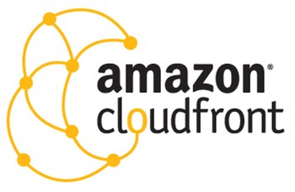  
  CloudFront is a content delivery network which is used to cache data to an edge location which reduces latency. To know more about Amazon Cloudfront, please go through the [S3 AWS/CloudFront Blog](https://www.edureka.co/blog/s3-aws-amazon-simple-storage-service/)
* **Amazon EBS**[](https://www.edureka.co/blog/ec2-aws-tutorial-elastic-compute-cloud/-elastic-compute-cloud#ebs)

Amazon Elastic Block Storage is a storage service wherein each block of storage acts like a separate hard drive. To know more about EBS, please refer our[AWS EC2/EBS Blog](https://www.edureka.co/blog/ec2-aws-tutorial-elastic-compute-cloud/-elastic-compute-cloud)

* **Amazon Glacier**  
  Glacier is an archiving service offered by Amazon, which offers low cost data archiving. To know more about Amazon Glacier, please refer our [S3 AWS/Glacier Blog](https://www.edureka.co/blog/s3-aws-amazon-simple-storage-service/)
* **AWS Import/Export Snowball**  
    
  It offers physical transfer of data between user’s location and AWS data centers, the device which is used to transfer the data is called Snowball. To know more about AWS Snowball, please refer out [S3 AWS/Snowball Blog.](https://www.edureka.co/blog/s3-aws-amazon-simple-storage-service/)

* **AWS Storage Gateway**  
  It is used to provide seamless integration with data security features between your on premise software appliance and AWS Cloud.
* **Database**
* **Amazon Aurora**  
  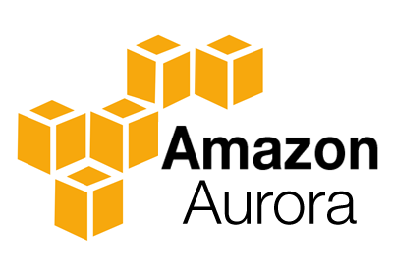

It is a relational database engine that combines the speed and reliability of high-end commercial databases and the cost effectiveness and simplicity of open-source databases.

* **Amazon RDS**Amazon RDS is a managed relational database service which does routine database tasks  in 6 familiar databases like  Amazon Aurora, MySQL, MariaDB, Oracle, Microsoft SQL Server, and PostgreSQL. To know more, please refer our [RDS AWS Blog.](https://www.edureka.co/blog/rds-aws-tutorial/)

* **Amazon DynamoDB  
  **

It is a fully managed No-SQL database service. It is known for extremely low latencies and scalability.

* **Amazon ElastiCache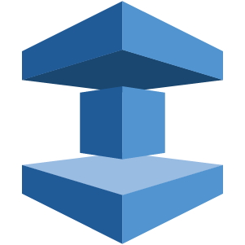**It is a web service that makes it easy to set up, manage and scale a distributed cache-in environment in the cloud.

* **Amazon Redshift  
  **

Amazon Redshift is a fully managed petabyte-scale data warehouse service in the cloud.

* **Networking**
* **VPC AWS**Amazon VPC lets you launch AWS resources in a virtual network that you define. It closely resembles a traditional network that you’d operate in your data center.

* **AWS Direct Connect  
  **

It helps you establish a private connection between your premises and AWS, therefore giving better network performance and throughput than an Internet based connection.

* **Amazon Route 53**Route 53 is a highly scalable and highly available Domain Name System by Amazon AWS. The name is in reference to the TCP and UDP’s port 53 where DNS requests are addressed.

* **Management Tools**
* **Amazon CloudWatch**  
  

It is a monitoring tool by AWS which is used to keep a track on the AWS resources and the applications you run on Amazon AWS.

* **AWS CloudFormation**  
  It is a service which helps you setup and model your Amazon AWS resources so that you can spend less time managing these resources and more time focusing on the development.

* **AWS CloudTrail**



AWS CloudTrail is a logging service which records the API calls to your Amazon AWS account and delivers them to you.

* **AWS Command Line Tool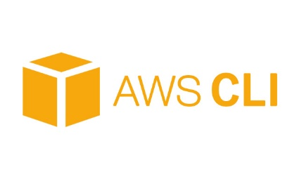**It is an all in one tool to manage all your AWS services, by downloading and configuring only one tool you can manage all the AWS services through the command line.

* **AWS OpsWorks**

It is a configuration management tool that helps configure and operate applications of all size and shapes using Chef.

* **Trusted Advisor**Trusted Advisor is a customized cloud monitoring tool, that analyzes your AWS environment and gives insights on the expense, performance improvement, security gaps and reliability.

* **Security and Identity**
* **AWS Identity and Access Management(IAM)**  
  

It is an AWS service that helps you control access to your AWS resources for your users.

* **AWS Key Management Service**It is a managed service that helps you create and control encryption keys which is used to encrypt your data, and uses Hardware Security Modules to protect the security of your keys.

* **Application Services**
* **Amazon SES**  
  

It is a cost effective emailing service which is built on the scalable and reliable infrastructure of Amazon.com

* **Amazon SNS**  
  It is a web service offered by AWS that manages the delivery of messages tosubscribed endpoints or clients.
* **Amazon SQS**

It is a fast, reliable and scalable message queuing service, it can be used to transmit any volume of data at any level of throughput, without losing any messages or without the use of any other service.

**AWS Pricing**

* AWS follows a pay per use model, meaning you only pay for what you use. For example, if you are using 10GB of space on S3 on AWS, you would be paying only for that 10GB, traditionally you have to buy an ‘x’ amount of storage say 20GB in advance, and even if you are using 10GB in the purchased space, you will be billed for the whole 20GB.
* You can get started with AWS for free, AWS runs a free usage tier in which you can use the AWS services in a very basic manner for free.

Advantages of Cloud Computing

Here is a list of some of the most important advantages that Cloud Computing has to offer −

* **Cost-Efficient** − Building our own servers and tools is time-consuming as well as expensive as we need to order, pay for, install, and configure expensive hardware, long before we need it. However, using cloud computing, we only pay for the amount we use and when we use the computing resources. In this manner, cloud computing is cost efficient.
* **Reliability** − A cloud computing platform provides much more managed, reliable and consistent service than an in-house IT infrastructure. It guarantees 24x7 and 365 days of service. If any of the server fails, then hosted applications and services can easily be transited to any of the available servers.
* **Unlimited Storage** − Cloud computing provides almost unlimited storage capacity, i.e., we need not worry about running out of storage space or increasing our current storage space availability. We can access as much or as little as we need.
* **Backup & Recovery** − Storing data in the cloud, backing it up and restoring the same is relatively easier than storing it on a physical device. The cloud service providers also have enough technology to recover our data, so there is the convenience of recovering our data anytime.
* **Easy Access to Information** − Once you register yourself in cloud, you can access your account from anywhere in the world provided there is internet connection at that point. There are various storage and security facilities that vary with the account type chosen.

Disadvantages of Cloud Computing

Although Cloud Computing provides a wonderful set of advantages, it has some drawbacks as well that often raise questions about its efficiency.

Security issues

Security is the major issue in cloud computing. The cloud service providers implement the best security standards and industry certifications, however, storing data and important files on external service providers always bears a risk.

AWS cloud infrastructure is designed to be the most flexible and secured cloud network. It provides scalable and highly reliable platform that enables customers to deploy applications and data quickly and securely.

Technical issues

As cloud service providers offer services to number of clients each day, sometimes the system can have some serious issues leading to business processes temporarily being suspended. Additionally, if the internet connection is offline then we will not be able to access any of the applications, server, or data from the cloud.

This is the basic structure of **AWS EC2**, where **EC2** stands for Elastic Compute Cloud. EC2 allow users to use virtual machines of different configurations as per their requirement. It allows various configuration options, mapping of individual server, various pricing options, etc. We will discuss these in detail in AWS Products section. Following is the diagrammatic representation of the architecture.

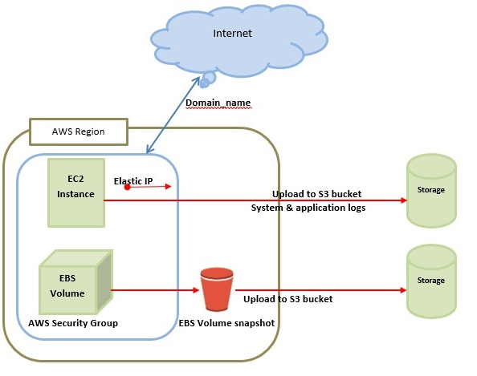

**Note** − In the above diagram **S3** stands for Simple Storage Service. It allows the users to store and retrieve various types of data using API calls. It doesn’t contain any computing element. We will discuss this topic in detail in AWS products section.

### Load Balancing

**Load balancing** simply means to hardware or software load over web servers, that improver's the efficiency of the server as well as the application. Following is the diagrammatic representation of AWS architecture with load balancing.

Hardware load balancer is a very common network appliance used in traditional web application architectures.

AWS provides the Elastic Load Balancing service, it distributes the traffic to EC2 instances across multiple available sources, and dynamic addition and removal of Amazon EC2 hosts from the load-balancing rotation.

**Elastic Load Balancing** can dynamically grow and shrink the load-balancing capacity to adjust to traffic demands and also support sticky sessions to address more advanced routing needs.

### Amazon Cloud-front

It is responsible for content delivery, i.e. used to deliver website. It may contain dynamic, static, and streaming content using a global network of edge locations. Requests for content at the user's end are automatically routed to the nearest edge location, which improves the performance.

Amazon Cloud-front is optimized to work with other Amazon Web Services, like Amazon S3 and Amazon EC2. It also works fine with any non-AWS origin server and stores the original files in a similar manner.

In Amazon Web Services, there are no contracts or monthly commitments. We pay only for as much or as little content as we deliver through the service.

### Elastic Load Balancer

It is used to spread the traffic to web servers, which improves performance. AWS provides the Elastic Load Balancing service, in which traffic is distributed to EC2 instances over multiple available zones, and dynamic addition and removal of Amazon EC2 hosts from the load-balancing rotation.

Elastic Load Balancing can dynamically grow and shrink the load-balancing capacity as per the traffic conditions.

### Security Management

Amazon’s Elastic Compute Cloud (EC2) provides a feature called security groups, which is similar to an inbound network firewall, in which we have to specify the protocols, ports, and source IP ranges that are allowed to reach your EC2 instances.

Each EC2 instance can be assigned one or more security groups, each of which routes the appropriate traffic to each instance. Security groups can be configured using specific subnets or IP addresses which limits access to EC2 instances.

### Elastic Caches

Amazon Elastic Cache is a web service that manages the memory cache in the cloud. In memory management, cache has a very important role and helps to reduce the load on the services, improves the performance and scalability on the database tier by caching frequently used information.

### Amazon RDS

Amazon RDS (Relational Database Service) provides a similar access as that of MySQL, Oracle, or Microsoft SQL Server database engine. The same queries, applications, and tools can be used with Amazon RDS.

It automatically patches the database software and manages backups as per the user’s instruction. It also supports point-in-time recovery. There are no up-front investments required, and we pay only for the resources we use.

### Hosting RDMS on EC2 Instances

Amazon RDS allows users to install RDBMS (Relational Database Management System) of your choice like MySQL, Oracle, SQL Server, DB2, etc. on an EC2 instance and can manage as required.

Amazon EC2 uses Amazon EBS (Elastic Block Storage) similar to network-attached storage. All data and logs running on EC2 instances should be placed on Amazon EBS volumes, which will be available even if the database host fails.

Amazon EBS volumes automatically provide redundancy within the availability zone, which increases the availability of simple disks. Further if the volume is not sufficient for our databases needs, volume can be added to increase the performance for our database.

Using Amazon RDS, the service provider manages the storage and we only focus on managing the data.

### Storage & Backups

AWS cloud provides various options for storing, accessing, and backing up web application data and assets. The Amazon S3 (Simple Storage Service) provides a simple web-services interface that can be used to store and retrieve any amount of data, at any time, from anywhere on the web.

Amazon S3 stores data as objects within resources called **buckets**. The user can store as many objects as per requirement within the bucket, and can read, write and delete objects from the bucket.

Amazon EBS is effective for data that needs to be accessed as block storage and requires persistence beyond the life of the running instance, such as database partitions and application logs.

Amazon EBS volumes can be maximized up to 1 TB, and these volumes can be striped for larger volumes and increased performance. Provisioned IOPS volumes are designed to meet the needs of database workloads that are sensitive to storage performance and consistency.

Amazon EBS currently supports up to 1,000 IOPS per volume. We can stripe multiple volumes together to deliver thousands of IOPS per instance to an application.

### Auto Scaling

The difference between AWS cloud architecture and the traditional hosting model is that AWS can dynamically scale the web application fleet on demand to handle changes in traffic.

In the traditional hosting model, traffic forecasting models are generally used to provision hosts ahead of projected traffic. In AWS, instances can be provisioned on the fly according to a set of triggers for scaling the fleet out and back in. Amazon Auto Scaling can create capacity groups of servers that can grow or shrink on demand.

## Key Considerations for Web Hosting in AWS

Following are some of the key considerations for web hosting −

### No physical network devices needed

In AWS, network devices like firewalls, routers, and load-balancers for AWS applications no longer reside on physical devices and are replaced with software solutions.

Multiple options are available to ensure quality software solutions. For load balancing choose Zeus, HAProxy, Nginx, Pound, etc. For establishing a VPN connection choose OpenVPN, OpenSwan, Vyatta, etc.

### No security concerns

AWS provides a more secured model, in which every host is locked down. In Amazon EC2, security groups are designed for each type of host in the architecture, and a large variety of simple and tiered security models can be created to enable minimum access among hosts within your architecture as per requirement.

### Availability of data centers

EC2 instances are easily available at most of the availability zones in AWS region and provides model for deploying your application across data centers for both high availability and reliability.