2048 game

* On Windows:

This code makes use of msvcrt module of python to implement getch type function. This feature is available only for Windows/DOS.

* For UNIX based operating system:

1. First install pip3 or pip depending upon python version. To check python version, type

*“python --version” .*

1. This will show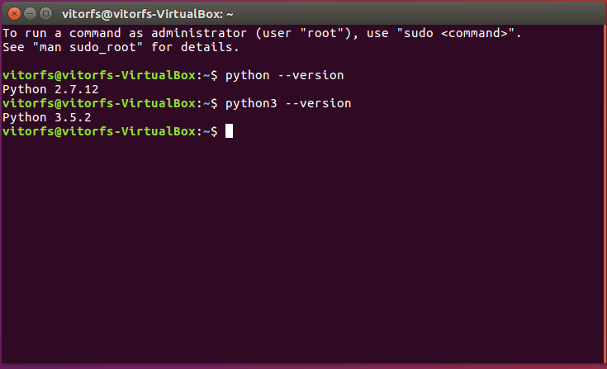
2. Then type “*sudo apt-get install pip3” or “sudo apt-get install pip”.*
3. For downloading getch function, *“pip3 install getch”.*
4. You can now run the code.
5. Other modules used in this code are **“os”, “argparse”, “random”, “copy”, “math.** If not available, they can be installed in similar manner.

* How to run:

1. For windows, open command prompt or Windows Powershell and type *“python filename --n “N” --x “X””,* where N and X are board size and number required to win respectively and filename has “.py” extension. If you don’t want to specify any input, just write “*python filename”;*

or to specify any one input, just write that respective argument only, else you’ll get error. Whenever not specified, default will set N to 5 and X to 2048. Ensure that X is a power of two; else you’ll never win.

1. For Unix based, type *“python3 filename --n “N” --x “X””,* or python2 depending upon python version. Rest is similar to windows.

* How it works:

1. After you run the program, it will display the board of specified dimensions.
2. Press w/a/s/d to shift numbers up/left/down/right respectively and “e” to quit.
3. If you enter any invalid move 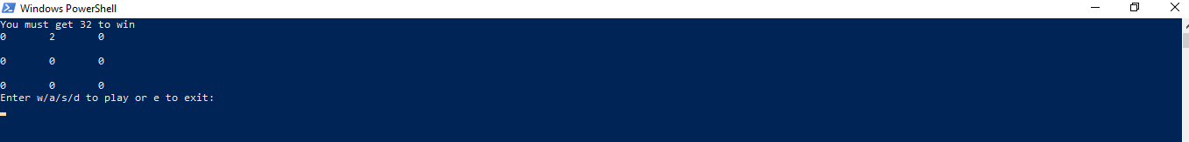

For example, here N=3 and X=32. This is initial board. In this “w” will be invalid since board wouldn’t change. It will look like

1. On entering any valid move, the board will change accordingly. This is how board looks in intermediate stage.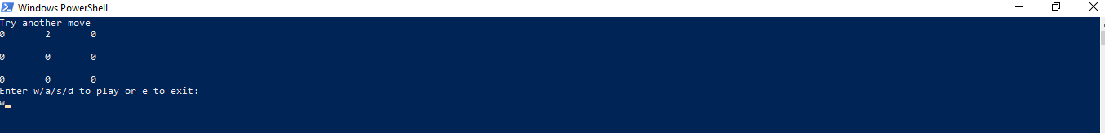

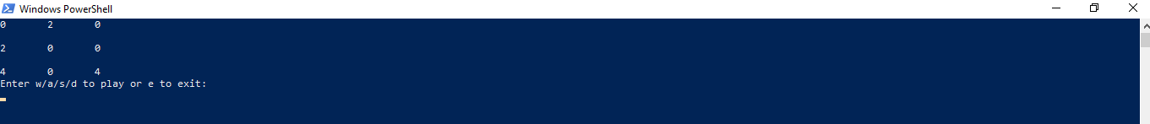

5

When you get the required number to win(in this case the highlighted number 32), you win the game and the program stops as shown.

6. Other case, if you can’t play any more moves,

you get a message game lost and program stops.



In this case, N=2 and X=32, since no more moves can be played, we get a message game lost and program stops.

-Done by Kalyani Sains