Logical Design Exercises / Task 5
Derive relations from the ER diagram below. 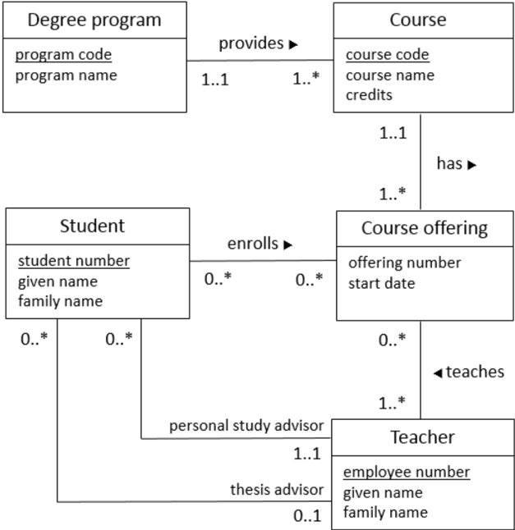

DegreeProgram (program_code, program_name)
Course (course_code, course_name, credits)
FK (X) REFERENCES Relation (X)
CourseOffering (offering_number, start_date)
Student (student_number, given_name, family_name)
Teacher (employee_number, given_name, family_name)

