BBACVS · BLOCKCHAIN-BASED ACADEMIC CREDENTIAL VERIFICATION SYSTEM
How a credential moves through BBACVS, and what actually lands on the blockchain
A walk through the as-built system: where each piece of data lives, which steps write to Ethereum, which stay off-chain, and why a verifier can trust the answer.
Network | Live at | Written | Registry today
Ethereum Sepolia (chain id 11155111) | bbacvs.kalootech.com | 15 September 2026 | 5 issuers on-chain · 12 anchored credentials · 5 ZAQA-validated

Contents

Right-click the contents and choose Update Field after editing headings.

1. The three stores and their trust ranking
BBACVS keeps data in three places with a strict hierarchy. The blockchain is the only source that decides whether a credential is genuine. IPFS holds the encrypted document the hash was computed from. MongoDB is a convenience index for portals and workflows, and nothing in it can make a forged credential verify.
Store | Role | Holds
Ethereum Sepolia | Authoritative | Which wallet addresses are authorised issuers; SHA-256 hash of every issued credential; keccak hash of its IPFS content ID; issuer address, DID and block timestamp; revocations with reason code
IPFS via Pinata | Decentralised store | The signed W3C Verifiable Credential, AES-256-GCM encrypted; institutions' uploaded accreditation documents; addressed by content (CID), so any change is a new CID
MongoDB (local) | Non-authoritative index | Accounts, roles, institution profiles, encrypted signing keys; credential index (names, qualification, year, QR payload, CID, anchor transaction); ZAQA validation state, suspensions, disputes, applications, billing; append-only event history per record

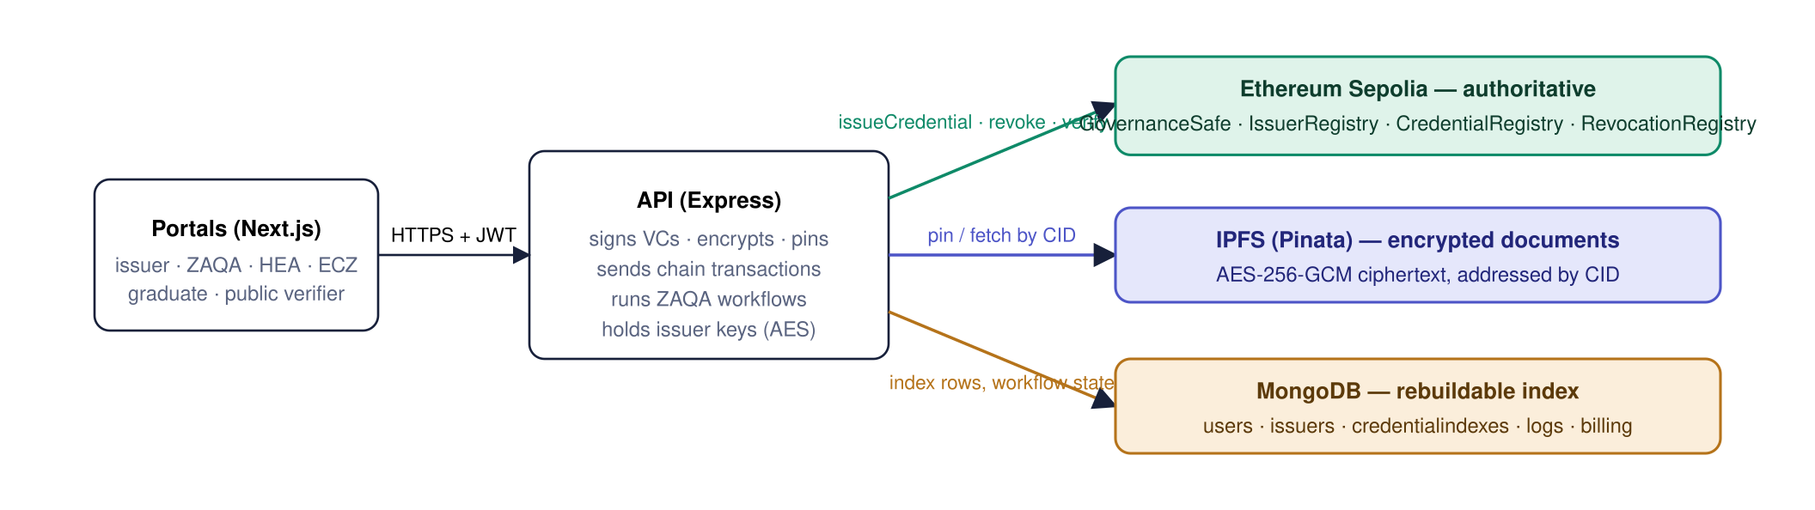
Figure 1. Every write goes through the API. Portals never talk to the chain directly except in MetaMask mode, where the institution's browser sends the anchoring transaction itself (section 3). The verifier path reads the chain through the API with a zero-gas call.
Why this ranking matters. Deleting the MongoDB database loses names and workflow state, but every anchored credential can still be re-verified, and the index can be rebuilt from the CredentialIssued events plus the IPFS documents. Editing a MongoDB row cannot make a tampered certificate pass, because the verifier recomputes and compares hashes against the chain.

2. Authorising an institution to issue
Before an institution can anchor anything, its wallet address must hold ISSUER_ROLE in the IssuerRegistry contract. Only the GovernanceSafe can grant that role, and the Safe needs two of its three regulator signatures. In the deployed prototype the API holds signer keys 1 and 2 and performs both steps.
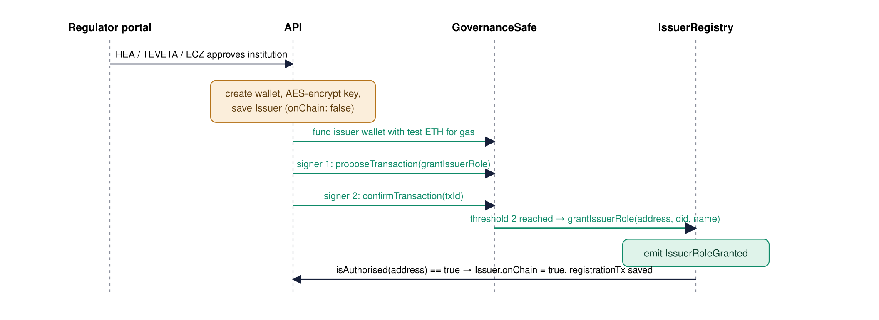
Figure 2. Two regulator signatures, one on-chain role grant. The institution's record is saved first with onChain: false, so a failed transaction can be retried without creating a duplicate wallet. Self-registered institutions sit at heaStatus: pending and only reach this sequence when their regulator approves them.

What the registry stores per issuer
Field | Meaning
did | keccak256 of the string did:ethr:0x…, stored as bytes32
institution | Name truncated to 31 bytes, stored as bytes32 (a label, not the legal record)
registeredAt | Block timestamp
active | True until revokeIssuerRole is executed through the Safe

Two signing modes exist. In server mode the API generates the wallet, and that same key later signs the anchoring transaction. In MetaMask mode the institution's own MetaMask address receives the role, and the API only ever signs the VC and QR with a separate server-held key. Either way the key that signs credentials at rest is AES-256-GCM encrypted in MongoDB.

3. Issuing a credential
Issuance is a fixed pipeline in issuance.service.js, shared by the institution portal, the ECZ certificate register and the graduate application workflow, so every credential in the system has exactly the same shape.
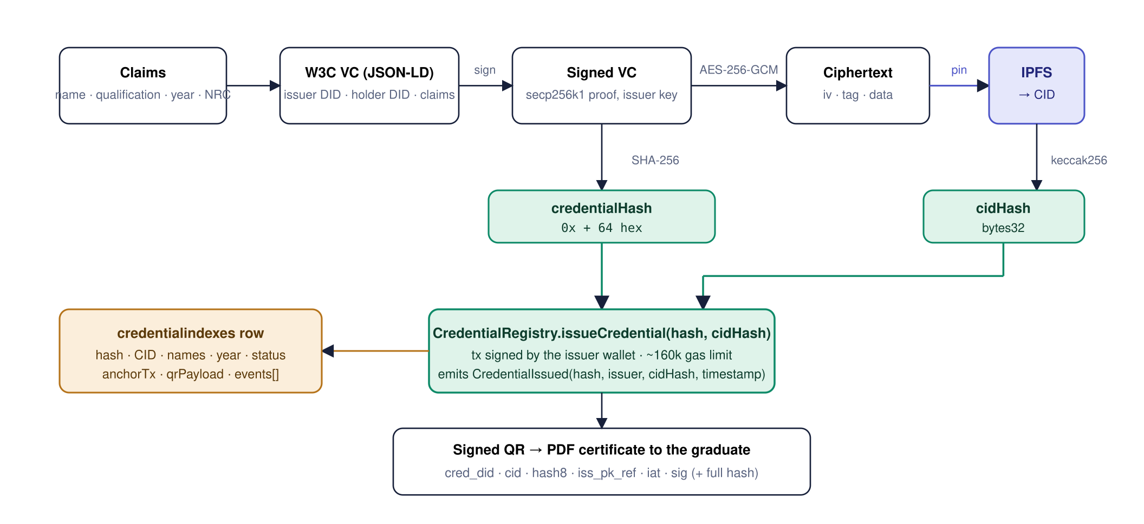
Figure 3. Only two 32-byte values reach the chain. The credential hash commits to the whole signed document, and the CID hash commits to the encrypted copy on IPFS. Names, the NRC and the qualification title never leave the API and MongoDB in plain form, and IPFS only ever holds ciphertext.
- Gate checks. The institution must be regulator-approved, the qualification must match an accredited programme when a programme register exists, and a duplicate for the same person, programme and year is refused (409). An in-memory lock stops a double-click from reaching the chain twice.
- Build the VC. buildCredential creates a W3C Verifiable Credential with the issuer DID, the holder DID (an existing graduate account's DID, otherwise a fresh did:ethr), and the claims.
- Sign it. signCredential attaches an EcdsaSecp256k1Signature2019 proof made with the institution's decrypted signing key.
- Hash it. sha256(JSON.stringify(signedVC)) is the credential hash. This is the identifier printed inside the QR and used everywhere else.
- Encrypt and pin. The signed VC is AES-256-GCM encrypted with the server key (random 12-byte IV per credential) and uploaded to Pinata as JSON. Pinata returns the CID; keccak256(CID) becomes the second on-chain value.
- Anchor. Server mode: the API signs issueCredential(hash, cidHash) with the issuer wallet and waits for the receipt. MetaMask mode: POST /prepare returns hash, cidHash and the contract address; the browser sends the transaction; POST /finalize re-reads the chain and only activates the record when verifyCredential already answers VERIFIED.
- Index and deliver. The MongoDB row is written with status active (or pending until MetaMask finalises), the transaction hash, and the signed QR payload. The graduate can download a PDF with that QR from their portal.

The signed QR
The QR is the offline credential. It carries six fields and a signature over five of them (cred_did|cid|hash8|iss_pk_ref|iat), plus the full credential hash for the online path. A verifier who has cached issuer public keys can check the signature with no network at all.
{ "cred_did": "did:ethr:0x9A…", "cid": "bafkrei…", "hash8": "3f9c1b7e2a04d6c8",
"iss_pk_ref": "did:ethr:0x5B…#keys-1", "iat": 1757900000,
"sig": "0x3045…", "hash": "0x3f9c1b7e2a04d6c8…" }

4. The on-chain record, field by field
Each anchored credential occupies three storage slots in CredentialRegistry, keyed by the credential hash. Nothing in it identifies the graduate.
Field | Type | Set by | Meaning
issuer | address | msg.sender | Wallet that anchored the credential. Must hold ISSUER_ROLE at that moment.
issuedAt | uint64 | block.timestamp | Anchoring time. Shown on verification as "Issued".
cidHash | bytes32 | API | keccak256 of the IPFS CID of the encrypted VC.
issuerDID | bytes32 | IssuerRegistry | Copied from the registry at issue time, so a later change of DID cannot rewrite history.

The contract refuses a hash that is already present, so a credential can only be anchored once. Revocation lives in a separate RevocationRegistry row: reason code 1 to 5, timestamp, revoking address, and optionally the hash of a corrected replacement. verifyCredential is a view function that combines both registries plus the issuer's current authorisation into one of four answers.
Contract | Sepolia address | Writes happen when
GovernanceSafe | 0x39aea70a718B5a77710aE0a40B4d79fcE18Ef990 | A regulator approves an institution (propose, confirm, auto-execute)
IssuerRegistry | 0x99B41d97B29E85831591a2fb0f5ce5132BFb73ED | Executed by the Safe: grant or revoke ISSUER_ROLE
CredentialRegistry | 0x785c52048cf543fd7907986BB77170345059B8D2 | Every issuance and every corrected reissue
RevocationRegistry | 0xB23E0922Bd655FbC4CE17d1236120e5685918263 | Institution or ZAQA revokes; supersession sets reason 1 and links the new hash

Approximate cost on Sepolia today: about 0.01 test ETH per institution registration and about 0.002 per anchor. The ZAQA funder wallet tops up new issuer wallets automatically so institutions never handle gas.

5. Validation and lifecycle: what is on-chain and what is not
The chain answers one question: is this exact document genuine and not revoked. Everything about national recognition is a ZAQA decision recorded off-chain, and the verify response folds both together.
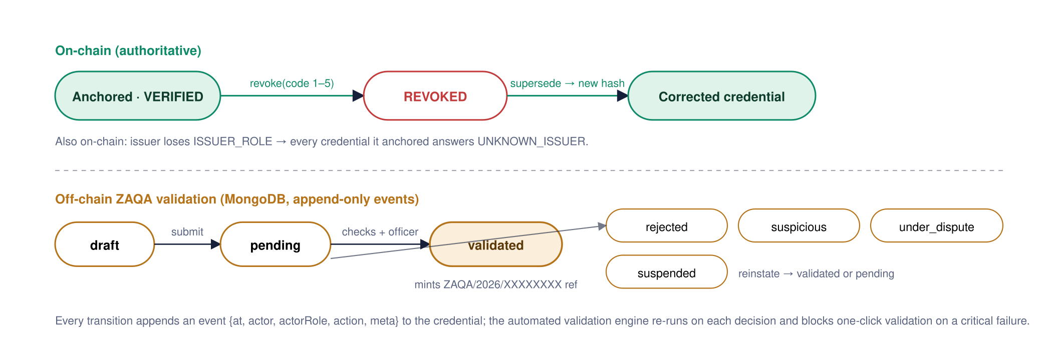
Figure 4. Two tracks, one answer. The verify response reports the on-chain status first (REVOKED, NOT_FOUND and UNKNOWN_ISSUER always win), then the ZAQA state: validated shows as Verified, pending as "Awaiting ZAQA validation", and so on. Suspension is purely off-chain: the anchor stays VERIFIED but the certificate download is blocked.
A ZAQA revocation is genuinely on-chain: the officer's decision makes the API sign RevocationRegistry.revoke with the custodied issuer key, so third parties see REVOKED without trusting BBACVS's database. A correction never edits the old record. The institution issues a new credential through the same pipeline, then the old hash is revoked with reason 1 (administrative error) and both index rows link to each other.

6. Verifying: online and offline
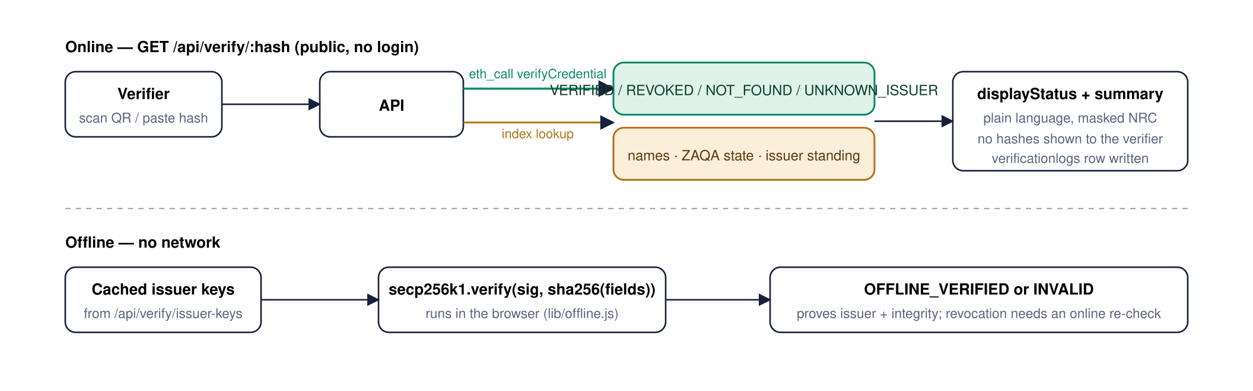
Figure 5. The online path never trusts the index for validity. The chain call decides the headline; MongoDB only adds human-readable context and the regulator's standing. The offline path proves that an authorised institution signed this exact QR, which is what a border post or employer with no signal needs first.

The ZAQA verification certificate
Once a credential is on-chain VERIFIED and ZAQA-validated, anyone can download the "Certificate of Verification and Evaluation of Qualification" PDF. It prints no hash, CID or wallet address at all. A second signed QR, made with ZAQA's own key (did:zaqa#keys-1) over the ZAQA reference and holder DID, carries the technical data so the certificate itself can be checked the same way.

7. Where each piece of data lives
Data | Store | Notes
Credential hash (SHA-256 of signed VC) | Chain · Index · QR | Chain copy is authoritative; index and QR carry it for lookup.
IPFS CID of the encrypted VC | Index · QR · Chain (keccak only) | The chain holds a hash of the CID, enough to detect a swapped document.
Signed VC document | IPFS | AES-256-GCM ciphertext; readable only with the server key.
Issuer wallet, DID, authorisation, revocation of role | Chain · Index | Chain decides; index mirrors as onChain, registrationTx.
Issuer signing private key | Index | AES-encrypted at rest in the issuers collection. Never on chain or IPFS.
Graduate name, NRC, qualification title, year, ZQF level | Index · IPFS (encrypted) | Never on chain. NRC is masked in every public response.
Revocation with reason code, supersession link | Chain · Index | Chain is authoritative; index adds supersededBy / supersedes both ways.
ZAQA validation state, ZAQA reference, validation report | Index | Regulatory decision, off-chain by design, with append-only events.
Suspension, disputes, correction requests | Index | Off-chain; suspension blocks certificate download but leaves the anchor VERIFIED.
Programmes, qualifications register, NQF levels | Index | Configuration data used by the validation engine's checks.
Applications, evidence uploads, accreditation documents | Index · IPFS | Uploaded files are pinned to IPFS; the CID is kept in the index.
Invoices, payments, receipts, notifications, activity log | Index | Operational records only.
Verification attempts | Index | verificationlogs: hash, result, mode, latency. No PII.

