# 2. Oracle Architecture - Parallel execution

## 2.1. Task 01: CREATE Example of Select Parallel execution

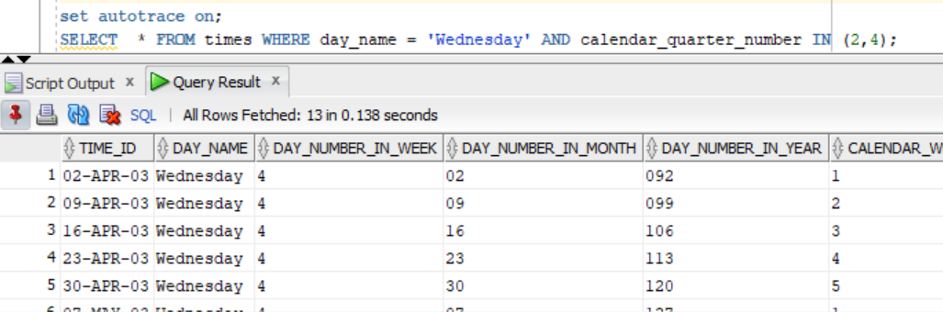

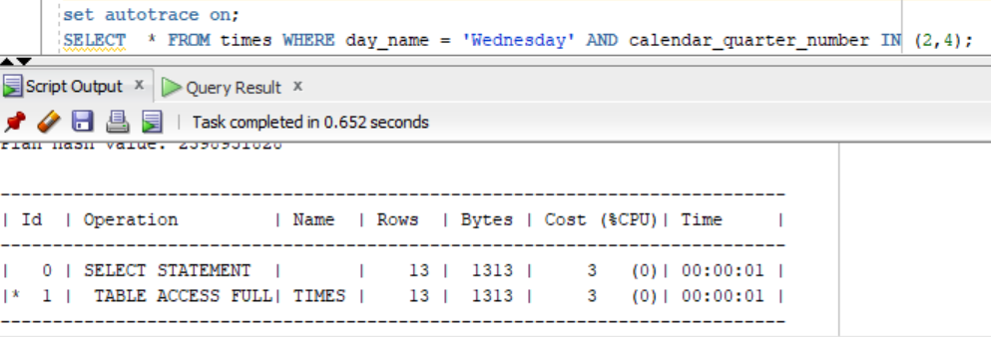

**parallel**

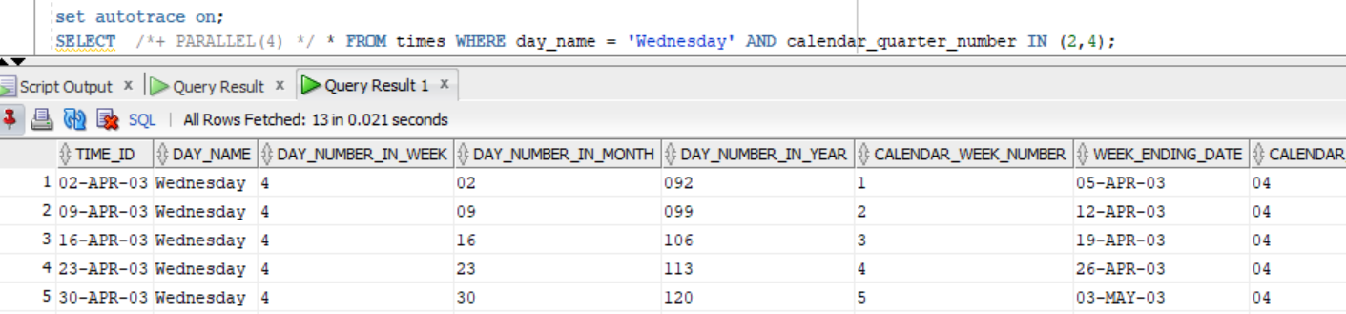

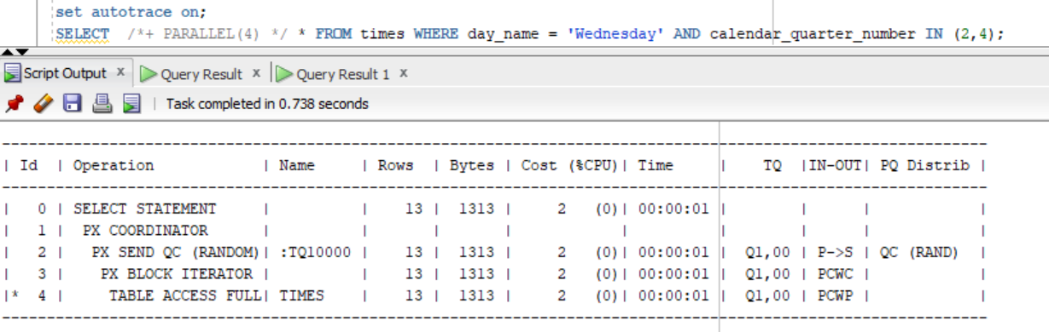

|  | SELECT | SELECT with PARALLEL execution |
| --- | --- | --- |
| time of the same operations | 0.652 | 0.021 |

## 2.2. Task 02: CREATE Example of Parallel DML

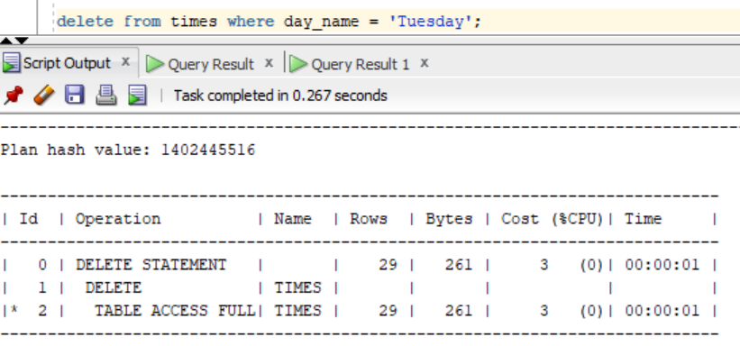

**parallel**

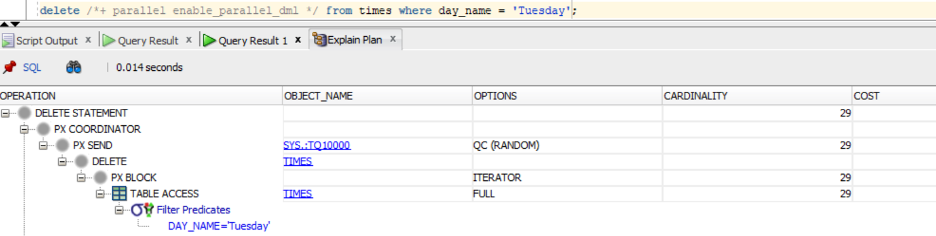

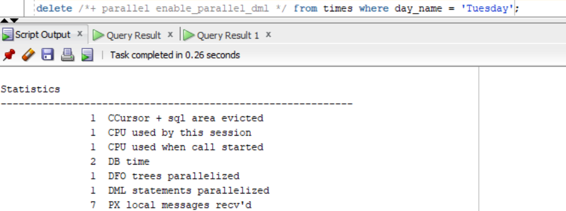

|  | DELETE | DELETE with PARALLEL execution |
| --- | --- | --- |
| time of the same operations | 0.267 | 0.26 |

## 2.3. Task 03: CREATE Example of Parallel DDL

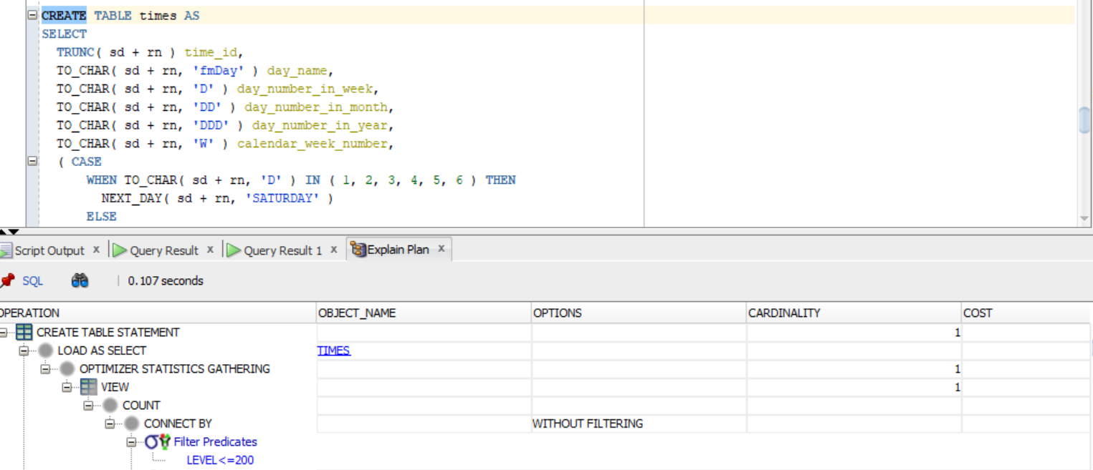

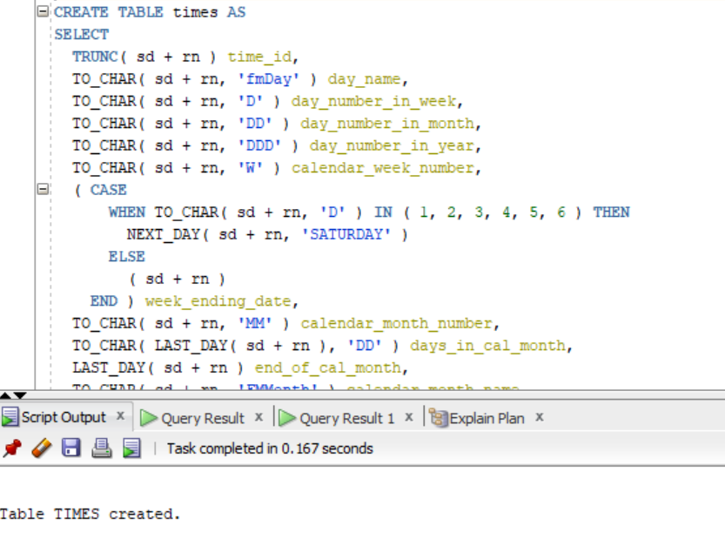

**parallel**

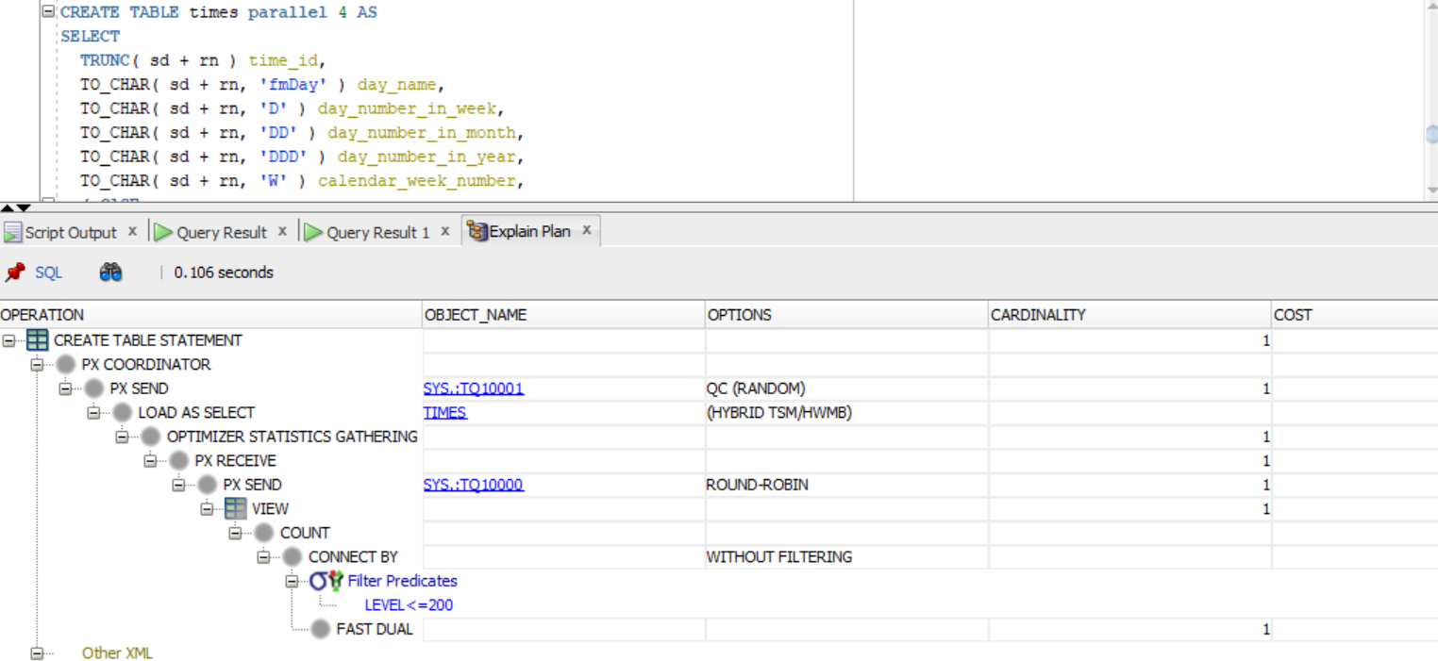

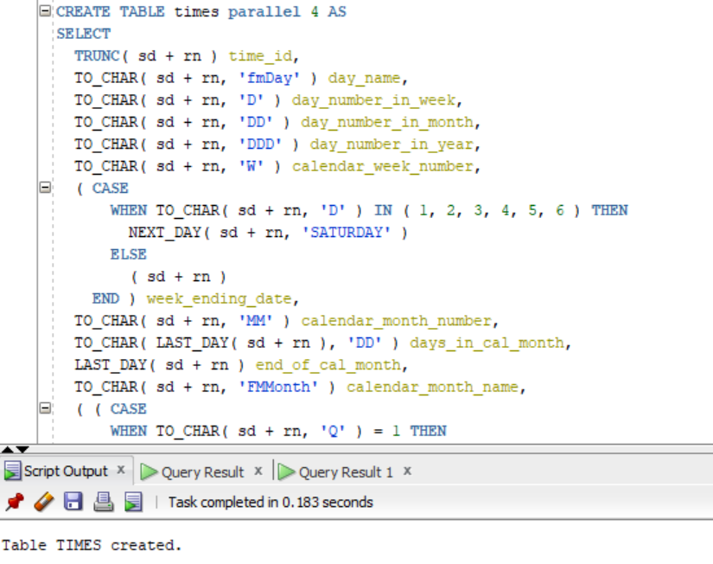

|  | CREATE | CREATE with PARALLEL execution |
| --- | --- | --- |
| time of the same operations | 0.167 | 0.183 |

Because of the small amount of data, the parallelization does not improve the results. To benefit from parallel query execution, we need to work with a large amount of information.

# 3. Business Task - Parallel execution

## 3.1. Task 03: CREATE Strategy of Parallel execution

In our data warehouse system, the large FCT_SALES, DIM_PIZZAS_SCD, DIM_CUSTOMERS, and DIM_GEN_PERIOD tables must be updated occasionally with new or updated data from the production system. We can do this efficiently by using parallel DML