# 2. Create and populate Dimension of TIME DW – Layer

**Notes:**

To Populate Time dims use External Resources:

| File Name | Path |
| --- | --- |
| Calendars.sql | … \Topic 07 - Dimension and Facts Basics\LabScripts\ |

## 2.1. Task 01: CREATE DW.T_DAYS

**The Main Task** is to create Physical diagram and Objects on DW layer:

**Task Results:**

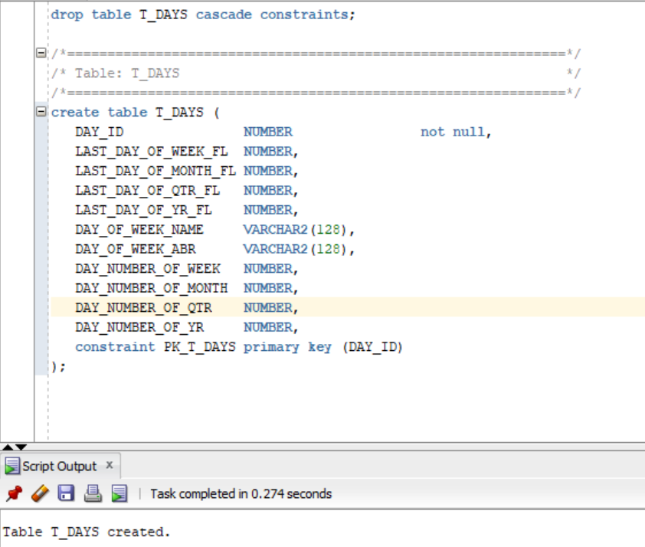

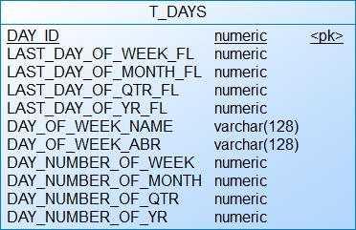

## 2.2. Task 02: CREATE DW.T_WEEKS

**The Main Task** is to create Physical diagram and Objects on DW layer:

**Task Results:**

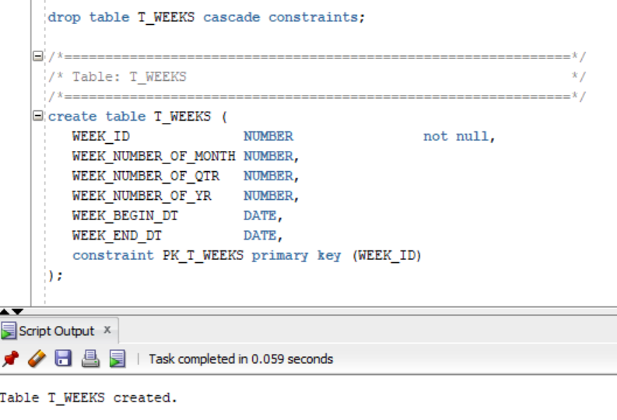

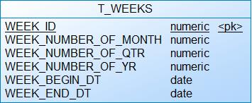

## 2.3. Task 03: CREATE DW.T_MONTHS

**The Main Task** is to create Physical diagram and Objects on DW layer:

**Task Results:**

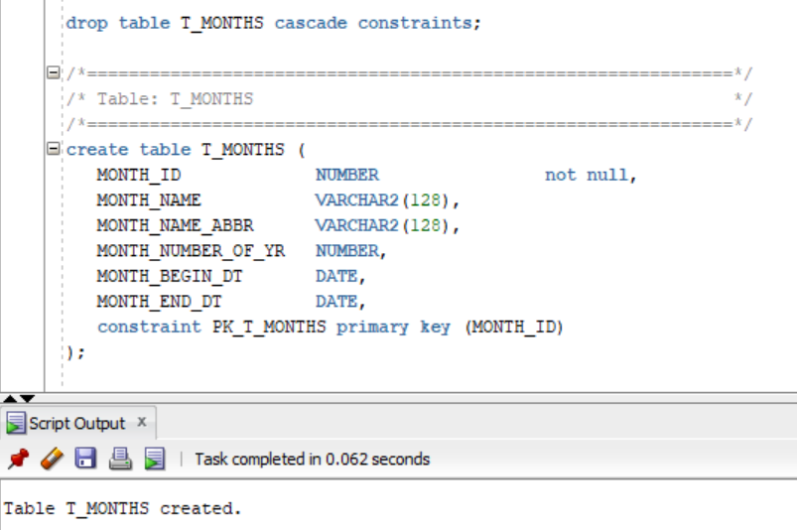

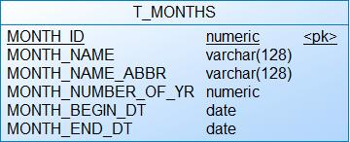

## 2.4. Task 04: CREATE DW.T_QUARTERS

**The Main Task** is to create Physical diagram and Objects on DW layer:

**Task Results:**

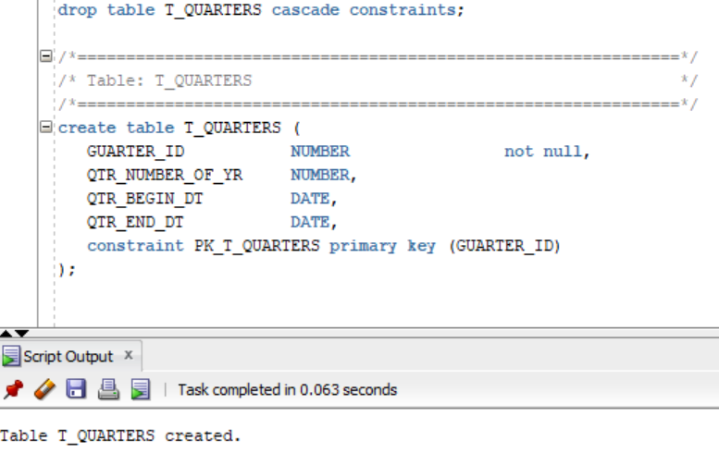

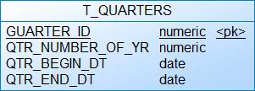

## 2.5. Task 05: CREATE DW.T_YEARS

**The Main Task** is to create Physical diagram and Objects on DW layer:

**Task Results:**

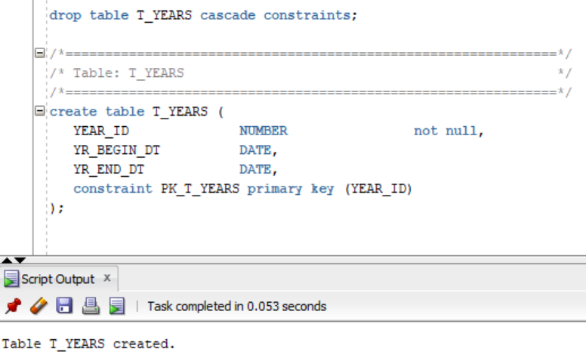

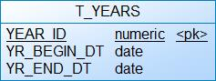

## 2.5. Task 05: CREATE T_DATE

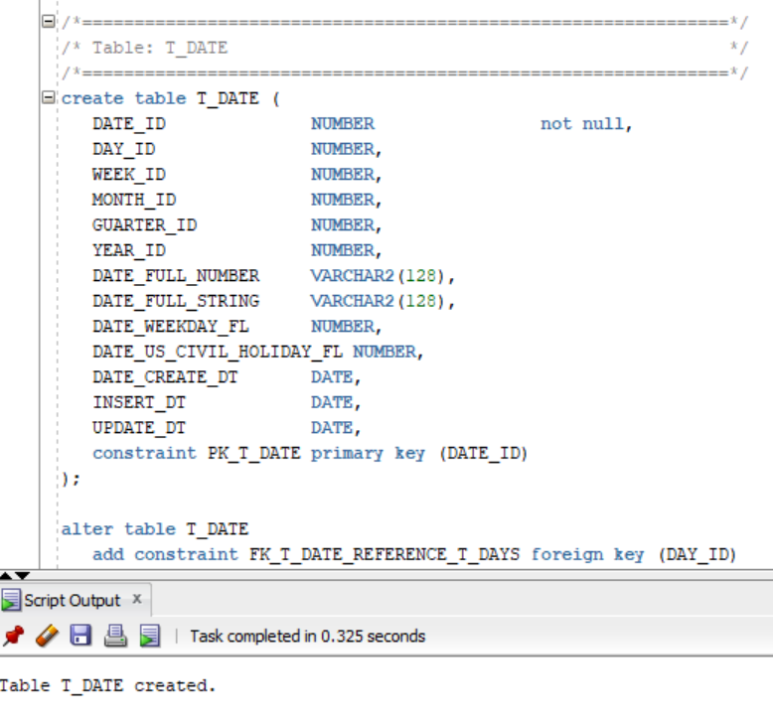

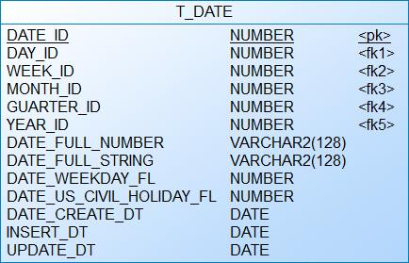

# 3. OLAP – Business analyses task

## 3.1. Task 06 – Solution concept – Add: Chapter Dimensions Types

| Name | Type | Size | DW – Merged Dimensions | Descriptions |
| --- | --- | --- | --- | --- |
| DIM_CUSTOMERS | SCD1 | BIG | - | This dimension contains detailed information about clients (age, address, contact info etc.) and will help to analyze the target audience |
| DIM_EMPLOYEES | SCD1 | SMALL | - | This dimension contains detailed information about employees (age, address, contact info, manager etc.) |
| DIM_PIZZAS_SCD | SCD2 | BIG | DW_T_CATEGORIES | This dimension contains detailed information about pizzas (weight, diameter, price, etc.) and their category. It will help to analyze the most popular pizza, category etc. |
| DIM_PROMOTIONS | SCD1 | SMALL | DW_T_PROMOTION_TYPE | This dimension contains detailed information about promotions and their type. It will help to analyze the most popular promotions and their types. |
| DIM_PAYMENT_METHODS | SCD1 | SMALL | - | This dimension contains information about payments types, bank. |
| DIM_STORES | SCD1 | SMALL | - | This dimension contains detailed information about stores (adress, manager etc.). It will help to analyze the amount of sales in particular stores, most popular pizzas and promotions in those stores. |
| DIM_GEN_PERIOD | SCD1 | SMALL | - | This dimension will help to categorize pizzas according to amount of sales. |
| DIM_DATES | SCD1 | BIG | DW.T_DAYS  DW.T_WEEKS  DW.T_MONTHS  DW.T_QUARTERS  DW.T_YEARS | These dimension consist of days, weeks, months, quarters and so on. It will help to analyze the amount of sales in a particular period, etc. |
| DIM_GEO_LOCATIONS | SCD1 | BIG | DW.T_COUNTRIES  DW.T_REGIONS  DW.T_PARTS  DW.T_SYSTEMS | This dimension will help to analyze the amount of sales in particular regions, find most popular pizzas and their categories according to regions, etc. |

## 3.2. Task 07 – Solution concept – Add: Chapter Dimensions Hierarchies

**DIM_DATES:**

**Hierarchy DAY-WEEK-MONTH-YEAR**

| Name | LEVEL_CODE | LEVEL_DESC | LEVEL_NATURAL_KEY |
| --- | --- | --- | --- |
| **DAY** | DAY | Store all day at the week | DAY_ID |
| **WEEK** | WEEK | Store all weeks at the month | WEEK_D |
| **MONTH** | MONTH | Store all months at the year | MONTH_ID |
| **YEAR** | YEAR | Store all years | YEAR _ID |

**Hierarchy DAY--MONTH- QUARTER -YEAR**

| Name | LEVEL_CODE | LEVEL_DESC | LEVEL_NATURAL_KEY |
| --- | --- | --- | --- |
| **DAY** | DAY | Store all day at the month | DAY_ID |
| **MONTHS** | MONTH | Store all months at the quarter | MONTHID |
| **QUARTER** | QUARTER | Store all quarters at the year | QUARTER_ID |
| **YEAR** | YEAR | Store all years | YEAR _ID |

**Hierarchy DAY - QUARTER -YEAR**

| **DAY** | DAY | Store all day at the quarter | DAY_ID |
| --- | --- | --- | --- |
| **QUARTER** | QUARTER | Store all quarters at the calendar year | QUARTER _ID |
| **YEAR** | YEAR | Store all years | YEAR _ID |

**DIM_GEO_LOCATIONS:**

**Hierarchy GEO_ COUNTRY- GEO_ REGION**

| **Name** | **LEVEL_CODE** | **LEVEL_DESC** | **LEVEL_NATURAL_KEY** |
| --- | --- | --- | --- |
| **GEO_COUNTRIES** | **GEO_COUNTRY** | **Store all**  **world**  **countries** | **GEO_ COUNTRY_ID** |
| **GEO_REGIONS** | **GEO_REGION** | **Store all**  **world**  **regions** | **GEO_ REGION_ID** |

**Hierarchy GEO_ COUNTRY- GEO_ REGION-GEO_PART-GEO_SYSTEM**

| **Name** | **LEVEL_CODE** | **LEVEL_DESC** | **LEVEL_NATURAL_KEY** |
| --- | --- | --- | --- |
| **GEO_COUNTRIES** | **GEO_COUNTRY** | **Store all**  **world**  **countries** | **GEO_ COUNTRY_ID** |
| **GEO_REGIONS** | **GEO_REGION** | **Store all**  **world**  **regions** | **GEO_ REGION_ID** |
| **GEO_PARTS** | **GEO_PART** | **Store all**  **Geo parts** | **GEO_PART_ID** |
| **GEO_SYSTEMS** | **GEO_SYSTEM** | **Store all**  **Geo systems** | **GEO_SYSTEM_ID** |

**DIM_PIZZAS_SCD:**

**Hierarchy PIZZA-CATEGORY**

| **Name** | **LEVEL_CODE** | **LEVEL_DESC** | **LEVEL_NATURAL_KEY** |
| --- | --- | --- | --- |
| **PIZZAS** | **PIZZA** | **Store all pizzas in database** | **PIZZA_ID** |
| **CATEGORIES** | **CATEGORY** | **Store pizza**  **categories** | **CATEGORY_ID** |

**DIM_PROMOTIONS:**

**Hierarchy PROMOTION-PROMOTION_TYPE**

| **Name** | **LEVEL_CODE** | **LEVEL_DESC** | **LEVEL_NATURAL_KEY** |
| --- | --- | --- | --- |
| **PROMOTIONS** | **PROMOTION** | **Store all promotions in database** | **PROMOTION_ID** |
| **PROMOTION_TYPES** | **PROMOTION_TYPE** | **Store all promotion types**  **categories** | **PROMOTION_TYPE_ID** |

## 3.3. Task 08 – Solution concept – Add: Chapter Facts Aggregations

| Name | Code | Table Name | Additive | Descriptions |
| --- | --- | --- | --- | --- |
| sum of sales | FCT_SALES_SUM | FCT_SALES | + | Calculates the total amount of sales in the selected period. |
| amount of sales | FCT_SALES_AMOUNT | FCT_SALES | + | Сalculates the amount of sales in the selected period. |