# 2. Data Warehouse Architecture

## 2.1. Task 01: CREATE Schema of simple Data Warehouse Architecture

| Level Type | Object Name | Tablespace | Description |
| --- | --- | --- | --- |
| Storage level  SA_* | SA_SALES | ts_sa_sales_data_01 | Loading from Flatfile storage system. Contains Sales information |
| SA_CUSTOMERS | ts_sa_customers_data_01 | Loading from Flatfile storage system. Contains Customers information |
| SA_STORES | ts_sa_stores_data_01 | Loading from Flatfile storage system. Contains Stores information |
| SA_EMPLOYEES | ts_sa_employees_data_01 | Loading from Flatfile storage system. Contains Employees information |
| SA_PIZZAS | ts_sa_pizzas_data_01 | Loading from Flatfile storage system. Contains Pizzas information |
| SA_PROMOTIONS | ts_sa_promotions_data_01 | Loading from Flatfile storage system. Contains Promotions information |
| SA_PAYMENT_METHODS | ts_sa_payment_methods_data_01 | Loading from Flatfile storage system. Contains Payment methods information |
| SA_GEO_LOCATIONS | ts_sa_geo_locations_data_01 | Loading from Flatfile storage system. Contains geo locations information |
| DW - Cleansing Level | DW_CL | ts_dw_cl_01 | Loading from stage level system. Contains all information, cleans, changes and prepares it for further usage. |
| DW – Level | DW_SALES | ts_dw_data_01 | Contains information about sales |
| DW_CUSTOMERS | ts_dw_data_01 | Contains information about customers |
| DW_STORES | ts_dw_data_01 | Contains information about stores |
| DW_EMPLOYEES | ts_dw_data_01 | Contains information about employees |
| DW_PIZZAS | ts_dw_data_01 | Contains information about pizzas |
| DW_PROMOTIONS | ts_dw_data_01 | Contains information about promotions |
| DW_PAYMENT_METHODS | ts_dw_data_01 | Contains information about payment methods |
| DW_GEO_LOCATIONS | ts_dw_data_01 | Contains information about geo locations |
| DW_DATES | ts_dw_data_01 | Contains information about dates |
| DW_GEN_PERIODS | ts_dw_data_01 | Contains information about sales categories |
| DW– Prepare Star Cleansing Level | SAL_DW_CL | ts_sal_dw_cl_01 | extract the necessary subset of the data needed to be stored in a particular data mart |
| STAR - Cleansing | SAL_CL | ts_sal_cl_01 | LOADING data from DW_CL system and cleaning any redundancy. |
| STAR – Level | FCT_SALES | ts_sa_fct_sales_01 | Contains facts (SALES) needed to be in particular data mart |
| DIM_CUSTOMERS | ts_sa_dim_customers_01 | Contains customers needed to be in particular data mart |
| DIM_STORES | ts_sa_dim_stores_01 | Contains stores needed to be in particular data mart |
| DIM_EMPLOYEES | ts_sa_dim_employees_01 | Contains employees needed to be in particular data mart |
| DIM_PIZZAS_SCD | ts_sa_dim_pizzas_scd_01 | Contains pizzas needed to be in particular data mart |
| DIM_PROMOTIONS | ts_sa_dim_promotions_01 | Contains promotions needed to be in particular data mart |
| DIM_PAYMENT_METHODS | ts_sa_dim_payment_methods_01 | Contains payment methods needed to be in particular data mart |
| DIM_GEO_LOCATIONS | ts_sa_dim_geo_locations_01 | Contains geo locations needed to be in particular data mart |
| DIM_DATES | ts_sa_dim_dates_01 | Contains dates needed to be in particular data mart |
| DIM_GEN_PERIOD | ts_sa_dim_gen_period_01 | Contains sales categories needed to be in particular data mart |

## 2.2. all scripts are located in the folder scripts

## 3. Star – Business analyses task

## 3.1. Task 07: CREATE Prepared Star Objects

## all scripts are located in the folder scripts

## 3.2. Task 08: DataFlow Diagram

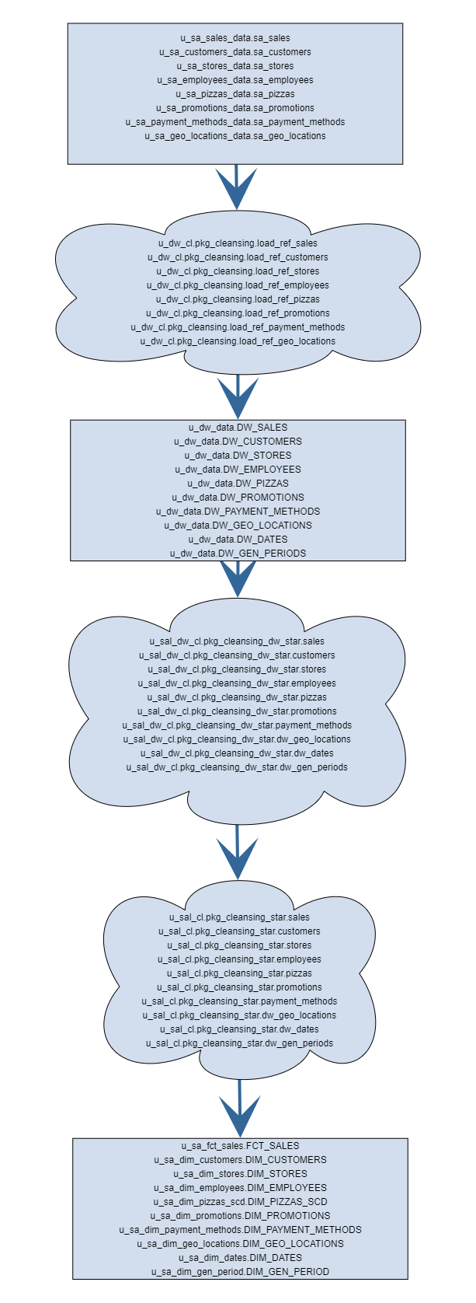

## 3.3. Task 09: Grants Object Privileges

| **USER** | **PRIVILEGES** |
| --- | --- |
| u_sa_sales_data | grant CONNECT,RESOURCE to |
| u_sa_customers_data | grant CONNECT,RESOURCE to u_sa_customers_data; |
| u_sa_stores_data | grant CONNECT,RESOURCE to u_sa_stores_data; |
| u_sa_employees_data | grant CONNECT,RESOURCE to u_sa_employees_data; |
| u_sa_pizzas_data | grant CONNECT,RESOURCE to u_sa_pizzas_data; |
| u_sa_promotions_data | grant CONNECT,RESOURCE to u_sa_promotions_data; |
| u_sa_payment_methods_data | grant CONNECT,RESOURCE to u_sa_payment_methods_data; |
| u_sa_geo_locations_data | grant CONNECT,RESOURCE to u_sa_geo_locations_data; |
| u_dw_cl | grant CONNECT,CREATE VIEW,RESOURCE to u_dw_cl; |
| u_dw_data | grant CONNECT,RESOURCE to u_dw_data; |
| u_sal_dw_cl | grant CONNECT,CREATE VIEW,RESOURCE to u_sal_dw_cl; |
| u_sal_cl | grant CONNECT,CREATE VIEW,RESOURCE to u_sal_cl; |
| u_sa_fct_sales | grant CONNECT,CREATE VIEW,RESOURCE to u_sa_fct_sales; |
| u_sa_dim_customers | grant CONNECT,CREATE VIEW,RESOURCE to u_sa_dim_customers; |
| u_sa_dim_stores | grant CONNECT,CREATE VIEW,RESOURCE to u_sa_dim_stores; |
| u_sa_dim_employees | grant CONNECT,CREATE VIEW,RESOURCE to u_sa_dim_employees; |
| u_sa_dim_pizzas_scd | grant CONNECT,CREATE VIEW,RESOURCE to u_sa_dim_pizzas_scd; |
| u_sa_dim_promotions | grant CONNECT,CREATE VIEW,RESOURCE to u_sa_dim_promotions; |
| u_sa_dim_payment_methods | grant CONNECT,CREATE VIEW,RESOURCE to u_sa_dim_payment_methods; |
| u_sa_dim_geo_locations | grant CONNECT,CREATE VIEW,RESOURCE to u_sa_dim_geo_locations; |
| u_sa_dim_dates | grant CONNECT,CREATE VIEW,RESOURCE to u_sa_dim_dates; |
| u_sa_dim_gen_period | grant CONNECT,CREATE VIEW,RESOURCE to u_sa_dim_gen_period; |