# 2. Oracle Architecture - Partitioning

all scripts are stored in folder scripts

## 2.1. Task 01: CREATE Example of Range partitioning

| Maintenance Operation | Range Composite Range-* | Interval Composite Interval-* | Hash | List Composite List-* | Reference |
| --- | --- | --- | --- | --- | --- |
| [Adding Partitions](http://docs.oracle.com/cd/B28359_01/server.111/b32024/part_admin.htm#i1007318) | ADD PARTITION | ADD PARTITION | ADD PARTITION | ADD PARTITION | N/A[Foot 1](http://docs.oracle.com/cd/B28359_01/server.111/b32024/part_admin.htm#BAJCBJBA) |
| [Coalescing Partitions](http://docs.oracle.com/cd/B28359_01/server.111/b32024/part_admin.htm#i1007442) | N/A | N/A | COALESCE PARTITION | N/A | N/A[Footref 1](http://docs.oracle.com/cd/B28359_01/server.111/b32024/part_admin.htm#sthref213) |
| [Dropping Partitions](http://docs.oracle.com/cd/B28359_01/server.111/b32024/part_admin.htm#i1007479) | DROP PARTITION | DROP PARTITION | N/A | DROP PARTITION | N/A[Footref 1](http://docs.oracle.com/cd/B28359_01/server.111/b32024/part_admin.htm#sthref214) |
| [Merging Partitions](http://docs.oracle.com/cd/B28359_01/server.111/b32024/part_admin.htm#i1007638) | MERGE PARTITIONS | MERGE PARTITIONS | N/A | MERGE PARTITIONS | N/A[Footref 1](http://docs.oracle.com/cd/B28359_01/server.111/b32024/part_admin.htm#sthref215) |
| [Moving Partitions](http://docs.oracle.com/cd/B28359_01/server.111/b32024/part_admin.htm#i1007920) | MOVE PARTITION | MOVE PARTITION | MOVE PARTITION | MOVE PARTITION | MOVE PARTITION |
| [Splitting Partitions](http://docs.oracle.com/cd/B28359_01/server.111/b32024/part_admin.htm#i1008028) | SPLIT PARTITION | SPLIT PARTITION | N/A | SPLIT PARTITION | N/A[Footref 1](http://docs.oracle.com/cd/B28359_01/server.111/b32024/part_admin.htm#sthref216) |
| [Truncating Partitions](http://docs.oracle.com/cd/B28359_01/server.111/b32024/part_admin.htm#i1008226) | TRUNCATE PARTITION | TRUNCATE PARTITION | TRUNCATE PARTITION | TRUNCATE PARTITION | TRUNCATE PARTITION |

# Range partitioning

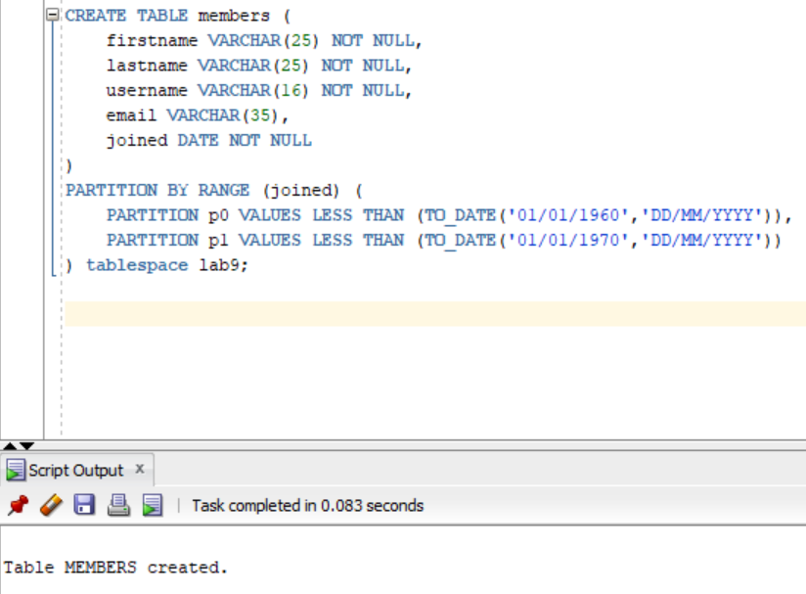

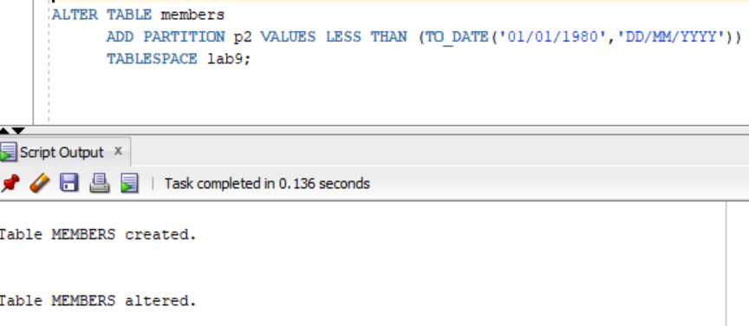

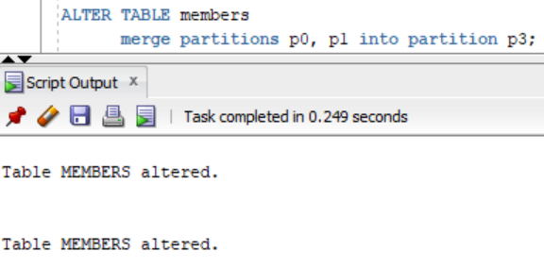

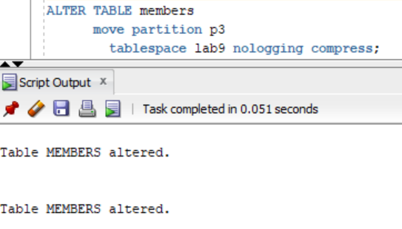

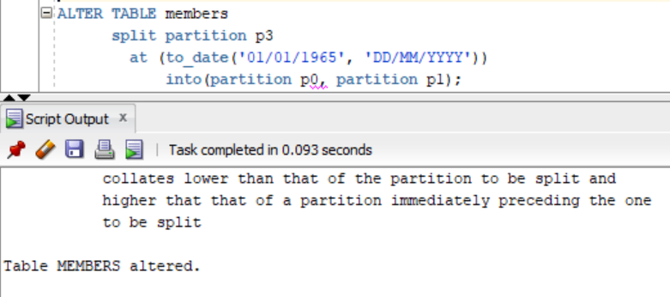

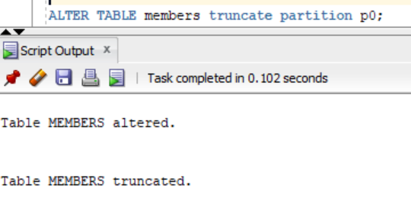

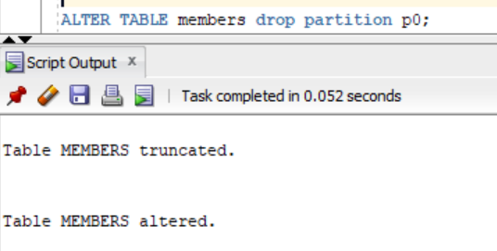

composite range

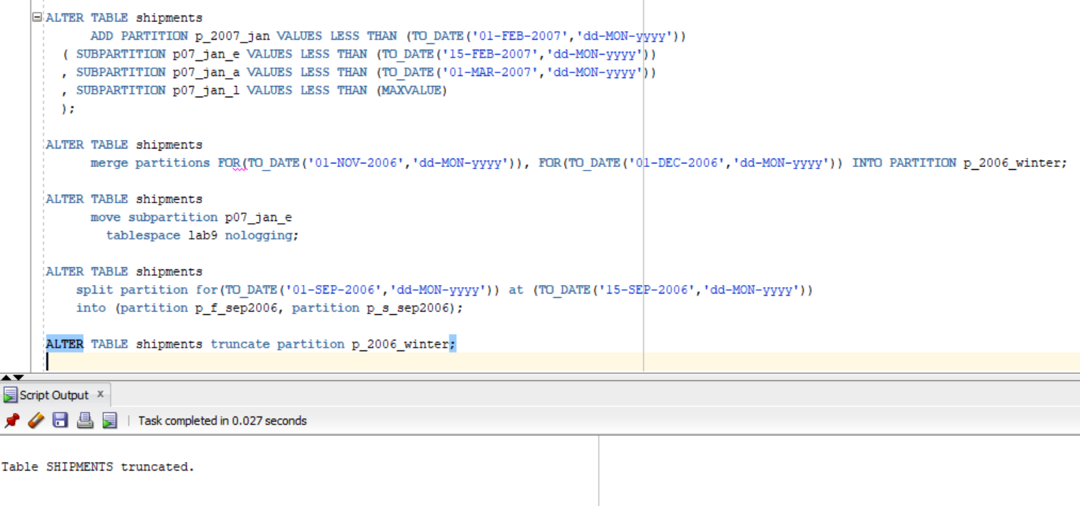

Interval partitioning

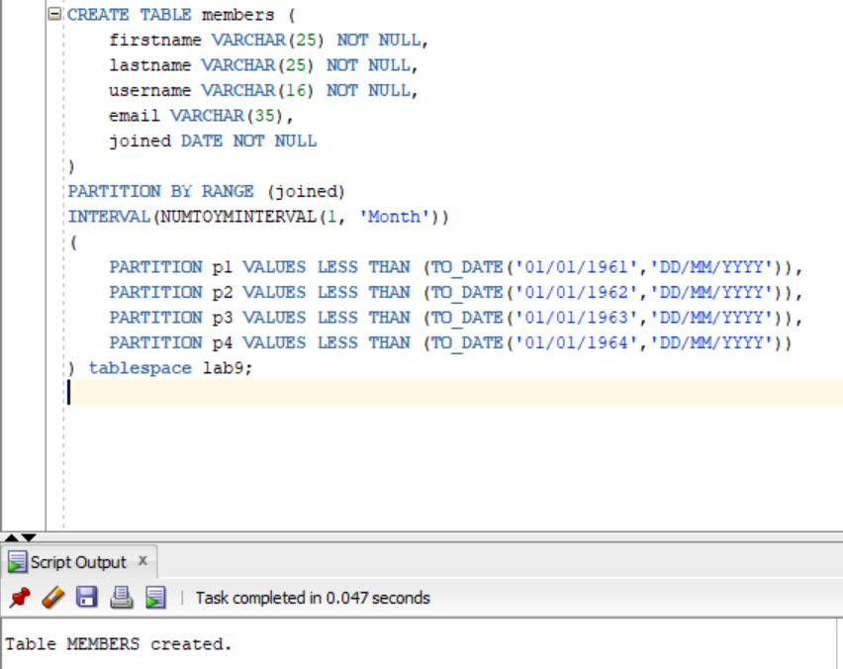

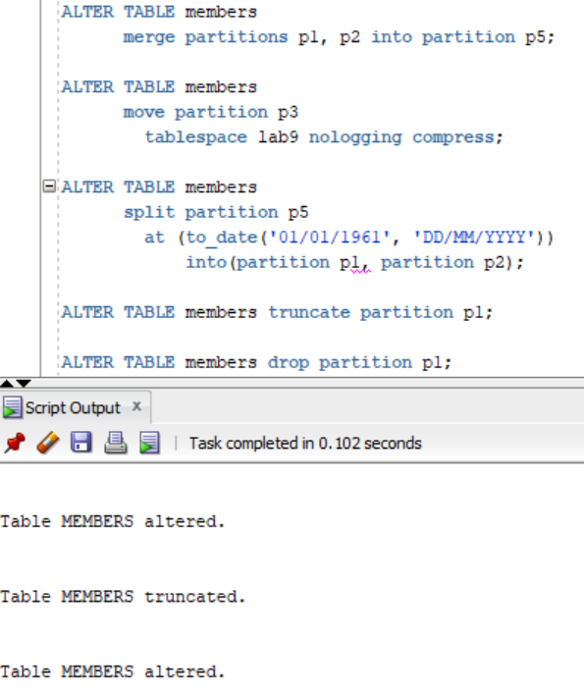

composite interval

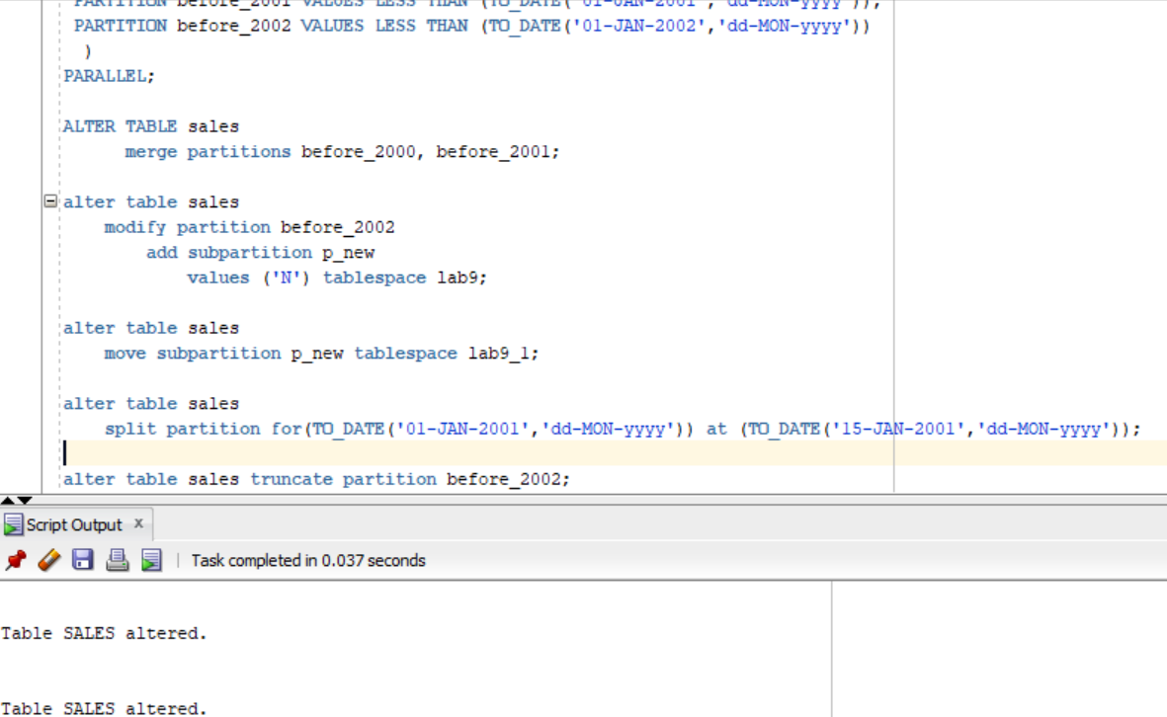

hash partitioning

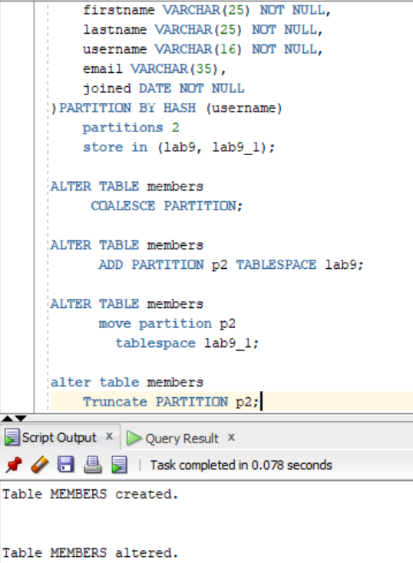

list partitioning

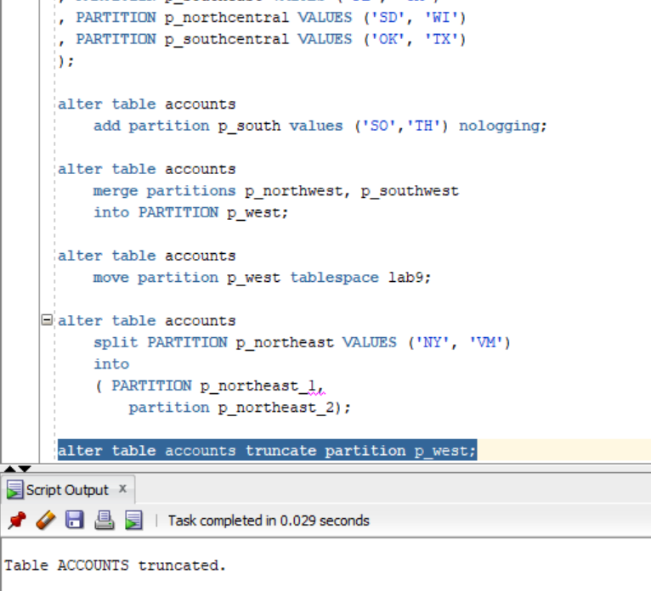

composite list

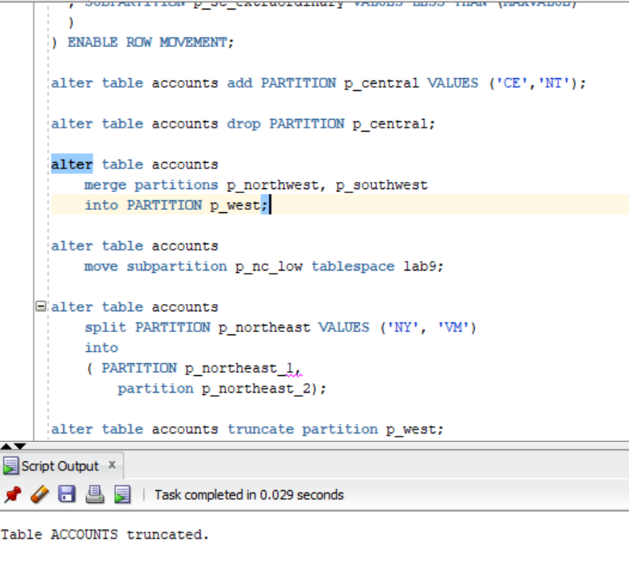

reference partitioning

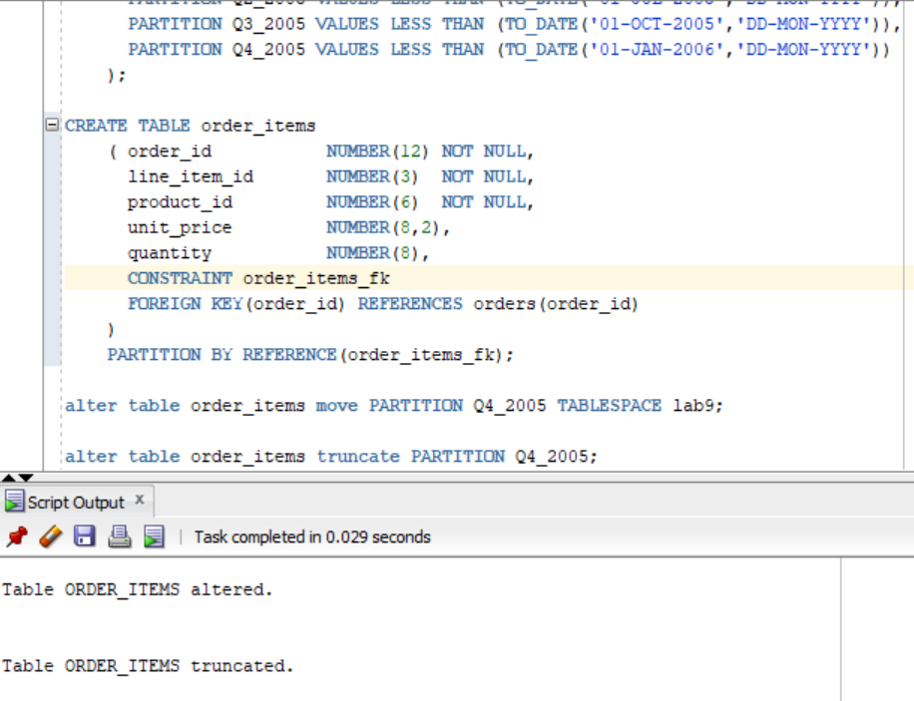

# 3. Business Task - Partitioning Facts

## 3.1. Task 02: Partitioning Facts

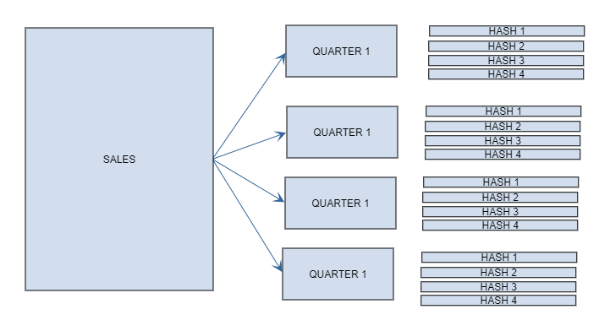

Sales data will be divided into 4 parts by quarters (quarter - information for 3 months) with range partition using event_dt. And each quarter partition will be divided into 4 subparts with a hash partition using sales_cat_id.  
####################################################

PARTITION BY RANGE (EVENT_DT)

subpartition by hash(SALES_CAT_ID) subpartitions 4

(

PARTITION QUARTER_1 VALUES LESS THAN(TO_DATE('01-apr-2020','dd-mon-yyyy'))

(

subpartition Q_1_1,

subpartition Q_1_2,

subpartition Q_1_3,

subpartition Q_1_4

),

PARTITION QUARTER_2 VALUES LESS THAN(TO_DATE('01-jul-2020','dd-mon-yyyy'))

(

subpartition Q_2_1,

subpartition Q_2_2,

subpartition Q_2_3,

subpartition Q_2_4

),

PARTITION QUARTER_3 VALUES LESS THAN(TO_DATE('01-oct-2020','dd-mon-yyyy'))

(

subpartition Q_3_1,

subpartition Q_3_2,

subpartition Q_3_3,

subpartition Q_3_4

),

PARTITION QUARTER_4 VALUES LESS THAN(TO_DATE('01-jan-2021','dd-mon-yyyy'))

(

subpartition Q_4_1,

subpartition Q_4_2,

subpartition Q_4_3,

subpartition Q_4_4

)

)

####################################################