# 2. Data Warehouse Architecture – Storage Layers

## 2.1. Task 01: CREATE Storage Objects

1. SA_CUSTOMERS

drop table u_sa_customers_data.sa_customers cascade constraints;

/*==============================================================*/

/* Table: sa_customers */

/*==============================================================*/

create table u_sa_customers_data.sa_customers (

CUSTOMER_ID NUMBER not null,

FIRST_NAME VARCHAR2(128) not null,

LAST_NAME VARCHAR2(128) not null,

GENDER VARCHAR2(10) not null,

AGE NUMBER not null,

EMAIL VARCHAR2(128) not null,

PHONE VARCHAR2(128) not null,

constraint PK_SA_CUSTOMERS primary key (CUSTOMER_ID)

)

tablespace ts_sa_customers_data_01;

1. SA_STORES

drop table u_sa_stores_data.sa_stores cascade constraints;

/*==============================================================*/

/* Table: sa_stores */

/*==============================================================*/

create table u_sa_stores_data.sa_stores (

STORE_ID NUMBER not null,

EMAIL VARCHAR2(128) not null,

PHONE VARCHAR2(128) not null,

constraint PK_SA_STORES primary key (STORE_ID)

)

tablespace ts_sa_stores_data_01;

1. SA_EMPLOYEES

drop table u_sa_employees_data.sa_employees cascade constraints;

/*==============================================================*/

/* Table: sa_employees */

/*==============================================================*/

create table u_sa_employees_data.sa_employees (

EMPLOYEE_ID NUMBER not null,

FIRST_NAME VARCHAR2(128) not null,

LAST_NAME VARCHAR2(128) not null,

EMAIL VARCHAR2(128) not null,

PHONE VARCHAR2(128) not null,

STORE_ID NUMBER not null,

HIRE_DATE DATE not null,

constraint PK_SA_EMPLOYEES primary key (EMPLOYEE_ID)

)

tablespace ts_sa_employees_data_01;

1. SA_PIZZAS

drop table u_sa_pizzas_data.sa_pizzas cascade constraints;

/*==============================================================*/

/* Table: sa_pizzas */

/*==============================================================*/

create table u_sa_pizzas_data.sa_pizzas (

PIZZA_ID NUMBER not null,

PIZZA_DESC VARCHAR2(128) not null,

PIZZA_WEIGHT NUMBER not null,

PIZZA_DIAMETER NUMBER not null,

PIZZA_PRICE NUMBER not null,

CATEGORY_ID NUMBER not null,

CATEGORY_DESC VARCHAR2(128) not null,

constraint PK_SA_PIZZAS_SCD primary key (PIZZA_ID)

)

tablespace ts_sa_pizzas_data_01;

1. SA_PROMOTIONS

drop table u_sa_promotions_data.sa_promotions cascade constraints;

/*==============================================================*/

/* Table: sa_promotions */

/*==============================================================*/

create table u_sa_promotions_data.sa_promotions (

PROMOTION_ID NUMBER not null,

PROMOTION_DESC VARCHAR2(128) not null,

PROMOTION_PERCENT NUMBER not null,

PROMOTION_TYPE_ID NUMBER not null,

PROMOTION_TYPE_DESC VARCHAR2(128) not null,

constraint PK_SA_PROMOTIONS primary key (PROMOTION_ID)

)

tablespace ts_sa_promotions_data_01;

1. SA_GEO_LOCATIONS

drop table u_sa_geo_locations_data.sa_geo_locations cascade constraints;

/*==============================================================*/

/* Table: sa_geo_locations */

/*==============================================================*/

create table u_sa_geo_locations_data.sa_geo_locations (

GEO_ID NUMBER not null,

GEO_COUNTRY_ID NUMBER not null,

GEO_COUNTRY_CODE_A2 VARCHAR2(128) not null,

GEO_COUNTRY_CODE_A3 VARCHAR2(128) not null,

GEO_COUNTRY_DESC VARCHAR2(128) not null,

GEO_REGION_ID NUMBER not null,

GEO_REGION_DESC VARCHAR2(128) not null,

GEO_REGION_CODE NUMBER not null,

GEO_PART_ID NUMBER not null,

GEO_PART_CODE NUMBER not null,

GEO_PART_DESC VARCHAR2(128) not null,

GEO_SYSTEM_ID NUMBER not null,

GEO_SYSTEM_CODE NUMBER not null,

GEO_SYSTEM_DESC VARCHAR2(128) not null,

constraint PK_SA_GEO_LOCATIONS primary key (GEO_ID)

)

tablespace ts_sa_geo_locations_data_01;

1. SA_SALES

drop table u_sa_sales_data.sa_sales cascade constraints;

/*==============================================================*/

/* Table: sa_sales */

/*==============================================================*/

create table u_sa_sales_data.sa_sales (

SALES_ID NUMBER not null,

SALES_AMOUNT NUMBER not null,

SALES_SUM NUMBER not null,

constraint PK_FCT_SALES primary key (SALES_ID)

)

tablespace ts_sa_sales_data_01;

## 2.2. Task 02: Generate Test Data in Storage Layers

1. SA_CUSTOMERS

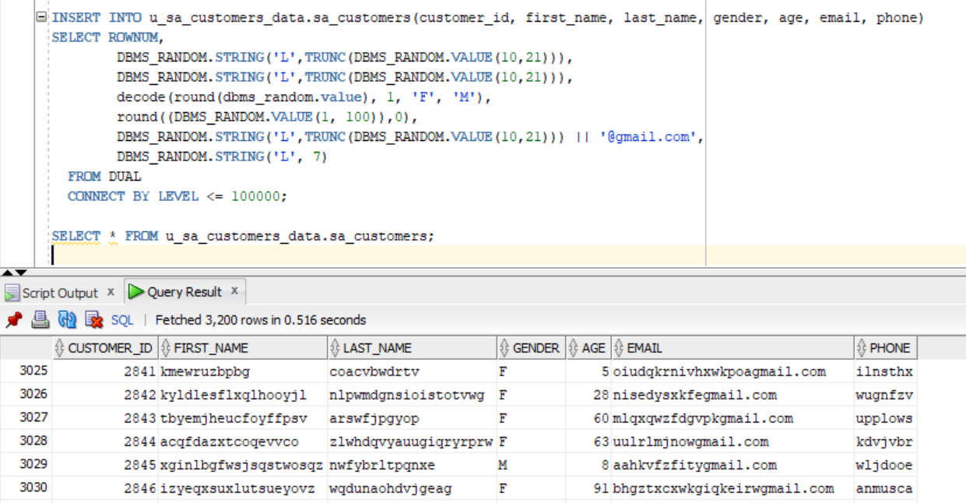

1. SA_STORES

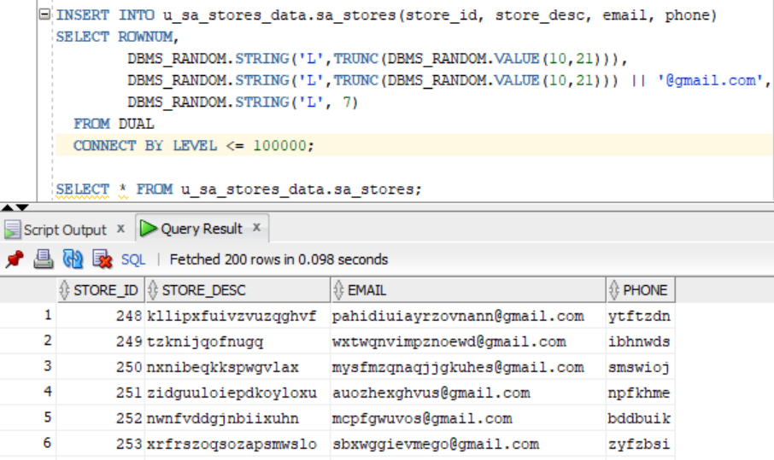

1. SA_EMPLOYEES

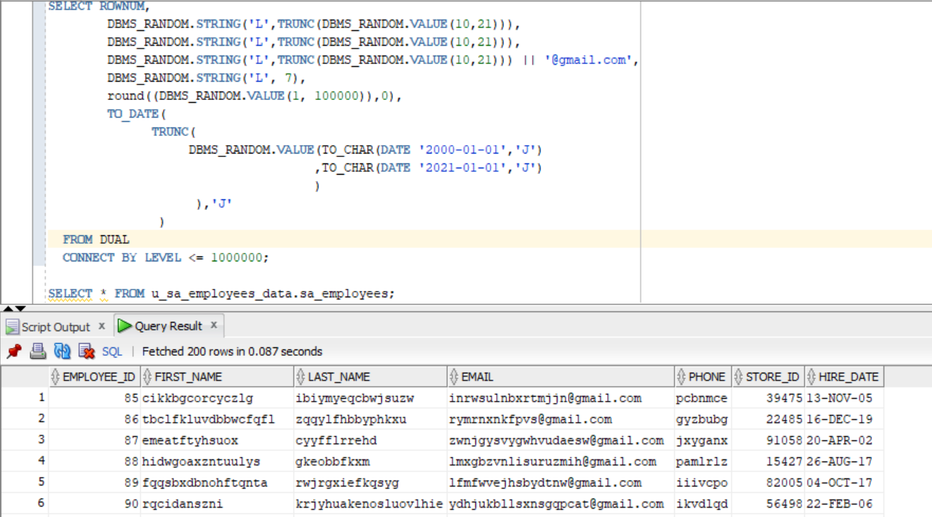

1. SA_PIZZAS

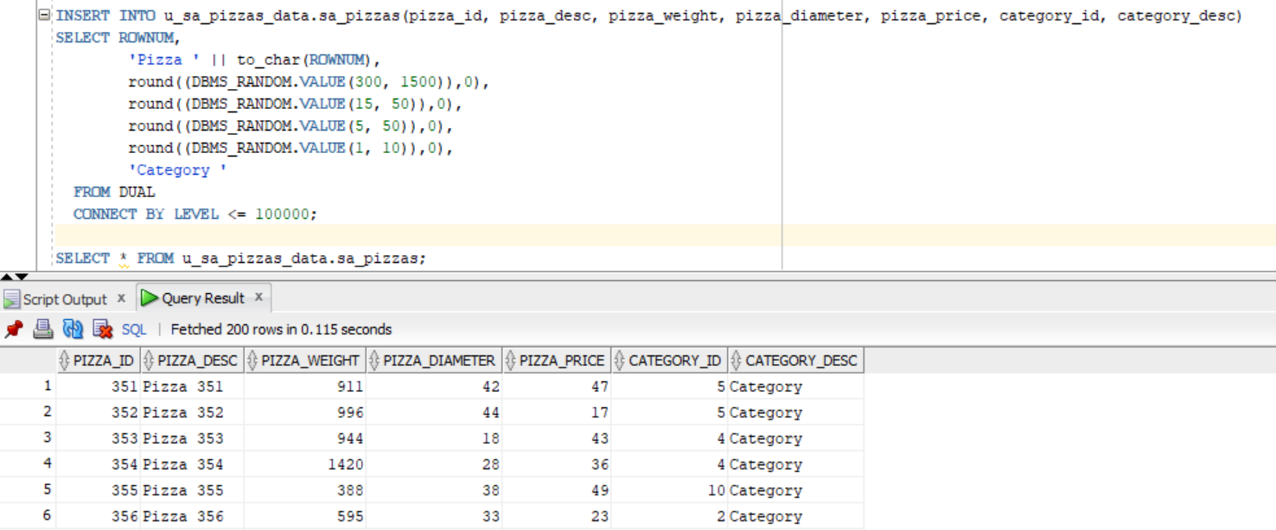

1. SA_PROMOTIONS

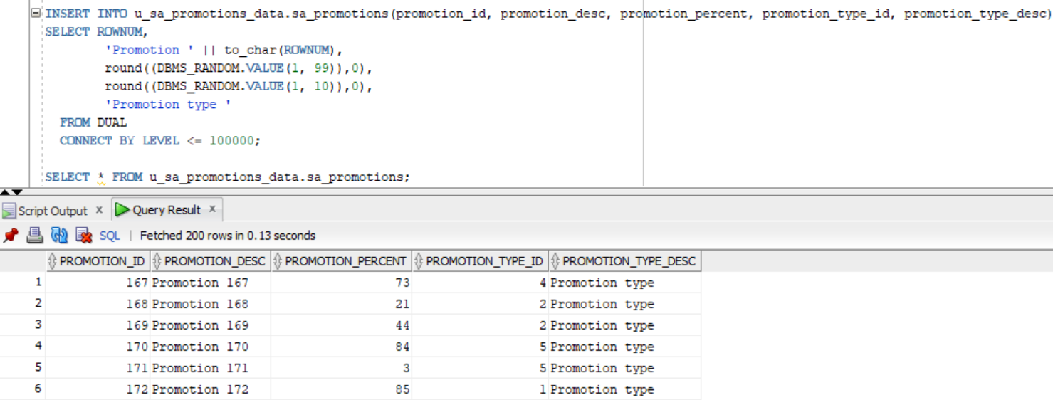

1. SA_SALES

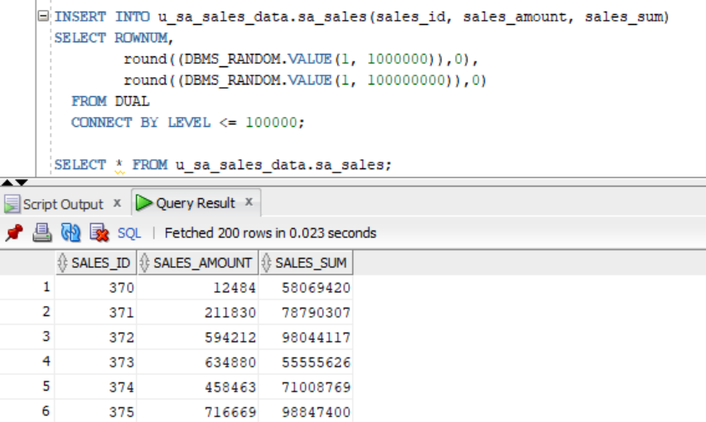

## 2.3. Task 03: Create Group by Plan

