How many cases can the bank handle completely per month with the current settings(according to "asis.pnml")?

Answer: 143
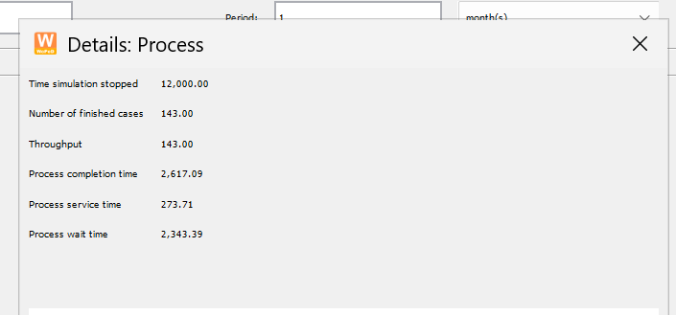

How many cases can the bank handle completely per month with the change you suggested based on "asis-refined.pnml")(according to asis.pnml)?

Answer: 205

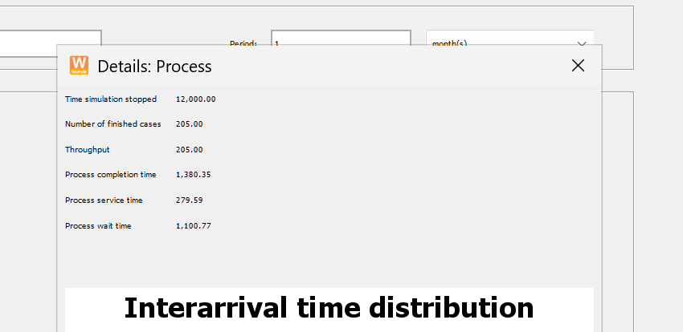

Change in resources:

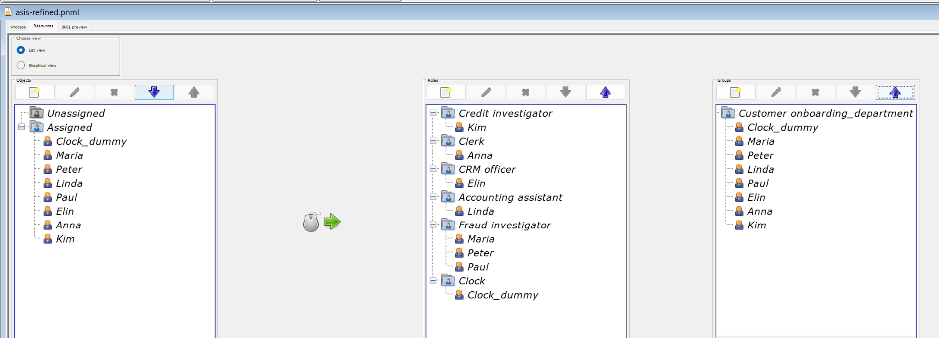

The easy fix and the only change we made was that we moved Paul from previously being an CRM - officer and “trained” him to become a fraud investigator which made a difference in the amount of cases being completed during the same period of time. A little over 24% difference in completed cases.

ProM:
Asis.pnml:

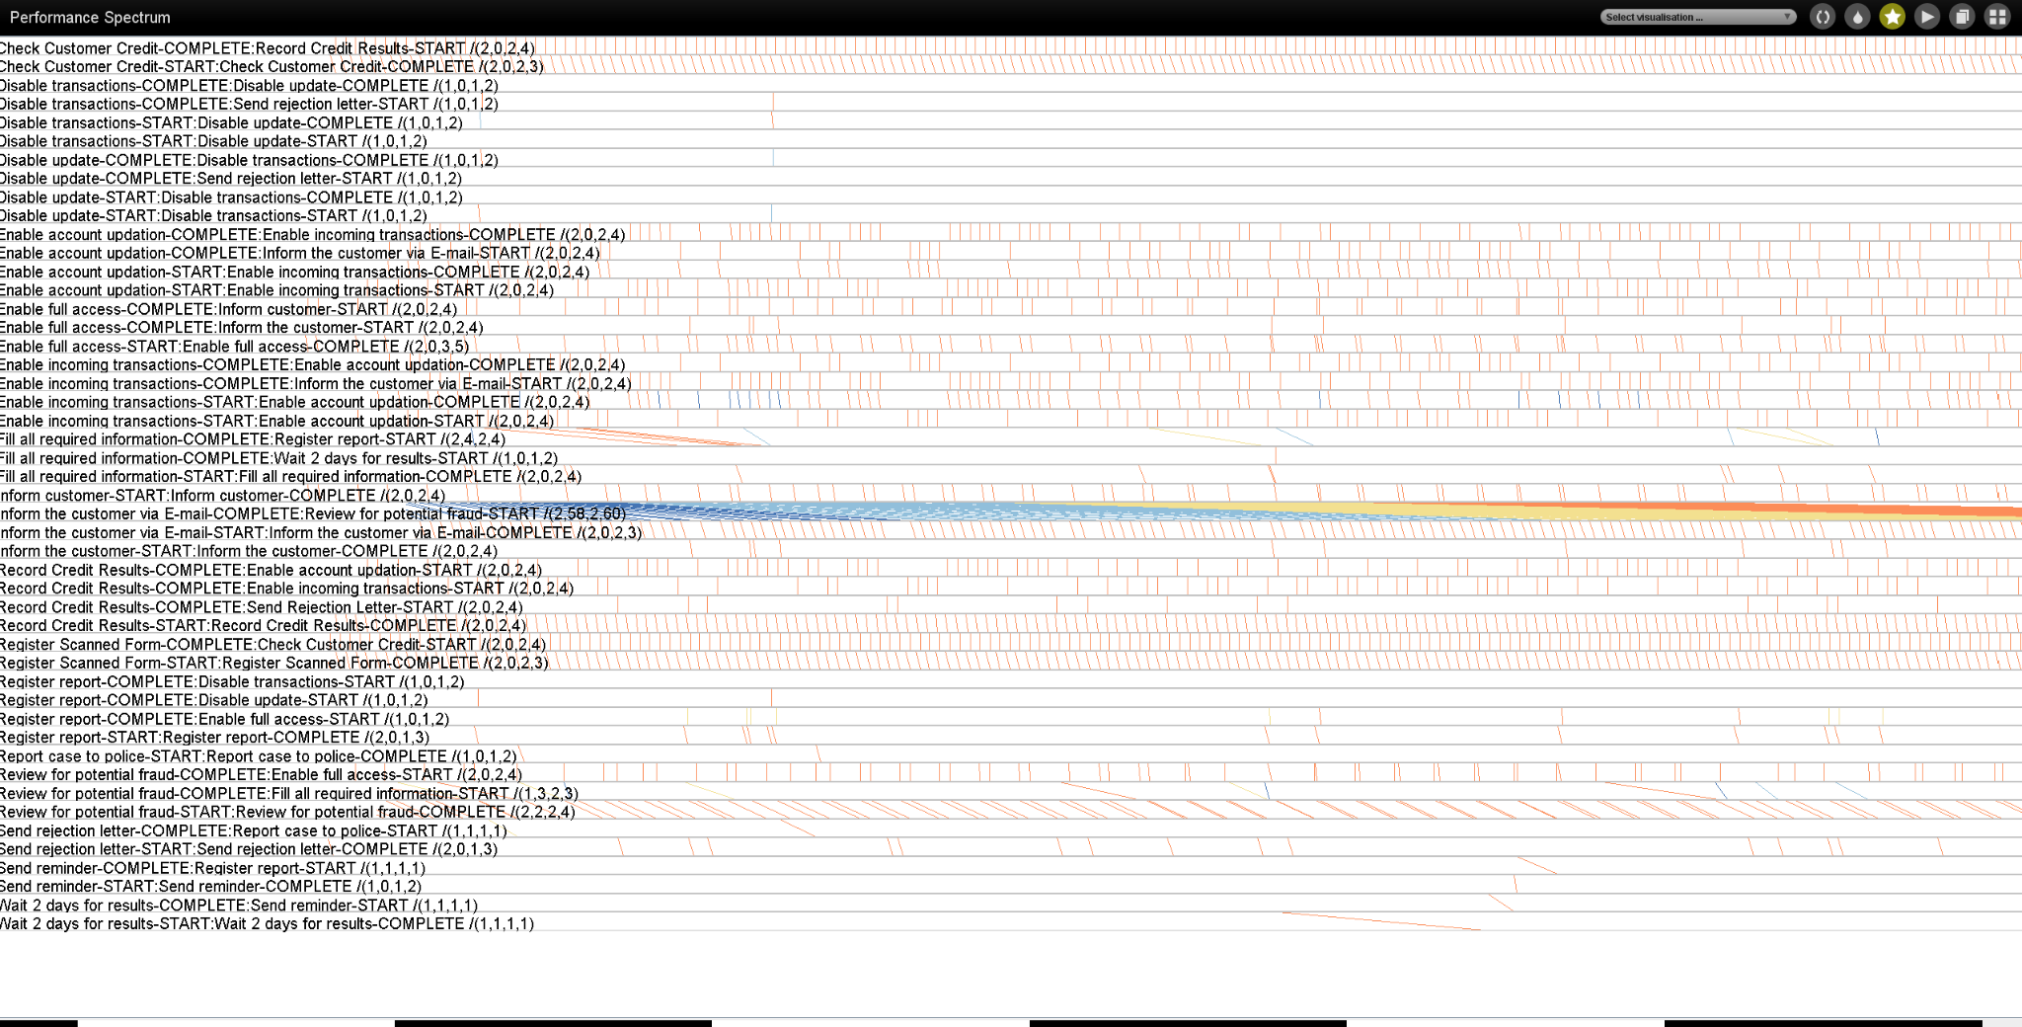

Asis-refined.pnml:
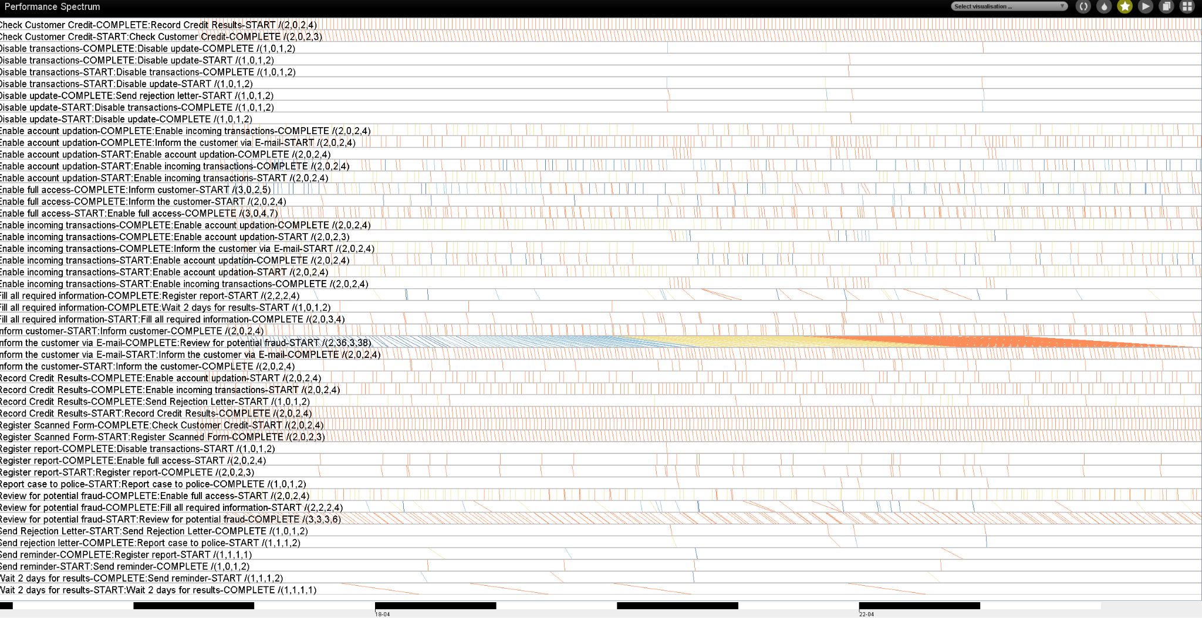

how changes in resources in asis-refined could affect some of the patterns?

In the asis model you can see the bottleneck in the spectrum pattern but in the asis-refined, its possible to see less waiting times aswell and little bit of improvement in the flow. You can see the this by looking at the blue “pattern” in this spectrum pattern and that it is less dense.

