ASSIGNMENT 1
DSA0114 - OBJECT ORIENTED PROGRAMMING WITH C++
Design, Implement and Validate the Fare Logic of a City Metro Smart-Card System
Name: Yallareddy Kaluvai
Reg.no: 192465047

Task 1: Understand the Problem and Identify the Objects

1.1 Objects, data and behaviour
Object | Data (private) | Behaviour | Why it is an object
SmartCard | balance in paise, optional pass | canTravel(), deduct(), recharge(), balance() | Owns the money and must protect the balance rule
Passenger | name, category (General, Student, Senior) | concessionPercent() | Concession depends on who travels
Journey | zone(s), hour, weekend flag | farthestZone(), isPeak() | One travel event with its own facts
Zone | enum class value | none (fixed set of values) | Closed set of named choices
FareTable | constexpr base fares, surcharge %, minimum balance | baseFare(zone), fare(journey) | Single place for fare rules

1.2 Procedural vs object-oriented
A procedural program uses global variables (balance, minBalance) and free functions (calcFare, deductFare). Any function can change balance, so a negative balance can appear anywhere, and fare values get copied into several functions (the problem in the scenario). In an object-oriented design the data and the rules that protect it are bundled together: SmartCard is the only code that can change the balance and FareTable is the only place that knows the fares, so a rule change is made in one place.

1.3 OOP principles in this system
- Encapsulation: SmartCard::balance_ is private; only deduct() and recharge() change it and they refuse invalid changes.
- Abstraction: the gate calls card.canTravel(fare) without knowing how the balance is stored.
- Inheritance: StudentPassenger and SeniorPassenger can derive from Passenger; MonthlyPass can derive from a TravelRight base.
- Polymorphism: a virtual concessionPercent() returns 0, 50 or 40 depending on the passenger type, and the fare code works with a Passenger& without checking the type.

1.4 Rules every correct journey must satisfy
- After the fare is deducted the balance is at least Rs 50 (5000 paise).
- The balance never goes negative and a recharge amount must be greater than 0.
- The fare depends on the farthest zone travelled.
- Peak hours are 8:00 to 9:59 and 17:00 to 19:59; 10:00 and 20:00 are off-peak (half-open interval [start, end)).
- The surcharge is 20% of the base fare, computed in integer paise.
- A denied journey must not change the balance.
Assumptions: time is a whole hour 0 to 23; one concession per passenger; concession percentages are chosen by the metro.

Program and output
#include <iostream>
#include <string>
enum class Zone { Inner, Middle, Outer };
constexpr long long MIN_BALANCE_PAISE = 5000;

class SmartCard {
long long balance_;
public:
explicit SmartCard(long long b) : balance_{b} {}
bool canTravel(long long f) const { return f >= 0 && balance_ - f >= MIN_BALANCE_PAISE; }
bool deduct(long long f) { if (!canTravel(f)) return false; balance_ -= f; return true; }
long long balance() const { return balance_; }
};
class Passenger {
std::string name_; int concessionPct_;
public:
Passenger(std::string n, int c) : name_{std::move(n)}, concessionPct_{c} {}
const std::string& name() const { return name_; }
int concessionPercent() const { return concessionPct_; }
};
struct Journey { Zone zone; int hour; };

int main() {
Passenger p{"Asha (student)", 50};
SmartCard card{10000};
Journey j{Zone::Outer, 9};
std::cout << "Object: Passenger -> " << p.name() << ", concession " << p.concessionPercent() << "%\n";
std::cout << "Object: SmartCard -> balance " << card.balance() << " paise\n";
std::cout << "Object: Journey -> zone " << static_cast<int>(j.zone) << ", hour " << j.hour << "\n";
std::cout << "Rule 1 (min balance): fare 4000 allowed? " << card.canTravel(4000) << '\n';
std::cout << "Rule 1 (min balance): fare 5001 allowed? " << card.canTravel(5001) << '\n';
std::cout << "Rule 6 (denied journey keeps balance): deduct(9000)=" << card.deduct(9000)
<< " balance=" << card.balance() << '\n';
}
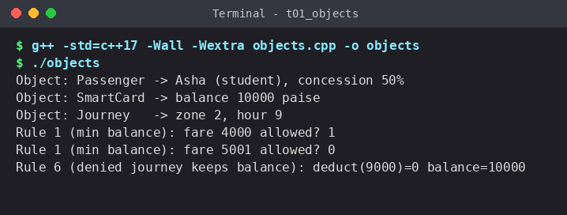
Figure 1.1: Output of Task01/objects.cpp (objects and rules demonstrated)

Alternative concept and complexity: purely procedural design
With global variables and free functions, time per journey is O(1) in both designs and memory per card is O(1) in both (one 8-byte balance). The difference is change cost: if a fare rule changes, the object-oriented design edits one FareTable member, whereas the procedural design must find every function that holds a copy of the number, so the edit effort is O(number of copies) and a missed copy causes a wrong fare.

Task 2: Tokens, Keywords, Identifiers and Constants

2.1 The five token kinds
For the line constexpr int PEAK_SURCHARGE_PERCENT = 20;
Token kind | Examples from the program
Keywords | constexpr, int, enum, class, return, switch, case
Identifiers | PEAK_SURCHARGE_PERCENT, fare, canTravel, balance
Constants (literals) | 20, 1000, 5000, '\n', "Denied"
Operators | =, +, -, /, %, >=, &&, <<
Punctuators | ;, { }, ( ), [ ], ,

2.2 #define vs const vs constexpr
- #define PEAK 20 is text substitution: no type, no scope, no debugger name, and macros like SQ(x) x*x break for SQ(a+1).
- const int PEAK = 20; is typed and scoped but its value may be fixed only at run time.
- constexpr int PEAK = 20; is typed, scoped and evaluated at compile time, so it can size arrays, appear in switch labels and static_assert. This is why it is preferred for the fare table.

2.3 enum vs enum class
A plain enum leaks its names into the enclosing scope and converts silently to int. enum class Zone needs Zone::Inner, does not convert implicitly and cannot be compared with another enum, so wrong zone arithmetic is a compile error (see Figure 2.2).

2.4 Naming conventions
An identifier uses letters, digits and underscore, must not start with a digit, must not be a keyword and is case-sensitive. Convention used: UPPER_SNAKE for constants, PascalCase for types, camelCase for functions and variables, a trailing underscore for private members (balance_).

2.5 Single set of constants and output
#include <iostream>
#define OLD_PEAK 20 // macro: no type, no scope
enum class Zone { Inner, Middle, Outer };
constexpr int BASE_PAISE[] = {1000, 2000, 3000};
constexpr int PEAK_SURCHARGE_PERCENT = 20;
constexpr long long MIN_BALANCE_PAISE = 5000;
static_assert(sizeof(BASE_PAISE) / sizeof(BASE_PAISE[0]) == 3, "three zones expected");
static_assert(PEAK_SURCHARGE_PERCENT > 0 && PEAK_SURCHARGE_PERCENT < 100, "bad surcharge");
int main() {
constexpr int arr[BASE_PAISE[0] / 500] = {1, 2}; // constexpr usable as array size
std::cout << "constexpr array size from BASE_PAISE[0]/500 = " << sizeof(arr) / sizeof(arr[0]) << '\n';
std::cout << "sizeof(Zone) = " << sizeof(Zone) << " bytes\n";
std::cout << "Zone::Outer as number = " << static_cast<int>(Zone::Outer) << " (cast needed)\n";
std::cout << "OLD_PEAK macro value = " << OLD_PEAK << " (no type)\n";
// int bad = Zone::Inner; // enum class: compile error, no silent conversion
// bool eq = (Zone::Inner == 0); // compile error
std::cout << "MIN_BALANCE_PAISE = " << MIN_BALANCE_PAISE << ", surcharge = " << PEAK_SURCHARGE_PERCENT << "%\n";
}
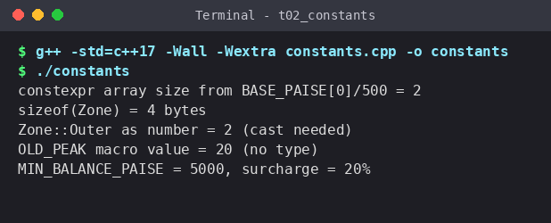
Figure 2.1: Output of Task02/constants.cpp (constexpr array size, static_assert passes)
enum class Zone { Inner, Middle, Outer };
int main() { int bad = Zone::Inner; return bad; }
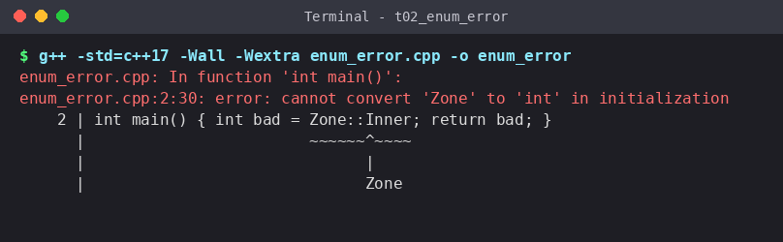
Figure 2.2: enum class refuses silent conversion to int (compile error)

Alternative concept and complexity: #define macros
With #define BASE_INNER 1000 there is no type checking (the macro can silently be used as a char), no scope (it affects every later line and every included header) and zones become loose integers. Memory: a macro occupies no storage; a constexpr value usually occupies none either because the compiler folds it into the instruction. Time: unchanged, O(1), because the constant is folded at compile time in both cases. The gain from constexpr and enum class is safety, not speed.

Task 3: Data Types and Type Compatibility

3.1 Data-type table
Value | Type | sizeof (this system) | Range | Reason
Fare, balance (paise) | long long | 8 bytes | +/- 9.22e18 | Exact integers, room for network totals
Base fare table | int | 4 bytes | +/- 2.147e9 | Single fares are small
Hour (0 to 23) | int | 4 bytes |  | Used in comparisons
Zone | enum class Zone | 4 bytes | 3 or 4 values | Type-safe
Peak / weekend flag | bool | 1 byte | true / false | Yes/no fact
Journey count | long long / unsigned | 8 / 4 bytes |  | Never negative
Category code | char | 1 byte |  | Single letter

3.2 Why integer paise, not double rupees
Binary floating point cannot store 0.1 exactly (see Figure 3.1: 0.1 + 0.2 == 0.3 is false). Money must match to the paisa, so Rs 36.00 is stored as 3600 and converted to rupees only when printed.

3.3 Type compatibility
In an expression bool, char and short are promoted to int, then the smaller type is converted to the larger (int, unsigned, long long, float, double). So true + 2.5 is 3.5.

3.4 Is int enough?
No. 3,000,000 journeys x Rs 10 (the cheapest fare) = 3,000,000,000 paise, which is above INT_MAX (2,147,483,647). long long is required.

3.5 Program and output (sizes, ranges, precision problem and fix)
#include <climits>
#include <iomanip>
#include <iostream>
int main() {
std::cout << "bool " << sizeof(bool) << " | char " << sizeof(char) << " | int " << sizeof(int)
<< " | unsigned " << sizeof(unsigned) << " | long long " << sizeof(long long)
<< " | float " << sizeof(float) << " | double " << sizeof(double) << '\n';
std::cout << "INT_MAX " << INT_MAX << "\nUINT_MAX " << UINT_MAX
<< "\nLLONG_MAX " << LLONG_MAX << '\n';
double s = 0; for (int i = 0; i < 10; ++i) s += 0.1;
std::cout << std::setprecision(17) << "double sum of ten 0.1 = " << s << (s == 1.0 ? " (equal)" : " (NOT equal to 1.0)") << '\n';
long long p = 0; for (int i = 0; i < 10; ++i) p += 10;
std::cout << "paise sum of ten 10p = " << p << (p == 100 ? " (equal)" : " (NOT equal)") << '\n';
std::cout << "0.1 + 0.2 == 0.3 ? " << std::boolalpha << (0.1 + 0.2 == 0.3) << '\n';
std::cout << "true + 2.5 = " << true + 2.5 << '\n';
std::cout << "\nRounding error when n fares of Rs 0.10 are added as double:\n";
for (long long n : {20000LL, 500000LL, 3000000LL}) {
double d = 0; for (long long i = 0; i < n; ++i) d += 0.10;
long long paise = 0; for (long long i = 0; i < n; ++i) paise += 10;
double exact = paise / 100.0;
std::cout << std::setw(8) << n << " double=" << std::fixed << std::setprecision(10) << d
<< " exact=" << exact << " error=" << std::scientific << std::setprecision(3) << (d - exact) << std::defaultfloat << '\n';
}
}
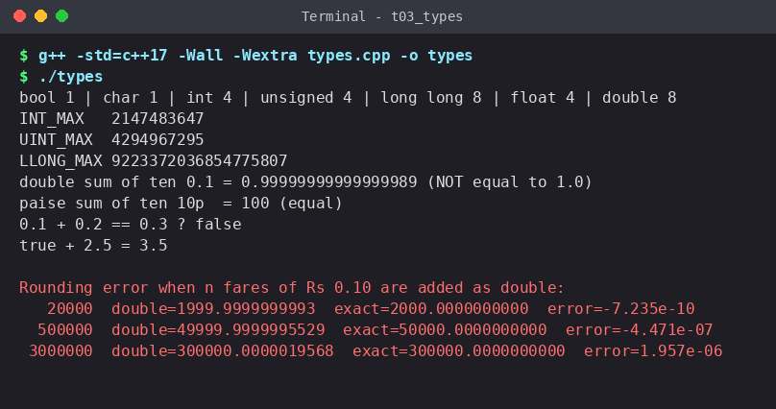
Figure 3.1: sizeof, climits ranges, the double precision problem and the paise fix
Resolution: the double sum of ten 0.1 values is 0.99999999999999989, not 1.0, while the integer paise sum is exactly 100. The measured error for adding Rs 0.10 repeatedly grows from -7.2e-10 (20,000 fares) to -4.5e-07 (500,000) to 1.96e-06 (3,000,000).

Alternative concept and complexity: double rupees
Time per addition: O(1) in both. Space per value: 8 bytes in both. Accuracy: each addition of a non-representable amount can add up to about one unit in the last place of rounding error, so the error after n fares grows roughly linearly with n (the measured table above shows it growing as n grows). Integer paise has error exactly 0 until overflow near 9.2e18.

Task 4: Control Implicit Conversions

4.1 Conversion points
- Integer division: 7 / 2 is 3 (both operands int), then converted to double 3.0.
- Promotion: char + int becomes int.
- int to bool: any non-zero value becomes true (1).
- Signed vs unsigned: in s < u the signed -1 becomes 4294967295.
- Narrowing: int x = 3.7; compiles (x is 3) but int x{3.7}; is a compile error (Figure 4.2).
- static_cast<double>(a) / b is needed when the conversion is intended.

4.2 Predict the Output
My predicted output (written before running):
3 3.5
C 68
1 true
s >= u
#include <iostream>
int main()
{
int a = 7, b = 2;
double c = a / b; double d = static_cast<double>(a) / b;
std::cout << c << ' ' << d << '\n';
char ch = 'A' + 2;
std::cout << ch << ' ' << ch + 1 << '\n';
bool flag = 5;
std::cout << flag << ' ' << std::boolalpha << flag << '\n';
unsigned int u = 1;
int s = -1;
std::cout << (s < u ? "s < u" : "s >= u") << '\n';
}
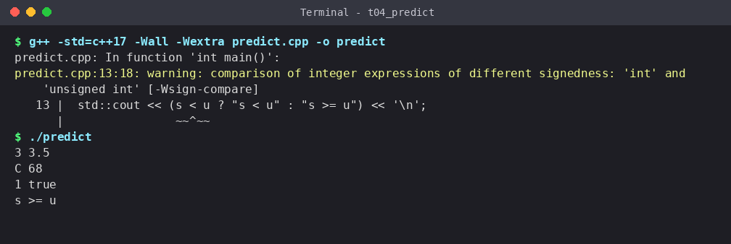
Figure 4.1: Actual output of the Predict-the-Output program, with the -Wsign-compare warning
Result: the actual output matches the prediction exactly (no differences). Explanation of each line:
- c = a / b: integer division gives 3, int to double gives 3.0, printed 3. d casts a first so it is 7.0 / 2 = 3.5.
- 'A' + 2 is int 67 stored in char as 'C'. ch + 1 is promoted to int (char to int promotion), so it prints 68.
- bool flag = 5 converts a non-zero int to true; it prints 1, then boolalpha makes the next print true (int to bool).
- s < u converts s (-1) to unsigned 4294967295 (signed to unsigned), so the test is false and prints s >= u. g++ warns: comparison of integer expressions of different signedness.

4.3 Corrected code
#include <iostream>
int main()
{
int a{7}, b{2};
double c{static_cast<double>(a) / b};
char ch{static_cast<char>('A' + 2)};
bool flag{a != 0};
unsigned int u{1};
int s{-1};
std::cout << c << ' ' << ch << ' ' << static_cast<int>(ch) + 1 << ' ' << std::boolalpha << flag << '\n';
std::cout << (static_cast<long long>(s) < static_cast<long long>(u) ? "s < u" : "s >= u") << '\n';
// int bad{3.7}; // would be a compile error: narrowing
}
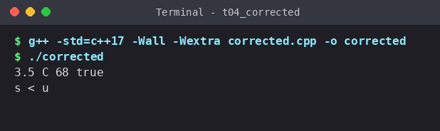
Figure 4.2a: Corrected program (static_cast and brace initialisation), no warnings; s < u is now correct
int main() { int x{3.7}; return x; }
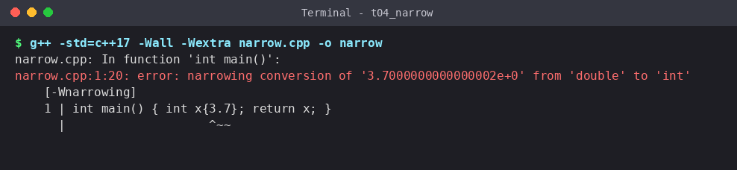
Figure 4.2b: Brace initialisation rejects the narrowing conversion int x{3.7} at compile time

Alternative concept and complexity: all conversions explicit
Writing every conversion with static_cast and brace initialisation changes nothing in running time (O(1)) or memory, because the casts compile to the same instructions as the implicit conversions. What improves is that narrowing mistakes are caught at compile time (Figure 4.2b) and signed/unsigned conversions are visible to the reader, instead of becoming silent run-time wrong answers such as 3 instead of 3.5.

Task 5: Expressions and Precedence

5.1 Fare expressions
bool peak = (hour >= 8 && hour < 10) || (hour >= 17 && hour < 20);
long long fare = base + (peak ? base * PEAK_SURCHARGE_PERCENT / 100 : 0);
fare -= fare * concessionPercent / 100; // compound assignment
Precedence (high to low): relational >= <, then &&, then ||; ?: and =/-= are lower and associate right to left. && binds tighter than ||, so the version without parentheses is equivalent, but the parentheses make the two intervals obvious. x++ returns the old value then increments; ++x increments then returns the new value. i = i++; modifies i twice without a meaningful order (undefined behaviour before C++17 and still meaningless after), so it must never be written. / truncates toward zero and % takes the sign of the left operand.

5.2 Predict the Output
My predicted output (written before running):
11 16
9 6 4
6 4
3 1 -3 -1
18
#include <iostream>
int main()
{
int x = 5, y = 3;
std::cout << x + y * 2 << ' ' << (x + y) * 2 << '\n';
int z = x++ + ++y;
std::cout << z << ' ' << x << ' ' << y << '\n';
std::cout << (x > y ? x : y) << ' ' << x % 4 * 2 << '\n';
std::cout << 10 / 3 << ' ' << 10 % 3 << ' ' << -10 / 3 << ' ' << -10 % 3 << '\n';
int k = 0;
for (int i = 0; i < 10; i += 3) k += i;
std::cout << k << '\n';
}
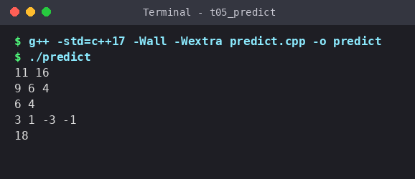
Figure 5.1: Actual output of the Predict-the-Output program (matches the prediction)
Result: identical to the prediction. Line by line:
- x + y * 2: * before +, so 5 + 6 = 11. (x + y) * 2: parentheses first, 8 * 2 = 16.
- x++ + ++y: x++ gives 5 (x becomes 6), ++y gives 4 (y becomes 4), z = 9; then x = 6 and y = 4 are printed.
- x > y ? x : y is 6. x % 4 * 2: % and * have equal precedence, left to right: (6 % 4) * 2 = 4.
- 10 / 3 = 3, 10 % 3 = 1, -10 / 3 = -3 (truncation toward zero), -10 % 3 = -1 (sign of the left operand).
- The loop runs for i = 0, 3, 6, 9, so k = 18.

Alternative concept and complexity: lookup table bool peak[24]
#include <iostream>
constexpr bool PEAK[24] = {0,0,0,0,0,0,0,0, 1,1, 0,0,0,0,0,0,0, 1,1,1, 0,0,0,0};
bool isPeakExpr(int h) { return (h >= 8 && h < 10) || (h >= 17 && h < 20); }
int main() {
bool allSame = true;
for (int h = 0; h < 24; ++h) {
if (PEAK[h] != isPeakExpr(h)) allSame = false;
std::cout << "hour " << h << (h < 10 ? " " : "") << ": expr=" << isPeakExpr(h) << " table=" << PEAK[h] << '\n';
}
std::cout << "Expression and table agree for all 24 hours: " << std::boolalpha << allSame << '\n';
}
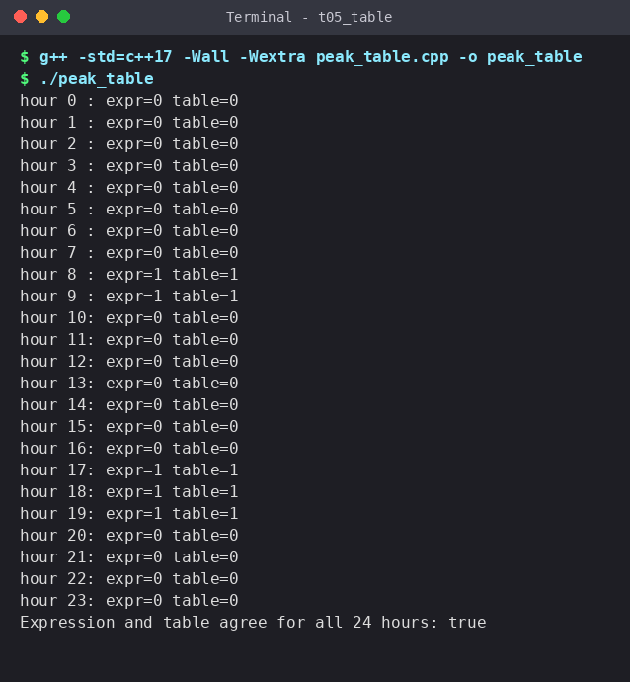
Figure 5.2: The lookup table and the && / || expression agree for all 24 hours
Time per check is O(1) in both; the table needs one index operation instead of up to four comparisons plus logical operators. Extra space is 24 bytes. The table needs a bounds check on hour (0 to 23) because an index outside the array is undefined behaviour.

Task 6: Control Structures

6.1 Choices
- if-else for ranges and conditions (peak hours, balance check); switch for one discrete value such as the zone; ?: for a short two-way value.
- Loops: a range-based for is best for processing every journey in order (no index errors); an index for when the position matters; while for reading until end of input.
- continue skips an invalid journey; break leaves a switch case or a search loop.
- If no case matches, control falls past the switch (or goes to default), so a default branch must report an invalid zone.

6.2 Pseudocode (adapt to the SIMATS Algorithmic Pseudocode standard)
ALGORITHM ComputeFare(zone, peak)
INPUT : zone (Inner | Middle | Outer), peak (true | false)
OUTPUT: fare in paise
BEGIN
SWITCH zone
CASE Inner : base <- 1000
CASE Middle: base <- 2000
CASE Outer : base <- 3000
DEFAULT : RETURN -1 // invalid zone
END SWITCH
IF peak THEN
base <- base + base * 20 / 100
END IF
RETURN base
END

6.3 Complete the Code (TODO 1 and TODO 2 filled)
#include <iomanip>
#include <iostream>
enum class Zone { Inner, Middle, Outer };
constexpr int BASE_PAISE[] = {1000, 2000, 3000}; // Rs 10, Rs 20, Rs 30
constexpr int PEAK_SURCHARGE_PERCENT = 20;
constexpr long long MIN_BALANCE_PAISE = 5000; // Rs 50 must remain on the card

long long fare(Zone z, bool peak)
{
long long base = 0;
switch (z) {
case Zone::Inner: base = BASE_PAISE[0]; break;
case Zone::Middle: base = BASE_PAISE[1]; break;
case Zone::Outer: base = BASE_PAISE[2]; break;
default: return -1;
}
if (peak) base += base * PEAK_SURCHARGE_PERCENT / 100;
return base;
}
bool canTravel(long long balance, long long f)
{
return f >= 0 && balance - f >= MIN_BALANCE_PAISE;
}
int main()
{
long long balance = 10000; // Rs 100.00 in paise
struct Trip { Zone zone; bool peak; };
Trip trips[] = {{Zone::Inner, false}, {Zone::Outer, true}, {Zone::Middle, false}};
for (const Trip& t : trips) {
long long f = fare(t.zone, t.peak);
if (canTravel(balance, f)) {
balance -= f;
std::cout << "Fare Rs " << f / 100 << '.' << std::setw(2)
<< std::setfill('0') << f % 100 << std::setfill(' ');
} else {
std::cout << "Denied (low balance)"; }
std::cout << " balance Rs " << balance / 100 << '\n';
}
}
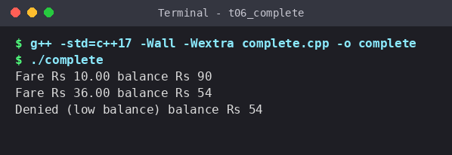
Figure 6.1: Output of the completed program, identical to the expected output

6.4 Peak boundary test (10 AM and 8 PM)
#include <iostream>
bool isPeak(int hour) { return (hour >= 8 && hour < 10) || (hour >= 17 && hour < 20); }
int main() {
for (int h : {7, 8, 9, 10, 16, 17, 19, 20})
std::cout << "hour " << h << (h < 10 ? " " : "") << " -> " << (isPeak(h) ? "PEAK" : "off-peak") << '\n';
std::cout << "10 AM off-peak: " << std::boolalpha << !isPeak(10) << " | 8 PM off-peak: " << !isPeak(20) << '\n';
}
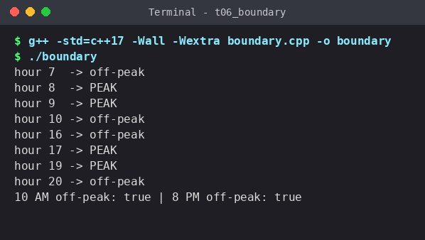
Figure 6.2: 8:00 and 17:00 are peak; 10:00 and 20:00 are off-peak
The half-open interval [start, end) fixes the inconsistency in the old software: 10:00 and 20:00 are always off-peak.

Alternative concept and complexity: array indexed by zone
constexpr long long FARE[] = {1000, 2000, 3000};
long long base = FARE[static_cast<int>(z)];
Time per lookup is O(1) in both (a switch may compile to a jump table). The array needs 3 x 8 = 24 bytes. For a fourth zone the array needs one more entry and the lookup line is unchanged, while the switch needs a new case. The array needs a bounds check; the switch has a safe default.

Task 7: From Procedural to Object-Oriented
The program below contains both versions. The procedural version cannot stop a bad deductP(9000) (balance becomes 1000, below the Rs 50 minimum). The SmartCard class refuses deduct(9000) and recharge(-500) and leaves the balance unchanged.
#include <iostream>
// ---------- Procedural ----------
long long gBalance = 10000;
constexpr long long MIN_BAL = 5000;
bool canTravelP(long long f) { return gBalance - f >= MIN_BAL; }
void deductP(long long f) { gBalance -= f; }
// ---------- Object-oriented ----------
class SmartCard {
long long balance_;
static constexpr long long MIN = 5000;
public:
explicit SmartCard(long long b) : balance_{b} {}
bool canTravel(long long f) const { return f >= 0 && balance_ - f >= MIN; }
bool deduct(long long f) { if (!canTravel(f)) return false; balance_ -= f; return true; }
bool recharge(long long a) { if (a <= 0) return false; balance_ += a; return true; }
long long balance() const { return balance_; }
};
int main() {
std::cout << "== Procedural ==\n";
deductP(9000); // bad call, nothing stops it
std::cout << "after unchecked deductP(9000): balance = " << gBalance << " (rule broken!)\n";
std::cout << "== Object-oriented ==\n";
SmartCard c{10000};
std::cout << "deduct(1000): " << c.deduct(1000) << ", balance = " << c.balance() << '\n';
std::cout << "deduct(9000): " << c.deduct(9000) << ", balance = " << c.balance() << " (refused)\n";
std::cout << "recharge(-500): " << c.recharge(-500) << ", balance = " << c.balance() << " (refused)\n";
std::cout << "recharge(2000): " << c.recharge(2000) << ", balance = " << c.balance() << '\n';
}
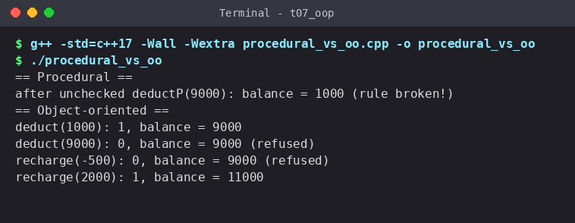
Figure 7.1: Procedural version breaks the rule; the OO version refuses invalid operations
The class prevents a negative balance because balance_ is private and the only way to reduce it is deduct(), which checks canTravel() first. If the minimum balance changes, the OO version edits one constant inside one class; the procedural version edits every function that uses it, and any function can still bypass the check.

UML class diagram
+---------------------------+ +-----------------------------+
| SmartCard | | FareTable |
+---------------------------+ +-----------------------------+
| - balance_ : long long | | - BASE_PAISE[4] : int |
+---------------------------+ | - PEAK_PCT : int |
| + canTravel(f) : bool |<---->| - WEEKEND_PCT : int |
| + deduct(f) : bool | +-----------------------------+
| + recharge(a) : bool | | + fare(zone,hour,wkend) |
| + balance() : long long | | : long long |
+------------+--------------+ +-----------------------------+
| 0..1
v
+---------------------------+
| Pass |
+---------------------------+
| - zoneA_, zoneB_ : Zone |
| - lastDay_ : int |
+---------------------------+
| + covers(zone, day) : bool|
+---------------------------+

Alternative concept and complexity: public data member
A public long long balance; has the same time (O(1)) and space (8 bytes). The difference is rule protection: any code can write card.balance = -500; or card.balance -= fare; without calling the check, so the minimum-balance rule, the no-negative-balance rule and the no-negative-recharge rule can all be broken by any part of the program (the procedural half of Figure 7.1 shows exactly this).

Task 8: Read and Print Data Safely
Input file input8.txt contains: abc, 9, xyz, 7, 1. The program rejects letters, clears the error state, discards the bad input, rejects an out-of-range zone (7) and finally accepts hour 9 and zone 1.
#include <iomanip>
#include <iostream>
#include <limits>
enum class Zone { Inner, Middle, Outer };
constexpr int BASE_PAISE[] = {1000, 2000, 3000};
bool isPeak(int h) { return (h >= 8 && h < 10) || (h >= 17 && h < 20); }
long long fare(Zone z, int hour) {
long long b = BASE_PAISE[static_cast<int>(z)];
return isPeak(hour) ? b + b * 20 / 100 : b;
}
bool readInt(const char* prompt, int lo, int hi, int& out) {
while (true) {
std::cout << prompt;
if (std::cin >> out) {
if (out >= lo && out <= hi) return true;
std::cout << "Out of range (" << lo << "-" << hi << "), try again.\n";
continue;
}
if (std::cin.eof()) return false;
std::cin.clear();
std::cin.ignore(std::numeric_limits<std::streamsize>::max(), '\n');
std::cout << "Invalid number, try again.\n";
}
}
void printMoney(long long p) {
std::cout << "Rs " << p / 100 << '.' << std::setw(2) << std::setfill('0') << p % 100 << std::setfill(' ');
}
int main() {
int hour, zone;
readInt("Enter hour (0-23): ", 0, 23, hour);
readInt("Enter zone (0=Inner 1=Middle 2=Outer): ", 0, 2, zone);
long long f = fare(static_cast<Zone>(zone), hour);
std::cout << "\n--- Journey report ---\n";
std::cout << std::left << std::setw(8) << "Hour" << std::setw(8) << "Zone" << std::setw(10) << "Peak" << "Fare\n";
std::cout << std::setw(8) << hour << std::setw(8) << zone << std::setw(10) << (isPeak(hour) ? "yes" : "no");
printMoney(f); std::cout << '\n';
std::cout << std::fixed << std::setprecision(2) << "Fare as double: " << f / 100.0 << '\n';
}
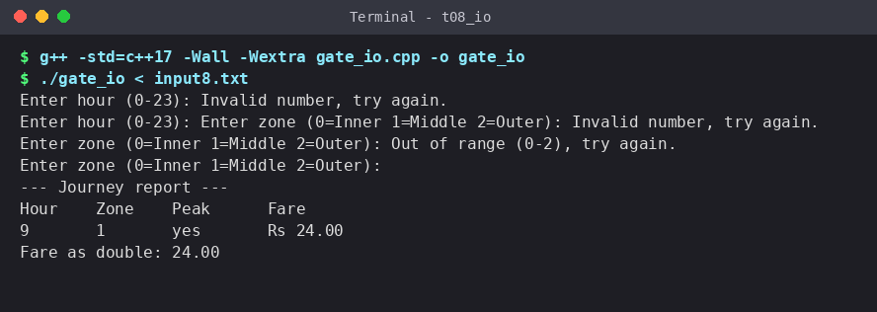
Figure 8.1: Recovery from letters typed instead of numbers, range check, and the formatted journey report
When letters are typed, cin >> out fails and sets failbit; later reads are skipped until cin.clear() resets the state and cin.ignore(...) removes the bad characters. setw(2) with setfill('0') prints paise as two digits (Rs 24.00), and fixed << setprecision(2) is used only when a double must be printed.

Alternative concept and complexity: getline + stoi in try/catch
std::string line;
std::getline(std::cin, line);
try { size_t pos; int h = std::stoi(line, &pos); if (pos != line.size()) throw 1; }
catch (...) { std::cout << "Invalid input\n"; }
Time to process a line of length L is O(L) in both. getline needs an O(L) buffer while cin >> int needs O(1) extra space. getline recovers more cleanly because the whole bad line is already consumed (no clear()/ignore()), and stoi throws invalid_argument or out_of_range. Caution: stoi("12abc") returns 12, so check pos == line.size(). Task 9 uses this approach in parseHour.

Task 9: Implement and Test the Fare Logic
#include <iomanip>
#include <iostream>
#include <string>
enum class Zone { Inner, Middle, Outer };
constexpr int BASE_PAISE[] = {1000, 2000, 3000};
constexpr int PEAK_PCT = 20;
constexpr long long MIN_BAL = 5000;
bool isPeak(int h) { return (h >= 8 && h < 10) || (h >= 17 && h < 20); }
long long fare(Zone z, int hour) {
long long b;
switch (z) {
case Zone::Inner: b = BASE_PAISE[0]; break;
case Zone::Middle: b = BASE_PAISE[1]; break;
case Zone::Outer: b = BASE_PAISE[2]; break;
default: return -1;
}
return isPeak(hour) ? b + b * PEAK_PCT / 100 : b;
}
bool canTravel(long long bal, long long f) { return f >= 0 && bal - f >= MIN_BAL; }
bool recharge(long long& bal, long long a) { if (a <= 0) return false; bal += a; return true; }
bool parseHour(const std::string& s, int& h) {
try { size_t pos; h = std::stoi(s, &pos); return pos == s.size() && h >= 0 && h <= 23; }
catch (...) { return false; }
}
int total = 0, passed = 0;
void check(int no, const char* name, long long got, long long expected) {
bool ok = got == expected; ++total; passed += ok;
std::cout << std::setw(2) << no << " " << std::left << std::setw(30) << name << std::right
<< " expected " << std::setw(5) << expected << " actual " << std::setw(5) << got << " " << (ok ? "PASS" : "FAIL") << '\n';
}
int main() {
check(1, "Inner 12:00 off-peak", fare(Zone::Inner, 12), 1000);
check(2, "Middle 12:00 off-peak", fare(Zone::Middle, 12), 2000);
check(3, "Outer 12:00 off-peak", fare(Zone::Outer, 12), 3000);
check(4, "Inner 9:00 peak", fare(Zone::Inner, 9), 1200);
check(5, "Middle 9:00 peak", fare(Zone::Middle, 9), 2400);
check(6, "Outer 18:00 peak", fare(Zone::Outer, 18), 3600);
check(7, "Boundary 8:00 (peak)", fare(Zone::Inner, 8), 1200);
check(8, "Boundary 10:00 (off-peak)", fare(Zone::Inner, 10), 1000);
check(9, "Boundary 17:00 (peak)", fare(Zone::Inner, 17), 1200);
check(10, "Boundary 20:00 (off-peak)", fare(Zone::Inner, 20), 1000);
check(11, "Leaves exactly Rs 50 allowed", canTravel(6000, 1000), 1);
check(12, "Leaves Rs 49.99 denied", canTravel(5999, 1000), 0);
check(13, "Unknown zone -> fare -1", fare(static_cast<Zone>(7), 12), -1);
long long bal = 6000; bool r = recharge(bal, -500);
check(14, "Negative recharge rejected", r || bal != 6000, 0);
int h = 0;
check(15, "Letters 'abc' for hour rejected", parseHour("abc", h), 0);
std::cout << passed << "/" << total << " tests passed\n\n";
std::cout << "Five journeys totalled by hand = 12000 paise, start 50000:\n";
struct J { Zone z; int h; } js[] = {{Zone::Inner,12},{Zone::Middle,9},{Zone::Outer,14},{Zone::Outer,18},{Zone::Middle,10}};
long long balance = 50000, sum = 0;
for (auto& j : js) { long long f = fare(j.z, j.h); balance -= f; sum += f;
std::cout << " fare " << std::setw(4) << f << " balance " << std::setw(5) << balance << '\n'; }
std::cout << " total " << sum << " paise (Rs " << sum / 100 << ".00), closing balance " << balance << " paise (Rs " << balance / 100 << ".00)\n";
}
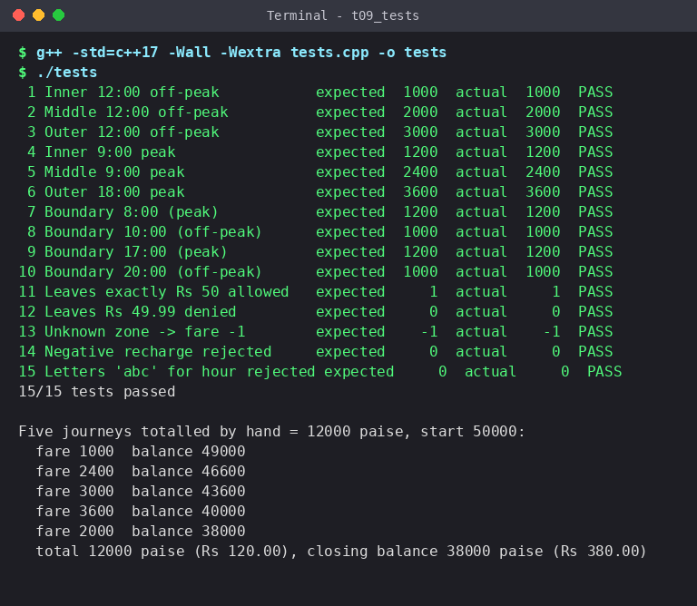
Figure 9.1: 15 test cases (expected vs actual) and the five-journey hand check, all PASS

Test table
# | Case | Input | Expected | Actual
1 | Inner off-peak | Inner, 12:00 | 1000 (Rs 10.00) | 1000 PASS
2 | Middle off-peak | Middle, 12:00 | 2000 | 2000 PASS
3 | Outer off-peak | Outer, 12:00 | 3000 | 3000 PASS
4 | Inner peak | Inner, 9:00 | 1200 | 1200 PASS
5 | Middle peak | Middle, 9:00 | 2400 | 2400 PASS
6 | Outer peak | Outer, 18:00 | 3600 | 3600 PASS
7 | Boundary 8:00 (peak) | Inner, 8:00 | 1200 | 1200 PASS
8 | Boundary 10:00 (off-peak) | Inner, 10:00 | 1000 | 1000 PASS
9 | Boundary 17:00 (peak) | Inner, 17:00 | 1200 | 1200 PASS
10 | Boundary 20:00 (off-peak) | Inner, 20:00 | 1000 | 1000 PASS
11 | Leaves exactly Rs 50 | balance 6000, fare 1000 | allowed | allowed PASS
12 | Leaves Rs 49.99 | balance 5999, fare 1000 | denied | denied PASS
13 | Unknown zone | zone value 7 | fare -1 | -1 PASS
14 | Negative recharge | recharge(-500) | rejected | rejected PASS
15 | Letters for the hour | "abc" | rejected | rejected PASS

Five journeys totalled by hand (start Rs 500.00 = 50000 paise)
# | Journey | Calculation | Fare (paise)
1 | Inner, 12:00 | 1000 | 1000
2 | Middle, 9:00 (peak) | 2000 + 2000 x 20 / 100 | 2400
3 | Outer, 14:00 | 3000 | 3000
4 | Outer, 18:00 (peak) | 3000 + 600 | 3600
5 | Middle, 10:00 (off-peak) | 2000 | 2000
Hand total = 1000 + 2400 + 3000 + 3600 + 2000 = 12000 paise = Rs 120.00; closing balance = 50000 - 12000 = 38000 paise = Rs 380.00. The program output in Figure 9.1 matches the hand calculation.

Alternative concept and complexity: table-driven tests
The table-driven approach in the loop runs t tests in O(t) time and needs O(t) memory for the table (one small struct per case). Separate hand-written checks need a new code block per case; a new boundary case here costs a single line, so it is much easier to add and review.

Task 10: Compare Expectations with Execution
Fares cycle through {1000, 2000, 3000, 3600} paise (average 2400). Expected by hand: 48,000,000 paise (20,000 journeys), 1,200,000,000 paise (500,000 journeys), 7,200,000,000 paise (3,000,000 journeys, above INT_MAX).
#include <climits>
#include <iomanip>
#include <iostream>
int main() {
const int fares[] = {1000, 2000, 3000, 3600};
std::cout << "INT_MAX = " << INT_MAX << " paise\n";
for (long long n : {20000LL, 500000LL, 3000000LL}) {
int iTotal = 0; long long lTotal = 0; double dTotal = 0;
for (long long i = 0; i < n; ++i) {
int f = fares[i % 4];
iTotal = static_cast<int>(static_cast<unsigned>(iTotal) + static_cast<unsigned>(f)); // wraps (shown deliberately, no UB)
lTotal += f;
dTotal += f / 100.0;
}
std::cout << "\nn = " << n << "\n int total = " << iTotal
<< (lTotal > INT_MAX ? " <-- OVERFLOW (wrong)" : " (ok)")
<< "\n long long total = " << lTotal << " paise = Rs " << lTotal / 100 << '.' << std::setw(2) << std::setfill('0') << lTotal % 100 << std::setfill(' ')
<< "\n double total = Rs " << std::fixed << std::setprecision(6) << dTotal
<< "\n difference double - paise/100 = " << std::scientific << std::setprecision(3) << dTotal - lTotal / 100.0 << std::defaultfloat << '\n';
}
}
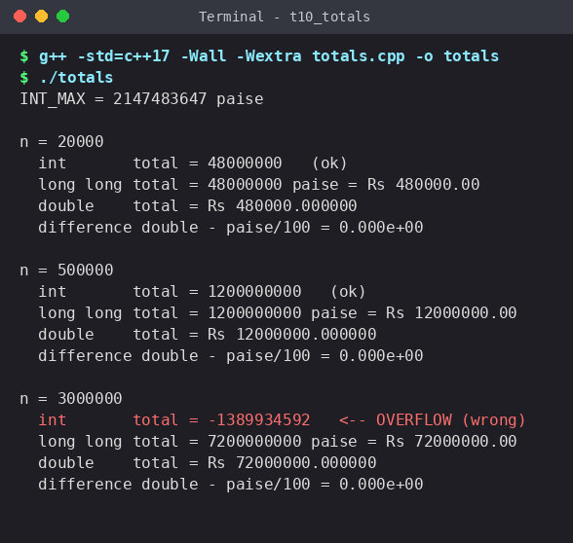
Figure 10.1: int, long long and double totals for 20,000 / 500,000 / 3,000,000 journeys
Journeys | int total (paise) | long long total (paise) | double total (Rs)
20,000 | 48,000,000 (ok) | 48,000,000 | 480000.000000
500,000 | 1,200,000,000 (ok) | 1,200,000,000 | 12000000.000000
3,000,000 | -1,389,934,592 (OVERFLOW) | 7,200,000,000 | 72000000.000000

Observations. The double and paise totals agree exactly (difference 0.000e+00) for these fares because each fare divided by 100 is a short decimal and the running sums stay exactly representable in a double at these sizes; the Task 3 experiment shows the gap appears as soon as fractional values like Rs 0.10 are added. int is correct up to 500,000 journeys but overflows at 3,000,000, producing a negative total. (The program wraps through unsigned to show the wrapped value without relying on undefined behaviour.)

Compiler warnings with -Wall -Wextra
#include <iostream>
#include <vector>
int main() {
unsigned u = 1; int s = -1;
int unusedVar = 5;
std::vector<int> v{1, 2, 3};
for (int i = 0; i < v.size(); ++i) std::cout << v[i];
std::cout << (s < u) << '\n';
}
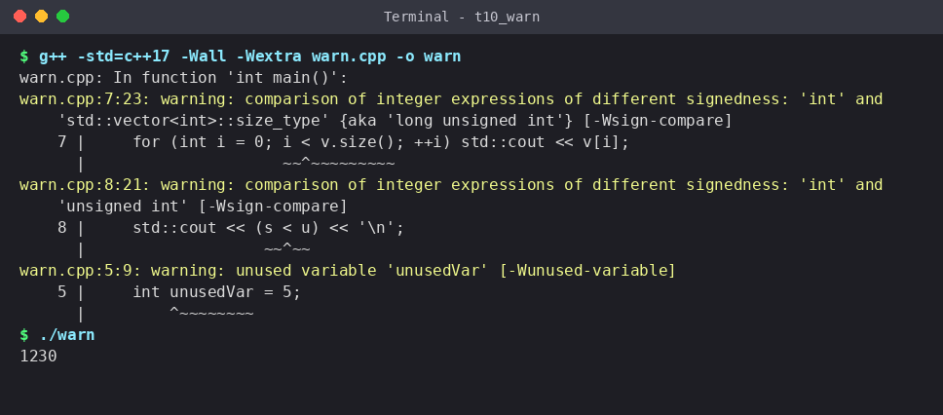
Figure 10.2: Three warnings produced by -Wall -Wextra
- -Wsign-compare (int vs size_type): an int loop index compared with v.size() (unsigned); the int is converted to unsigned.
- -Wsign-compare (int vs unsigned int): s < u converts -1 to 4294967295, giving a surprising result (Task 4).
- -Wunused-variable: unusedVar is declared but never used; usually a typo or leftover code.

Alternative concept and complexity: which accumulator fails
Type | At 3,000,000 journeys | Failure kind | Time / add | Space
int | Fails (7.2e9 > 2.147e9) | Overflow (wrong value) | O(1) | 4 bytes
long long | Correct | None until 9.2e18 | O(1) | 8 bytes
double | Correct for these totals | Loss of precision for fractions / totals above 2^53 | O(1) | 8 bytes

Task 11: Recommend and Defend the Final Design

11.1 Recommendation
- Types: long long paise for all money and totals; int for hours, zones and percentages; bool for flags; enum class Zone.
- Constants: one constexpr block (or a FareTable class) holding the fare array, surcharge %, discount %, minimum balance and peak hours.
- Classes: SmartCard (private balance, canTravel, deduct, recharge), FareTable, Pass, Journey.
- Evidence: Task 3 showed double accumulating error (up to 1.96e-06 at 3,000,000 additions of Rs 0.10); Task 10 showed int overflowing at 3,000,000 journeys while long long stays exact; Task 9 showed all 15 tests passing including 10:00 and 20:00; Figure 11.1 shows the network-scale run.
#include <chrono>
#include <iomanip>
#include <iostream>
enum class Zone { Inner, Middle, Outer };
constexpr long long BASE_PAISE[] = {1000, 2000, 3000};
constexpr int PEAK_PCT = 20;
bool isPeak(int h) { return (h >= 8 && h < 10) || (h >= 17 && h < 20); }
long long fare(Zone z, int hour) {
long long b = BASE_PAISE[static_cast<int>(z)];
return isPeak(hour) ? b + b * PEAK_PCT / 100 : b;
}
int main() {
for (long long n : {20000LL, 500000LL, 3000000LL}) {
auto t0 = std::chrono::steady_clock::now();
long long total = 0;
for (long long i = 0; i < n; ++i) total += fare(static_cast<Zone>(i % 3), static_cast<int>(i % 24));
auto t1 = std::chrono::steady_clock::now();
double ms = std::chrono::duration<double, std::milli>(t1 - t0).count();
std::cout << std::setw(8) << n << " journeys: total " << std::setw(11) << total << " paise (Rs "
<< total / 100 << '.' << std::setw(2) << std::setfill('0') << total % 100 << std::setfill(' ')
<< "), time " << std::fixed << std::setprecision(2) << ms << " ms, " << std::defaultfloat << "LLONG_MAX headroom ok\n";
}
}
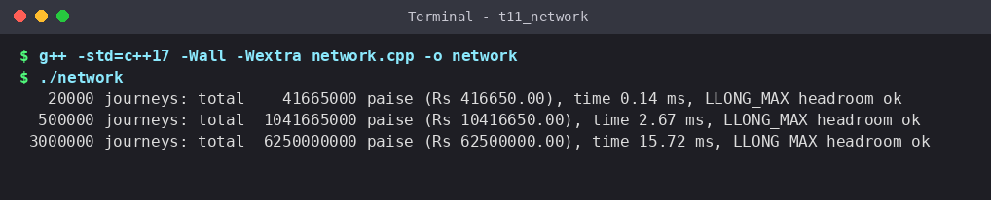
Figure 11.1: Fare logic on 20,000 / 500,000 / 3,000,000 journeys with measured run time
At 3,000,000 journeys the loop took about 16 ms on this machine (time grows linearly, O(n), with O(1) per journey), and the largest total is far below LLONG_MAX, so the design remains correct for the whole network. Timings vary by machine.

11.2 Fare revision
Edit the constants in one place, rebuild with -Wall -Wextra, rerun the test table (all rows must pass), then redeploy to the gates.

11.3 Limitations
Fares are compiled in, so every revision needs a rebuild and redeployment; whole-hour time resolution; no public-holiday calendar; concession percentages are assumed.

Alternative concept and complexity: fare table from a configuration file
At start-up the gate reads z fare values in O(z) time (plus a few milliseconds of file I/O) and stores them in O(z) memory (about 32 bytes for four long long values). A revision then needs only a file edit and a restart, with no recompilation or redeployment. The costs are extra parsing and validation code (missing file, bad number, negative fare) and losing compile-time guarantees such as constexpr and static_assert.

Task 12: Day-4 Design Challenge
Changed requirement: fourth zone Airport (Rs 60), a 10% weekend discount that does not combine with the peak surcharge, and a monthly pass with unlimited journeys in two chosen zones. Assumptions: the weekend discount takes priority over the peak surcharge; the pass covers journeys in either of its two zones; a pass journey costs Rs 0 and skips the minimum-balance check; the pass is valid up to a last day.

A. Impact analysis (2 marks)
Item | Affected? | What changes
BASE_PAISE[] | Yes | Add 6000 as the fourth entry
enum class Zone | Yes | Add Airport
switch (z) in fare() | Yes | New case Zone::Airport; every switch on Zone must be revisited
Peak expression | No | Unchanged, but must be skipped on weekends
Fare expression | Yes | New weekend branch, 10% discount, no surcharge
MIN_BALANCE_PAISE, canTravel() | Partly | Pass journeys must bypass the check
SmartCard | Yes | Needs to hold a pass
New Pass class | New | Zones, validity, covers()

B. Evaluation of the original design (2 marks)
The switch can absorb Airport by adding a case, and the weekend rule by adding a parameter, but fare(Zone, bool peak) has no weekend input, so the signature and every call site must change. Worked example 1: Airport on a weekday at 9:00 is 6000 + 1200 = 7200 paise. Worked example 2: Outer at 9:00 on a Sunday is 3000 - 300 = 2700 paise, not 3600 (peak) and not 2970 (discount applied after the surcharge). A switch with a peak flag cannot express that the two rules exclude each other, so extra if nesting is needed inside every case. Pass: the original SmartCard holds only a balance, and a card with Rs 30 should still take a pass journey, but the old rule (balance - fare >= 5000) would deny it. Verdict: MODIFY the class design (paise, constexpr and encapsulation remain sound) and REDESIGN the fare computation into a table plus separate rule functions.

C. Adaptation and implementation (2 marks)
#include <iostream>
enum class Zone { Inner, Middle, Outer, Airport };
constexpr long long BASE_PAISE[] = {1000, 2000, 3000, 6000};
constexpr int PEAK_PCT = 20, WEEKEND_DISC_PCT = 10;
constexpr long long MIN_BALANCE_PAISE = 5000;
bool isPeak(int h) { return (h >= 8 && h < 10) || (h >= 17 && h < 20); }
long long fare(Zone z, int hour, bool weekend) {
long long b = BASE_PAISE[static_cast<int>(z)];
if (weekend) return b - b * WEEKEND_DISC_PCT / 100;
if (isPeak(hour)) return b + b * PEAK_PCT / 100;
return b;
}
class Pass {
Zone zoneA_{Zone::Inner}, zoneB_{Zone::Inner};
int lastDay_{-1};
public:
Pass() = default;
Pass(Zone a, Zone b, int lastDay) : zoneA_{a}, zoneB_{b}, lastDay_{lastDay} {}
bool covers(Zone z, int day) const { return day <= lastDay_ && (z == zoneA_ || z == zoneB_); }
};
class SmartCard {
long long balance_; Pass pass_;
public:
explicit SmartCard(long long b) : balance_{b} {}
void setPass(const Pass& p) { pass_ = p; }
bool recharge(long long a) { if (a <= 0) return false; balance_ += a; return true; }
bool travel(Zone z, int hour, bool weekend, int day) {
if (pass_.covers(z, day)) return true;
long long f = fare(z, hour, weekend);
if (balance_ - f < MIN_BALANCE_PAISE) return false;
balance_ -= f; return true;
}
long long balance() const { return balance_; }
};
int main() {
int pass = 0, total = 0;
auto chk = [&](const char* n, long long got, long long exp) {
++total; pass += got == exp;
std::cout << (got == exp ? "PASS " : "FAIL ") << n << ": expected " << exp << ", actual " << got << '\n'; };
chk("Airport weekday 9:00 (peak)", fare(Zone::Airport, 9, false), 7200);
chk("Airport weekday 12:00", fare(Zone::Airport, 12, false), 6000);
chk("Airport weekend", fare(Zone::Airport, 12, true), 5400);
chk("Outer weekend at peak hour 9:00", fare(Zone::Outer, 9, true), 2700);
chk("Original: Outer weekday peak", fare(Zone::Outer, 18, false), 3600);
SmartCard c{20000};
c.travel(Zone::Airport, 9, false, 5); chk("Balance after Airport peak", c.balance(), 12800);
c.travel(Zone::Outer, 9, true, 6); chk("Balance after Outer weekend", c.balance(), 10100);
c.setPass(Pass{Zone::Inner, Zone::Middle, 30});
bool ok = c.travel(Zone::Middle, 18, false, 7);
chk("Pass journey allowed", ok, 1); chk("Pass journey costs 0", c.balance(), 10100);
c.travel(Zone::Outer, 12, false, 8); chk("Zone not on pass is charged", c.balance(), 7100);
c.travel(Zone::Middle, 12, false, 31); chk("Expired pass is charged", c.balance(), 5100);
std::cout << pass << "/" << total << " tests passed\n";
}
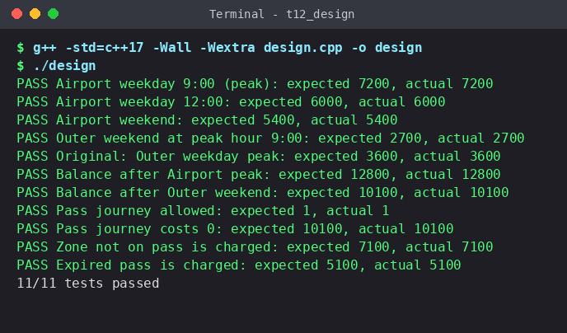
Figure 12.1: Revised design, 11 tests (new zone, weekend, pass, expired pass) all PASS

D. Evidence-based defence (2 marks)
- Decision: MODIFY the class design (keep SmartCard, long long paise, constexpr, enum class) and REDESIGN the fare computation (table indexed by zone, separate weekend/peak rule, Pass class).
- Evidence: Figure 12.1 shows the original weekday peak fare (Outer 3600) still correct, the new Airport and weekend fares correct (7200, 5400, 2700), a pass journey costing 0, and uncovered-zone and expired-pass journeys charged normally; the Task 9 table still applies to weekday cases.
- Trade-offs: the array lookup is O(1) like the switch and costs 32 bytes but needs a bounds check that the switch's default gave for free. The weekend priority rule must be confirmed with the metro. The Pass adds one small object per card with no change to per-journey time. Fares are still compiled in; a configuration file (Task 11) would help if revisions become frequent.

