Title: | LIN network  SW Component Slave 3

History
Issue status  (Index) | Maturity/Date  (draft/invalid/valid)  (dd-mmm-yyyy) | Author  Department | Check/Release  Department | Description
1.0 | 06-Aug-15 | Misael AD  Kevin CG |  | Creation of the DSD_Slave3 document.

Table of Contents
1 Purpose 4
2 Definitions and abbreviations 4
3 Realization constraints and targets 6
3.1 Network Graphical Description 6
3.2 Use Case 7
3.3 Command Sequence Diagram 8
3.4 Response Sequence Diagram 9
4 SW Component internal breakdown 10
4.1 Diagrams 10
4.1.1 Component Diagram 10
4.1.2 Network Components Diagram 11
4.2 LIN Network 12
4.3 Functional Decomposition 14
4.3.1 Function <Type> <function name> (type par 1, .., type par n) 15
4.3.2 Function <Type> <function name> (type par 1, .., type par n) 15
4.4 Macros 16
4.5 SW module global variables 16
4.6 Design solutions for general features 17
4.7 SW Component integration 17
4.7.1 Integration context / constraints 17
4.7.2 Include files 17
4.7.3 Initialization 17
4.7.4 Interrupts 17
4.7.5 Real time scheduler task 17
4.7.6 Other entry points 17

Purpose
The system described in this text is based on LIN 2.0 communication protocol.
5 nodes are designated; 1 master node and 4 slave nodes, from which we will focus on the slave node 3 (Slave3) while the rest will be developed by other teams.
After executing the corresponding sequence of commands and specifications defined by the protocol itself, the nodes will control the On-board LEDs of the TRK-MCP5006B Freescale board to display the commands defined in the requirements document, such as ON, OFF and TOGGLING, as well as the node’s own status (enabled/disabled).

Definitions and abbreviations
Definitions
LIN 2.0  Master (node)  Slave (node) | Serial network protocol used for communication between components in vehicles  Node chosen to control all communications. Bus arbiter.  Node that responds to the master in three possible ways: Receive data, transmit data or ignore data.

Abbreviations
LIN Local Interconnected Network.

t_slv_stat Signal to display slave node status.

t_cmdType Signal to control LED states and slave node state.

t_LEDstat Signal to display LED status.

t_boolean Signal response that indicates slave node status.

array Signal that contains the team member’s initials for the Msg ID.

scalar Signal that contains the team assigned number for the Msg ID.

References
N° | Document name | Reference
1 | SW Architecture description

Realization constraints and targets
The LIN network should be able to communicate integrally and effectively with each and every node, and in this specific case, with the Slave Node 3.
The following diagrams show how is the system expected to work from both a general and specific perspective.

Network Graphical Description

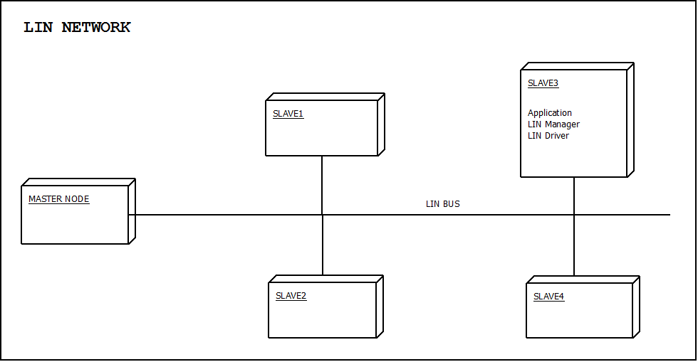

The network showed in the figure above represents the full integrated system, which consists of the master node and the four slaves shown.

Our assignment is to develop the slave node labeled as Slave3, with all its internal components and the required actions to perform.

Use Case

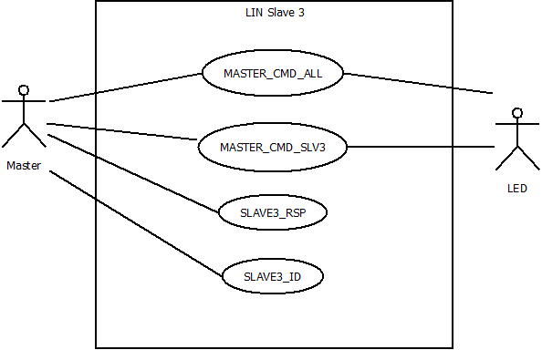

Master: Node that controls the network. This node can send up to of 13 pre-defined messages, but in this diagram only the messages relevant to Slave3 node are shown.

LED: Physical On-board LEDs which will respond to the commands given by the system.

MASTER_CMD_ALL: Message sent to every slave node to execute a command.

MASTER_CMD_SLV3: Message sent specifically to slave node 3 to execute a command.

SLAVE3_RSP: Message sent from Slave3 to the master node with a specific response.

SLAVE3_ID: Message sent from Slave3 node to the master with the corresponding ID.

Command Sequence Diagram
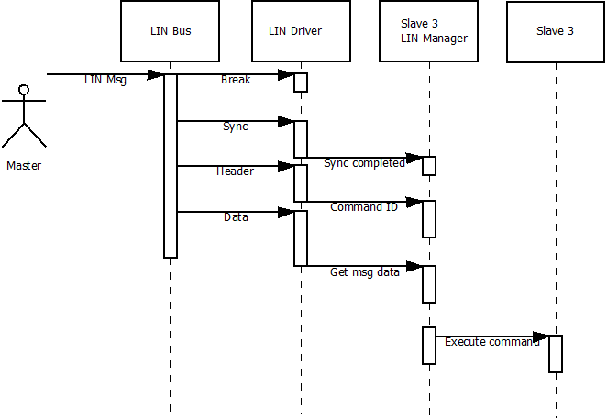

Response Sequence Diagram

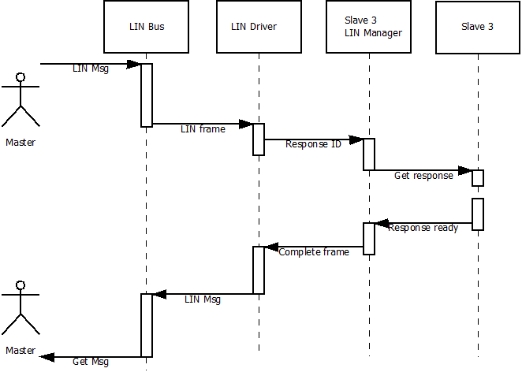

SW Component internal breakdown

Diagrams

Component Diagram
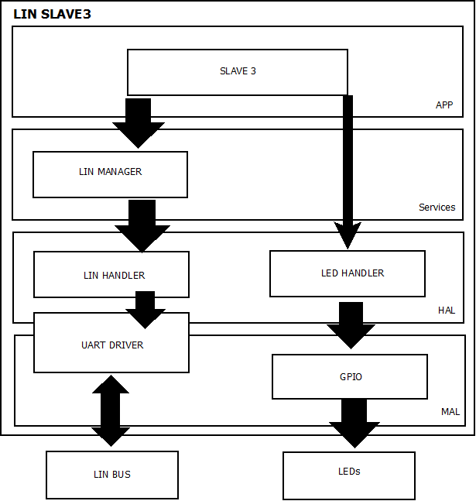

Network Components Diagram

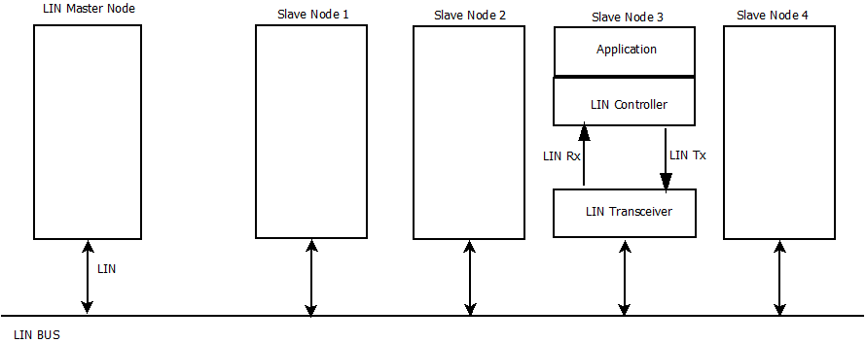

LIN Network

Messages defined for this network.

Msg ID | Msg Name | Msg Data Length (byte) | Msg Publisher | Msg Subscribers | Msg Callback
CF | MASTER_CMD_ALL | 1 | MASTER | SLAVE1, SLAVE2, SLAVE3, SLAVE4 | auto
50 | MASTER_CMD_SLV1 | 1 | MASTER | SLAVE1 | auto
11 | MASTER_CMD_SLV2 | 1 | MASTER | SLAVE2 | auto
92 | MASTER_CMD_SLV3 | 1 | MASTER | SLAVE3 | auto
D3 | MASTER_CMD_SLV4 | 1 | MASTER | SLAVE4 | auto
20 | SLAVE1_RSP | 2 | SLAVE1 | MASTER | auto
61 | SLAVE2_RSP | 2 | SLAVE2 | MASTER | auto
E2 | SLAVE3_RSP | 2 | SLAVE3 | MASTER | auto
A3 | SLAVE4_RSP | 2 | SLAVE4 | MASTER | auto
F0 | SLAVE1_ID | 7 | SLAVE1 | MASTER | auto
B1 | SLAVE2_ID | 7 | SLAVE2 | MASTER | auto
32 | SLAVE3_ID | 7 | SLAVE3 | MASTER | auto
73 | SLAVE4_ID | 7 | SLAVE4 | MASTER | auto
*Messages used for and by slave 3

Signal Types defined for this network.

Type Name | Elements…
 | 0 | 1 | 2 | 3 | 4 | 5
t_slv_stat | ENABLED | DISABLED
t_cmdType | cmd_NONE | cmd_LED_on | cmd_LED_off | cmd_LED_  toggling | cmd_disable  _slv | cmd_enable_slv
t_LEDstat | ON | OFF | TOGGLING
t_target_active | ACTIVE | INACTIVE
t_boolean | VERDADERO | FALSO

Signals defined for this network.

Signal Name | Signal Msg | Signal Start Byte | Signal Start Bit | Signal Len (bits) | Signal Type | Signal Endianess
master_cmdForAll | MASTER_CMD_ALL | 0 | 0 | 4 | t_cmdType | LE
master_cmdForSlave1 | MASTER_CMD_SLV1 | 0 | 0 | 4 | t_cmdType | LE
master_cmdForSlave2 | MASTER_CMD_SLV2 | 0 | 0 | 4 | t_cmdType | LE
master_cmdForSlave3 | MASTER_CMD_SLV3 | 0 | 0 | 4 | t_cmdType | LE
master_cmdForSlave4 | MASTER_CMD_SLV4 | 0 | 0 | 4 | t_cmdType | LE
slave1_LEDstat | SLAVE1_RSP | 0 | 0 | 2 | t_LEDstat | LE
slave1_enabled | SLAVE1_RSP | 1 | 0 | 1 | t_boolean | LE
slave1_supplier | SLAVE1_ID | 0 | 0 | 8 | scalar | LE
slave1_serial | SLAVE1_ID | 1 | 0 | 48 | array | LE
slave2_LEDstat | SLAVE2_RSP | 0 | 0 | 2 | t_LEDstat | LE
slave2_enabled | SLAVE2_RSP | 1 | 0 | 1 | t_boolean | LE
slave2_supplier | SLAVE2_ID | 0 | 0 | 8 | scalar | LE
slave2_serial | SLAVE2_ID | 1 | 0 | 48 | array | LE
slave3_LEDstat | SLAVE3_RSP | 0 | 0 | 2 | t_LEDstat | LE
slave3_enabled | SLAVE3_RSP | 1 | 0 | 1 | t_boolean | LE
slave3_supplier | SLAVE3_ID | 0 | 0 | 8 | scalar | LE
slave3_serial | SLAVE3_ID | 1 | 0 | 48 | array | LE
slave4_LEDstat | SLAVE4_RSP | 0 | 0 | 2 | t_LEDstat | LE
slave4_enabled | SLAVE4_RSP | 1 | 0 | 1 | t_boolean | LE
slave4_supplier | SLAVE4_ID | 0 | 0 | 8 | scalar | LE
slave4_serial | SLAVE4_ID | 1 | 0 | 48 | array | LE

*Messages used for and by slave 3

Functional Decomposition

State Machines

Slave 3
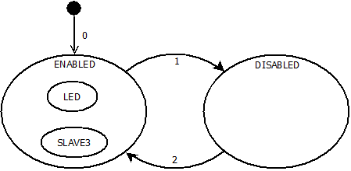

TRANSITION | CONDITION | ACTION
0 | Initialize LIN Slave3 | Initialize node as enabled.
1 | t_cmdType==cmd_disable_slave | Node==Disabled
2 | t_cmdType==cmd_enable_slave | Node==Enabled / Access to either super state.

LIN Manager
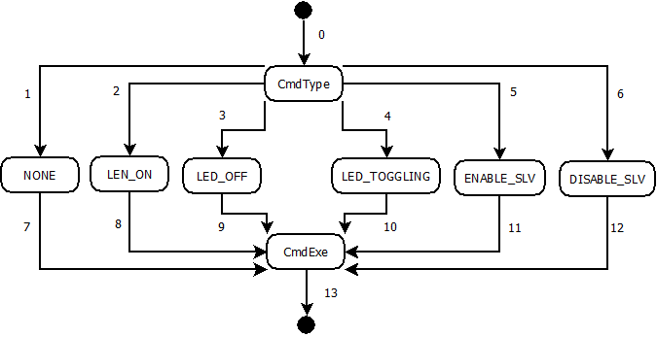

TRANSITION | CONDITION | ACTION
0 | Signal Msg == MASTER_CMD | Initialize CmdType
1 | t_cmdType==cmd_NONE | Initialize none.
2 | t_cmdType==cmd_LED_on | Initialize LED_ON
3 | t_cmdType==cmd_LED_off | Initialize LED_OFF
4 | t_cmdType==cmd_LED_toggling | Initialize LED_TOGGLING
5 | t_cmdType==cmd_enable_slv | Initialize ENABLE_SLV
6 | t_cmdType==cmd_disable_slv | Initialize DISABLE_SLV
7 | Command variable updated to None. | Go to CmdExe
8 | Command variable updated to LED on. | Go to CmdExe
9 | Command variable updated to LED off. | Go to CmdExe
10 | Command variable updated to LED toggling. | Go to CmdExe
11 | Command variable updated to Enable. | Go to CmdExe
12 | Command variable updated to Disable. | Go to CmdExe
13 | Cmd==executed. | Exit state machine.

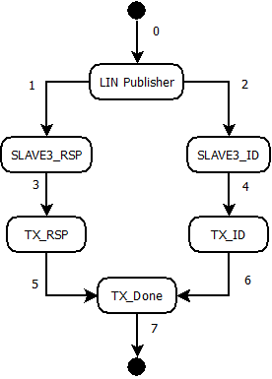

TRANSITION | CONDITION | ACTION
0 | (Signal Msg == SLAVE3_RSP)II(Signal Msg==SLAVE3_ID) | Initialize LIN Publisher.
1 | If Signal Msg == SLAVE3_RSP | Initialize SLAVE3_RSP.
2 | If Signal Msg == SLAVE3_ID | Initialize SLAVE3_ID.
3 | (ID field==valid)&&(Header==sent) | Initialize TX_RSP.
4 | (ID field==valid)&&(Header==sent) | Initialize TX_ID.
5 | Data TX_RSP==transmitted | Go to TX_Done.
6 | Data Tx_ID==transmitted | Go to TX_Done.
7 | Transmission completed. | Exit state machine.

LIN Handler

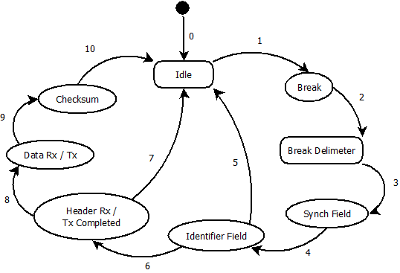

TRANSITION | CONDITION | ACTION
0 |  | Initialize Idle
1 |  | Go to break.
2 |  | Enter Break Delimiter.
3 |  | Enter Synch Field.
4 |  | Initialize Identifier Field.
5 |  | Return to Idle.
6 |  | Enter Header Rx/ Tx compl.
7 |  | Return to Idle.
8 |  | Go to Data Rx/Tx.
9 |  | Enter Checksum.
10 |  | Return to Idle.

LED Handler
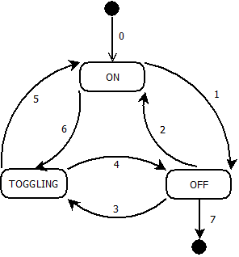

TRANSITION | CONDITION | ACTION
0 | Initialize MCU | Default state is ON
1 |  | Go to OFF
2 |  | Return to ON.
3 |  | Set to TOGGLING
4 |  | Go to OFF.
5 |  | Go to ON.
6 |  | Go to TOGGLING.
7 |  | Exit the state machine.

Function Description and Dynamic Behavior
Provide detailed static and dynamic description of all functions of the SW Component.
Functions which are defined in other SW Components shall only be referenced in the external interface description!
The signature description shall be done inside the function header in the source code.
For each function, the following section should be copied

Function <Type> <function name> (type par 1, .., type par n)

Description | Brief description of the function behavior and useful remarks
Parameter 1  <input| output| inout> | Give an explanation if the parameter shall be checked by the user, or if a check is implemented in the function here
Parameter 2..n
Return Value
Precondition | e.g. Function can only be called in a certain state, SW component is initialized  Relation between input parameters where applicable (Input for Module Test)
Post condition | e.g. specific State change e.g. car is locked, EEPROM Values written,  Relation between output parameters where applicable
Error Conditions

Dynamic Behavior
State Chart¹, Flow Chart¹
¹ Preferred
In this document, the dynamic behavior shall be designed on an abstract level showing the principle workflow of a function. Do not show the detailed implementation to ensure that the design description can be maintained with a reasonable effort. The target is not to show the complete detailed implementation 1:1.
The detailed design shall reflect in detail what a function is doing from a black box view. The internal details are useful on an abstract, but not very detailed level.
If the function is not complex a short textual description might be sufficient and a graphical description is not needed.
Symbol and function names shall be self explaining.
The link to the implementation may be provided by using the same names as in the design or by a comment showing the full name followed by the declaration showing the implementation.

Function <Type> <function name> (type par 1, .., type par n)
Description | Brief description of the function behavior and useful remarks
Parameter 1
<input| output| inout>
Parameter 2..n
Return Value
Precondition | e.g. Function can only be called in a certain state, SW component is initialized  Relation between input parameters where applicable (Input for Module Test)
Post condition | e.g. specific State change e.g. car is locked, EEPROM Values written,  Relation between output parameters where applicable
Error Conditions

Dynamic Behavior
State Chart¹, Flow Chart¹, Nassi Shneiderman
¹ Preferred
In this document, the dynamic behavior shall be designed on an abstract level showing the principle workflow of a function. Do not show the detailed implementation to ensure that the design description can be maintained with a reasonable effort. The target is not to show the complete detailed implementation 1:1.
The detailed design shall reflect in detail what a function is doing from a black box view. The internal details are useful on an abstract, but not on a very detailed level.
Symbol and function names shall be self explanatory.
The link to the implementation may be provided by using the same name as in the design or by a comment showing the full name followed by the declaration showing the implementation.

Macros

Only complex macros shall be described here. A complex macro is longer then one line or has more then one parameter or command. A complete description of all macros shall be done by code comments.
Be aware: macros shouldn’t be part of the interface: Don’t use macros at interface level!
If you still think you need macros: document them like functions.
Internal Interfaces
For internal interaction a data flow and/or a message sequence chart shall be provided. If the Static Function Tree already contains a data flow description then just reference it

SW module global variables
Where shared variables can not be avoided, a risk analysis is mandatory.
Name | Type | Memory section | Description | Shared
Klstrg_status | T_UBYTE | NON_INIT_RAM | Status of terminal control | X

Design solutions for general features
It should describe detailed design solutions for general features of our products. i.e ”Layer Programming”

SW Component integration

Integration context / constraints
Tbd: help text

Include files
List here the necessary include files and their order,

Initialization
e.g. Sequence Chart for initialization
All function bellow shall be called on initialization
Call Order | Service | Call constraints linked to another module
1 | BCM_Warning_Output_Init_Function | After EEPROM init

Interrupts
If described in the SW Architecture Document, just put the reference here.

Real time scheduler task
If described in the SW Architecture Document, just put the reference here.

Other entry points
Name | Service | Task level

