**From PyTorch:**

**- Four Layers:**

1. FeatureSelector

2. GatingLayer

3. LinearLayer

4. MLPlayer

**- Three Models: (find the difference here between STG and L1RegressionModel)**

1. STGClassificationModel (MLPModel, ModelIOKeysMixin)

2. MLPModel (MLPLayer)

3. ModelIoKeysMixin (Object)

**- Model STGClassificationModel:**

0. layer: Get Input

1. layer: FeatureSelector

2. layer: Linear Hidde Layers (According to the hidden layers to append nn.Linear)

**- Loss Function:**

1. Loss part = nn.CrossEntropyLoss 🡪 for updating theta(normal parameters)

2. Regular part = torch.mean(self.***reg***((**mu** + 0.5)/ **sigma**)

***Reg:*** defined by layer FeatureSelector

Regularizer(self.x) 🡪 0.5*(1+torch.erf(x / math.sqrt(2)))

Torch.erf 🡪 gaussian error function

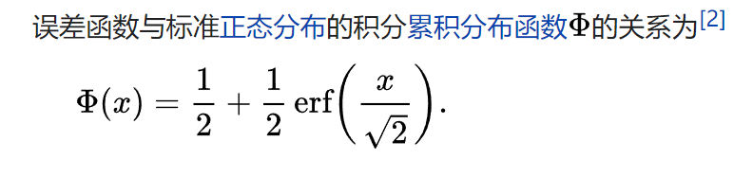

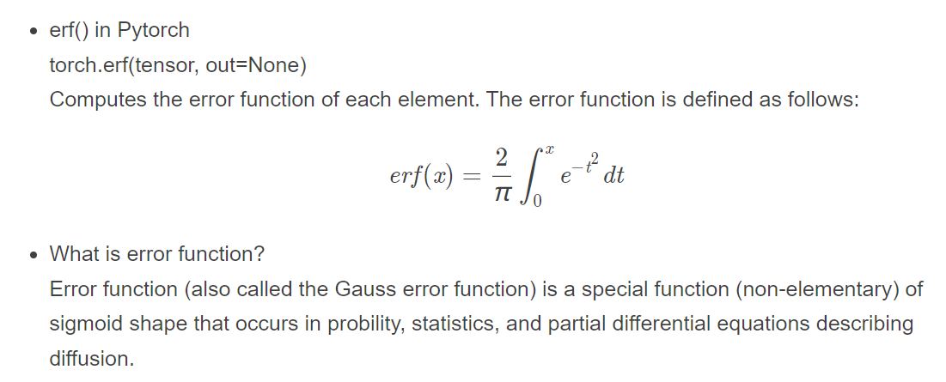

**mu,sigma**: are parameters which can be trained

Total Loss = 1.Loss part + 2. Regular part * lam 🡪 for updating mu

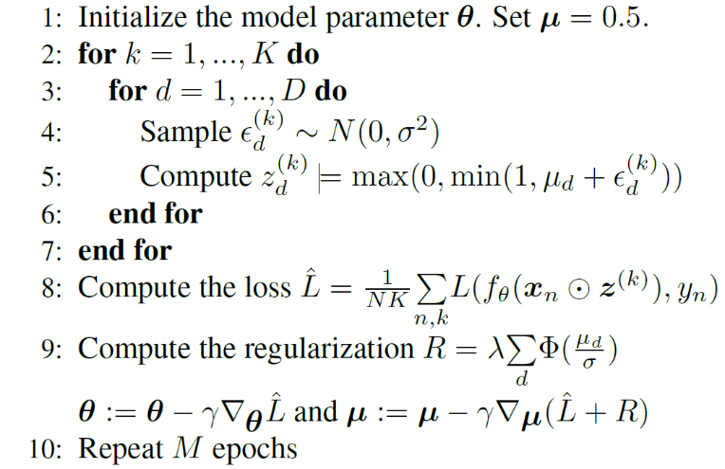

**FeatureSelector:**

How to compute z?

**Step 1**

Z = self.**mu** + self.sigma * self.**noise**.normal_() * self.training(==1)

Self.**mu** = torch.nn.Parameter(0.01 * torch.randn(input_dim, ), requires_grad=True)

Self.**noise** = torch.randn(self.mu.size())

**Step 2**

Stochastic_gate = self.hard_sigmoid(z) (stochastic_gate is the final z)

Hard_sigmoid(z) = torch.clamp(z+0.5, 0.0, 1.0)

Torch.clamp(input, min, max, out=None) to restrict the value of input between[min, max]

**Step 3**

New_x = prev_x * stochastic_gate

Return new_x