Investcorp

**Security Remediation Status Report**

**Document Created by**

**Atlas Systems**  
Modified: 01-SEP-2022

by Justin, Harish, Kalyankumar, Pankaj, Raj

# 1 Report URL and Inputs

URL  
[Security Remediate Status Report](https://app.powerbi.com/groups/82ace604-0425-4224-84b7-4cd22d810b21/reports/bd1921d9-8773-4786-8947-375c42ba965d/ReportSection105204b969591893fe8c)Input files

|  |  |  |
| --- | --- | --- |
| **#** | **Power BI Report** | **URL** |
| 1 | SharePoint Site: Tech | [2020-Sep IS NCC.xlsx](https://investcorp.sharepoint.com/:x:/s/tech/EXZ3Q3R09A9IjsHufqV-AtgBpGraSE130InEFC5qEc1XOg?e=SLc1YI) |
| 2 | SharePoint Site: Tech | [2021-July IA User Access Management (UAM) - Consolidated.xlsx](https://investcorp.sharepoint.com/:x:/s/tech/EWWxfMSF9-RLn-QtHENNPd4BN9eRWc8wr-NbdTAvkR-YJA?e=ECVTuP) |
| 3 | SharePoint Site: Tech | [2021-Jun IA KPMG.xlsx](https://investcorp.sharepoint.com/:x:/s/tech/EYsQDbf2P_RMhn5c9ZaI9ukBBwlSwqTFo0kiWLCBcuCY1w?e=cpPYGC) |
| 4 | SharePoint Site: Tech | [2021-Nov IS log4j.xlsx](https://investcorp.sharepoint.com/:x:/s/tech/ER19VHWDd59EgIKjXmQkWIEB4jX-B4G6027bClWkwtXubA?e=jJ37r1) |
| 5 | SharePoint Site: Tech | [2022-Jan IS NCC.xlsx](https://investcorp.sharepoint.com/:x:/s/tech/EXvdCWBd5h9FqeYFRzL4n9kBCWSpwLCsJ64VYJlfeO0Fiw?e=kOtPBH) |
| 6 | SharePoint Site: Tech | [2022-Jul IA Internal Application Security.xlsx](https://investcorp.sharepoint.com/:x:/s/tech/EV52e4cSlE9EiMWoeUBiX4sBrucWwaMLzwOqSx5zx77j0g?e=VcFcfe) |
| 7 | SharePoint Site: Tech | [2022-Jul IA IT Operations and Project Management.xlsx](https://investcorp.sharepoint.com/:x:/s/tech/EUj1p5g5jY1Aj_Fnmxjm1egB_N7JV7WkVY5c5mrdqhuJkQ?e=3WM7y7) |
| 8 | SharePoint Site: Tech | [2022-Jul IS KeyPoint.xlsx](https://investcorp.sharepoint.com/:x:/s/tech/Ea9BTABVUFRLhKlbcKMDghwBFfkXU12tZw3PixAxmFbfag?e=rDZx9W) |
| 9 | SharePoint Site: Tech | [2022-Jul IT Rubrik Assessment.xlsx](https://investcorp.sharepoint.com/:x:/s/tech/EY08DHK1lqhGtitszQh1ALEBTheaRndro2Ll5oxulfEkIg?e=NN1IE4) |
| 10 | SharePoint Site: Tech | [2023-Jan IA IT Application.xlsx](https://investcorp.sharepoint.com/:x:/s/tech/EW6F4fGeXqNMgRMstZTnMJMBfaP9CQOPYwoUrnQtZolWgg?e=S3yvfL) |
| 11 | SharePoint Site: Tech | [2023-Jul IA-Cyber Security-Cloud Security.xlsx](https://investcorp.sharepoint.com/:x:/s/tech/EXd1IbyFiKNGvtGNQ47_aWUBh93xfq-6gleWNpg6yGuBcg?e=kuj5AW) |
|  | Risk Registry -  A manual extract. It is not an input to any Power BI dashboard. Purpose was to create it so it can be presented to Najib and close out all 2021 Remediation report. | [https://investcorp.sharepoint.com/sites/tech/docs/Infrastructure/Operations/Audit/Risk%20Matrix/Infosec%20IT%20Vulnerabilities%20Risk%20Matrix%20June%202022%20-%20Draft.xlsx](https://euc-word-edit.officeapps.live.com/Audit/Risk%20Matrix/Infosec%20IT%20Vulnerabilities%20Risk%20Matrix%20June%202022%20-%20Draft.xlsx) |

**Development Process**:

**Power Query:**

Power Bi Team has been given a source file format to vulnerability team which is common format to all new source files to import and merge the data into a single table in power bi. Also provided an example below.

We are using SharePoint folder as a source location; the folder location is given above, and we are using different source files and merging them into a main table. Import all files using SharePoint Folder Option and choose the location using the text filters and choose only required files otherwise it will import all files. Once we import all files then create a merge table and add all sources in the merge table. Date columns should be in datetime type. Filename is renamed as “Audit company” Please follow the M-code to combine the tables:

Procedure to create/add a new source file:

1. Go to Get Data-> Share Point Folder-> paste the SharePoint link in the pop-up box <https://investcorp.sharepoint.com/sites/Tech/>

2. once the Query editor loads all the files associated with this link, scroll right, and choose File Path column and click on the dropdown. Click on Text filters -> contains. Another pop window will open give a condition like contains equals to “Audit Input Files” to filter specific source location then you will see only source files filter only required source xlsx file and click on combine.

3. Rename the source file name column to “Audit_Company”

4. replace the values in the Audit_Company with the name as we want like “2021-JUN | IA – KPMG”

Follow the applied steps to other source files. Check the Date column Data type if it is not in proper format change it.

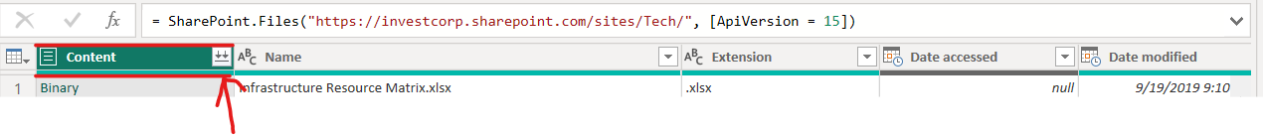

5. Once you have created all tables in the Power Query then combine all tables into a single main table. Given below is the code to combine the newly created/added table in the power query.

For example: If this is the table name - **"IA_IT Applications_2023"** and the below are the columns.

|  |  |
| --- | --- |
| **Actual column Name** | **Assigned Name** |
| Code | Code |
| Issue Title | Title |
| Risk | Risk |
| Owner | Assigned To |
| Affects | Affected List |
| Description | Description |
| Start Date | Start_Date |
| Infrastructure Response | Infrastructure Response |
| Recommendations | Recommendations |
| Target Implementation Date | Target_Implementation_Date |
| Target Resolution Date | Target_Resolution_Date |
| Notes | Additional Notes |
| Status | Info_Status |
| Actual Completion Date | Due_Date |

6. Arrange the columns in the given below code and add this code in the “Table.Combine” function.

**Table.RenameColumns(#"IA_IT Applications_2023",{{"Code","Code"},{"Issue Title","Title"},{"Risk","Risk"},{"Owner","Assigned To"},{"Affects","Affected List"},{"Description","Description"},{"Start Date","Start_Date"},{"Infrastructure Response","Infrastructure Response"},{"Recommendations","Recommendations"},{"Target Implementation Date","Target_Implementation_Date"},{"Target Resolution Date","Target_Resolution_Date"},{"Notes","Additional Notes"},{"Status","Info_Status"},{"Actual Completion Date","Due_Date"}})**

**Comb_Audit_Comp:**

**let**

**Source = Table.Combine({Table.RenameColumns(NCC_2022,{{"Issue Title","Title"},{"Status","Info_Status"},{"Owner","Assigned To"},{"Infrastructure Response","Infrastructure Response"},{"Target Implementation Date","Target_Implementation_Date"},{"Start Date","Start_Date"},{"Actual Completion Date","Due_Date"},{"Target Resolution Date","Target_Resolution_Date"}}), Table.RenameColumns(Log4j,{{"Ticket_ID","Code"},{"Infrastructure Response","Infrastructure Response"},{"IP","Affected List"},{"DNS","Title"},{"Recommendation","Recommendations"},{"Target Implementation Date","Target_Implementation_Date"},{"Target Resolution Date","Target_Resolution_Date"},{"Actual Completion Date", "Due_Date"},{"Exploitability","Description"},{"Action","Action Plan"},{"Infosec_status","Info_Status"},{"SNOW Change Request","Change Request"},{"Assigned Engineer","Assigned To"},{"Impact","Technical Impact"},{"Solution","Additional Notes"}}),Table.RenameColumns(NCC_2021,{{"Issue Title","Title"},{"InfoSec Status","Info_Status"},{"Infrastructure Response","Infrastructure Response"},{"Target Implementation Date","Target_Implementation_Date"},{"Target Resolution Date","Target_Resolution_Date"},{"Start Date","Start_Date"},{"Actual Completion Date","Due_Date"}}),Table.RenameColumns(KPMG_2021,{{"Ref No","Code"},{"Issue Title","Title"},{"Issue Description","Description"},{"InfoSec Status","Info_Status"},{"Risk Category","Risk"},{"Owner","Assigned To"},{"Infrastructure Response","Infrastructure Response"},{"Target Implementation Date","Target_Implementation_Date"},{"Target Resolution Date","Target_Resolution_Date"},{"Start Date","Start_Date"},{"Actual Completion Date","Due_Date"}}),Table.RenameColumns(#"IT Security Assessment",{{"Issue Title","Title"},{"Status","Info_Status"},{"Owner","Assigned To"},{"Affects","Affected List"},{"Target Implementation Date","Target_Implementation_Date"},{"Target Resolution Date","Target_Resolution_Date"},{"Start Date","Start_Date"},{"Infrastructure Response","Infrastructure Response"},{"Actual Completion Date","Due_Date"}}), Table.RenameColumns(#"IT Operations and Project Mgmt",{{"Issue Title","Title"},{"Infrastructure Response","Infrastructure Response"},{"Status","Info_Status"},{"Owner","Assigned To"},{"Affects","Affected List"},{"Target Implementation Date","Target_Implementation_Date"},{"Target Resolution Date","Target_Resolution_Date"},{"Start Date","Start_Date"},{"Actual Completion Date","Due_Date"}}), Table.RenameColumns(#"Rubrik Assessment",{{"Issue Title","Title"},{"Owner","Assigned To"},{"Infrastructure Response","Infrastructure Response"},{"Affects","Affected List"},{"Status","Info_Status"},{"Target Implementation Date","Target_Implementation_Date"},{"Target Resolution Date","Target_Resolution_Date"},{"Start Date","Start_Date"},{"Actual Completion Date","Due_Date"}}), Table.RenameColumns(#"KeyPoint 07/2022",{{"Issue Title","Title"},{"Status","Info_Status"},{"Infrastructure Response","Infrastructure Response"},{"Target Implementation Date","Target_Implementation_Date"},{"Owner","Assigned To"},{"Affects","Affected List"},{"Target Resolution Date","Target_Resolution_Date"},{"Start Date","Start_Date"},{"Actual Completion Date","Due_Date"}}), Table.RenameColumns(#"User Access Management",{{"Code","Code"},{"Issue Title","Title"},{"Risk","Risk"},{"Owner","Assigned To"},{"Affects","Affected List"},{"Status","Info_Status"},{"Description","Description"},{"Start Date","Start_Date"},{"Infrastructure Response","Infrastructure Response"},{"Recommendations","Recommendations"}}),Table.RenameColumns(#"Cyber Security-Cloud Security",{{"Code","Code"},{"Issue Title","Title"},{"Risk","Risk"},{"Owner","Assigned To"},{"Affects","Affected List"},{"Description","Description"},{"Start Date","Start_Date"},{"Infrastructure Response","Infrastructure Response"},{"Recommendations","Recommendations"},{"Target Implementation Date","Target_Implementation_Date"},{"Target Resolution Date","Target_Resolution_Date"},{"Notes","Additional Notes"},{"Status","Info_Status"},{"Actual Completion Date","Due_Date"}}), Table.RenameColumns(#"IA_IT Applications_2023",{{"Code","Code"},{"Issue Title","Title"},{"Risk","Risk"},{"Owner","Assigned To"},{"Affects","Affected List"},{"Description","Description"},{"Start Date","Start_Date"},{"Infrastructure Response","Infrastructure Response"},{"Recommendations","Recommendations"},{"Target Implementation Date","Target_Implementation_Date"},{"Target Resolution Date","Target_Resolution_Date"},{"Notes","Additional Notes"},{"Status","Info_Status"},{"Actual Completion Date","Due_Date"}})}),**

**#"Replaced Value" = Table.ReplaceValue(Source,"Informational","Info",Replacer.ReplaceText,{"Risk"}),**

**#"Replaced Value1" = Table.ReplaceValue(#"Replaced Value","BestPractice","Best Practice",Replacer.ReplaceText,{"Risk"}),**

**#"Sorted Rows" = Table.Sort(#"Replaced Value1",{{"Risk", Order.Ascending}}),**

**#"Replaced Value2" = Table.ReplaceValue(#"Sorted Rows","Exempted","Risk Registered",Replacer.ReplaceText,{"Info_Status"}),**

**#"Replaced Value3" = Table.ReplaceValue(#"Replaced Value2","Close","Closed",Replacer.ReplaceValue,{"Info_Status"}),**

**#"Replaced Value4" = Table.ReplaceValue(#"Replaced Value3","close","Closed",Replacer.ReplaceText,{"Info_Status"}),**

**#"Replaced Value5" = Table.ReplaceValue(#"Replaced Value4","Closedd","Closed",Replacer.ReplaceValue,{"Info_Status"}),**

**#"Replaced Value6" = Table.ReplaceValue(#"Replaced Value5","open","Open",Replacer.ReplaceValue,{"Info_Status"}),**

**#"Replaced Value7" = Table.ReplaceValue(#"Replaced Value6","In-Progress","Open",Replacer.ReplaceText,{"Info_Status"}),**

**#"Replaced Value8" = Table.ReplaceValue(#"Replaced Value7","WorkAround-Applied","Risk Registered ",Replacer.ReplaceText,{"Info_Status"}),**

**#"Filtered Rows" = Table.SelectRows(#"Replaced Value8", each ([Audit_Company] <> "Sec_Best_Practices") and ([Risk] <> "Best Practice")),**

**#"Duplicated Column" = Table.DuplicateColumn(#"Filtered Rows", "Target_Resolution_Date", "Target_Resolution_Date - Copy"),**

**#"Renamed Columns" = Table.RenameColumns(#"Duplicated Column",{{"Target_Resolution_Date - Copy", "Target_Resolution_Dates"}}),**

**#"Changed Type" = Table.TransformColumnTypes(#"Renamed Columns",{{"Target_Resolution_Dates", type datetime}}),**

**#"Filtered Rows1" = Table.SelectRows(#"Changed Type", each ([Category] <> "Sheet1" and [Category] <> "Sheet3")),**

**#"Changed Type1" = Table.TransformColumnTypes(#"Filtered Rows1",{{"Target_Implementation_Date", type datetime}}),**

**#"Removed Bottom Rows" = Table.RemoveLastN(#"Changed Type1",7),**

**#"Changed Type2" = Table.TransformColumnTypes(#"Removed Bottom Rows",{{"Due_Date", type date}}),**

**#"Removed Errors" = Table.RemoveRowsWithErrors(#"Changed Type2"),**

**#"Filtered Rows2" = Table.SelectRows(#"Removed Errors", each true)**

**in**

**#"Filtered Rows2"**

**The below 3 tables are the user defined tables:**

1. **Sort_Risk Table:**

| **Risk** | **RiskSort_By** |
| --- | --- |
| Critical | 1 |
| High | 2 |
| Medium | 3 |
| Low | 4 |
| Info | 5 |
| Best Practice | 6 |

1. **Sort_Status Table:**

| **Info_Status** | **StatSort_By** |
| --- | --- |
| Open | 1 |
| Risk Registered | 2 |
| Closed | 3 |

1. **Timeline_sort Table:**

| **Timelines** | **Timelines_Sort** |
| --- | --- |
| Overdue | 1 |
| Within 30 Days | 2 |
| Upcoming Months | 3 |
| TBD | 4 |

1. **NCC 2021:**
   1. Import the source file using the SharePoint link <https://investcorp.sharepoint.com/sites/Tech/>
   2. Expand the rows if there are any.
   3. “Use First row as header” option if power Query did not detect the headers.
   4. Remove unwanted or empty columns.
   5. Rename “External Infrastructure” column to Category.
   6. Add a custom column "Audit_Company", and value in each row is " NCC 09/2020","2020-SEP | IS - NCC"
   7. Rename "Affects" column to "Affected List".
2. **KPMG 2021:**
3. Import the source file using the SharePoint link <https://investcorp.sharepoint.com/sites/Tech/>
4. Expand the rows if there are any.
5. “Use First row as header” option if power Query did not detect the headers.
6. Remove unwanted or empty columns.
7. Rename “KPMG” column name to “Audit_Company”.
8. Replace values in "Audit_Company" column, and value in each row should be "2021-JUN | IA - KPMG"
9. Rename " Affected Hosts" column to "Affected List"
10. **Log4j:**
11. Import the source file using the SharePoint link <https://investcorp.sharepoint.com/sites/Tech/>
12. Expand the rows if there are any.
13. “Use First row as header” option if power Query did not detect the headers.
14. Remove unwanted or empty columns.
15. Add a custom column "Audit_Company", With a value in all rows " 2021-NOV | IS - Log4j".
16. Filter the rows with a condition in “Ticket_ID” column as Ticket_ID is not equal TO NULL
17. **NCC_2022:**
18. Import the source file using the SharePoint link <https://investcorp.sharepoint.com/sites/Tech/>
19. Expand the rows if there are any.
20. “Use First row as header” option if power Query did not detect the headers.
21. Remove unwanted or empty columns.
22. Rename the columns "SQL Server Build Reviews" column name as "Category", “SQL Server Build Reviews_1" column name as "Categories", "Affects" column name as "Affected List".
23. Add a custom column "Audit_Company", With a value in all rows in it as " 2022-JAN | IS - NCC".
24. Filter the rows with a condition in “Ticket_ID” column as Ticket_ID is not equal TO NULL
25. **Rubrik Assessment:**
26. Import the source file using the SharePoint link <https://investcorp.sharepoint.com/sites/Tech/>
27. Expand the rows if there are any.
28. “Use First row as header” option if power Query did not detect the headers.
29. Remove unwanted or empty columns.
30. Rename “Rubrik Assessment” column name as "Audit_Company" and replace values with a value in all rows in it as " 2022-JUL | IT - Rubrik Assessment".
31. **IT Security Assessment:**
32. Import the source file using the SharePoint link <https://investcorp.sharepoint.com/sites/Tech/>
33. Expand the rows if there are any.
34. “Use First row as header” option if power Query did not detect the headers.
35. Remove unwanted or empty columns.
36. Rename “Internal Application Security” column name as "Audit_Company" and replace values with a value in all rows in it as " 2022-JUL | IA - IT Security Assessment".
37. Replace the values in Code column from 2/1/2001 to 2.1.1, from 2/1/2002 to 2.1.2, 2/1/2003 to 2.1.3 and so on for the rest of the values.
38. **IT Operations & Project Management:**
39. Import the source file using the SharePoint link <https://investcorp.sharepoint.com/sites/Tech/>
40. Expand the rows if there are any.
41. “Use First row as header” option if power Query did not detect the headers.
42. Remove unwanted or empty columns.
43. Rename “Operations & Project Management” column name as "Audit_Company" and replace values with a value in all rows in it as " 2022-JUL | IA - Operations & Project Management".
44. Replace the values in Code column from "2.2000000000000002","2.2, and from “2.2999999999999998","2.3”.
45. **KeyPoint 07/2022:**
46. Import the source file using the SharePoint link <https://investcorp.sharepoint.com/sites/Tech/>
47. Expand the rows if there are any.
48. “Use First row as header” option if power Query did not detect the headers.
49. Remove unwanted or empty columns.
50. Rename “Source.Name” column name as "Audit_Company" and replace values with a value in all rows in it as " 2022-JUL | IS - KeyPoint".
51. **User Access Management:**
52. Import the source file using the SharePoint link <https://investcorp.sharepoint.com/sites/Tech/>
53. Expand the rows if there are any.
54. “Use First row as header” option if power Query did not detect the headers.
55. Remove unwanted or empty columns.
56. Rename “Source.Name” column name as "Audit_Company" and replace values with a value in all rows in it as " 2022-JUL | IS - KeyPoint".
57. Replace the values in Code column from "2.2000000000000002","2.2", and from "2.2999999999999998","2.3".
58. Change the data type of columns “Target Implementation Date”, “Target Resolution Date” to ‘date’ type using time locale (United Kingdom time zone).
59. **IA - IT Applications:**
60. Import the source file using the SharePoint link <https://investcorp.sharepoint.com/sites/Tech/>
61. Expand the rows if there are any.
62. “Use First row as header” option if power Query did not detect the headers.
63. Remove unwanted or empty columns.
64. Rename “Source.Name” column name as "Audit_Company" and replace values with a value in all rows in it as "2023-JAN | IA - IT Applications".
65. Replace the values in Code column from " 2.2000000000000002","2.2", and from " 2.2999999999999998","2.3".
66. **IA - Cyber Security-Cloud Security:**
67. Import the source file using the SharePoint link <https://investcorp.sharepoint.com/sites/Tech/>
68. Expand the rows if there are any.
69. “Use First row as header” option if power Query did not detect the headers.
70. Remove unwanted or empty columns.
71. Rename “Source.Name” column name as "Audit_Company" and replace values with a value in all rows in it as " 2023-JUL | IA - Cyber Security-Cloud Security".
72. Change the data type of columns “Target Implementation Date”, “Target Resolution Date” and “Actual Completion Date” to ‘datetime’ type using time locale (United Kingdom time zone).

**Report Design guidance:**

1. All the visuals are made based on Comb_Audit_comp. It has all audit findings collected and combined form other tables.
2. No complex calculations were implemented since the data itself ready to use.
3. One Tooltip is used here to highlight the source name and category. It is using in two visual those are “Total Findings by Risk Level” and “Total Findings by Status”.
4. Audit source Filter contains all the source file information to filter the data across the report.
5. Summary findings are the count of code, taken from the Comb_Audit_Comp.
6. Few findings have their respective Implementation date as 2050 so, the visual “findings open by target implementation date” will show 2050 year for few findings.
7. Summary of delivery is based on the Timelines from the timeline_sort.
8. The other visuals are made based on the guidelines from Raj and Pankaj.

Definitions

**Target Implementation Date Column.**  
- When the team will do the work.  
- Each blank item is referred to as a **finding to be reviewed** as the team has not looked at it.  
  
**Target Resolution Date Column.**  
- Promised to management. Most important as used to set expectations with management.  
  
**Overdue Task Formula.**  
- When implementation date is greater than the resolution date   
- i.e. We will get it done in December (target implementation) but promised management November (target resolution date)

* Requires an explanation on why resolution date missed AND the plan to resolve and when.

**Incorrect Implementation Date Data.**  
Non-Overdue but original implementation date missed or will be Missed   
- Update implementation date to not be in the past  
- Update description why date was missed and next steps  
- DO NOT alter the target date

**Risk Registry**   
Review all risk registry items. Each must have a plan and cannot stay on registry indefinitely.  
  
**IA – Internal Audit.**   
**IS – Information Security.**   
**IT – Information Technology.**

# Audit Sources Slicer

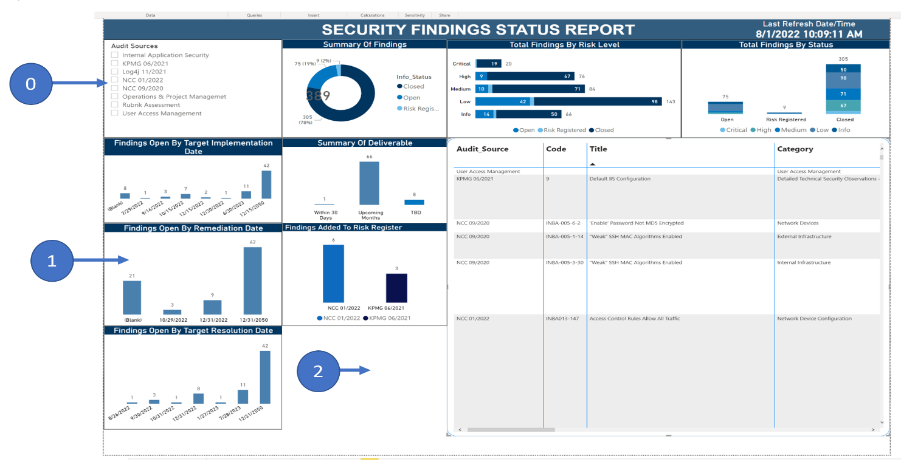3.1 Mockup

#1 in Mockup  
- Rename chart to **Findings to be Reviewed**  
**-** Should show all items with NO target implementation date (currently chart is based on Actual Completion Date Column but again should be based on target implementation date column)  
  
#2 in Mockup  
- Add a new chart   
- **Chart Title.** Findings Closed By Actual Remediation Date   
- **Bars:** One bar for last 6 months including current month (6 total bars)  
- Do not show items with Actual_Completion_Date in the future.

#0 in Mockup   
Audit Sources Slicer Details:

|  |
| --- |
| **Audit Sources Slicer Values (Naming and order by date)** |
| Select ALL 2022-JUL| IA - Operations & Project Management 2022-JUL | IT - Rubrik Assessment  2022-JUL | IA - User Access Management  2022-JAN | IS – NCC  2021-JUL | IA – Internal Application Security  2021-NOV| IS – Log4j  2021-JUN | IA – KPMG  2020-SEP | IS – NCC |

3. Clean up a couple of columns of data

**3. Remove the Management Response Column.**  
  
**4. Infrastructure Response Column.**

- Rename Infrastructure Response to **Assigned To Response**.

# 4 Implement Meaningful Bookmarks that reflect recent updates

4.1 Bookmark 1:   
**Name.** Completed Over Last Quarter  
**What it should show:**   
What completed since last quarter start up through today.

4.2 Bookmark 2:  
**Name. Findings to be reviewed.**  
**What it should show:**  
What has not been looked at and why. 100 items is huge vs. Say 5.

**New Source File (KeyPoint 07/2022):**

<https://investcorp.sharepoint.com/:x:/r/sites/log4jTracker/_layouts/15/Doc.aspx?sourcedoc=%7BACD34EBC-8DCB-4604-8863-59F957A397A1%7D&file=KeyPoint-18-July%202022-Internal%20Network%20VA%20%26%20PT.xlsx>

New source file added to report named as KeyPoint 07/2022.

Good job with the new report. We’re almost there:

1. The Audit Sources should be alphabetical.

1. Add a border to each graph. This will show separation. As an example, the final report should look like this:

1. Add the year in the following graph:

1. What is the *Findings to be Reviewed* graph depicting? It should only include items with NO implementation date.

**Custom Date Range Filter Requirement requested By Robert Olivarez**

Custom Date range filter is implemented in the report.

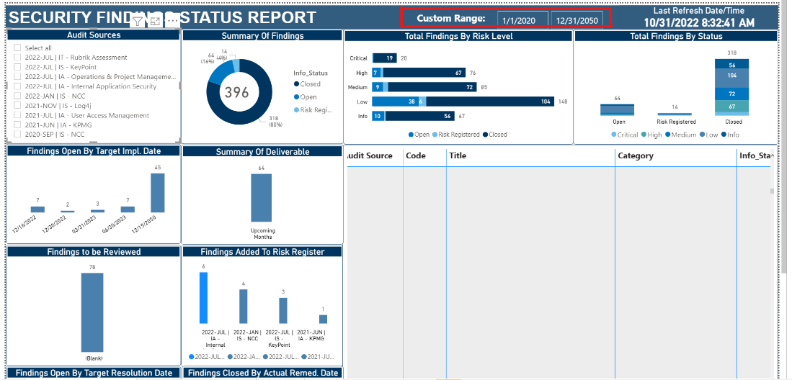

**New Source files:**

1. Added a new source file [2023-Jul IA-Cyber Security-Cloud Security.xlsx](https://investcorp.sharepoint.com/:x:/s/tech/EXd1IbyFiKNGvtGNQ47_aWUBh93xfq-6gleWNpg6yGuBcg?e=kuj5AW) named as 2023-JUL | IA – Cyber Security-Cloud Security and [2023-Jan IA IT Application.xlsx](https://investcorp.sharepoint.com/:x:/s/tech/EW6F4fGeXqNMgRMstZTnMJMBfaP9CQOPYwoUrnQtZolWgg?e=S3yvfL) named as IA - IT Applications_2023.
2. **Total no of findings:** 414.