**Voice Assistent**

**End Term Report**

**By**

**Group no 22**

|  |  |  |  |  |  |
| --- | --- | --- | --- | --- | --- |
| Sr. No. | Registration No | Name of Students | Roll No | Total Marks | Marks Obtained |
| 1 | 11803691 | A.Sai Kiran | A-01 |  |  |
| 2 | 11801572 | D.Hari Krishna | B-34 |  |  |
| 3 | 11802331 | Soma Kalyan | B-52 |  |  |



**Department of Intelligent Systems**

**School of Computer Science Engineering**

**Lovely Professional University, Jalandhar**

April-2020

**Student Declaration**

This is to declare that this report has been written by us. No part of the report is copied from other sources. All information included from other sources have been duly acknowledged. We aver that if any part of the report is found to be copied, we are shall take full responsibility for it.

Soma Kalyan-52

D.Hari Krishna-34

A.Sai Kiran-1

**Table of Contents**

|  |  |
| --- | --- |
| **s.no** | **Contents** |
| 1 | Bonafide |
| 2 | Introduction |
| 3 | Description of project |
| 4 | Individual roles in project |
| 5 | Implementation |
| 6 | Technologies and framework |
| 7 | Analysis in project |

**BONAFIDE CERTIFICATE**

Certified that this project report **“ VOICE ASSISTENT** ” is the bonafide work of “ Sai Kiran, Soma Kalyan, Hari Krishna” who carried out the project work under my supervision.

INT 404

Dr. Dhanpratap singh

Professor of Artificial Intelligence

Department of computer science

**INTRODUCTION:**

As we know Python is a suitable language for script writers and developers. Let’s write a script for Personal Voice Assistant using Python. The query for the assistant can be manipulated as per the user’s need.

The implemented assistant can open the application (if it’s installed in the system), search Google, Wikipedia and YouTube about the query, calculate any mathematical question, etc by just giving the voice command. We can process the data as per the need or can add the functionality, depends upon how we code things.

I’m using Google speech recognition API and google text to speech for voice input and output respectively.

There are two functions included that is search web and open application.

search web is just a web crawler which uses selenium package to process. It can search google, Wikipedia and can open YouTube. You just have to say include the name and it will open it in the Firefox browser. For other browsers, you need to install a proper browser package in selenium. Here we are using web driver for Firefox.

open application is just a function uses os package to open the application present in the system.

**MODULES:**

1.Recognize Spoken Voice

2.Answer In Spoken Voice

**1. Recognize Spoken Voice:**

In this module the system will recognize the spoken voice by the user and follow that instructions accordingly. We use pyaudio which uses the microphone to recognize the voice. If the voice is not clear or the pronunciation is wrong, it will say please repeat again or I can’t understand what your saying.

In this module it can also print the recognized spoken voice so that we can verify what we spoken.

**2.Answer In Spoken Voice:**

In this module the system will give the answer in spoken voice. By default, there are two voices in the system one is male voice, and another is female voice. We can also download the voices from the browser, and we can use them.

We should also specify which language should system will spoke(eng-in).

**LIBRARIES USED:**

1. pyttsx3
2. speech_recognition
3. datetime
4. Wikipedia
5. Webbrowser
6. Os
7. Smtplib

**1.PYTTSX3:**

pyttsx is a cross-platform text to speech library which is platform independent. The major advantage of using this library for text-to-speech conversion is that it works offline.

First we need to import the library and then initialise it using init() function. This function may take 2 arguments.

init(driverName string, debug bool)

* **drivername :** [Name of available driver] ***sapi5***on Windows | ***nsss***on MacOS
* **debug:** to enable or disable debug output

After initialisation, we will make the program speak the text using say() function. This method may also take 2 arguments.

say(text unicode, name string)

* **text :** Any text you wish to hear.
* **name :** To set a name for this speech. (optional)

Finally, to run the speech we use runAndWait() All the say() texts won’t be said unless the interpreter encounters runAndWait().

**2.SPEECH_RECOGNITION:**

Speech Recognition is an important feature in several applications used such as home automation, artificial intelligence, etc. This article aims to provide an introduction on how to make use of the SpeechRecognition library of Python.

Before importing it we should install speech recognition.

The syntax for using it is

**Import speech_recognition as sr**

**a=sr. speech_recognition()**

**3.DATETIME:**

A date in Python is not a data type of its own, but we can import a module named datetime to work with dates as date objects. The date contains year, month, day, hour, minute, second, and microsecond. The datetime module has many methods to return information about the date object.

To create a date, we can use the datetime() class (constructor) of the datetime module.

The datetime() class requires three parameters to create a date: year, month, day.

The datetime() class also takes parameters for time and timezone (hour, minute, second, microsecond, tzone), but they are optional, and has a default value of 0, (None for timezone).

The syntax for using it is

**import datetime**

**x = datetime.datetime(2020, 5, 17)**

**print(x)**

The datetime object has a method for formatting date objects into readable strings.

The method is called **strftime()**, and takes one parameter, format, to specify the format of the returned string:

**4.WIKIPEDIA:**

Wikipedia is a Python library that makes it easy to access and parse data from Wikipedia.

Search Wikipedia, get article summaries, get data like links and images from a page, and more. Wikipedia wraps the MediaWiki API so you can focus on using Wikipedia data, not getting it.

To use this library first we should install it by(pip install wikipedia)

**Import Wikipedia**

**print wikipedia.summary("Wikipedia")**

**5.** **WEBBROWSER:**

In Python, **webbrowser module** provides a high-level interface which allows displaying Web-based documents to users. The webbrowser module can be used to launch a browser in a platform-independent manner

Syntax for using this is

**import webbrowser**

**webbrowser.open('**[**http://www.python.org**](http://www.python.org/)**')**

This opens the requested page using the default browser. To have a bit more control over how the page gets opened.

**c.open_new_tab('http://docs.python.org')**  this will help us to open the site in new tab.

**6.OS:**

The OS module in python provides functions for interacting with the operating system. OS, comes under Python’s standard utility modules. This module provides a portable way of using operating system dependent functionality. The *os* and *os.path* modules include many functions to interact with the file system.

In this project it is used to open files, playing music etc…

**7. SMTPLIB:**

1. First of all, “smtplib” library needs to be imported.
2. After that, to create a session, we will be using its instance SMTP to encapsulate an SMTP connection.

**s = smtplib.SMTP('smtp.gmail.com', 587)**

In this, you need to pass the first parameter of the server location and the second parameter of the port to use. For Gmail, we use port number 587.

1. For security reasons, now put the SMTP connection in the TLS mode. TLS (Transport Layer Security) encrypts all the SMTP commands. After that, for security and authentication, you need to pass your Gmail account credentials in the login instance.  
   The compiler will show an authentication error if you enter invalid email id or password.

**FLOW CHART:**

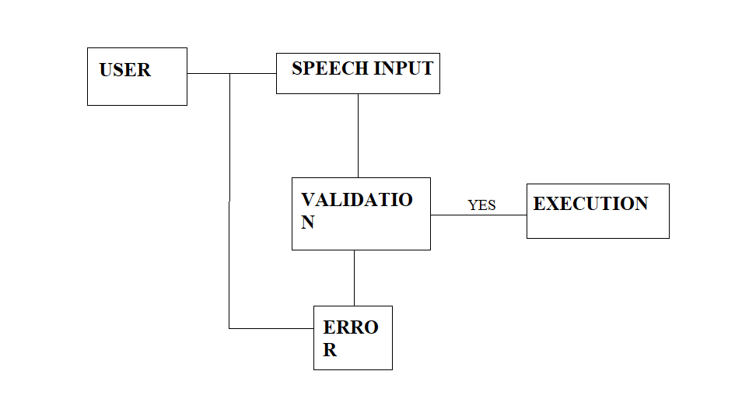

**REFERENCES:**

[www.w3school.com](http://www.w3school.com)

[www.geeksforgeeks.com](http://www.geeksforgeeks.com)

[www.tutorialpoint.com](http://www.tutorialpoint.com)