In this project, we will predict emoji using other columns from csv file.

So we will use SVM, decision Tree and KNN classification algorithm.

Below are python packages that I will use in this project.

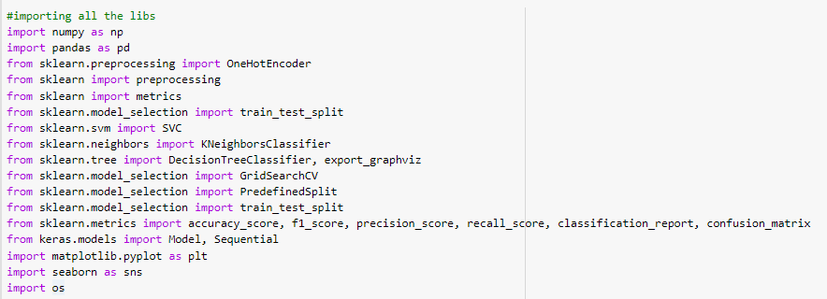

Read csv file and rename pixels and Usage column as pixels and Usage.

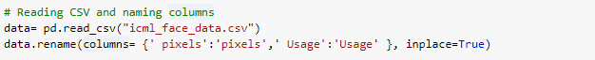

We will check how much rows in this csv file.

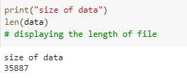

We will get how much data there is for each emotion.

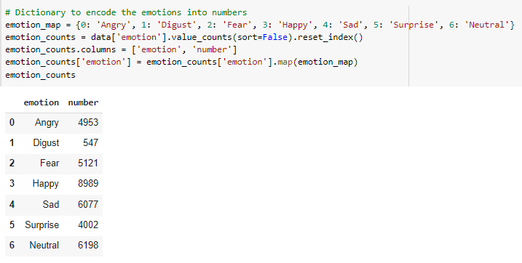

After that we will see as image using python package(matplotlib.pyplot barplot).

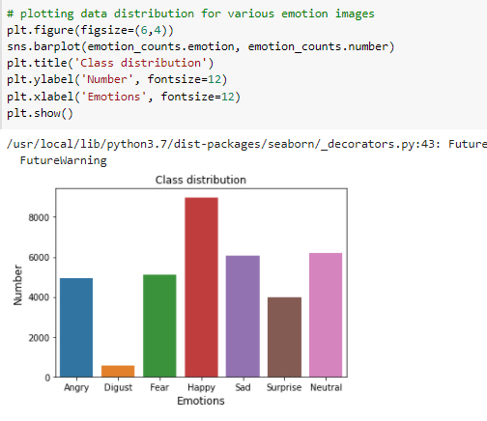

We will check emotion images for each emoji

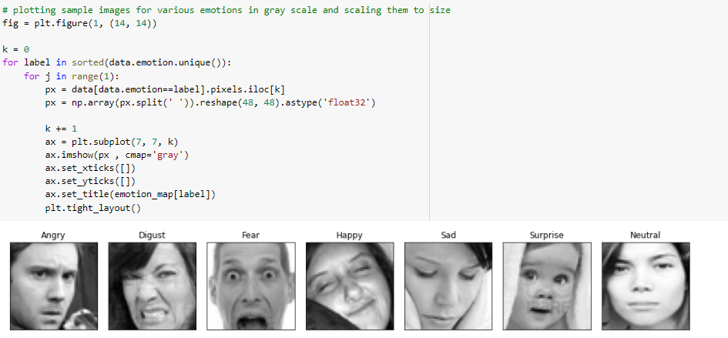

In csv file, there are string values in pixels column so that we will get whole pixel values using split method in python code.



In this project, we will use gray color image pixel values.

If we use RGB or other color system, we have to have 3 dimensional list for that.

But for now we will use only 1d list for pixel values.

And also that will be values as 0~255.

But we have to convert integer value to float value because my model will use those values.

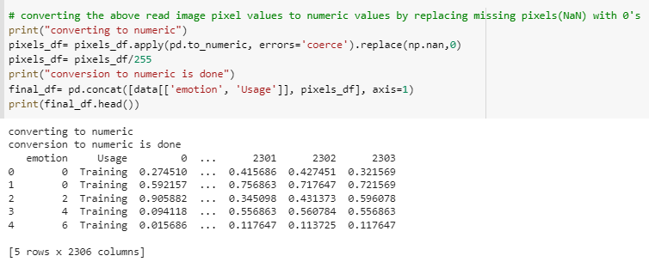

Split data as training and test data using train_test_split python packages.

Here testing size is 15%, training size is 85%.

And then we will split data as training and testing data once more.

At that time, testing size is 18%, training size is 82%.

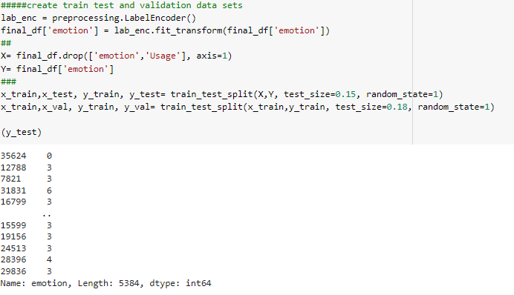

In this project we will classify as 7 classes.

So that we will use kernel of SVM as poly.

There are some parameter to create SVM model as like C, gamma, degree and kernel.

In this part, we will create new list for C, gamma and degree.

We will use whole parameters from list and will get best score.

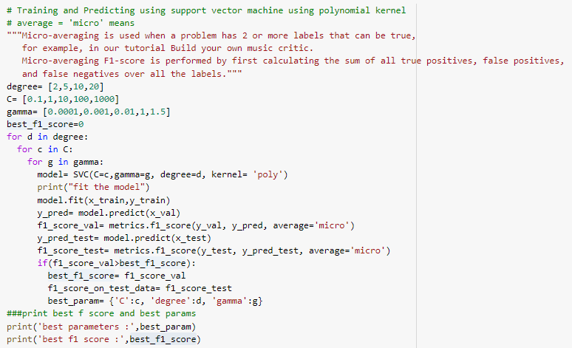

The output of SVM is like below.

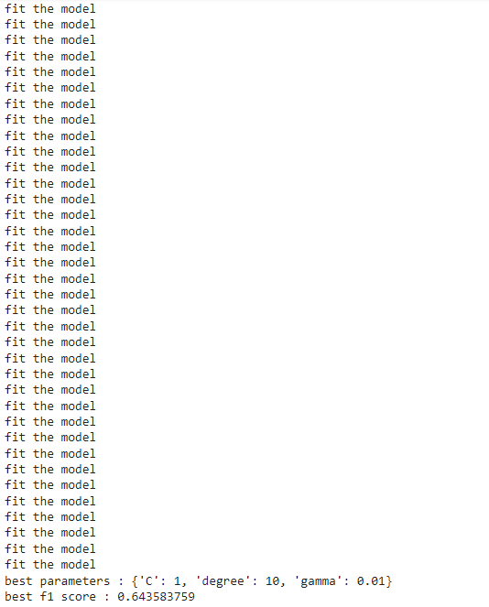

After that we will calculate f1 score for testing data.

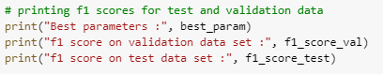

Output of f1 score for testing data is like below.



Second we will use SVM model using rbf.

That’s Gaussian Kernel.

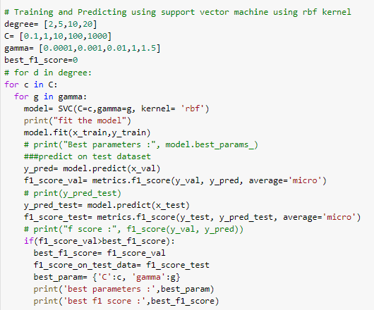

Output of this model is like below.

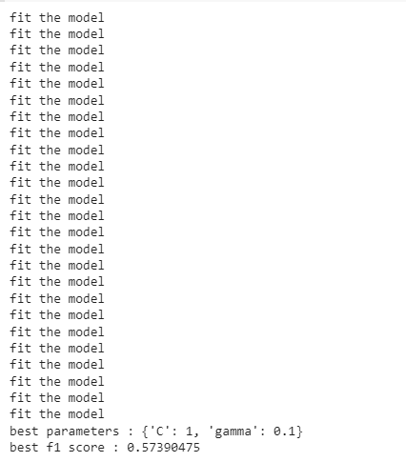

We will calculate testing accuracy like below



Third, we will create decision tree model to classify emoji.

So we will set depth as 4, 10, 20, 50 and random state as 17.

We will loop all depth and will get accuracy and will get best score.

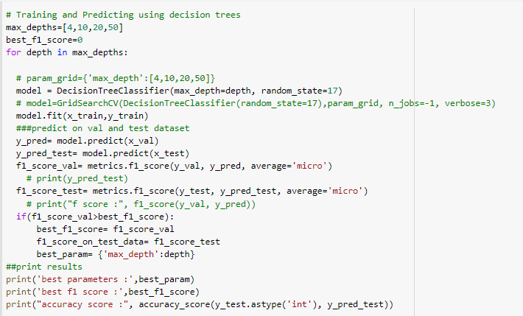

The output of DT model is like below.

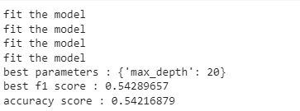

The output of DT model with testing data is like below

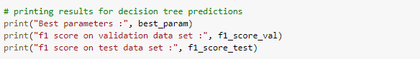

Finally we will create KNN model for classification.

K neighbor will be random values from python random package.

In this model, we will loop for all neighbor count and calculate best score.

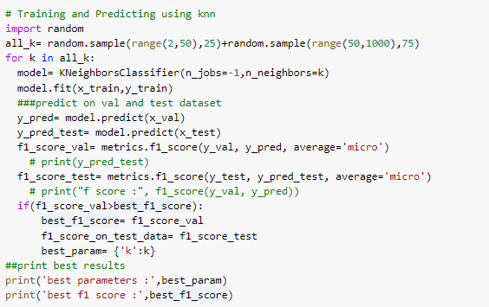

Output of this model is like below

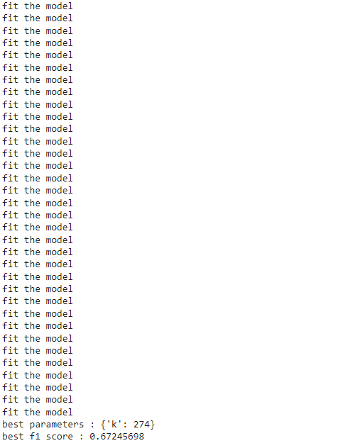

Output of this model with testing data is like below



F1_score for SVM poly model like below

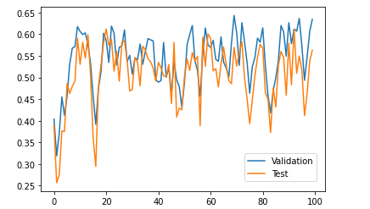

F1_score for SVM rbf model like below

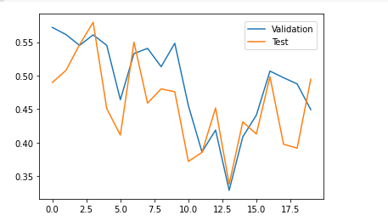

Finally F1_score for each model like below

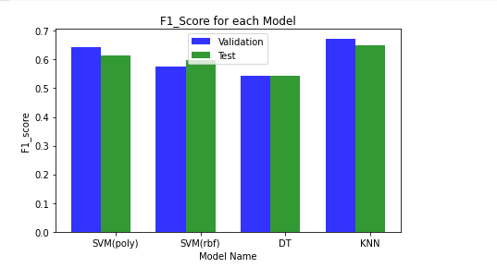

Problems/Error Encounter in this project.

Current project works well, there is no any error or problem.

But when you train or test model, length of x and length of y has to be same.

If not, there will error.

And also we need convert all string to integer or float values. If not, that occur error, because model will use only number.