**1. Write a Python program to calculate the area of a rectangle given its length and width.**

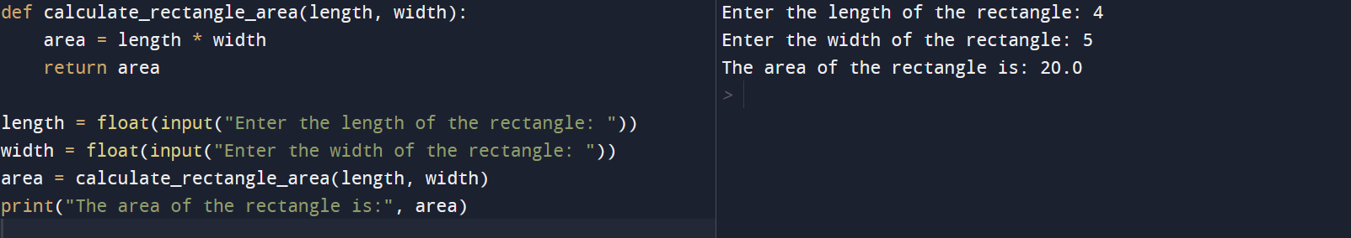

**2. Write a program to convert miles to kilometers**

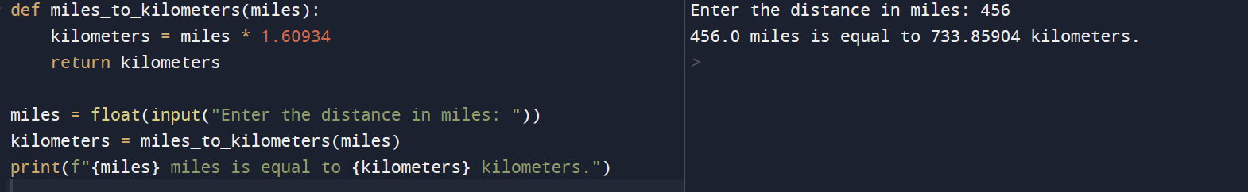

**3. Write a function to check if a given string is a palindrome.**

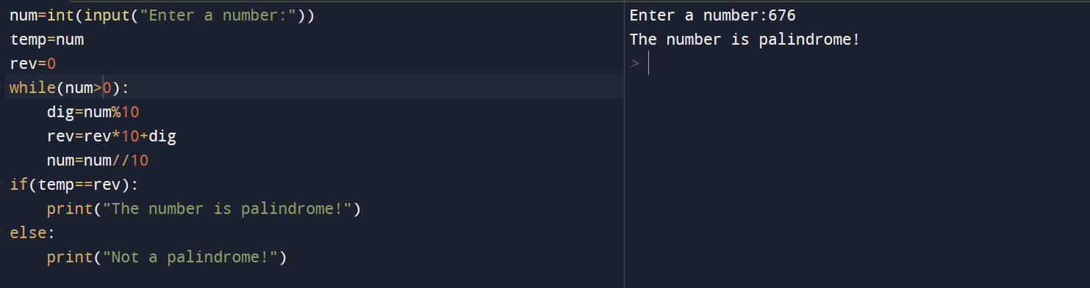

**4. Write a Python program to find the second largest element in a list.**

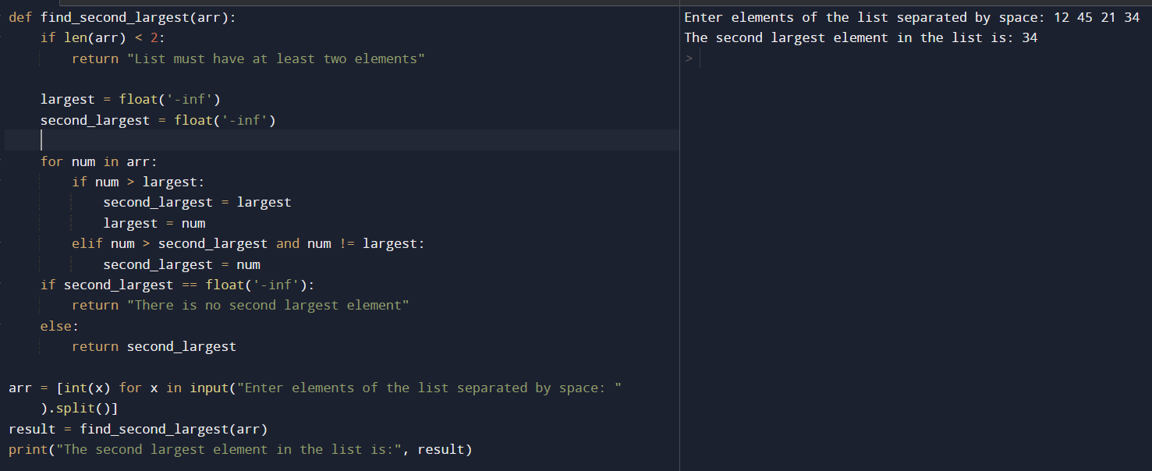

**5. Explain what indentation means in Python.**

**Blocks of Code**: Code blocks in Python, such as those within loops, conditional statements (like if, elif, and else), function definitions, and class definitions, are defined by indentation.

**6. Write a program to perform set difference operation.**

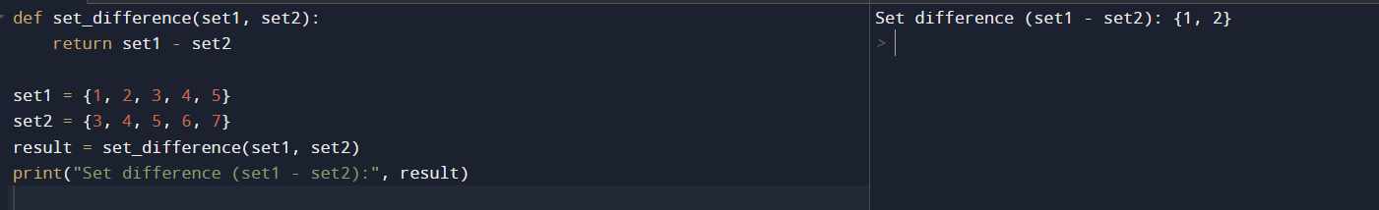

**7. Write a Python program to print numbers from 1 to 10 using a while loop.**

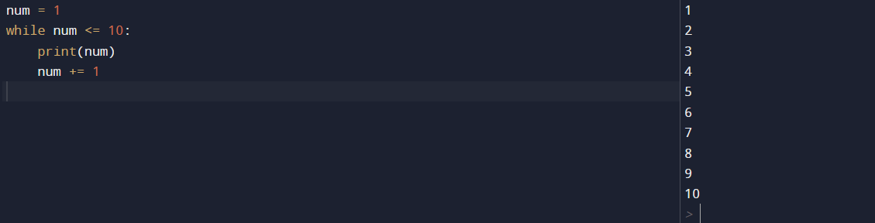

**8. Write a program to calculate the factorial of a number using a while loop.**

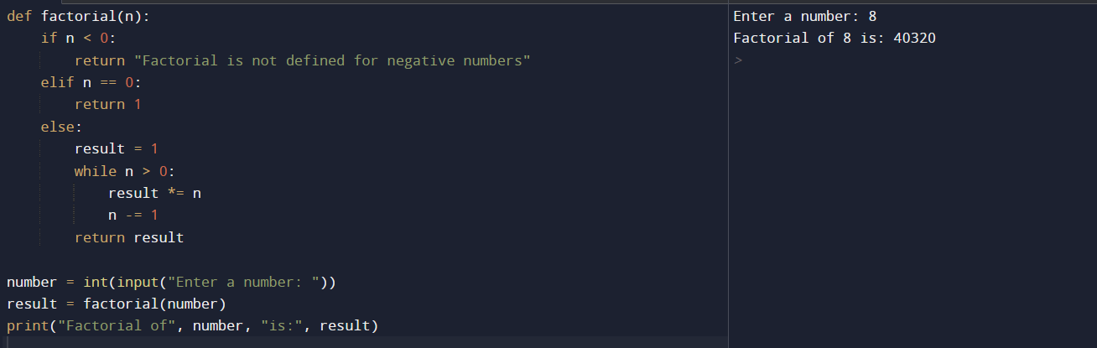

**9. Write a Python program to check if a number is positive, negative, or zero using if-elif-else**

Statements

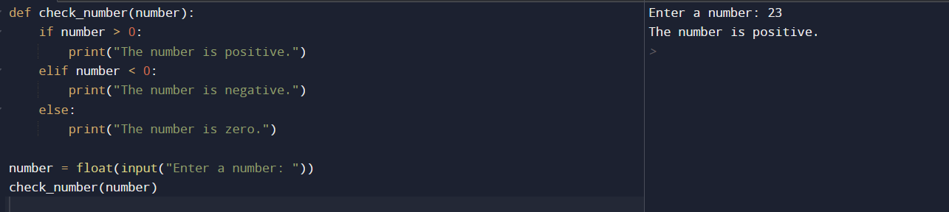

**10. Write a program to determine the largest among three numbers using conditional**

statements.

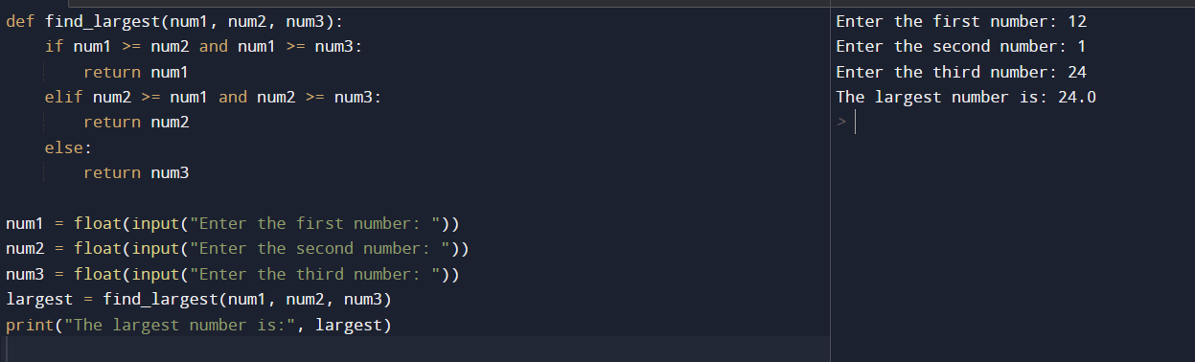

**11. Write a Python program to create a numpy array filled with ones of given shape.**

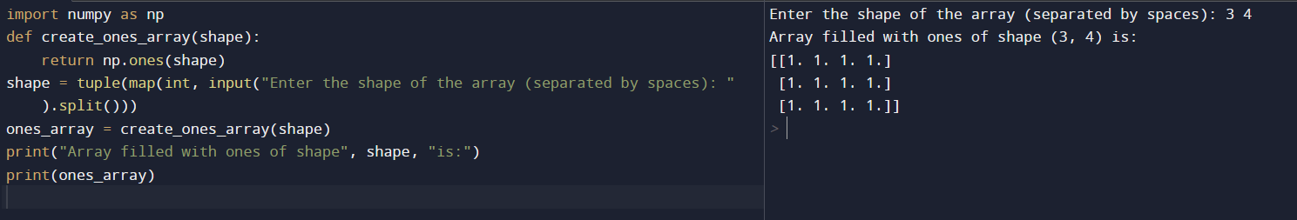

**12. Write a program to create a 2D numpy array initialized with random integers**

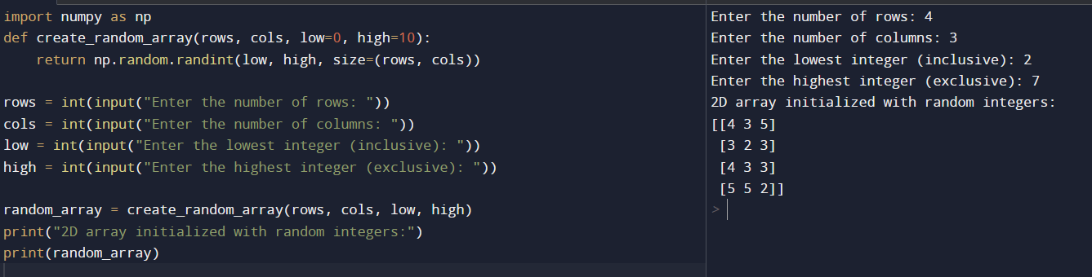

**13. Write a Python program to generate an array of evenly spaced numbers over a specified**

range using linspace.

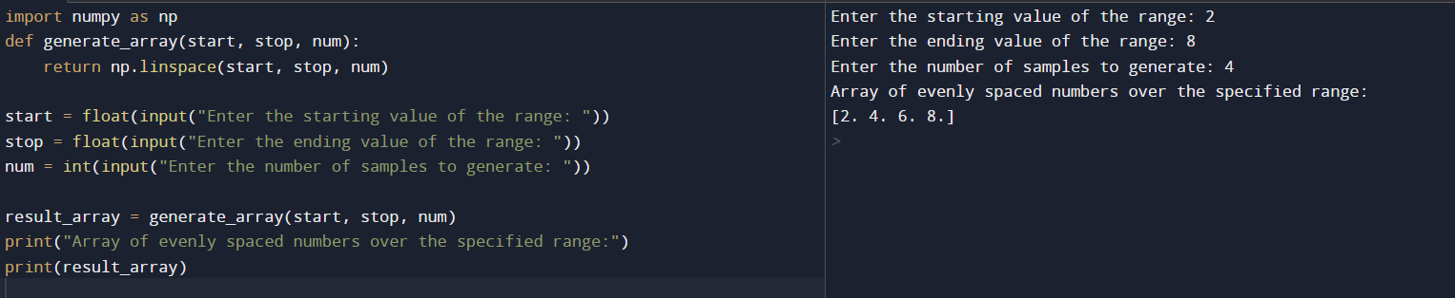

**14. Write a program to generate an array of 10 equally spaced values between 1 and 100 using**

**linspace.**



**15. Write a Python program to create an array containing even numbers from 2 to 20 using**

arange.

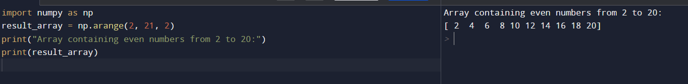

**16. Write a program to create an array containing numbers from 1 to 10 with a step size of 0.5**

using arange.

