LockedME Project Submission
by
Kalyan Chakravarthy B

Date of submission:28-04-22

Source Code Git Location: https://github.com/Kalyan7804/Javaprojects.git
(Please refer below path: Javaprojects/JavaProject/CompanyLockersProject)

LockedMe Project Source Code
package com.company.lockers;

import java.io.File;
import java.io.FileWriter;
import java.util.Scanner;

public class LockedMe {
static final String projectPath="D:\\FSD\\JAVA\\JavaProject\\LockedMeFiles";

public static void main(String[] args) {
int ch;
do {
display();

System.out.println("Please enter your choice:");
Scanner scn =new Scanner(System.in);
ch=Integer.parseInt(scn.nextLine());

switch(ch){
case 1:displayAllFiles();
break;
case 2:createFile();
break;
case 3:deleteFile();
break;
case 4:searchFile();
break;
case 5:System.exit(0);
break;
default: System.out.println("Invalid option");
break;
}
}while(ch>0);

}

public static void display() {
System.out.println("***************************************************************");
System.out.println("\tWelcome to Company Lockers-LockedMe.com");
System.out.println("\tDeveloper's name: Kalyan Chakravarthy B");
System.out.println("***************************************************************");
System.out.println("\t1.Display all the files");
System.out.println("\t2.Add files to existing directory");
System.out.println("\t3.Delete a file");
System.out.println("\t4.Search for a file");
System.out.println("\t5.Exit");
System.out.println("***************************************************************");
}

public static void displayAllFiles() {
File files=new File(projectPath);
File[] listOfFiles=files.listFiles();
if(listOfFiles.length==0)
System.out.println("The directory is empty");
else {
for(File f:listOfFiles) {
System.out.println(f.getName());
}
}
}

public static void createFile() {
try {
Scanner sc1=new Scanner(System.in);
String fileName;
int linesCount;

System.out.println("Enter the new file name:");
fileName=sc1.nextLine();

System.out.println("Enter how many lines of data to enter in file:");
linesCount=Integer.parseInt(sc1.nextLine());
FileWriter fw= new FileWriter(projectPath+"\\"+fileName);

for(int i=1;i<=linesCount;i++) {
System.out.println("Enter data of line"+i+" :");
fw.write(sc1.nextLine()+"\n");
}
System.out.println("flie creation is successful!");
fw.close();
}
catch(Exception Ex) {
System.out.println("some error occured, see below for more details");
System.out.println(Ex);
}
}

public static void deleteFile() {
try {
Scanner sc2=new Scanner(System.in);
System.out.println("Enter file name to delete: ");
String fileName=sc2.nextLine();

File fl=new File(projectPath+"\\"+fileName);

if(fl.exists()) {
fl.delete();
System.out.println(fileName+" file is deleted succesfully");
}
else
System.out.println("Entered file does not exist in directory");
}
catch(Exception ex) {
System.out.println("Some error occured");

}
}

public static void searchFile() {
Scanner sc3=new Scanner(System.in);
System.out.println("Enter file name to serch:");
String fileName=sc3.nextLine();

File fl=new File(projectPath+"\\"+fileName);

if(fl.exists()) {
System.out.println("entered file exists in directory");
}
else
System.out.println("entered file doesnt exist");
}

}

Screenshots:
1.Main Menu
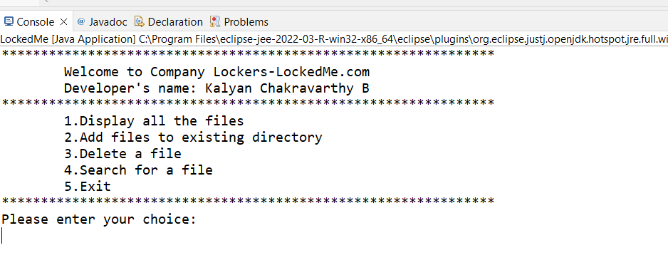
2.Create file
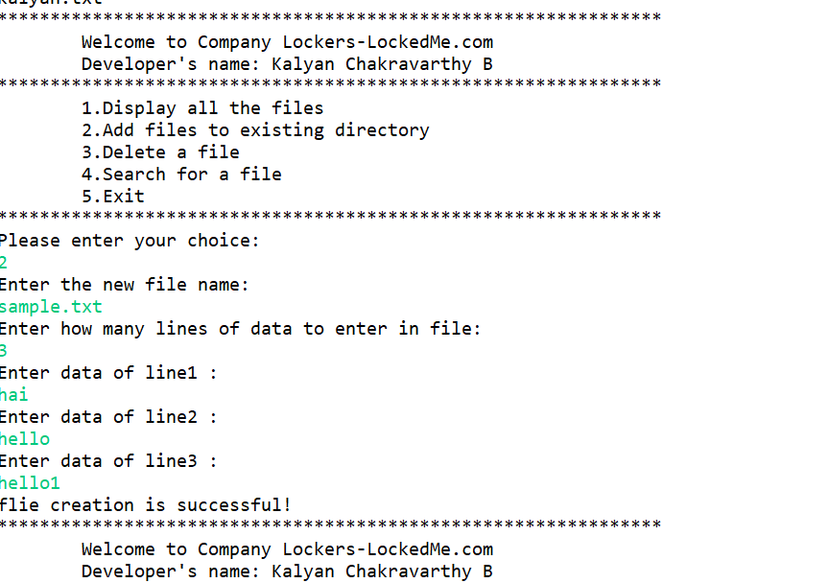
3. Delete File
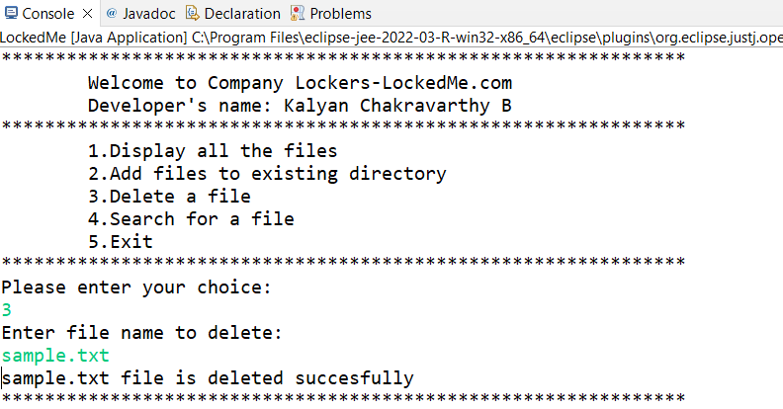
4. Search file
