SCWCD Study Material

11/02/2009

IS-Retail & Distribution1-Parent/TNC-ADM-RMS-US-OFF

Annapoorna SR/210402
annapoorna.sr@tcs.com

Chapter 1: HTTP

- HTTP stands for HyperText Transport Protocol, and is the network protocol used over the web. It runs over TCP/IP
- HTTP uses a request/response model. Client sends an HTTP request, then the server gives back the HTTP response that the browser will display (depending on the content type of the answer)
- If the response is an HTML file, then the HTML file is added to the HTTP response body
- An HTTP response includes : status code, the content-type (MIME type), and actual content of the response
- A MIME type tells the browser what kind of data the response is holding
- URL stands for Uniform Resource Locator: starts with a protocol, then a server name, optionally followed by a port number, then the path to the resource followed by the resource name. Parameters may appear at the end, separated from the rest by a?

HTTP methods:

GET | Gets the data identified by an URI
POST | Same, the request’s body is passed to the resource specified by the URI
HEAD | Sends back only the header of the response that would be sent by a GET
PUT | Sends to the server data to store at specified URI. Server does not process the data ; it only stores them
DELETE | Delete specified resource
TRACE | When it receives this request, the server sends it back to the client
OPTIONS | Ask server informations about a resource or about its own capabilities
CONNECT | Ask for a connection (tunnelling)

Differences between GET and POST

GET:
  - GET parameters are passed on the URL line, after a? The URL size is limited.
  - The parameters appear in the browser URL field, hence showing any password to the world.
  - GET is supposed to be used to GET things (only retrieval, no modification on the server).
  - GET processing must be idempotent.
  - A click on a hyperlink always sends a GET request.
  - GET is the default method used by HTML forms. Use the method=”POST” to change it.
POST:
  - In POST requests, the parameters are passed in the body of the request, after the header. There is no size-limit. Parameters are not visible from the user.
  - POST is supposed to be used to send data to be processed.
  - POST may not be idempotent and is the only one.

Chapter 2: Web App architecture

Containers:
- A container runs and controls the servlets.
- A full J2EE application server must have both a web container and an EJB container.
- When a request is received by the webserver and needs to access a servlet, the webserver hands the request to the servlet-helper app: the container. Then the container hands the request to the servlet itself.

Role of Containers:
- Matches the request URL to a specific servlet
- Creates request and response objects used to get informations from the client and send back informations to him;
- Creates the thread for the servlet;
- Calls the servlet’s service() method, passing request and response objects as parameters;
- service() method will call the doXxx() method of the servlet depending on request type;
- Get the response object from the finished service() method and converts it to an HTTP response;
- Destroys request and response objects;
- Sends back response to the webserver

Capabilities of containers
Containers provide :
- Communications support : handles communication between the servlets and the webserver
- Lifecycle management : controls life and death of servlets, class loading, instantiation, initialization, invocation the servlets’ methods, and making servlet instances eligible for GC
- Multithreading support : Automatically creates a new thread for every servlet request received. When the Servlet service() method completes, the thread dies.
- Declarative security : manages the security inside the XML deployment descriptor file. Security can be configured and changed only by modifying this file.
- JSP support: Manages the JSPs.

URL to servlet mapping
- The servlet container uses the deployment descriptor to map URL to servlets. Two DD elements are used to achieve this are :
- <servlet> : maps internal name to fully qualified class name;
- <servlet-mapping> : maps internal name to public URL name.

Chapter 3: Mini MVC tutorial

Application creation process
- Review the user’s views and the high level architecture;
- Create the development environment (if necessary);
- Create the deployment environment (if necessary);
- Perform iterative development and testing.

1. Create user’s views and architecture
  - Define the views (jsp/html): list of screens reachable by the user.
  - Create the architecture:
- define the static part (webserver logic, static documents);
- define architecture components (i.e. MVC model, controler and view
Components) (inside the container)

2. Create the development environment

- Create a development directory with one subdirectory for each web application.
- Each of these subdirectories contain :

  - one etc directory : deployment descriptor, and other configuration files;
  - one lib directory : stores all the external jar files needed;
  - one src directory : where all the source files are;
  - one classes directory : containing the compiled java files;
  - one web directory : stores all the web resources (jsp/html/etc...)

3. Create the deployment environment

- The Servlet specification says a web app is deployed in a context root, containing :

- the web resources : html/jsp/etc.
- WEB-INF : holds the deployment descriptor;
- WEB-INF/lib : contains all the external jars needed;
- WEB-INF/classes : contains the compiled java class files with hierarchy.

- Create the deployment descriptor

The deployment descriptor, named web.xml, must be created in the development env. Under the etc/ directory, then copied into the WEB-INF/ directory of the deployment env.
The <servlet-class> element holds the real, fully-qualified (including package) servlet class name.
The <url-pattern> holds the user friendly name, the name we want users to use to access the servlet. In this element, the / represents the context root of the webapp.

In a webapp stored in the mvc context-root, the url-pattern :

<url-pattern>/login.do</url-pattern>

is reached by this url : http://servername:serverport/mvc/login.do
The two are linked via the <servlet-name> element, which is an internal servlet name, reserved to the DD.

- Create the model class (POJO)
- Create the POJO model class and update the controler servlet to make it use the model to get informations and send it to the client.

Chapter 4: Being a servlet
Servlets are controlled by the container:

- Request arrives for a servlet
- The container creates the HttpServletRequest and HttpServletResponse objects
- It finds the correct servlet based on the URL, then creates or allocates a thread for that request;
- Container calls the servlet’s service() method, and passes the request and response objects as parameters
- The service() method calls the doGet() or doPost() method corresponding to the request HTTP method.
- Servlet uses the response object to write the response .service () method completes, so the thread dies.The request and response objects are not referenced any more, so they become eligible for garbage collection.

Servlet Life Cycle:

- Servlets are loaded when the container starts up, or when the client first uses the servlet.
- Servlet’s constructor makes it an object.
- Servlet’s init () makes it a servlet(called only once in the servlet life cycle)
- Servlet’s service () method will be called which handles the client requests.
- Service() method calls the doGet or doPost methods depending on HTTP method of request.
- Servlet’s destroy () method will be called .(called only once in the servlet life cycle)

Servlet API:

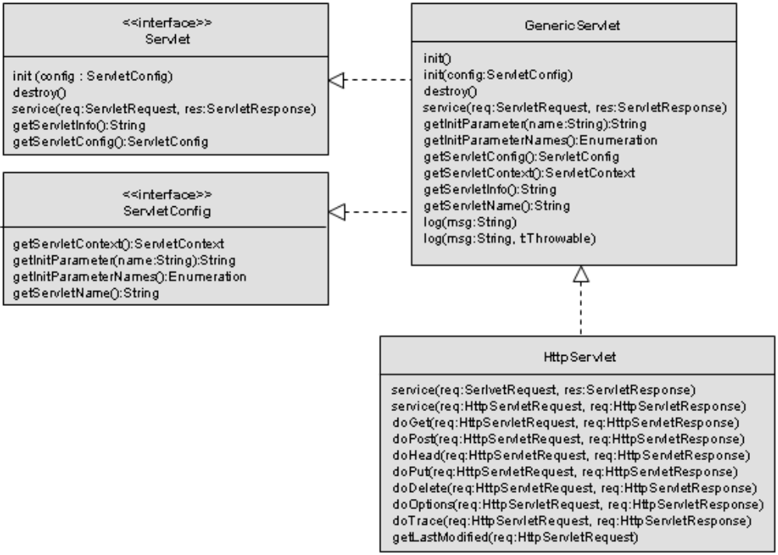

ServletConfig:

- There should be only one ServletConfig per servlet.
- It can be used to access the servletContext.

ServletContext:
- There should be only one ServletContext per application.
- It can be used to access the Webapp parameters configured in DD.

HttpServletRequest and HttpServletResponse :

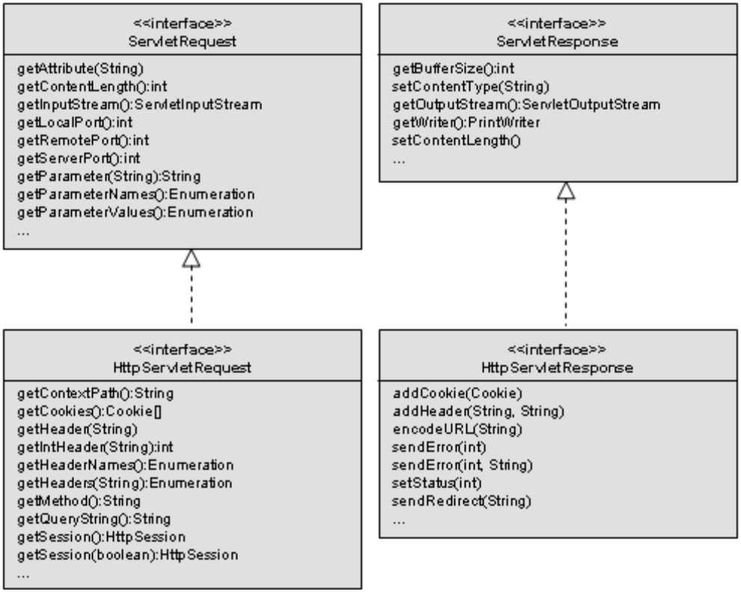

Chapter 5 : Being a Web App

Servlet Init parameters :

- These are defined in the DD, in the servlet element.
<init-param>
<param-name>...</param-name>
<param-value>...</param-value>
</init-param>
- It can be accessed using ServletConfig object:
getServletConfig().getInitParameter(name:String)

Context init parameters :

- These are available to the whole web application.
- These are defined in the DD, in the <context-param> block
<context-param>
<param-name>...</param-name>
<param-value>...</param-value>
</context-param>
- It can be accessed using ServletContext object:
getServletConfig().getServletContext().getInitParameter(name:String)

ServletContextListener :

- The ServletContextListener receives context initialization and destruction events.
- It’s an interface with two methods :
public void contextInitialized(ServletContextEvent);
public void contextDestroyed(ServletContextEvent);
- A listener is declared in the web app DD, in a <listener> block.
<listener>
<listener-class>...</listener-class>
</listener>

Attributes and Parametes:

- An attribute is a name/value pair (name is a String, value is an Object).
- Attributes can be bound to one of the three other servlet objects :
HttpSession;
(Http)ServletRequest;
ServletContext.
- Attributes can be bound to context, request, session.
- Parameters can be bound to context, request, servlet.
- Attributes can be set with setAttribute(String, Object).
- Parameters cannot be set (only read once from DD).
- Attributes return type is Object.
- Parameters return type is String.
- Attributes are retrieved with getAttribute(name:String):Object. A cast is needed.
- Parameters are retrieved with getInitParameter(name:String):String.

Attribute scope

- Context : available to everyone in the web app.
- Session : accessible to those who have access to the specific HttpSession.
- Request : accessiblte to those who have access to the specific ServletRequest.

RequestDispatcher
- RequestDispatcher is used to pass the request to another web app component.
RequestDispatcher dispatch = request.getRequestDispatcher(url:String)
view.forward(request, response);

Chapter 6: Session

Session management
- Sessions are identified by a JSESSIONID.
- There are two ways to manage cookies: Cookies and URL encoding.
Cookies :
Cookies are the default mechanism to manage sessions.
The cookie is exchanged in the request/response header. Its name MUST be JSESSIONID.

URL encoding :
- The URL encoding method is used when the cookies are disabled for the browsers.URL encoding is handled by the response object:
response.encodeURL()
response.encodeRedirectURL()

Session creation:
- request.getSession()
- request.getSession(bool) : if bool==false, return an existing session or null.
if bool==true,it works like getSession()

Setting time out in the DD :
<session-config>
<session-timeout>minutes</session-timeout>
</session-config>
Managing cookies:
- Cookies are added to a response, and retrieved from a request object.
- Cookies are a name/value pair.
HttpServletRequest.getCookies(): returns Cookie[]
HttpServletResponse.addCookie(Cookie)

Session events and Listeners :

The listeners and events dedicated to sessions are represented in this diagram :

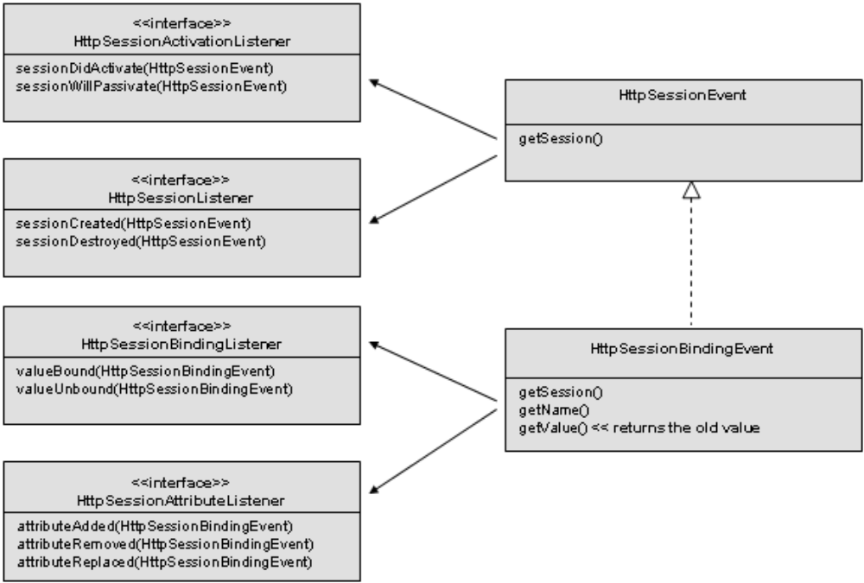

Chapter 7: Being a JSP

JSP are translated into servlet and compiled the first time they are accessed. This translation/compilation process happens only once in the JSP life.

JSP elements :

Directives:
There are three directives page, taglib and include.
The page directive : attributes are
- import: like java import; creates import statements in the final servlet.
- isThreadSafe : default value is true; indicates if the servlet is thread safe. If not, it will use the SingleThreadModel interface.
- contentType : defines MIME type and character encoding of the response.
- isELIgnored : indicates whether EL expressions within the JSP must be ignored.
- isErrorPage : default value is false; indicates if this JSP is the target of another JSP errorPage. If true, then the exception implicit object is available. If false, exception is not available,
- errorPage : defines the URL of a resource that should be called when an uncaught Throwable is raised.

The include directive : The directive inserts the text of the specified resource into the page or tag file.
<%@ include file=”relativeURLspec” %>

The taglib directive : The taglib directive in a JSP page declares that the page uses a tag library, uniquely identifies the tag library using a URI and associates a tag prefix that will distinguish usage of the actions in the library.
Declaration Syntax :
<%@ taglib prefix=”tagPrefix” ( uri=”tagLibraryURI” | tagdir=”tagDir” ) %>
Scriptlet :
- Scriplets represents java code in the JSP which are copied into _jspService() method in the servlet at translation time.
- Variable declared in the scriptlet is a local variable.
- Syntax : <% java code %>
Expressions :
- An expression element in a JSP page is a scripting language expression that is evaluated and the result is coerced to a String. The result is passed as a parameter to an out.print() statement in the final _jspService() method.
- Syntax : <%= expression %>

Declarations :
- Declarations are used to declare member variables and methods in the final servlet.
- Syntax : <%! Declaration of method and variables>

JSP implicit objects:
out : JspWriter
request :HttpServletRequest
response :HttpServletResponse
session :HttpSession
application :ServletContext
config :ServletConfig
exception :JspException
pageContext :PageContext
page :Object

Scopes and attributes: JSP scopes and attributes are
- PAGE_SCOPE
- REQUEST_SCOPE
- SESSION_SCOPE
- APPLICATION_SCOPE
Expression Language:
      - Syntax : ${ expression}
      - EL are enabled by default.
      - There are two ways to disable EL :
      - Using <el-ignored> tag in the DD.
      - Using the isELIgnored attribute in the page directive.

Chapter 8: Scriptless Pages (EL)

Standard actions :
Bean declaration :
- The standard action tag for bean declaration is <jsp:useBean> : <jsp:useBean id=”titi” type=”Person” class=”Employee” .../>
- useBean action body :
Synax :
<jsp:useBean ... scope=”page” />
body
</jsp:useBean>
Bean property tags :
- getProperty tag
- setProperty tag

Include : There are two include mechanisms which can be used in JSP

include directive :
- The include directive is used to insert the included file’s source into a Jsp at translation time.
      - Syntax : <%@ include file=”header.jsp” %>

include standard action:
      - The include standard action is used to insert the included page’s result (output) into the the current Jsp at runtime.
      - Syntax : <jsp:include page="header.jsp” />
Forward :
      - A Jsp may forward the request to another webapp component with the forward mechanism.
      - Syntax : <jsp:forward page=”invalidUser.jsp”/>

Include and forward parameters :

- Syntax :
<jsp:forward page=”invalidUser.jsp”>
<jsp:param name=”userName” value=”...”/>
</jsp:forward>

Expression Language :

- Syntax : ${firstArg.secondArg}

- EL first argument : must be either one of implicit objects or an attribute in one of the scopes.
- EL second argument : must be either a map key or bean property.

EL operators :
dot operator : The rules of the dot operator are :
A variable on the left of a dot should be a map or a bean.
A variable on the right of a dot should be a map key or a bean property.

[] operator :
Syntax : leftVariable[“content”]
Rules are :
A variable on the left of a [] may be a map,a bean, a list or an array.
The content of [] may be a map key,bean property,index into a list or an index into an array.
EL functions :
EL functions associate Java public static methods to EL callable symbols. EL functions usage is:
- Create a java class with a public static method. The method MUST be public and static, and it may have parameters. The return type shouldn’t be void, but it’s not an error.
- Write a tag library descriptor file (tld). This file creates the mapping between the actual java public static method and the EL accessible function name. The two names may be different.
- Put a taglib directive into the JSP file. It describes the uri of the linked tld and the prefix to associate to it.
- Use the EL function by calling the function name as defined in the <name> tag of the tld.

EL operators:
      - EL operators are operators are artihmetic, logical and relational.
      - The arithmetic operators are : + , - , * , / or div
      - Logic operators are : && or and , || or or, ! or not
      - Relational operators are : == or eq , != or ne , > or gt, < or lt , >= or ge , <= or le.

EL reserved words:
EL has special reserved words that cannot be used as identifiers : true , false , instanceof,null and empty.

Chapter 9: JSTL

Core Custom Tags :

c:forEach : Allows iteration through a Collection, a Map, an array
    - Syntax : <c:forEach[var=”varName”] items=”collection” [varStatus=”varStatusName”] [begin=”begin”] [end=”end”] [step=”step”]>

c:if :
    - Syntax : <c:if test=”testCondition” [var=”varName”] [scope=”{page|request|session|application}”]>

c:set :
    - Syntax 1: Set the value of a scoped variable using attribute value
<c:set value=”value”
var=”varName” [scope=”{page|request|session|application}”]/>
    - Syntax 2: Set the value of a scoped variable using body content
<c:set var=”varName” [scope=”{page|request|session|application}”]>
body content
</c:set>
    - Syntax 3: Set a property of a target object using attribute value
<c:set value=”value”
target=”target” property=”propertyName”/>
    - Syntax 4: Set a property of a target object using body content
<c:set target=”target” property=”propertyName”>
body content
</c:set>

c:remove : this tag is used to remove the attribute.
    - Syntax : <c:remove var=”varName”
[scope=”{page|request|session|application}”]/>

c:import : Adds contents of imported resource to the current page at request time.
    - Syntax : <c:import url=”url” [context=”context”]
[var=”varName”] [scope=”{page|request|session|application}”] >

c:url : Handles Handle url, with automatic url rewriting (session tracking) and implicit url encoding when used with c:param.
    - Syntax : <c:url value=”value” [context=”context”]
[var=”varName”] [scope=”{page|request|session|application}”]>
<c:param> subtags encoded
</c:url>

Error pages :
page directive attributes :
    - isErrorPage: true means exception implicit object is accessible and initialized;
    - errorPage : declares the page to which to redirect in case uncaught exception occurs.
c:catch : It allows to wrap risky code into sort-of a try/catch block.
    - Syntax : <c:catch [var=”varName”]>
risky code
</c:catch>
Custom tag TLD definition :
TLD is equivalent to a custom tag API. Every thing needed to use a custom tag is in the TLD.
    - TLD attributes :
tlib-version : mandatory;
short-name : mandatory;
uri : mandatory; uniquely identifies the taglib in the container taglibs map.
    - Tag description :
Syntax :
<tag>
<description>
<name>
<tag-class>
<body-content>
<attribute>
<name>
<type>
<required>
<rtexprvalue>
</attribute>
</tag>
    - Body content : The body content may take four values; empty, scriptless, tagdependent and JSP.

Chapter 10: Custom tags development

Tag files :
Tagfiles are JSP fragments renamed with the .tag extension.
Usage :
<%@ taglib prefix=”...” tagdir=”...” %>
<prefix:TagFileName/>

Tag attributes :

Attrbutes can be sent to tags in two ways tag attributes and tag body contenets.
    - Attributes : Attributes are declared in the tag file itself, using the attribute directive.
<%@ attribute name=”attrName” required=”true” rtexprvalue=”true” %>
<prefix:tagName attrName=”blah” />
    - Body content :
Usage :
<prefix:tagName>
This is the tag value passed in its body
</prefix:tagName>
<strong> <jsp:doBody/> </strong>
Storage : Tag files may be deployed in :

    - WEB-INF/tags/ directory (or one of its subdirectories);

    - META-INF/tags (or one of its subdirectories) in a JAR file in the WEB-INF/lib/ directory.

Tag file TLD entry : In the tag lib descriptor file, tag files may be described as below :
<tag-file>
<name>tagFileName</name>
<path>/META-INF/tags/ tagFileName.tag</path>
</tag-file>

Tag Handlers :
Tag handlers implement their functionality in a special java class.
Simple tags : This tag extends SimpleTagSupport and implements SimpleTag

      - Response writer : Writer can be obtained with
getJspContext().getOut()
      - Body content processing : body processing is done in dotag() method.
getJspBody().invoke(java.io.Writer)
      - Tag attributes : Tag attributes must be defined in the TLD file with the attribute block :
<attribute>
<name>tagAttribute</name>
<required>...</required>
<rtexprvalue>...</rtexprvalue>
</attribute>
      - Stop page processing : Simple tag handlers may stop further page processing by throwing a SkipPageException.
      - JSP Fragments : JSP fragment must not containt any scripting element.

Classis tags : Extends TagSupport or BodyTagSupport and implements Tag, IterationTag, BodyTag.
      - Response writer : Writer can be obtained with pageContext.getOut().
      - Body content processing : To process tag’s body contents, doStartTag() MUST return EVAL_BODY_INCLUDE.
      - Stop page processing : Classic tag handlers may stop further page processing by returning a SKIP_PAGE value in the doEndTag() method.

Chapter 11: Web app deployment

War files:

A webapp may be deployed as a directory structure or as a war file. A WAR file is a Web Archive. It’s just a JAR containing a web app directory structure.
Deployment descriptor Declarations :
Servlet mapping :

- <servlet> : declares the servlet internat name and the servlet class;
- <servlet-mapping> : associates a url-mapping to the servlet internal name.
URL patterns : Containers looks for matches in DD for three differents patterns, in the following order : exact match, directory match and extension match.

Error pages : Error pages are declared in the DD with the error-page tag
<error-page>
<exception-type>fully qualified exception class</exception-type>
OR
<error-code>404</error-code>
<location>/error.jsp</location>
</error-page>
Startup loading : To load servlets at container start-up load-at-startup tag in the servlet block can be used :
<servlet>
<load-at-startup>x</load-at-startup>
</servlet>
JNDI environment :
<env-entry>
<env-entry-name> JNDI lookup name
<env-entry-type> any type using a String as a constructor arg.
<env-entry-value> will be passed as a String
</env-entry>
Mime type :
<mime-mapping>
<extension>
<mime-type>
</mime-mapping>

Chapter 12 : Security

Security concepts :

Authentication :

Roles definition : Two steps are :
declare login/passwords and associated roles in a vendor specific place and in the webapp DD.

Enabling authentication : Login configuration is declared in DD as below
<login-config>
<auth-method>…</auth-method>
</login-config>

Security constraints : Security constraint declaration in DD is the way to declare protected/restricted requests.It can be described in DD as below :
<security-constraint>
<web-resource-collection>
<web-resource-name>blah</web-resource-name>
<url-pattern>/toto/*</url-pattern> // one or more
<http-method>GET</http-method> // zero or more
</web-resource-collection>
<auth-constraint>
<role-name>guest</role-name> // zero or more
</auth-constraint>
</security-constraint>

Security constraint rules : Web-resource-collection has two primary sub-elements url- pattern(can be one or more) and http-method(can be zero or more).

Role-name rules :

- role-name element are optional;

- if role-name present, only the declared roles are allowed to make the requests;

- if role-name not present, NO USER is allowed;

- <role-name>*</role-name> : ALL users are allowed

- role names are case sensitive

Auth-constraint rules :

- auth-constraint is optional;

- if auth-constraint present, associated urls will require authentication;

- if auth-constraint not present, no authentication is required.

- Empty <auth-constraint/> element : no user allowed.

- A description element is optional.

Authorization : There are four types of authorization.

- Basic

- Digest

- Client-cert

- Form

Confidentiality : Confidentiality can be configured in DD as below :
<security-constraint>
<transport-guarantee>…</transport-guarantee>
</security-constraint>

Chapter 13: Filters

Key points about Filters :

- Container knows Filter API;

- Container manages Filter’s lifecycle;

- Filters are declared in the DD;

- Only ONE interface : javax.servlet.Filter (and FilterChain).

FilterChain :
The FilterChain object is initialized with DD information about what Filters are to be applied and in which order they must be chained. FilterChain defines one method :
doFilter(ServletRequest, ServletResponse)

Deployment Descriptor :
Declaration :
<filter>
<filter-name>...</filter-name>
<filter-class>...</filter-class>
<init-param>
<param-name>...</param-name>
<param-value>...</param-value>
</init-param>
</filter>
Mapping :
<filter-mapping>
<filter-name>...</filter-name> // refers to filter group name
<url-pattern>...</url-pattern>
</filter-mapping>

Ordering :

- All the filters with a matching URL pattern are placed first in the chain, in the order they are declared in the DD.

- All the filters with a matching servlet name are place after, in the order they are declared in the DD.

Wrapper : There are four types of wrappers

- ServletRequestWrapper and HttpServletRequestWrapper;

- ServletResponseWrapper and HttpServletResponseWrapper.

Chapter 14: Design Patterns

Business Delegate :
Features :
- It acts as a proxy, implementing remote service’s interface;
- It initiates communications with remote service;
- It handles communication details and exceptions;
- It receives request from a controller component;
- It translates the request and forwards it to the business service (via the stub);
- It translates the response and returns it to the controller component;
- By handling details of remote component lookup and communications, it makes the controller more cohesive.

Principles :

- Business Delegate is based on hiding complexity, coding to interfaces, loose coupling and separation of concerns.
- Minimizes changes on web tier when changes occur on business tier;
- Reduces coupling between tiers;
- Adds a layer to the app, which increases complexity;

Transfer Object :
Functions :

- Provides a local representation of a remote entity,
- Minimizes network traffic;
- Can follow JavaBean conventions so that it can move across the network;
- Implemented as a Serializable object so that it can move across the network;
- Typically easilly accessible by view components.

Principles :

- Transfer Object is based on reducing network traffic.
- Minimizes impact on web tier when remote components’ data is accessed with fine-grained calls;
- Minimizes coupling between tiers;
- A drawback is that components accessing the Transfer Object can receive out-of-date data, because the Transfer Object is a snapshot of remote data;
- Making updatable Transfer Objects concurrency-safe is complex.

Model-View-Controler :

Features :
- Views can change independently from controllers and models;
- Model components hide internal details (data structures) from views and controlers;
- If model adheres to a strict contract, then they can be reused in other applications as GUIs or J2ME;
- Separation of model and controller code allows for easier migration to using remote business components.

Principles :
- MVC is based on :
- Separation of concerns;
- Loose coupling.
- Increases cohesion of individual components;
- Increases the overall complexity of the application;
- Minimizes the impact of changes in other tiers of the application.

Front controller :
Features :

- Centralizes a webapp initial request handling task to a single component;
- Using Front Controller with other patterns can provide loose coupling by making presentation tier dispatching declarative.
- A drawback of Front Controller (on its own, without Struts) is that it’s very barebones compared to Struts. Creating a webapp based on Front Controller would end up in rewriting most of Struts features.

Principles :
- Front Controller is based on hiding complexity, separation of concerns and loose coupling.
- Increases cohesion in application controller components;
- Decreases the overall complexity of the application;
- Increases the maintanability of the infrastructure code.

