**Outfit Rating Application**

Kalyan Kumar

18/07/2024

*Abstract*

This report introduces an outfit rating app developed using AI and machine learning technologies. The app enables users to upload photos of their outfits, which are analysed using computer vision techniques such as CNNs and OpenCV. It provides users with objective ratings on a scale of 1-10 based on style coherence and colour combinations.   
The project explores the integration of backend infrastructure using Python frameworks for model deployment and API integrations with fashion retailers. Emphasis is placed on scalability and performance optimization. The report discusses the technical implementation, business strategy focusing on affiliate commissions, and the app's potential impact in revolutionizing personalized fashion evaluation.

**1. Introduction**

In the increasingly digital age of fashion, consumers often face challenges in objectively evaluating their outfit choices based on current trends and style coherence. Without a dedicated platform for outfit rating, individuals may struggle to receive unbiased feedback on their fashion selections, hindering their ability to refine personal style and make informed purchasing decisions. Existing fashion evaluation methods lack the objectivity and technological integration needed to provide real-time, personalized feedback.  
This project aims to address these challenges by developing an outfit rating app powered by AI and machine learning. Users will upload photos of their outfits, which will be analysed using advanced computer vision techniques, including convolutional neural networks (CNNs) and OpenCV. The app will assign objective ratings on a scale of 1-10 based on criteria such as style coherence and colour combinations. Additionally, the app will integrate with fashion retailer partnerships to offer users exclusive insights and recommendations, potentially revolutionizing how consumers engage with fashion trends and make purchasing decisions. The backend infrastructure will utilize Python frameworks for efficient model deployment and API integrations, ensuring scalability and performance optimization.

1

**2. Market and Customer Need Assessment**

**2.1 Market Analysis**

In the booming $1.5 trillion global fashion industry, digital transformation is key. Consumers increasingly seek online fashion advice and shopping experiences, but they often lack objective feedback on their outfit choices. Outfit rating app is essential in this market, offering unbiased ratings based on style coherence and colour combinations. This objective feedback helps users make confident fashion decisions, enhancing their overall shopping experience. Additionally, the app fosters a community of fashion enthusiasts, driving engagement and loyalty. By addressing these gaps, Outfit rating app becomes a mandatory tool for modern fashion consumers.

* 1. **Customer Segmentation**

The outfit rating app appeals to a diverse range of customers who seek to enhance their fashion choices through objective feedback. Key customer segments include:

* **Fashion Enthusiasts:** Individuals passionate about fashion and keen on staying updated with the latest trends.

Users who regularly experiment with new styles and seek validation for their fashion choices.

* **Young Professionals:** Professionals who want to present themselves confidently in both professional and social settings.

Users who need quick, reliable outfit assessments to ensure they look their best for important events and meetings.

* **Online Shoppers:** Consumers who frequently purchase clothing online and desire trustworthy feedback before making a purchase.

Users who wish to minimize the hassle of returns by choosing well-rated outfits that suit their style.

* **Fashion Influencers and Bloggers:** Influencers and bloggers looking for tools to enhance their content with expert-backed fashion advice.

Users who seek to engage their followers with credible and objective fashion ratings.

* **Fashion Retailers:** Brands and stores looking to increase customer engagement and drive sales through targeted insights and promotions.

Retailers who want to partner with the app to reach a wider audience and boost their online presence.

* **College Students and Young Adults:** Students and young adults who are developing their personal style and need guidance. Users who participate in fashion-related events, competitions, or social activities where appearance matters. 2

**3. Target Specifications**

**3.1 Core Functionality and Design**

**User Authentication:**

* **Sign-Up/Login:** Users can register and log in using email or social media accounts.
* **Profile Management:** Users can edit their profiles, including personal details, preferences, and saved outfits.

**Outfit Rating:**

* **Photo Upload:** Users can upload photos from their gallery or take new ones within the app.
* **AI Rating:** The app uses AI (CNNs and OpenCV) to analyse and rate outfits on a scale of 1-10 based on style, colour combination, and fashion trends.
* **Rating Summary:** Users receive detailed feedback explaining the rating and suggesting improvements.

**Community Features:**

* **Social Sharing:** Users can share their rated outfits with the app's community or on social media.
* **Comments and Likes:** Users can interact by commenting on and liking shared outfits.
* **Fashion Challenges:** Regular style challenges to encourage participation and engagement.

**Retail Integration:**

* **Product Recommendations:** Suggests products from partner retailers that match the user's style based on outfit ratings.
* **Affiliate Links:** Provides links for users to purchase recommended products from partner stores.
* **Exclusive Deals:** Offers special discounts and deals from partner retailers for app users.

**User Support:**

* **Help Centre:** Provides FAQs, tutorials, and guides.
* **Customer Support:** Easy access to customer support for assistance and feedback.

**3.2 Performance Requirements**

**Responsiveness:**

* The app should load within 2-3 seconds on most devices.
* Real-time processing of outfit ratings should not exceed 5 seconds. 3

**Scalability:**

* The app should support thousands of concurrent users without performance degradation.
* Scalable backend architecture to handle increased user traffic and data volume.

**Accuracy:**

* The AI model should maintain high accuracy in rating outfits, with an error margin of less than 10%.
* Continuous learning and improvement of AI algorithms to enhance rating precision.

**Security:**

* Secure authentication and data encryption to protect user information.
* Regular security audits and updates to prevent data breaches and unauthorized access.

**Availability:**

* The app should have an uptime of 99.9%, ensuring it is always accessible.
* Redundant systems and failover mechanisms to minimize downtime.

**User Experience:**

* Intuitive and user-friendly interface for easy navigation.
* Consistent performance across different devices and operating systems.

**4. External Search**

To develop outfit rating app efficiently, we can leverage pre-trained models and incorporate external libraries and tools.

**Choosing Pre-Trained Models:**

* **Convolutional Neural Networks (CNNs):** These are effective for image recognition and analysis. Pre-trained models like VGG16, ResNet, or InceptionV3, available in TensorFlow or PyTorch, can be fine-tuned for your specific needs.
* **Transfer Learning:** Use transfer learning to adapt these models for rating outfits. This involves training the last few layers of the pre-trained model on your specific dataset.

**Using External Libraries:**

* **OpenCV:** Utilize OpenCV for image preprocessing and analysis. It can help with tasks like image resizing, cropping, and feature extraction.
* **Keras Applications:** Keras provides easy access to pre-trained models like VGG16, ResNet50, etc. These can be loaded and modified for task.  
   4

**4.1 Bench Marking**

**1. Existing Platform**

After extensive external search on similar platform in internet here is the one platform almost similar to outfit-rating app

Sidewalk: It is an outfit rating app designed by apple and recommends the out-fit designed and developed by Apple Org.

**2. Exploration of Rating Algorithms:** The rating algorithms involves two steps, feature extraction and building MLP with labelling data

**Convolutional Neural Networks (CNNs)**

**Purpose:** Extract and classify features from images.

**Example Algorithms:**

**VGG16/19:** Good for extracting features and fine-tuning for your specific rating task.

**ResNet:** Helps in learning complex features through residual connections.

**Custom Deep Learning Models**

**Purpose:** Develop a model specifically designed to rate outfits based on features extracted by CNNs.

**Examples:**

**Fully Connected Neural Networks:** Build on top of features extracted by CNNs to predict a rating score.

**Multi-Layer Perceptron (MLPs):** Can be used if you need a more straightforward approach to combine and process features.

**3.Integration with Partners**

To recommend retailers, integrate retailer APIs to access product data and join affiliate programs to obtain tracking links. Use these APIs to fetch real-time product information and embed affiliate links into app’s recommendations. Develop algorithms to match high-rated outfits with products from partner retailers. Implement a recommendation engine to display these suggestions within app. Track clicks and conversions using affiliate tools, and optimize recommendations based on performance data. Ensure a seamless user experience when transitioning to retailer sites and incorporate user feedback for continuous improvement.

5

**5. Constraints and Regulations**

**1. Data Privacy and Security:**

We prioritize the privacy and security of our users’ data. Our app adheres to stringent data protection standards, including encryption for data transmission and storage. We use secure authentication methods to safeguard user accounts and ensure that personal information is handled in compliance with privacy regulations such as GDPR and CCPA. User data is anonymized where possible, and we provide clear options for users to manage and delete their information. Additionally, we work with trusted retailers and utilize secure APIs to protect data integrity. Our commitment to privacy and security is integral to delivering a safe and reliable user experience.

**2. License:**

**Software Licenses:** Ensure compliance with open source and commercial software licenses for any tools or libraries used in development.

**Data Usage Licenses:** Secure permissions to use data from retailers and join affiliate programs to use affiliate links for tracking and commissions.

**Business Licenses:** Register your business and acquire any necessary trade licenses or permits required by local regulations.

**Content Licenses:** Obtain licenses for any third-party media or content included in your app.

**Intellectual Property:** Avoid infringing on existing patents or trademarks and consider protecting your own intellectual property.

**6. Monetization Strategies for Outfit Rating App:**

#### 1. Freemium Model

* **Overview:** Offer basic features for free and charge for premium features.
* **Basic Features:** Outfit rating, basic wardrobe organization.
* **Premium Features:** Detailed fashion analysis, advanced styling tips, exclusive content, ad-free experience.
* **Implementation:** Attract users with free features and encourage them to upgrade for additional benefits.

**2. In-App Advertising**

* **Overview:** Display ads within the app to generate revenue.
* **Types of Ads:** Banner ads, interstitial ads, native ads, video ads.
* **Targeted Advertising:** Use user data to show relevant ads, increasing the likelihood of engagement.
* **Implementation:** Partner with ad networks like Google AdMob or Facebook Audience Network to serve ads. 6

**3. Affiliate Marketing**

* **Overview:** Earn commissions by promoting partner brands and products.
* **Integration:** Display recommended products and outfits from partner brands.
* **Revenue:** Earn a percentage of sales made through the app’s referral links.
* **Implementation:** Partner with fashion retailers and e-commerce platforms, integrating their products into the app.

#### 4. Sponsored Content and Partnerships

* **Overview:** Collaborate with brands to create sponsored content.
* **Types of Sponsored Content:** Branded outfits, styling tips featuring sponsor products, sponsored challenges, and contests.
* **Revenue:** Charge brands for featuring their products and content in the app.
* **Implementation:** Develop partnerships with fashion brands and retailers looking to reach your user base.

**7. Final Product Prototype**

The Outfit Rating App is an innovative mobile application designed to help users receive ratings for their outfits. By leveraging advanced machine learning, deep learning, and computer vision technologies, the app provides users with an objective rating of their outfits based on various fashion elements. The app aims to assist fashion enthusiasts, designers, and everyday users in making better fashion choices and gaining valuable feedback on their style.

**7.1 Key Features:**

**1.Photo-Based Outfit Rating:**

* Users can upload a photo of themselves in their outfit.
* The app analyses the outfit and provides a rating from 1 to 10 based on fashion elements such as colour coordination, style, and overall look.

**2.Advanced Image Analysis:**

* Utilizes Convolutional Neural Networks (CNN) and OpenCV for detailed image analysis.
* Evaluates various aspects of the outfit, including color combinations, patterns, fit, and overall aesthetic appeal.

**3.User-Friendly Interface:**

* Intuitive and easy-to-use interface for seamless photo uploading and rating retrieval.
* Clean design ensures a smooth user experience for all age groups.

7

**4.** **In-App Purchases and Subscription Model:**

* Offers premium features such as detailed fashion analysis, personalized styling tips, and ad-free experience through a subscription model.
* Includes in-app purchases for additional content and services.

**5. Partnerships with Fashion Retailers:**

* Collaborates with fashion brands and retailers to recommend shops and clothing items based on user preferences.
* Provides exclusive discounts and offers to users, generating revenue through affiliate marketing.

**7.2 User Flow**

**1.Onboarding**

**1. Welcome Screen**

User is greeted with a welcome message and an introduction to the app’s features.

**2. Sign Up / Log In**

Sign Up: User enters their email, creates a password, and provides basic information (optional profile setup).

Log In: User enters their email and password to access their account.

**3. Tutorial (Optional)**

A brief tutorial explains how to use the app’s key features.

User can skip or complete the tutorial.

**2. Main Dashboard**

**1. Home Screen**

Displays navigation options: Upload Outfit, My Ratings, Competitions, Profile, and Settings.

**2. Upload Outfit**

Upload Button: User taps to upload a photo of their outfit.

Photo Upload: User selects or takes a photo of their outfit.

Image Review: User reviews the image and proceeds. 8

**3. Outfit Rating**

Processing: The app analyses the outfit using machine learning and computer vision algorithms.

Rating Display: User receives a rating for their outfit (1 to 10) along with a summary of the rating criteria (colour combination, fit, style).

**4.View Rating Details**

Detailed Analysis: User can view a breakdown of the rating, including feedback on various fashion elements.

Tips and Recommendations: Provides tips for improving their outfit.

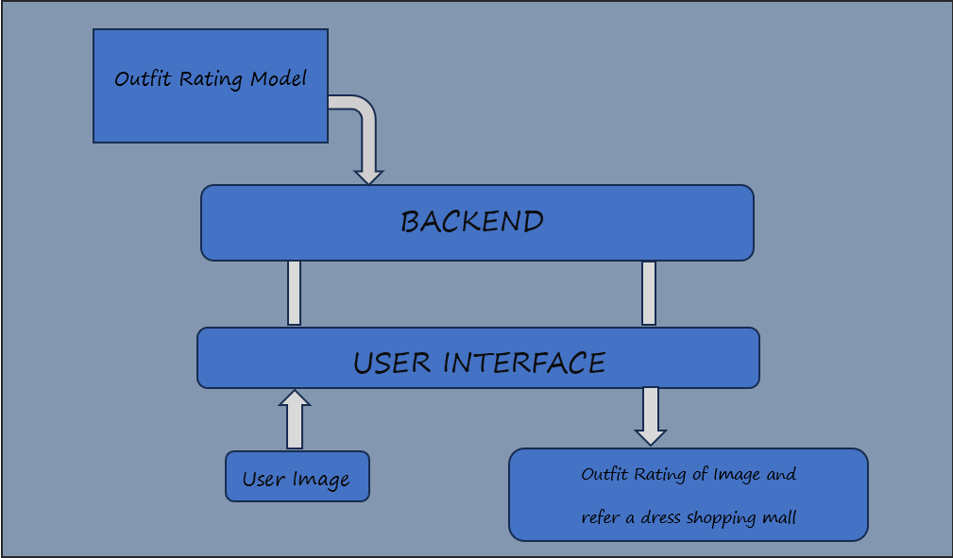

9

**Conclusion:**

The Outfit Rating App leverages advanced machine learning, deep learning, and computer vision technologies to provide users with objective and insightful ratings for their outfits. By offering a user-friendly platform that delivers valuable fashion feedback, the app helps users make informed style decisions. Key features include photo-based outfit rating, historical rating tracking, and social sharing. The app employs monetization strategies like in-app purchases, subscriptions, and partnerships with retailers. With its innovative approach and user-centric design, the Outfit Rating App addresses a clear market need, empowering users and fostering a vibrant fashion community. As it grows, it will solidify its market position, offering unique value and becoming an essential tool for fashion enthusiasts.

10