Object Oriented Programming

Name: M.Kalyan Kumar
ID: B191644
RollNo: 31
Class: CSE-E3-C1
WEEK 1

1. Java Program that Prins the roots of the given quadratic equation.

import java.util.*;
import java.lang.*;
class quadratic
{
public static void main(String[] args)
{
Scanner sc=new Scanner(System.in);
double a,b,c;
System.out.print("Enter Co-Efficient of x**2: ");
a=sc.nextDouble();
System.out.print("Enter Co-Efficient of x: ");
b=sc.nextDouble();
System.out.print("Enter Constant term: ");
c=sc.nextDouble();
double dscrt=b*b-4*a*c;
if(dscrt>0)
{
double ans1= ((-b)+Math.sqrt(dscrt))/(2*a);
double ans2= ((-b)-Math.sqrt(dscrt))/(2*a);
System.out.println("root1: "+ans1+"\n"+"root2: "+ans2);
}
else if(dscrt==0)
{
double ans= ((-b)+Math.sqrt(dscrt))/(2*a);
System.out.println("root1: "+ans+"\n"+"root2: "+ans);
}
else
{
double rt1=(-b/2*a);
double rt2=Math.sqrt(-1*dscrt)/2*a;
System.out.printf("root1: %.2f+i%.2f\n",rt1,rt2);
System.out.printf("root2: %.2f-i%.2f\n",rt1,rt2);
//System.out.printf("root2: "+rt1+"-i"+rt2);
}
}
}

Output:

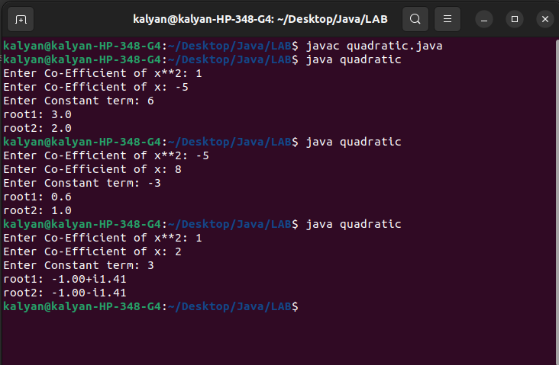

2. Java program that implements calculator opearation

import java.util.*;
class Calculator
{
public static void main(String[] args)
{
Scanner sc=new Scanner(System.in);
System.out.println("Enter 1 for Addition");
System.out.println("Enter 2 for Subtraction");
System.out.println("Enter 3 for Mutilpication");
System.out.println("Enter 4 for Division");
System.out.print("ENTER HERE: ");
int sct=sc.nextInt();
while(sct!=-1)
{
switch(sct)
{
case 1:
{
System.out.print("Enter num1: ");
double num1=sc.nextDouble();
System.out.print("Enter num2: ");
double num2=sc.nextDouble();
System.out.println(num1+num2);
break;
}
case 2:
{
System.out.print("Enter num1: ");
double num1=sc.nextDouble();
System.out.print("Enter num2: ");
double num2=sc.nextDouble();
System.out.println(num1-num2);
break;
}
case 3:
{
System.out.print("Enter num1: ");
double num1=sc.nextDouble();
System.out.print("Enter num2: ");
double num2=sc.nextDouble();
System.out.println(num1*num2);
break;
}
case 4:
{
System.out.print("Enter num1: ");
double num1=sc.nextDouble();
System.out.print("Enter num2: ");
double num2=sc.nextDouble();
System.out.println(num1/num2);
break;
}
default:
{
System.out.print("Enter valid Input");
break;
}
}
System.out.print("If want to continue Enter Opeatarion Digit or to STOP Enter -1: ");
sct=sc.nextInt();
}
}
}
Output:

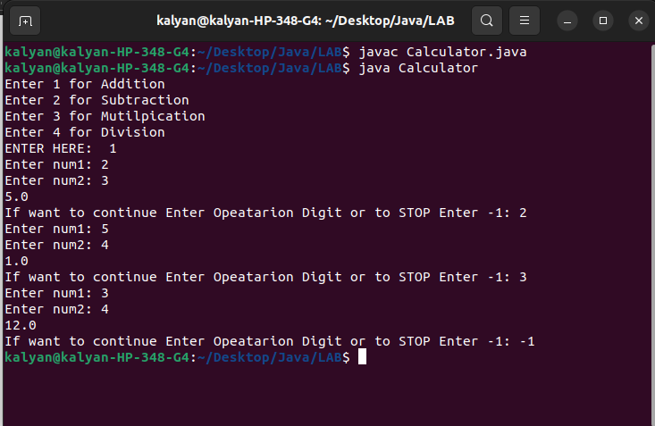

3. Java Programme to print the prime factors of a given number

import java.util.*;
class Prime_factor
{
public static void main(String[] args)
{
Scanner sc=new Scanner(System.in);
System.out.print("Enter number to know its prime factors: ");
int num=sc.nextInt();
for(int i=1;i<=num;i++)
{
if(num%i==0)
{
int ct=0;
for(int j=1;j<=i;j++)
{
if(i%j==0)
ct+=1;
}
if(ct==2)
System.out.println(i);
}
}
}
}

Output:

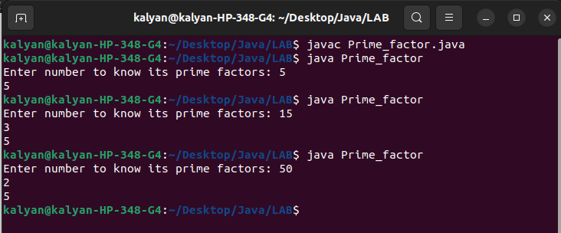

4. Java Program to find whether a given number is Palindrome or not

import java.util.*;
class Palindrome
{
public static void main(String[] args)
{
Scanner sc=new Scanner(System.in);
int num;
System.out.print("Enter number to know whether it is palindrome or not: ");
num=sc.nextInt();
int temp=num;
int rem,sum=0;
while(num!=0)
{
rem=num%10;
sum=sum*10+rem;
num/=10;
}
if(sum==temp)
{
System.out.print(sum+" is Palindrome");
}
else
System.out.print(temp+" is not Palindrome");
}
}

Output:

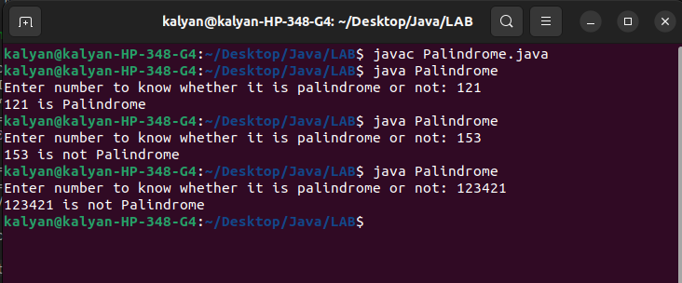

5. Java Program that prints the Largest and Smallest numbers in given 5 numbers

import java.util.*;
class Big
{
public static void main(String[] args)
{
Scanner sc=new Scanner(System.in);
int arr[]=new int[5];
int min=Integer.MAX_VALUE;
int max=Integer.MIN_VALUE;
System.out.print("Enter any 5 numbers: ");
for(int i=0;i<5;i++)
arr[i]=sc.nextInt();
for(int i:arr)
{
if(min>i)
min=i;
if(max<i)
max=i;
}
System.out.print("Minimum: "+min+"\nMaximum: "+max);
}
}

Output:

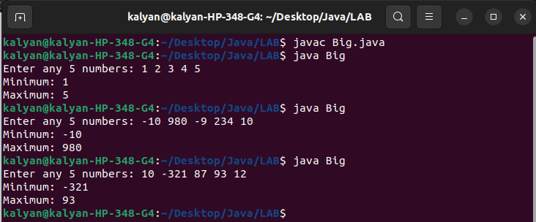

WEEK 2

1. Find the Area and Perimeter of the Circle this programme must include ClassName,Datafields
Contructors,Methods

import java.util.*;
import java.lang.*;
public class Circle
{
private double radius;
public Circle(double elem)
{
radius=elem;
}
public double getArea()
{
return Math.PI*radius*radius;
}
public double getPerimeter()
{
return 2*Math.PI*radius;
}
public static void main(String[] args)
{
Circle obj=new Circle(4);
System.out.println("Area: "+obj.getArea());
System.out.println("Perimeter: "+obj.getPerimeter());
Circle obj1=new Circle(5);
System.out.println("Area: "+obj1.getArea());
System.out.println("Perimeter: "+obj1.getPerimeter());
Circle obj2=new Circle(6);
System.out.println("Area: "+obj2.getArea());
System.out.println("Perimeter: "+obj2.getPerimeter());
}
}

Output:

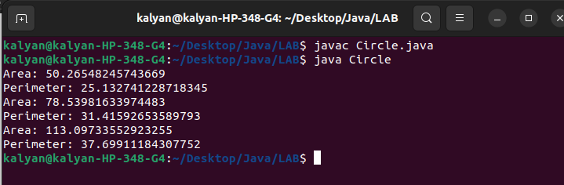

2. Switch on/off of the led light and switch on/off the halogen light

class Lamp
{
public boolean isOn;
public String lampType;
public Lamp(boolean state,String str1)
{
this.isOn=state;
this.lampType=str1;
}
public boolean turnOn()
{
System.out.println("Previous: "+isOn);
this.isOn=true;
return isOn;
}
public boolean turnOff()
{
System.out.println("Previous: "+isOn);
this.isOn=false;
return isOn;
}
public static void main(String[] args)
{
Lamp obj1=new Lamp(false,"LED");
Lamp obj2=new Lamp(true,"Halogen");
Lamp obj3=new Lamp(true,"Philips");

System.out.println(obj1.lampType+":"+obj1.turnOn());
System.out.println(obj2.lampType+":"+obj2.turnOff());
System.out.println(obj3.lampType+":"+obj3.turnOff());

System.out.println(obj1.lampType+":"+obj1.turnOff());
System.out.println(obj2.lampType+":"+obj2.turnOn());
System.out.println(obj3.lampType+":"+obj3.turnOn());

System.out.println(obj1.lampType+":"+obj3.turnOff());
System.out.println(obj2.lampType+":"+obj2.turnOn());
System.out.println(obj3.lampType+":"+obj3.turnOff());
}
}
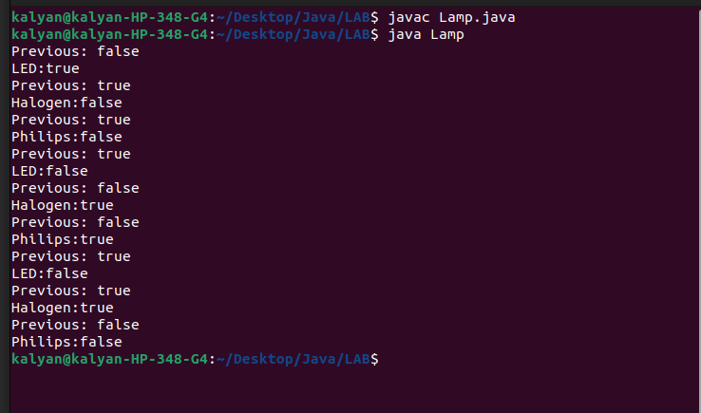

3.Television Simuation

import java.util.*;
class TV
{
public int channel;
public int volume;
public boolean on;
public TV(int ch,int vol,boolean state)
{
channel=ch;
vol=volume;
on=state;
}
public boolean state()
{
return this.on;
}
public void setChannel(int ch)
{
this.channel=ch;
}
public void setVolume(int ch)
{
this.volume=ch;
}
public void channelUp()
{
this.channel+=1;
}
public void channelDown()
{
this.channel-=1;
}
public void volumeUp()
{
this.volume+=1;
}
public void volumeDown()
{
this.channel-=1;
}
public void turnOn()
{
on=true;
}
public void turnOff()
{
on=false;
}
public int Present_Channel()
{
return this.channel;
}
public int Present_Volume()
{
return this.volume;
}
public static void main(String[] args)
{
Scanner sc=new Scanner(System.in);
int swth;
TV obj1=new TV(0,0,false);
System.out.print("Follow the following,to do Oprations\n1. Enter 1111 to turn on Tv\n2.Enter 0000 to turn off the Tv\n3. Enter 1 to set channel\n4. Enter 2 to set volume\n5. Enter 11 to channel up\n6. Enter 21 to volumeup\n7. Enter 10 to channel down \n8.Enter 20 to volume down \n9. Enter 111 to see present channel\n10. Enter 222 to see present volume\n11.Enter 1010 to know whether TV is ON or OFF\n");
System.out.print("Enter Here to Continue: ");
swth=sc.nextInt();
while(swth!=-1)
{
switch(swth)
{
case 0000:
{
obj1.turnOff();
break;
}
case 1111:
{
obj1.turnOn();
break;
}
case 1:
{
System.out.print("Enter Channel Number: ");
int ch=sc.nextInt();
obj1.setChannel(ch);
break;
}
case 2:
{
System.out.print("Enter Volume Number: ");
int vl=sc.nextInt();
obj1.setVolume(vl);
break;
}
case 11:
{
obj1.channelUp();
break;
}
case 21:
{
obj1.volumeUp();
break;
}
case 10:
{
obj1.channelDown();
break;
}
case 20:
{
obj1.volumeDown();
break;
}
case 111:
{
System.out.println(obj1.Present_Channel());
break;
}
case 222:
{
System.out.println(obj1.Present_Volume());
break;
}
case 1010:
{
System.out.println(obj1.state());
break;
}
default:
System.out.print("Enter Valid Input");
}
System.out.print("Enter -1 to exit or any Oparation Command to continue: ");
swth=sc.nextInt();
}

}
}

Output:

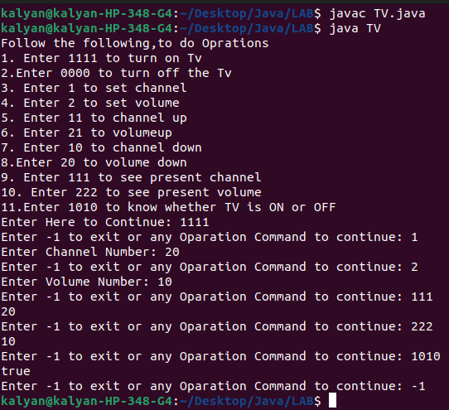

4. Suggest Car for Journey

import java.util.*;
class Car
{
public String name;
public double mileage;
public double speed;
public String color;
public double time=0;
public double fuel=0;
public Car(String nm,double mil,double spd,String col)
{
name=nm;
mileage=mil;
speed=spd;
color=col;
}
public String getName()
{
return this.name;
}
public String getColor()
{
return this.color;
}
public double getMileage()
{
return mileage;
}
public double getSpeed()
{
return speed;
}
public void setTime(double dist)
{
this.time=dist/speed;
}
public void setFuel(double dist)
{
this.fuel=dist/mileage;
}
public double getTime()
{
return this.time;
}
public double getFuel()
{
return this.fuel;
}
public double getTotalValue()
{
double tm=this.time;
double fl=this.fuel;
return tm+fl;
}
public static void main(String[] args)
{
int n;
Scanner sc=new Scanner(System.in);
System.out.println("Enter No.of Cars Details to Enter :");
n=sc.nextInt();
List<Car>l=new ArrayList<>();
//Scanner sc=new Scanner(System.in);
Scanner sct=new Scanner(System.in);
for(int i=0;i<n;i++)
{
System.out.println("Enter Name of the Car: ");
String name=sct.nextLine();
System.out.println("Enter Speed of the Car: ");
double speed=sc.nextDouble();
System.out.println("Enter Mileage of the Car: ");
double mil=sc.nextDouble();
System.out.println("Enter Color of the Car: ");
String col=sct.nextLine();
Car obj=new Car(name,mil,speed,col);
l.add(obj);
}
double tot=Double.MAX_VALUE;
Car car=null;
System.out.println("Enter Dist: ");
double dist=sc.nextInt();
for(Car obj: l)
{
obj.setTime(dist);
obj.setFuel(dist);
obj.getTotalValue();
if(tot>obj.getTotalValue())
{
tot=obj.getTotalValue();
car=obj;
}
}
if(car!=null)
{
System.out.println(car.getName());
System.out.printf("Time: %.2f\n",car.getTime());
System.out.printf("Fuel: %.2f\n",car.getFuel());
System.out.println(car.getColor());
}

}

}

Output:

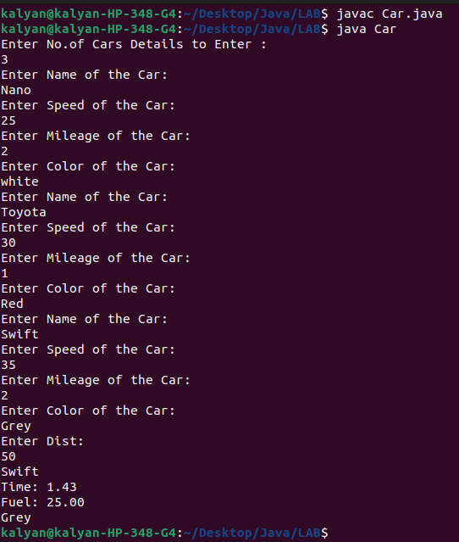

Week 3

Write a program that comapres two given strigns

import java.util.*;

public class lab31
{
public static void main(String[] args)
{
Scanner sc=new Scanner(System.in);

System.out.print("Enter 2 strings : ");
String str1=sc.next();
String str2=sc.next();

if(str1.compareTo(str2)==0)
System.out.println("Equal");
else
System.out.println("Not Equal");
}
}
Output:
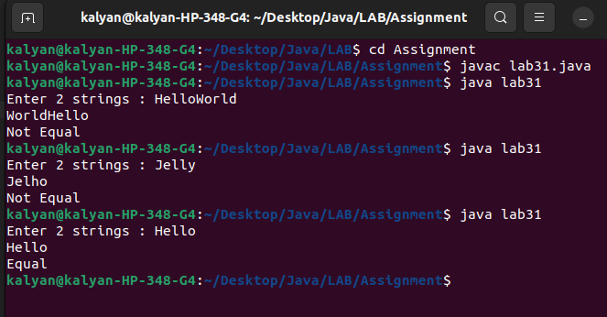

2. write a program that checks whether two given strings are equal or not using equals and equalsIgnorecase
import java.util.*;

public class lab32
{
public static void main(String[] args)
{
Scanner sc=new Scanner(System.in);

System.out.print("Enter 2 strings : ");
String str1=sc.next();
String str2=sc.next();

if(str1.equals(str2)==true)
System.out.println("Equal");
else if(str1.equalsIgnoreCase(str2)==true)
System.out.println("Equal");
else
System.out.println("Not Equal");
}
}

Output:
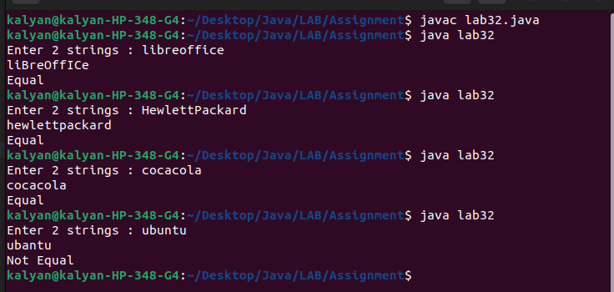

3.write a program Count the occurence of a given alphabet in a given string

import java.util.*;

public class lab33
{
public static void main(String[] args)
{
Scanner sc=new Scanner(System.in);

System.out.print("Enter any text: ");
String text=sc.next();

System.out.print("Enter alpha to find freq: ");
char ch=sc.next().charAt(0);

int index = text.indexOf(ch);
int count=0;
while(index !=-1)
{
count++;
index = text.indexOf(ch, index+1);
}
System.out.println("Freq: "+count);
}
}

Output:
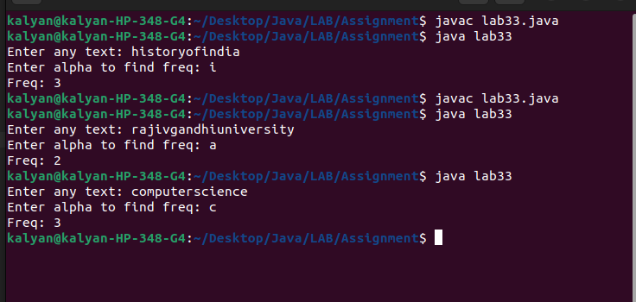

4. Write program that concats two strings

import java.util.*;

public class lab34
{
public static void main(String[] args)
{
Scanner sc=new Scanner(System.in);

System.out.print("Enter 2 strings : ");
String str1=sc.next();
String str2=sc.next();

System.out.println(str1.concat(str2));
}
}

Output:
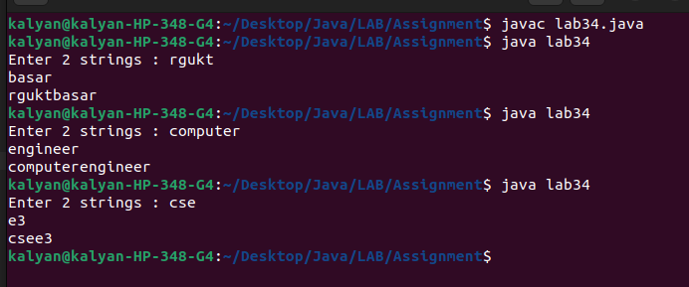

5. Write a program that prints the vowels and count of vowels and consonants in the given text

import java.util.*;

public class lab35
{
public static void main(String[] args)
{
Scanner sc=new Scanner(System.in);

System.out.print("Enter string : ");
String s=sc.next();

int n=s.length(),vowelCount=0;

for(int i=0;i<s.length();i++)
{
if(s.charAt(i)=='a'||s.charAt(i)=='A'|| s.charAt(i)=='e'||s.charAt(i)=='E'||s.charAt(i)=='i'||s.charAt(i)=='I'||s.charAt(i)=='o'||s.charAt(i)=='O'||s.charAt(i)=='u'||s.charAt(i)=='U')
{
System.out.print(s.charAt(i)+" ");
vowelCount++;
}
}

System.out.println("\nNo of vowels : "+vowelCount);
System.out.println("No of consonants: "+(n-vowelCount));
}
}

Output:

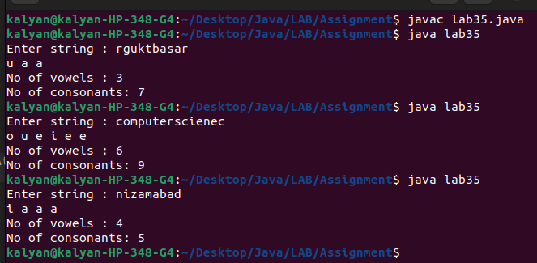

6. write a program that finds the length of the salary

import java.util.*;

public class lab36
{
public static void main(String[] args)
{
Scanner sc=new Scanner(System.in);

System.out.print("Enter string : ");
String s=sc.nextLine();
System.out.println(s.length());
}
}

Output:

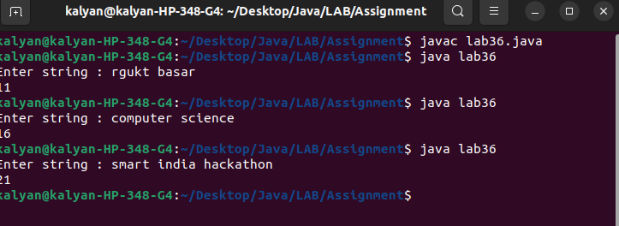

7. write a program that uses charAt to reverse the given string

import java.util.*;

public class lab37
{
public static void main(String[] args)
{
Scanner sc=new Scanner(System.in);

System.out.print("Enter string : ");
String s=sc.nextLine();
String new_str="";
int n=s.length();

for(int i=0;i<n;i++)
{
char ch=s.charAt(i);
new_str=ch+new_str;
}
System.out.println("Reversed string : "+ new_str);
}
}

Output:
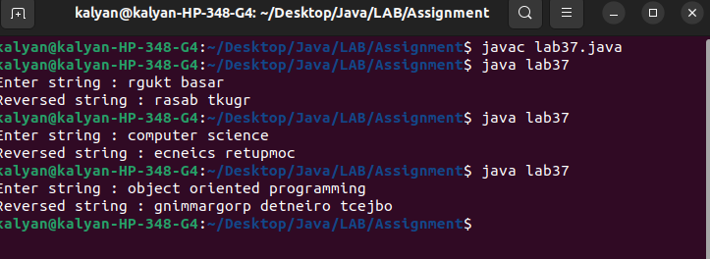

8. write a program that changes whole string to uppercase and lowercase

import java.util.*;

public class lab39
{
public static void main(String[] args)
{
Scanner sc=new Scanner(System.in);

System.out.print("Enter string in lowercase: ");
String s=sc.nextLine();

System.out.println("UpperCase: "+ s.toUpperCase());
System.out.println("Back To LowerCase: "+ s.toLowerCase());
}
}

Output:

