Statistics Additional Assignment

**Q1**, The marks awarded for an assignment set for a Year 8 class of 20 students were as follows:

6 7 5 7 7 8 7 6 9 7 4 10 6 8 8 9 5 6 4 8

Mean = (6 +7 + 5 + 7 + 7 + 8 + 7 + 6 + 9 + 7+ 4+ 10 + 6 + 8 + 8 +9 + 5 +6 + 4 + 8)/n

**Mean = 6.85**

**Median:** (4,4,5,5,6,6,6,6,7 **7, 7**, 7,7,8,8,8,8,9,9,10) = (7+7)/2 = **7**

(Arrange all number in descending and select middle two number & divide /2)

**Mode: 7** – most occurred number

**Standard Deviation = 580.036**

1)Find Mean

2) subtract mean value from each number

3 Apply below formula

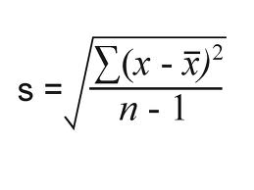

**Q2,** the number of calls from motorists per day for roadside service was recorded for a particular month:

28, 122, 217, 130, 120, 86, 80, 90, 140, 120, 70, 40, 145, 113, 90, 68, 174, 194, 170, 100, 75, 104, 97, 75,

123, 100, 75, 104, 97, 75, 123, 100, 89, 120, 109

**Mean = 107.51**

**Median = 195**

**Mode: 75**

**Standard Deviation = 0**