**FakeNews Detection**

**Group Members(CSE-H):**

**1.Kalyan** (AP20110010509)

**2.Vyshnavi** (AP20110010559)

**3.DevaRaj** (AP20110010560)

**4.Arief** (AP20110010524)

**5.Deepika** (AP20110010520)

**6.Aditya** (AP20110010533)

# ABSTRACT

Social media for news consumption is a double-edged sword. On the one hand, its low cost, easy access, and rapid dissemination of information lead people to seek out and consume news from social media. On the other hand, it enables the wide spread of “fake news”, i.e., low quality news with intentionally false information. The extensive spread of fake news has the potential for extremely negative impacts on individuals and society. Therefore, fake news detection on social media has recently become an emerging research that is attracting tremendous attention. Fake news detection on social media presents unique characteristics and challenges that make existing detection algorithms from traditional news media ineffective or not applicable. First, fake news is intentionally written to mislead readers to believe false information, which makes it difficult and nontrivial to detect based on news content; therefore, we need to include auxiliary information, such as user social engagements on social media, to help make a determination. Second, exploiting this auxiliary information is challenging in and of itself as users’ social engagements with fake news produce data that is big, incomplete, unstructured, and noisy. Because the issue of fake news detection on social media is both challenging and relevant, we conducted this survey to further facilitate research on the problem. In this survey, we present a comprehensive review of detecting fake news on social media, including fake news characterizations on psychology and social theories, existing algorithms from a data mining perspective, evaluation metrics and representative datasets. We also discuss related research areas, open problems, and future research directions for fake news detection.

INTRODUCTION

As an increasing amount of our lives is spent interacting online through social media platforms, more and more people tend to seek out and consume news from social media rather than traditional news organizations. The reasons for this change in consumption behaviors are inherent in the nature of these social media platforms: (i) it is often more timely and less expensive to consume news on social media compared with traditional news media, such as newspapers or television; and (ii) it is easier to further share, comment on, and discuss the news with friends or other readers on social media. For example, 62 percent of U.S. adults get news on social media in 2016, while in 2012, only 49 percent reported seeing news on social media1 . It was also found that social media now outperforms television as the major news source2 . Despite the advantages provided by social media, the quality of news on social media is lower than traditional news organizations. However, because it is cheap to provide news online and much faster and easier to disseminate through social media, large volumes of fake news, i.e., those news articles with intentionally false information, are produced online for a variety of purposes, such as financial and political gain. It was estimated that over 1 million tweets are related to fake news “Pizzagate”3 by the end of the presidential election. Given the prevalence of this new phenomenon, “Fake news” was even named the word of the year by the Macquarie dictionary in 2016. The extensive spread of fake news can have a serious negative impact on individuals and society. First, fake news can break the authenticity balance of the news ecosystem. For example, it is evident that the most popular fake news was even more widely spread on Facebook than the most popular authentic mainstream news during the U.S. 2016 president election4 . Second, fake news intentionally persuades consumers to accept biased or false beliefs. Fake news is usually manipulated by propagandists to convey political messages or influence. For example, some report shows that Russia has created fake accounts and social bots to spread false stories5 . Third, fake news changes the way people interpret and respond to real news. For example, some fake news was just created to trigger people’s distrust and make them confused, impeding their abilities to differentiate

What is true from what is not6 . To help mitigate the negative effects caused by fake news–both to benefit the public and the news ecosystem–It’s critical that we develop methods to automatically detect fake news on social media.

Detecting fake news on social media poses several new and challenging research problems. Though fake news itself is not a new problem–nations or groups have been using the news media to execute propaganda or influence operations for centuries–the rise of web-generated news on social media makes fake news a more powerful force that challenges traditional journalistic norms. There are several characteristics of this problem that make it uniquely challenging for automated detection. First, fake news is intentionally written to mislead readers, which makes it nontrivial to detect simply based on news content. The content of fake news is rather diverse in terms of topics, styles and media platforms, and fake news attempts to distort truth with diverse linguistic styles while simultaneously mocking true news. For example, fake news may cite true evidence within the incorrect context to support a non-factual claim [22]. Thus, existing hand-crafted and data-specific textual features are generally not sufficient for fake news detection. Other auxiliary information must also be applied to improve detection, such as knowledge base and user social engagements. Second, exploiting this auxiliary information actually leads to another critical challenge: the quality of the data itself. Fake news is usually related to newly emerging, time-critical events, which may not have been properly verified by existing knowledge bases due to the lack of corroborating evidence or claims. In addition, users’ social engagements with fake news produce data that is big, incomplete, unstructured, and noisy [79]. Effective methods to differentiate credible users, extract useful post features and exploit network interactions are an open area of research and need further investigations.

In this article, we present an overview of fake news detection and discuss

promising research directions. The key motivations of this survey are summarized as follows:

* Fake news on social media has been occurring for several years; however, there is no agreed upon definition of the term “fake news”. To better guide the future directions of fake news detection research, appropriate clarifications are necessary.
* Social media has proved to be a powerful source for fake news dissemination. There are some emerging patterns that can be utilized for fake news detection in social media. A review on existing fake news detection methods under various social media scenarios can provide a basic understanding on the state-of-the-art fake news detection methods.
* Fake news detection on social media is still in the early age of development, and there are still many challenging issues that need further investigations. It is necessary to discuss potential research directions that can improve fake news detection and mitigation capabilities. To facilitate research in fake news detection on social media, in this survey we will review two aspects of the fake news detection problem: characterization and detection. As shown in Figure 1, we will first describe the background of the fake news detection problem using theories and properties from psychology and social studies; then we present the detection approaches. Our major contributions of this survey are summarized as follows:
* We discuss the narrow and broad definitions of fake news that cover most existing definitions in the literature and further present the unique characteristics of fake news on social media and its implications compared with the traditional media;
* We give an overview of existing fake news detection methods with a principled way to group representative methods into different categories;
* We discuss several open issues and provide future directions of fake news detection in social media. The remainder of this survey is organized as follows. In Section 2, we present the definition of fake news and characterize it by comparing different theories and properties in both traditional and social media. In Section 3, we

continue to formally define the fake news detection problem and summarize the methods to detect fake news. In Section 4, we discuss the datasets and evaluation metrics used by existing methods. We briefly introduce areas related to fake news detection on social media in Section 5. Finally, we discuss the open issues and future directions in Section 6 and conclude this survey in Section 7. 2. FAKE NEWS CHARACTERIZATION In this section, we introduce the basic social and psychological theories related to fake news and discuss more advanced patterns introduced by social media. Specifically, we first discuss various definitions of fake news and differentiate related concepts that are usually misunderstood as fake news. We then describe different aspects of fake news on traditional media and the new patterns found on social media.

**LITERATURE REVIEW/RELATED WORK**

Fake news data are pervasive, and it has become an exploration challenge to con-sistently check the data, content, and distribution to label it as right or wrong. Manyresearchers have been trying to work on this problem, and they have also somehow beensuccessful. Some have researched the field of machine learning, and some have exploreddeep learning. Still, no one has ever produced research in the field of sentiment analysis orsentimentinformation.Ahmed et al. [18] applied a 4-g model with term frequency and TF-IDF to extract fakecontents. The nonlinear machine learning models did not perform well than the linearmodels for simulated and actual news. A limitation of the study was less accuracy whenapplied higher n-gram.Conroy et al. [19] overviewed two significant classes of strategies for discoveringfake/false news. The first overviewed class was related to linguistic methodologies,wherein the material of beguiling messages is removed and dissected to relate languagedesigns with doubledealing. The second overviewed type was related to network approaches, in which network data, for example, message metadata or organized informationorganization inquiries, could be compiled to produce total misdirection measures. We seethe guarantee of an imaginative half and half methodology that joins semantic sign andartificial intelligence with network-based social information.Hussein [20] has produced 41 articles on sentiment analysis (SA) through naturallanguage processing (NLP). Thestudy did not manage wrong/bogus/fake news, butinstead, it continued detecting fake websites or inaccurate reviews. Moreover, the moreexploration in a feeling challenge, the less the average precision rate is. This paper explainsthe work that could be completed in the future. The article says that the focus should be ondeveloping a larger examination circle that can explore input consistently in the future.Bondielli and Marcelloni [21], played with features that were considered to help detectwrong, fake, or even rumored approaches, providing an examination of the different methods used to complete these assignments, and featured how the assortment of applicableinformation for performing these assignments is challenging. The limitation of the studywas that one is to report and examine the different meanings of fake news and bits ofgossip/rumors that have not been written correctly. Second, the assortment of important in-formation featured in the study to represent fake news was incorrect, and the performanceof the machine learning models was lower.Bali et al. [22] study on fake news detection was addressed from the standpoint ofNLP and ML. Three representative datasets were assessed, each with its own set of featuresextracted from the headlines andcontents.According to the study’s results, gradientboosting surpassed all other classifiers. The accuracy and F1 scores of seven alternativemaching learning algorithms were investigated, but they all remained under 90%.Faustini and Covões [23] recommend using one-class classification to detect take newsby developing a solely bogus sample in the training dataset (OCC) model. The case studyfocuses on the Brazilian political scene at the beginning of the 2018 general elections anduses information from Twitter and WhatsApp. The study consumed a great deal of humanlabour for fact-checking, and the study was quite costly and time-consuming.Shaikh and Patil’s [24] study extracted features from the TF-IDF of news datasetsto detect fake news resources, and their datasets were limited. The passive-aggressiveclassifier and SVM model achieved 95% accuracy. The dataset samples were minimal.Recent research by Ahmad et al. [25] looks into different linguistic qualities that candifferentiate betweenfake and actual content. They use a variety of ensemble approaches to training a variety of machine learning algorithms. In comparison toindividual learners,experimental evaluation reveals the higher performance of the suggested ensemble learner

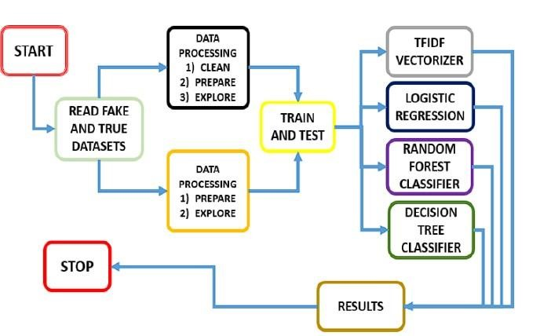

## PROBLEM DEFINITION

In this subsection, we present the details of mathematical formulation of fake news detection on social media. Specifically, we will introduce the definition of key components of fake news and then present the formal definition of fake news detection. The basic notations are defined below,

* Let a refer to a News Article. It consists of two major components: Publisher and Content. Publisher ~pa includes a set of profile features to describe the original author, such as name, domain, age, among other attributes. Content ~ca consists of a set of attributes that represent the news article and includes headline, text, image, etc.
* We also define Social News Engagements as a set of tuples E = {eit} to represent the process of how news spread over time among n users U = {u1, u2, ..., un} and their corresponding posts P = {p1, p2, ..., pn} on social media regarding news article a. Each engagement eit = {ui, pi, t} represents that a user ui spreads news article a using pi at time t. Note that we set t = Null if the article a does not have any engagement yet and thus ui represents the publisher. Definition 2 (Fake News Detection) Given the social news engagements E among n users for news article a, the task of fake news detection is to predict whether the news article a is a fake news piece or not, i.e.,

F : E → {0, 1} such that, F(a) = ( 1, if a is a piece of fake news, 0, otherwise.

(1) where F is the prediction function we want to learn. Note that we define fake news detection as a binary classification problem for the following reason: fake news is essentially a distortion bias on information manipulated by the publisher. According to previous research about media bias theory [26], distortion bias is usually modeled as a binary classification problem. Next, we propose a general data mining framework for fake news detection which includes two phases: (i) feature extraction and (ii) model construction. The feature extraction phase aims to represent news content and related auxiliary information in a formal mathematical structure, and model construction phase further builds machine learning models to better differentiate fake news and real news based on the feature representations.

**Data Preprocessing/preprocessing:**

In the preprocessing part we are removing the columns which are not required so after merging the two true and fake dataframes we are dropping the title, subject,date and after that we are filling the nullvaules with the sum and we are randomlyshuffling the dataframe,we are reseting the index and droping the index this is the part where we have applied the preprocessing techniques which are dropping the columns and filling the nullvalues with sum

**Resultant Graphs(Output):**

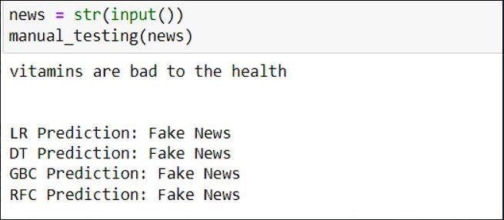

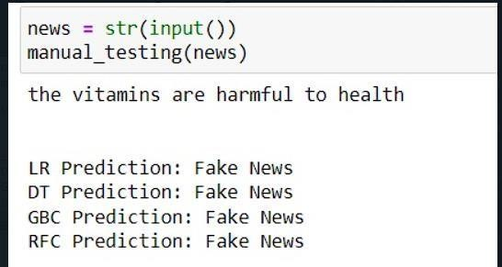

**Conclusion:**

Our social media is generating every kind of news; mostly, these are fake. Usually,we see clashing realities for a similar point and wonder whether both are valid. We setourselves in a fix trying to figure out which source to put our confidence. As we havealso discussed in the Discussion section, cleaning the dataset is very important. It isessential because it changes the results of the study. As we have seen from determiningthe frequencies of words as they occur in the dataset, we see that when the data is cleaned,the words such as Trump and said are the most frequently occurring. However, when thedataset has not been cleaned, words such as the, are, and appear the most often. Thesewords on their own have no identity and are considered meaningless until they are usedwith the other terms. Hence, the datasets should be cleaned to produce accurate results.On a concluding note,the authors want to say that sometimes spreading fake news causeshappiness, but for many, it causes sorrow. The spreading of fake news should be stoppedas soon as possible. In our research, we used some excellent machine learning algorithmsthat we’re able to show us some splendid results. The algorithms showed an accuracyof more than 99%, which is almost perfect. As a result of this research, people who arepretty addictied to the internet are now not to be afraid of fake news. In the end, thereare some limitations and insufficiencies in the presented paper. These occur if the datasetis unbalanced or has not been cleaned, as it will not give accurate results and may beineffective. The extensive data framework, Spark machine learning, could achieve betterresults in terms of processing time [40–45]. Furthermore, deep learning-enabled big datamodels could also be applied to fake news datasets from recently inspired LSTM [46–50].

**References:**

1.Alonso, M.; Vilares, D.; Gómez-Rodríguez, C.; Vilares, J. Sentiment Analysis for Fake News Detection. Electronics 2021, 10, 1348.[CrossRef]

2.Rehma, A.A.; Awan, M.J.; Butt, I. Comparison and Evaluation of Information Retrieval Models. VFAST Trans. Softw. Eng.

3. Alam, T.M.; Awan, M.J. Domain analysis of information extraction techniques. Int. J. Multidiscip. Sci. Eng. 2018, 9, 1–9.

4.Kim, H.; Park, J.; Cha, M.; Jeong, J. The Effect of Bad News and CEO Apology of Corporate on User Responses in Social Media.

PLoS ONE 2015, 10, e0126358. [CrossRef]

5.Pulido, C.M.; Ruiz-Eugenio, L.; Redondo-Sama, G.; Villarejo-Carballido, B. A New Application of Social Impact in Social Mediafor Overcoming Fake News in Health. Int. J. Environ. Res. Public Health 2020, 17, 2430. [CrossRef] 6.Hamborg, F.; Donnay, K.; Gipp, B. Automated identification of media bias in news articles: An interdisciplinary literature review.

Int. J. Digit. Libr. 2018, 20, 391–415. [CrossRef]

7. Jang, Y.; Park, C.-H.; Seo, Y.-S. Fake News Analysis Modeling Using Quote

Retweet. Electronics 2019, 8, 1377. [CrossRef]

8.Lazer, D.M.J.; Baum, M.A.; Benkler, Y.; Berinsky, A.J.; Greenhill, K.M.; Menczer, F.; Metzger, M.J.; Nyhan, B.; Pennycook, G.;

Rothschild, D.; et al. The science of fake news. Science 2018, 359, 1094– 1096. [CrossRef]

9.Kogan, S.; Moskowitz, T.J.; Niessner, M. Fake News in Financial Markets; Working Paper; Yale University: New Haven, CT, USA, 2017.

10.Lai, C.-M.; Shiu, H.-J.; Chapman, J. Quantifiable Interactivity of Malicious URLs and the Social Media Ecosystem. Electronics 9, 2020. [CrossRef].