FLY AWAY

AN AIRLINE booking portal

Developed by Naveen kumar.k

**This Code is hosted on the GitHub**

[**https://github.com/Kalyanapu/FlyAwayAirlines**](https://github.com/Kalyanapu/FlyAwayAirlines%20)

• Sprints planned and the tasks achieved in them

  Flyaway was divided in 3 sprints of 1 week each.

**Sprint 1: ‐**

1. Initialized the project, made it Hibernate project and added dependencies: ‐

MySQL Connector Hibernate libraries, JSTL, Servlet API.

1. Setting MySQL database environment and tomcat server
2. Made E.R. diagram for database and entities relationship.
3. Made classes for entities and established relationship between them.
4. Configured hibernate and mapped classes as entities.
5. Populated the data by hibernate

**Sprint 2: ‐**

1. Planned the structure of the website
2. Made a Hibernate util. class to use it across the servlets.
3. Made servlets for each class list.
4. Made an Admin Login page to login in to the Booking portal
5. Made Admin Dashboard to know the Structure of the Booking portal
6. Made the change password page to change the password when required

**Sprint 3: ‐**

1. Made login.html page to login into the portal for the flight status
2. Made password verified page to detect the changes in the password updation
3. Made registration page to register for the Account
4. Made a payment gateway page to trace the payment details and updation of the amount detected from your account
5. Made connection between JAVA application and the Database MYSQL to fetch the details from the Database

**Core concepts used in the project**

•Server request response object

•HTTP Session, Cookies URL Redirect Hidden Field.

•Collection Framework

•Date Time object with simpleDateFormat

•Hibernate, Different types of mapping (one to one, one too many, many to one, many too many).

•Sorting technique using database query as well as using Collection framework comparator methods.

•MVC Framework where View (Html pages), Controller (Servlet pages), Data Model (Entity

Classes and interface which interact to backend database using hibernate framework)

•Table Joins, Filters, Sub queries Transaction Control

•HTML and Servlet

•HTML to design view

•Web container such as Tomcat server usage deployment of web application and

Running/configuration.

•MySQL Database and SQL Query language.

Classes: ‐

* Admin Class
* Users Class
* Data base tables
* Util class

The below classes are

1. Changed password,

2. Login

3. Confirmation Page

4. Pay Online, Registration

5. Search Flights

6. SetupDB.sql

7. Admin, Airline, Flight& Payment, Person

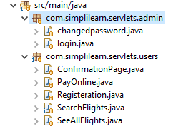

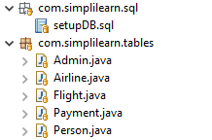



Below are the outputs for the above Classes & HTMLpages:

Admin login page:

Where the user can create their account and login into the portal to see the flight details



Admin Dashboard:

Where the user can login and see the status of the flights

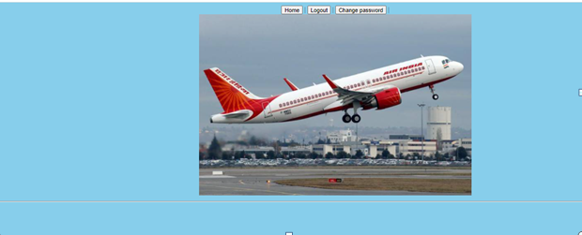

Change Password:

Where the User can change the password when required

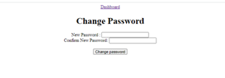

User after changing his password successfully

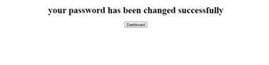

Search Flights to see the present status of the flights :

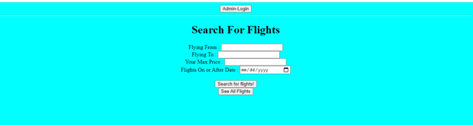

List of all flights:

Where user can see the all flights available for the booking slot

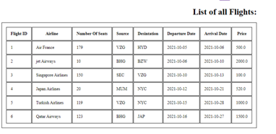

Flight Registration page:

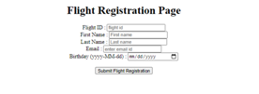

Payment Details:

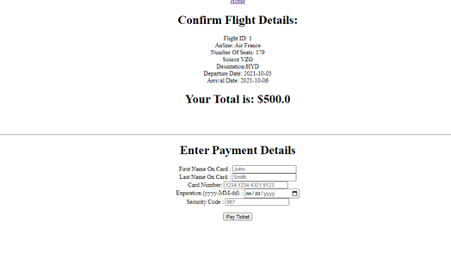

Confirmation status:

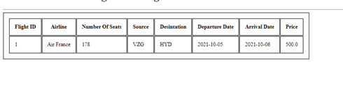

**THANK YOU**