# Scroll trigger

Animation is activated when the name given to scrollTrigger comes into the view port.

|  |  |
| --- | --- |
| **Before** | **After** |
| In this case animation is triggered into className of “c” no matter where the component. Even if not in the viewport of the user. Meaning even if we have not scrolled in position to see that component. | In this case animation is triggered only when user reach the component “c”. |

## Start

By default with no start set, animation starts whenever top of the triggered item in our case “c” comes into viewport. Jaba screen ko bottom ma triggered item le chunca then animation suru bhai sakca. But we can change it to start where we want it to start.

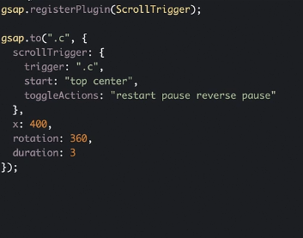

First element of start is for the container or item in this case “c” and second is for the whole screen.

In case above, animation starts when top of container “c” reaches center of the viewport. Screen ko bich ma aai puge pachi matra animation is started in above.

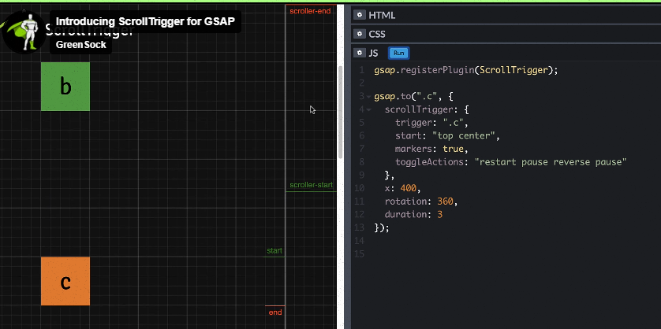

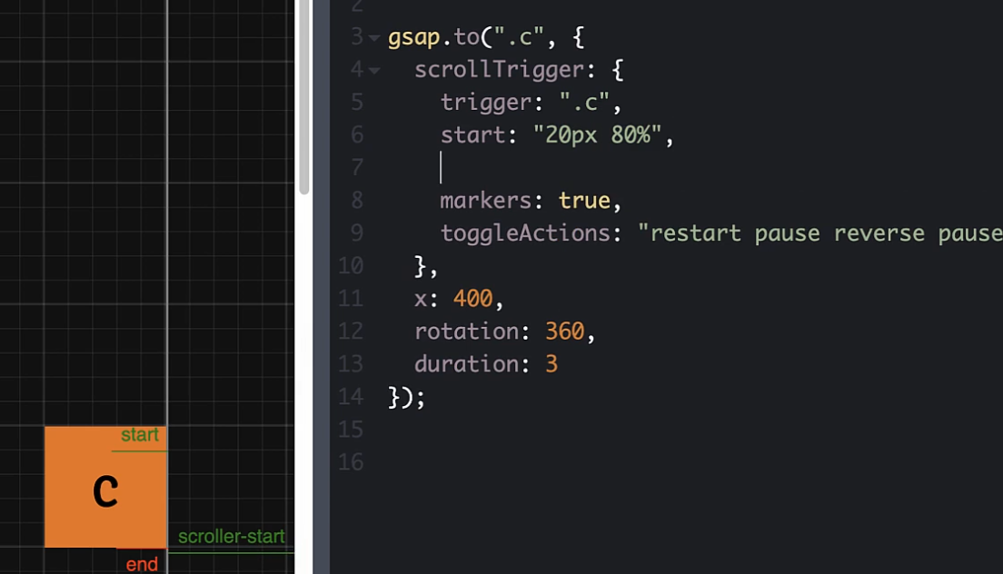

## End

By default animation of scroll ends when bottom of the triggered element in our case “c” hits top of the viewport or the screen.

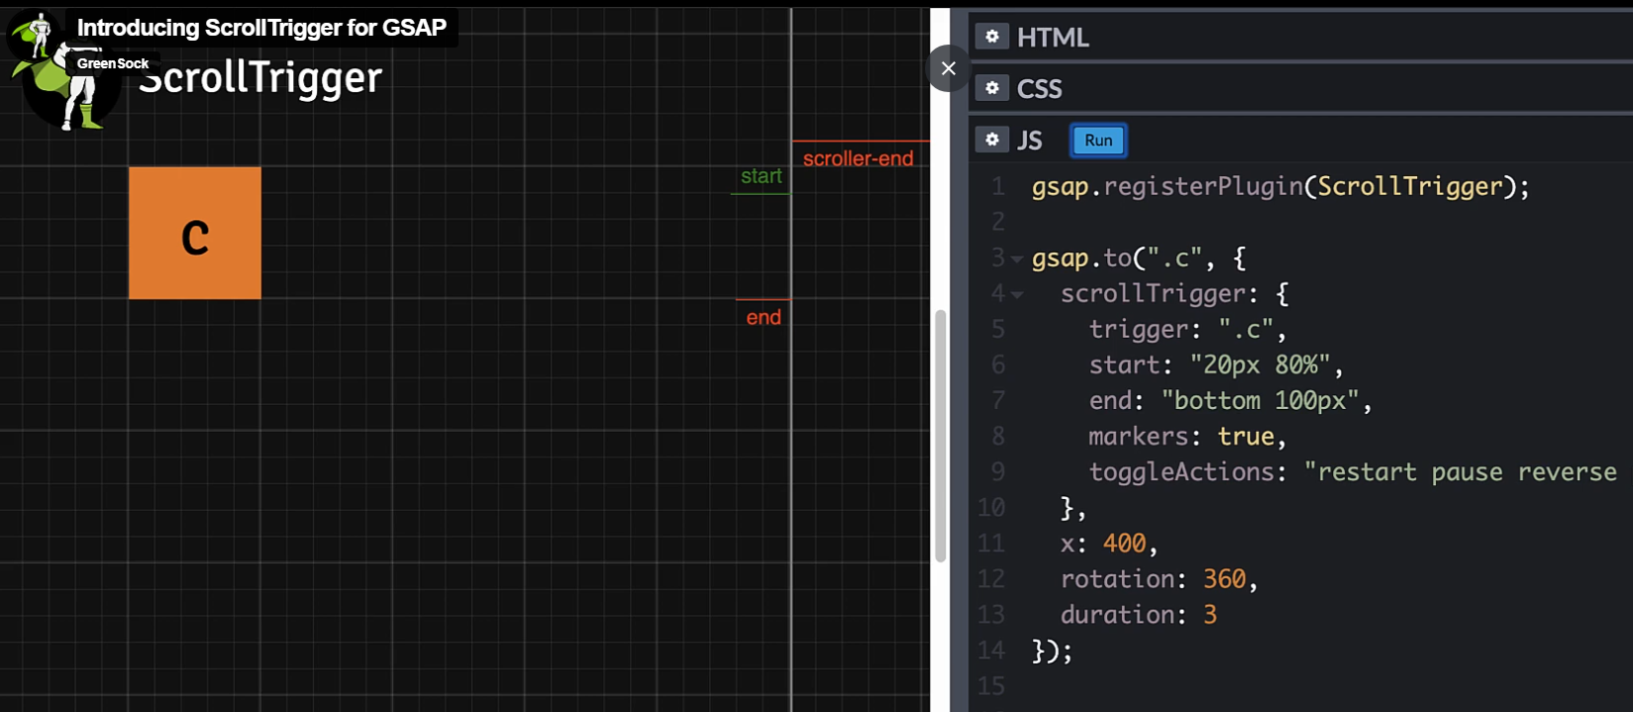

## Scrub

Set to “true” it basically goes back to previous state from animation.