

Retail Banking Transaction Analysis
MySQL Business Analytics Project

Project Introduction
A retail bank serves customers through different banking products such as accounts, cards, and loans. The bank operates through multiple branches and handles a large number of customer transactions and loan payments.
The bank's management team wants to use data to understand its customers, account activity, transaction patterns, loan performance, and banking product usage.
You will work as a Data Analyst supporting the Retail Banking team. Your task is to understand the business, understand the data model, build the database, analyse the data using MySQL, and communicate meaningful business insights.

Sprint 1: Business Understanding and Data Understanding

1.1 Company Background
Understand the retail banking business, the different banking products and services offered, and the business context behind the analysis.

1.2 Role
Assume the role of a Data Analyst supporting the Retail Banking team. Your responsibility is to use the available data to answer business questions and support banking-related decisions.

1.3 Understanding the ER Diagram
Study the ER diagram carefully before accessing the database. Understand the tables, columns, primary keys, foreign keys, and relationships between tables.
For any time-based analysis (for example, card expiry or loan maturity), treat the latest transaction_date in the data as "today" rather than the actual current date.
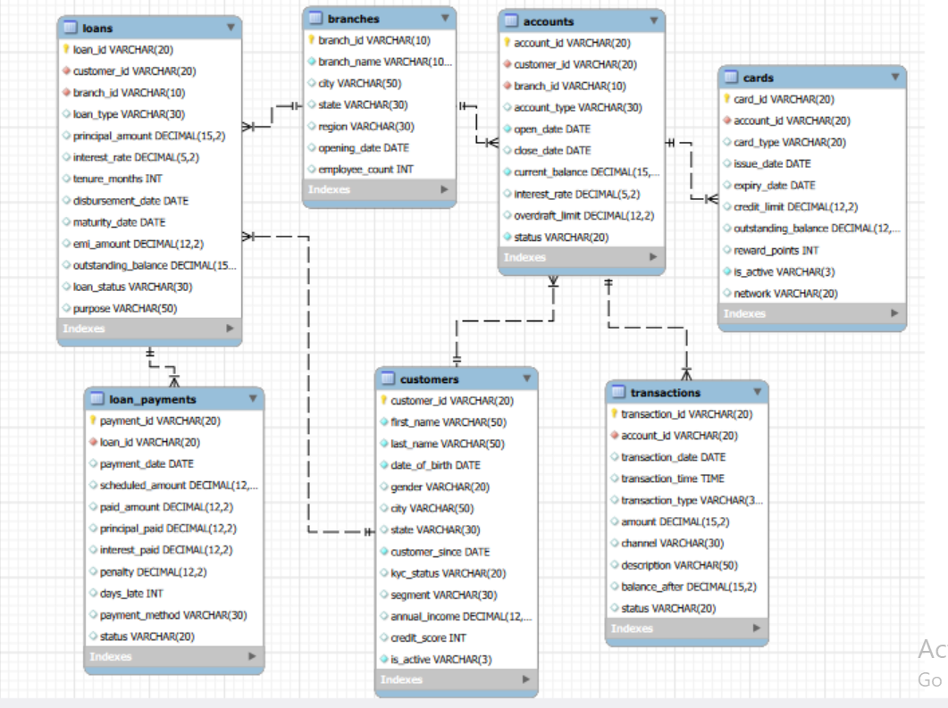
Figure 1: Retail Banking database ER diagram

1.4 Analytical Thinking from the ER Diagram
Before accessing the database or writing SQL queries, use the ER diagram to plan how you would investigate each business situation.
- Do not write SQL queries at this stage.
- For each situation, identify the tables and columns you would need.
- Explain how the required tables are related.
- Describe what information you would compare or examine and the logical flow you would follow.
- The Customer team wants to identify customers and understand which customer segment they belong to. What information would you need?
- Management wants to identify customers who have more than one bank account. Which tables and columns would you need?
- The Branch team wants to compare the accounts associated with different branches. What information would you need from the database?
- The bank wants to understand how customers are using their accounts through transactions. Which tables would you need to connect?
- Management wants to identify which types of transactions are most common and through which channels they occur. Where would you find this information?
- The Loans team wants to understand which customers have loans and what type of loans they have. Which tables and columns would you need?
- The Loans team wants to examine whether loan customers are making their payments on time. What information would you need, and which tables would you connect?
- Management wants to compare loan performance across different branches. Which tables and columns would you need?
- The bank wants to understand which customers have cards linked to their accounts. What information would you need to connect customers, accounts, and cards?
- Management wants to understand how customers are using different banking products such as accounts, cards, and loans. Which tables would you bring together?

Sprint 2: Database Setup

2.1 Design the Database from the ER Diagram
Using the provided ER diagram as your blueprint, create the database and tables in MySQL. The table-creation queries are not provided.
- Choose appropriate data types.
- Define primary keys.
- Define foreign keys.
- Apply essential constraints such as NOT NULL, UNIQUE, and DEFAULT where appropriate.
- Create tables in an appropriate order based on their dependencies.

2.2 Data Import
Import the provided CSV files into the respective MySQL tables and verify that the data has been loaded correctly. MySQL Import Wizard may be used.

Dataset Overview
Table | Rows | Columns
customers | 500 | 13
accounts | 700 | 10
branches | 40 | 7
loans | 300 | 13
loan_payments | 2,000 | 11
cards | 600 | 10
transactions | 5,000 | 10

Sprint 3: Basic Analysis / Data Exploration
Write SQL queries to answer the following basic questions. The purpose of this sprint is to become familiar with the database before moving into objective-based analysis.
- What is the total number of customers?
- What is the total number of accounts?
- What are the different account types available?
- How many customers are currently active?
- What are the different transaction types available?
- What is the total amount of completed transactions?
- What are the different loan types available?
- What is the total number of loans?
- What are the different card types available?
- What is the total outstanding loan balance?

Sprint 4: Objective-Based Analysis
For each objective, understand the business requirement, formulate your own analytical questions, determine the required data, write multiple meaningful SQL queries, interpret the results, and record your business insights.

4.1 Understand Customer Profile and Segmentation
Business Objective: The bank wants to understand its customer base and identify differences between customer groups.
Things to Consider While Analyzing:
- Compare customers across different segments.
- Look at customer demographics.
- Compare customers across cities and states.
- Examine income and credit-score differences.
- Look at customer activity and KYC status.
- Understand customer tenure with the bank.
Formulate the analytical questions required to address the objective and support your analysis with multiple meaningful SQL queries. The points above are starting points, not predefined SQL questions.

4.2 Understand Account Usage and Branch Activity
Business Objective: The bank wants to understand how its accounts are being used and how account activity differs across account types and branches.
Things to Consider While Analyzing:
- Compare different account types.
- Compare account activity across customers.
- Examine account balances.
- Compare account activity across branches.
- Look at interest rates across account types.
- Identify differences between active and closed accounts.
Formulate the analytical questions required to address the objective and support your analysis with multiple meaningful SQL queries. The points above are starting points, not predefined SQL questions.

4.3 Analyze Transaction Patterns
Business Objective: The bank wants to understand how customers use their accounts and how money moves through the banking system.
Things to Consider While Analyzing:
- Compare different transaction types.
- Compare transactions across different channels.
- Examine transaction amounts.
- Look at common transaction descriptions.
- Examine transaction activity over time.
- Compare transaction activity across accounts or customer groups.
- Look at how transaction activity affects account balances.
Formulate the analytical questions required to address the objective and support your analysis with multiple meaningful SQL queries. The points above are starting points, not predefined SQL questions.

4.4 Evaluate Loan Performance and Repayment Behaviour
Business Objective: The bank wants to understand how its loans are performing and whether customers are repaying their loans as expected.
Things to Consider While Analyzing:
- Compare different loan types.
- Compare loans based on their purpose.
- Examine loan amounts and outstanding balances.
- Compare loan statuses.
- Identify loans with repayment delays.
- Examine penalties and late payments.
- Compare repayment behaviour across loan types or branches.
- Look at payment methods used by customers.
Formulate the analytical questions required to address the objective and support your analysis with multiple meaningful SQL queries. The points above are starting points, not predefined SQL questions.

4.5 Understand Card Usage and Product Engagement
Business Objective: The bank wants to understand how customers use its card products and how card usage relates to their broader banking relationship.
Things to Consider While Analyzing:
- Compare different card types.
- Examine credit limits and outstanding balances.
- Compare active and inactive cards.
- Examine reward points.
- Compare card usage across accounts and networks.
- Identify customers using multiple banking products.
- Look at relationships between cards, accounts, and loans.
Formulate the analytical questions required to address the objective and support your analysis with multiple meaningful SQL queries. The points above are starting points, not predefined SQL questions.

SQL Deliverable
- ER diagram interpretation and Sprint 1.4 logical solutions.
- MySQL database created from the provided ER diagram.
- Imported and verified project data.
- SQL queries for Sprint 3.
- Your analytical questions for each Sprint 4 objective.
- Supporting SQL queries for each objective.
- Findings and business insights.
- Final conclusions and recommendations wherever appropriate.

Final Outcome
By completing this project, you should be able to move from a business requirement to a data-driven answer: understand the business problem, reason from a data model, plan an analytical solution, build a relational database, formulate questions, write SQL queries, interpret results, and communicate meaningful business insights.

