# **DEVOPS**

<https://www.youtube.com/watch?v=Kw91yxwpKLs&list=PLaFzfwmPR7_Ifxq-udm66fhReFeGOe2x_&index=5>

What is DEVOPS?

SDLC

* Plan
* Code
* Build
* Test
* Deploy
* Operate
* Monitor

If small organization, these are all done by same team or different team.

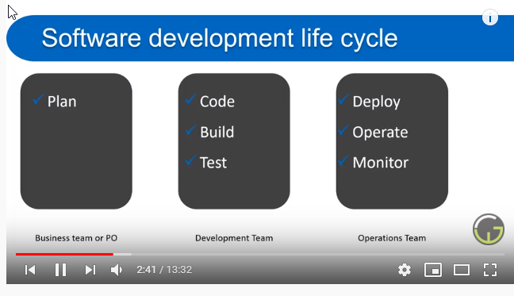

* Development + Operations = =Devops
* Agile team helps Business and DEVOPS helps on IT side
* Devops is a culture or practice which fills the gap between development team and th eoperations team
* Both team work together in entire SDLC to ensure the quality of product, ability of product to work in differnet environments
* Lot of tools are avialble in market to automate this process
* Devlops help us to run the lifecycle on each commit or particular uinterval by using automate process

Who should learn DEVOPS:

Each person who is working in softeare dev team. Devleopers, testers, PO, Scrum Masters etc..,

And who work with any software language..Java, .net, PHP etc..

Operations Team – who deploy and monitor the servers

Individual developers- It will improve the time you process your code.

Management team – to manage Devlopment work

Client – You can get clear picture of dev and monitor progress.

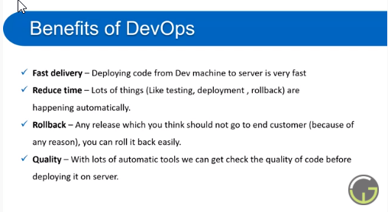

Colloboration

Agility-Every commit is treated as final deliverty

Easy to Use

No Maintenance

Reliable

Security

# **Azure Devops**

1. What is Azure Devops
   1. Azure Devops is set of modern services which is used to plan smarter, Colloborate better, ship faster
   2. Azure Devops provides all these features. You can use all of them or as per your need and role.
   3. Azure Devops is developed and managed by Microsoft
   4. Azure Devops is formely known as Visual Team Services (VSTS)
   5. Azure Devops provides a set of integrated features that you can access through your web browser.
2. Relation between Azure and Azure Devops
   1. Azure is a cloud solution which provides lots of services and features to help your organization in almost all ways during the development of any product by providing multiple tools and technologies
   2. Azure Devops is a feature or service of Azure
3. Azure Devops Services – 5 available Services
   1. Boards
      1. To plan your work.
      2. Manage and schedule works
   2. Repos
      1. To manage code- it is a TFS/ Code repository
   3. Pipeline
      1. CI/CD
   4. Test Plans
      1. Manual / Automate
   5. Artifacts
      1. Packages required for deployment.
4. Azure Devops Server
   1. Lot of company donot want to use cloud because they do not want their data to be stored on some other server. They want to store data on their own server
   2. Azure Devops provides 2 types of server configuration
      1. Cloud
      2. On-Premises
5. VSTS to Azure Devops
   1. On Sep,2018, Microsoft renamed VSTS to Azure Devops Services

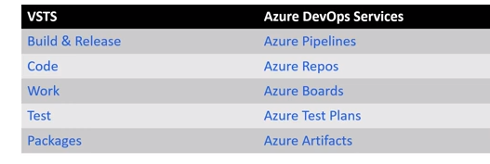

# **Pipelines in Azure**

* What is pipelines in Azure Devops
  + Pipeline is devops is set of process (automated or can be triggered manually) which is used to make available your project code to users.
  + Azure pipeline is a cloud service that you can use to automatically build and test your code project and make it available to other users
  + Azure pipelines can be used for Testing also.
  + Pipeline in azure Devops is designed as per project need
  + We can increase or decrease number of steps while designing the pipeline
    - Repo
    - Build
    - Test
    - Deploy
* What process are available in azure devops pipeline.
* What type of application and programming language can we use in pipeline
  + Any programming language or any framework
  + .NET, .NET core, Angular, C#, Jave, Ruby
* Where can I store my project code to use pipeline
  + It should be in Version Control System
    - Git, github,bitbucket, etc..,
* Where can I deploy(server, VM etc) my project code.
  + Can be deplyed to any / Multiple Targets
    - Container Registries
    - VM
    - Azure Service
    - Any cloud Target
    - Any on-Premises
* Is pipeline free to use?
  + For Public repo- it is free
  + For private repo – 30 brs free /month then charge.
* What is CI and CD in pieplines
  + CI – Continous Integration: CI is used to automate Tests and build for the projects.
  + It is used to find bugs or other build issue in ealry phase
  + CD(Continous Delivery) – CD is used to automatically deploy and test code in multiple stages(qa, dev, taging, etc..,)
* When CI & CD will be triggered
  + Manually: Anytime you can run the CI and CD pipeline to test your code
  + Automate:
    - On each commit
    - On a fixed interval
    - At a particular time

# **Create a Build Piepline**

* How to create a new build (CI) pipeline
  + Go to Repo
    - Select Setup Build
  + Go to Pipeline
    - Select New Pipeline
    - Select Azure git
    - Select . Net desktop Template. It will create a YAML file
* Build project automatically
* Get success/error notification in email
* View build logs to fix the error

# **Key concepts in pipeline**

Agent:

* When your build or deployment runs, the system begins one or more jobs. An agent is installable software that runs one job at a time
* To build your code or deploy your software using Azure Pipelines. You need at least one Agent
* In Azure Devops we can use two types of Agent
* Microsoft hosted Agent
* Self Hosted Agent:

<https://docs.microsoft.com/en-us/azure/devops/pipelines/agents/agents?view=azure-devops&tabs=browser>

* How to add Agent Pool:

<https://docs.microsoft.com/en-us/azure/devops/pipelines/agents/pools-queues?view=azure-devops&tabs=yaml%2Cbrowser>

* Artifacts
* Job
* Run
* Stage – QA, Stage,
* Trigger- A setup that tells pipeline when to run.

