**Document for Testing**

**=========================================================**

**What is Software Testing:-**

Testing is the process of evaluating something to determine whether it meets certain criteria or functions correctly. Testing can apply to many areas, such as software, hardware, products, services, and more. The goal is to identify any issues, defects, or areas of improvement before the item is released or used. And it helps to deliver a high-quality.

* It is one of the process in software development and here testers are involve and they will checking wheathere the developed software is properly developed or not.

**Key purposes of testing include:**

1. Verification
2. Validation
3. Quality Assurance
4. Performance Evaluation

**Quality needs in software industry**:

1. QA :- Quality Assurance------verification
2. QC :- Quality Control----------validation
3. QE :- Quality Engineer ---------Automation Script

**Advantages :**

Here are some of the key benefits:

1. Improved Quality
2. Risk Reduction
3. Cost Efficiency
4. Customer Satisfaction
5. Enhanced Security
6. Continuous Improvement
7. Documentation and Reporting

**Software testing was followed by 2 ways:**

1. Manual Testing
2. Automation Testing

Manual Testing:**-**

If Testing done by human interaction is know as Manual Testing.

Automation Testing**:-**

If Testing done by tools interaction is know as automation testing ex:[selenium tool]

Key words :-

1. Error :- A human made mistakes.
2. Defect:- Mismatch between Exception and Actual behavior.
3. Bug:- Defect is accepted by developer.
4. Failure:-Defect found by market user in their environment is know as failure.

**SDLC (SOFTWARE DEVELOPMENT LIFE CYCLE )**

It is process used by software industry. There are 7 ways to used the SDLC:-

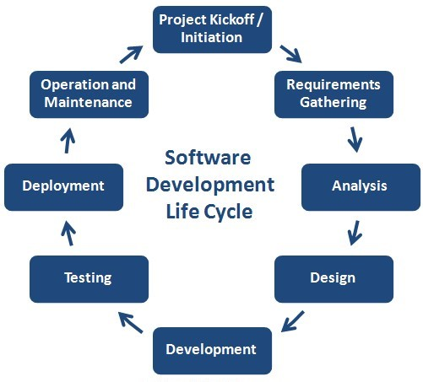

**1.Software Requirements& Gathering:-**

Here business analyst will collect the requirements from the client. After gathering the requirements will prepare the document **Business Requirements** **Specifications**(BRS). After sending requirements to forward to analysis**.**

**2.Analysis & Planning:-**

The documents are Studie and understanding the document what is the requirements will do or not. After complete the understanding they will prepare the document is **Software Requirement Specification**(SRS). And also planning the team ,schedules, strategy etc..

**3.Design:-**

There will prepare the blue print for the application.

**4.coding:**

Starting the coding to the client requirement and there complete the coding there will send testers.

**5.Testing:-**

The testers follows the verification and validation process and there verify the requirement document functional and non-functionality (functional means click button actions and linking actions etc.. and non functionality means graphical visible etc.)

**6.Deployment:-**

Release the software application to client there check the application for there requirements or not.

**7.Maintance:-**

Give the updates for the client side requirements.

**VERIFICATION & VALIDATION:**

**==============================**

VERIFICATION:-

Before the coding and while developing process checking the project related documents and developing process is know as verification. It is also know as static testing. By verification is prevent the defect. It is process oriented.

Verification done in 3 types:

* Reviews
* Inspections
* Walkthroughs

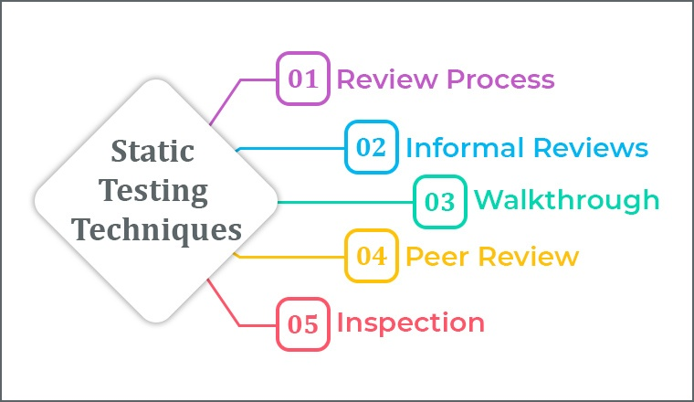

1**.Review:-**

Checking the correctness and completeness.

sub types:

1.self review

2.peer review

**2.Inspection**:

It is a formal type review done by special team in middle of the process with information.

3**.walkthrough:-**

It is informal type review done by anyone and anytime without information.

**VALIDATION:-**

After the coding the developed software was developed properly or not is know as validations.

It is a dynamic testing. It is product oriented .

Validation done in 4 ways:-

* Unit Testing
* Integration Testing
* System Testing
* User acceptance Testing

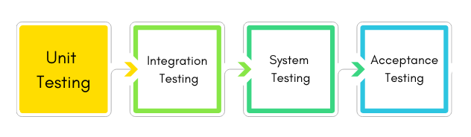

**Unit Testing:-**

* It is first level testing done by developers.
* It is a white box testing type and it is also known as module level testing.
* The developers are checking the code after development by using white box testing technique.

white box testing design techniques:

* Syntax Coverage
* Conditions Coverage
* Looping Coverage
* Path Coverage
* Mutation(mutation means valid or in vaild wil be responed)

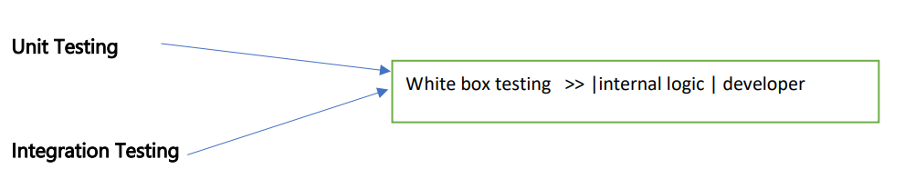

**Integration Testing:**

* It is also done by developers. It is a white box testing type.
* Here developers are integrated with one module to another module and checking the data between 2 moules.

Integration done in 2 ways :

* Incremental :- Top-Down, Bottom-top
* Non-incremental :-Big-Bang

**System Testing:-**

It is done by testing .It is a black box testing type. Here testers are validation the functional and non functional.

**Functional Testing :-**

Checking the all user requirements is know as functional testing.

**Non-Functional Testing:-**

Checking the all user expectation are known as non-functional testing

They are different types of functional testing:

* Smoke Testing
* Positive & Negative Testing
* Retesting
* Regression Testing
* Data Base Testing
* End-End Testing
* Sanity Testing
* Localization and Globalization Testing
* Adhoc Testing

1. buddy
2. pair
3. exploratory
4. monkey

**Smoke Testing:-**

Checking the basis functional of the application is a smoke testing.it is also know as a build verification testing.(URL, login, log out,)

**Positive and Negative Testing:**

Checking the application with valid inputs is know as positive .

and checking the application with invalid inputs is know as negative.

**Retesting:-**

After the defect fixed by developer checking the application again whether the defect was properly fixed or not is known as resting.

**Regression Testing:-**

when any changes happen to the application then checking that changes was showing any impact to the existing function.

(Note:-Manually regression is the time taking process mostly followed by automation testing tools.)

**Data Base Testing:-**

Checking the data base is known as data base testing.

It done in 3 ways:-

1.Data validity:- Data was inserting properly or not.

2.Data Integrity:- Updating data properly or not.

3.Data volume:-Data Capacity.

**End-End Testing:-**

Checking application for first module to last module is known as end-end testing.

**Globalization and Localization Testing:**

Checking the county codes, Languages, etc……..

ADHOC Testing:

It is a informal type testing ,when we have a lack of time, knowledge, testing documents.

We can perform in 4 types:-pair, buddy, Exploratory, Money.

**Buddy:-** we have lack of time to test, then testers are join with developers and test the application parallelly.

**Pair:-** The testers are join with another testing team and complete the testing.

**Exploratory:-** we have lack of Knowledge on the scenario, or consult experience testers.

**Monkey:-** we have lack of test documents, then testing the application randomly in own approaches.

**Non-Functional Testing:-**

To validation the Non-functionality .They are different types of testing are available**:**

1. Graphical user interface Testing
2. Usability Testing