**Document for Testing**

**=========================================================**

**What is Software Testing:-**

Testing is the process of evaluating something to determine whether it meets certain criteria or functions correctly. Testing can apply to many areas, such as software, hardware, products, services, and more. The goal is to identify any issues, defects, or areas of improvement before the item is released or used. And it helps to deliver a high-quality.

* It is one of the process in software development and here testers are involve and they will checking wheathere the developed software is properly developed or not.

**Key purposes of testing include:**

1. Verification
2. Validation
3. Quality Assurance
4. Performance Evaluation

**Quality needs in software industry**:

1. QA :- Quality Assurance------verification
2. QC :- Quality Control----------validation
3. QE :- Quality Engineer ---------Automation Script

**Advantages :**

Here are some of the key benefits:

1. Improved Quality
2. Risk Reduction
3. Cost Efficiency
4. Customer Satisfaction
5. Enhanced Security
6. Continuous Improvement
7. Documentation and Reporting

**Software testing was followed by 2 ways:**

1. Manual Testing
2. Automation Testing

Manual Testing:**-**

If Testing done by human interaction is know as Manual Testing.

Automation Testing**:-**

If Testing done by tools interaction is know as automation testing ex:[selenium tool]

Key words :-

1. Error :- A human made mistakes.
2. Defect:- Mismatch between Exception and Actual behavior.
3. Bug:- Defect is accepted by developer.
4. Failure:-Defect found by market user in their environment is know as failure.

**SDLC (SOFTWARE DEVELOPMENT LIFE CYCLE )**

It is process used by software industry. There are 7 ways to used the SDLC:-

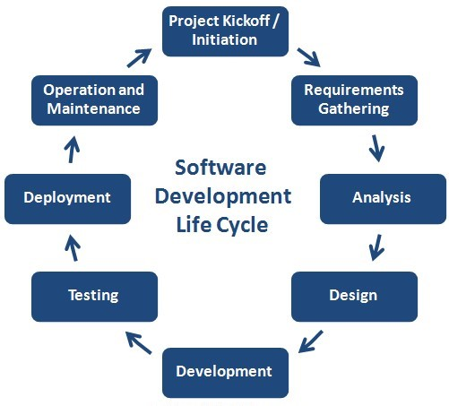

**1.Software Requirements& Gathering:-**

Here business analyst will collect the requirements from the client. After gathering the requirements will prepare the document business requirements specifications. After sending requirements to forward to analysis**.**

**2.Analysis & Planning:-**

The documents are Studie and understanding the document what is the requirements will do or not. After complete the understanding they will prepare the document is software requirement specification. And also planning the team ,schedules, strategy etc..

**3.Design:-**

There will prepare the blue print for the application.

**4.coding:**

Starting the coding to the client requirement and there complete the coding there will send testers.

**5.Testing:-**

The testers follows the verification and validation process and there verify the requirement document functional and non-functionality (functional means spelling mistakes ,syntax errors etc.. and non functionality means click button etc.)

**6.Deployment:-**

Release the software application to client there check the application for there requirements or not.

**7.Maintance:-**

Give the updates for the client side requirements.

**VERIFICATION & VALIDATION:**

VERIFICATION:-

Before the coding and while developing process checking the project related documents and developing process is know as verification. It is also know as static testing. By verification is prevent the defect. It is process oriented.

Verification done in 3 types:

* Reviews
* Inspections
* Walkthroughs

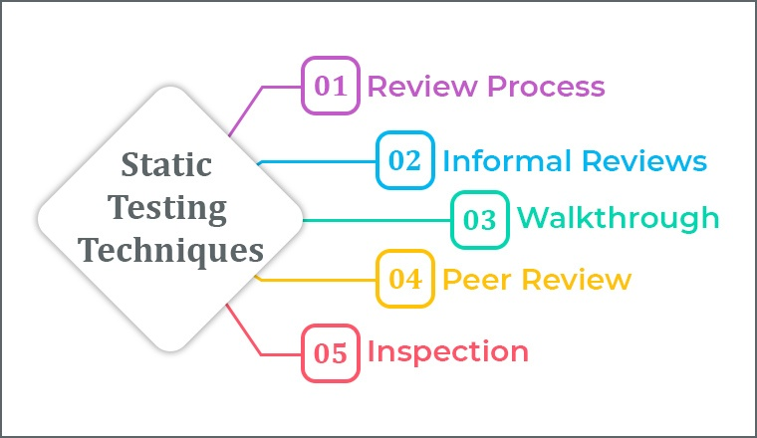

1**.Review:-**

Checking the correctness and completeness.

sub types:

1.self review

2.peer review

**2.Inspection**:

It is a formal type review done by special team in middle of the process with information.

3**.walkthrough:-**

It is informal type review done by anyone and anytime without information.

**VALIDATION:-**

After the coding the developed software was developed properly or not is know as validations.

It is a dynamic testing. It is product oriented .

Validation done in 4 ways:-

* Unit level Testing
* Integration level Testing
* System level Testing
* User acceptance level Testing

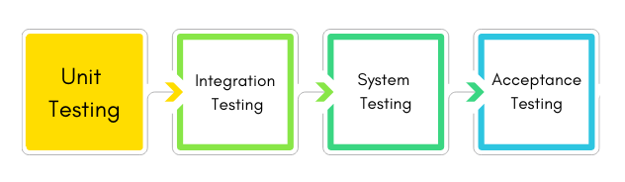

**Unit Level Testing:-**

* It is first level testing done by developers.
* It is a white box testing type and it is also known as module level testing.
* The developers are checking the code after development by using white box testing technique.

white box testing design techniques:

* Syntax Coverage
* Conditions Coverage
* Looping Coverage
* Path Coverage
* Mutation(mutation means valid or in vaild wil be responed)

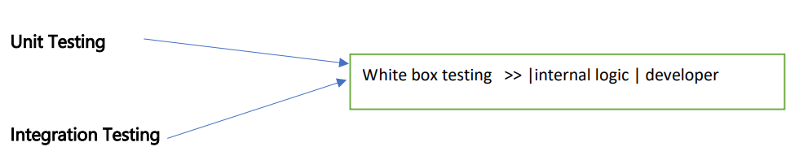

**Integration Level Testing:**

* It is also done by developers.It is a white box testing type.
* Here developers are integrated with one module to another module and checking the data between 2 moules.

Integration done in 2 ways :

* Incremental :- Top-Down,Bottom-top
* Non-incremental :-Big-Bang