Step 1- Install Dependencies-
py -m venv .venv
.\.venv\Scripts\activate
py -m pip install --upgrade pip
pip install googlemaps polyline geopy requests python-dotenv

Check the other setup doc--

Installing Roboflow-
1. pip install inference-sdk
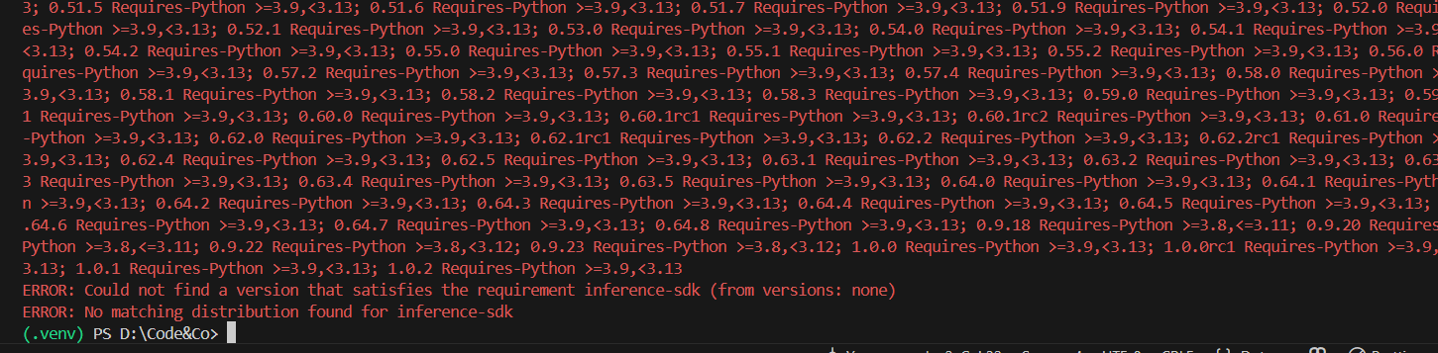
The above error occurs if Python3 is installed and its version is too new for inference-sdk.
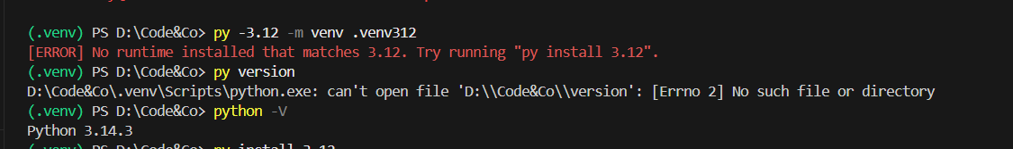
Run these-
py install 3.12
Then check the installed versions-
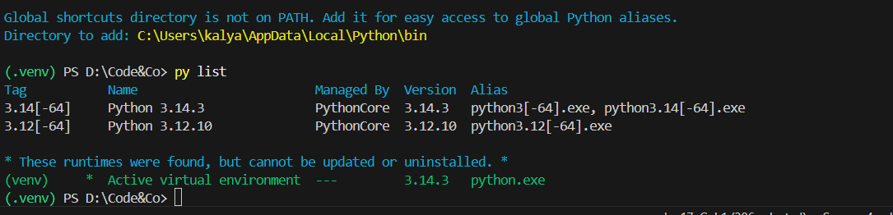
Create a new venv with 3.12-
py -3.12 -m venv .venv312
Activate the venv-
.\.venv312\Scripts\Activate.ps1
Confirm the python version. It should be 3.12
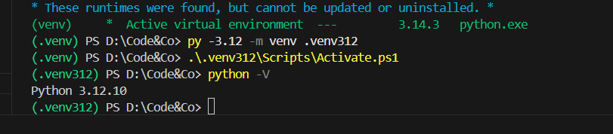
2. Install the Roboflow SDK
inference-sdk currently requires Python >=3.9 and <3.13, so it will install on 3.12 but not on 3.14.
python -m pip install --upgrade pip
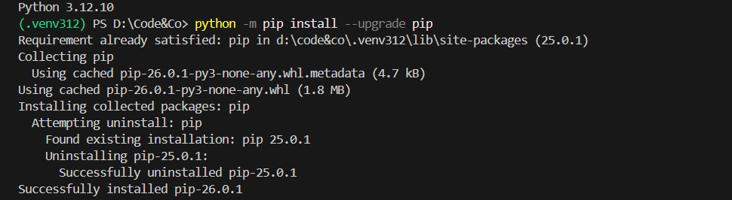
python -m pip install inference-sdk
Tis step will take some time.
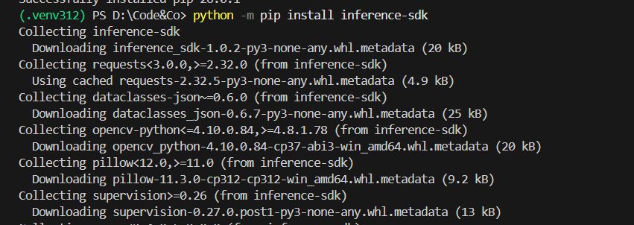
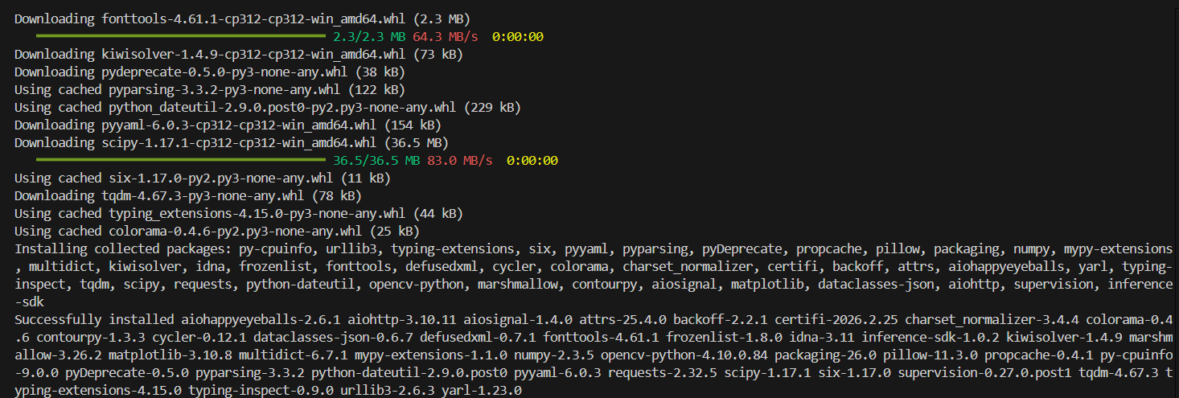
2. Setup your API Key -
$env:ROBOFLOW_API_KEY="YOUR_API_KEY"

Application Runnning Steps
- Install backend package, cors
python -m pip install flask flask-cors
- Set ROBOFLOW api key
$env:ROBOFLOW_API_KEY="YOUR_REAL_ROBOFLOW_API_KEY"
- Run backend
python app.py
- Flask (backend) runs on
http://127.0.0.1:5000
- Open the frontend.html
Results-
