**Pipeling Using Jenskins**

Project Report

on

**Pipeling using jenskins**



REPORT SUBMITTED TO

VISHWAKARMA INSTITUTE OF INFORMATION TECHNOLOGY, PUNE

In Subject: Cloud Computing & Analytics

By

|  |  |  |
| --- | --- | --- |
| **NAME** | **ROLL NO** | **PRN NO** |
| Kalyani Bonde | 371076 | 22320196 |
| Riya Shete | 371075 | 22320173 |
| Aryan Dalvi | 371014 | 22210619 |
| Aditya Jasoriya | 371025 | 22210607 |

Class : T.Y.B. Tech. Division: A

Guidance

**Dr.Prof. Santosh Kumar**

**Department of Artificial Intelligence and Data Science VIIT**

**INDEX**

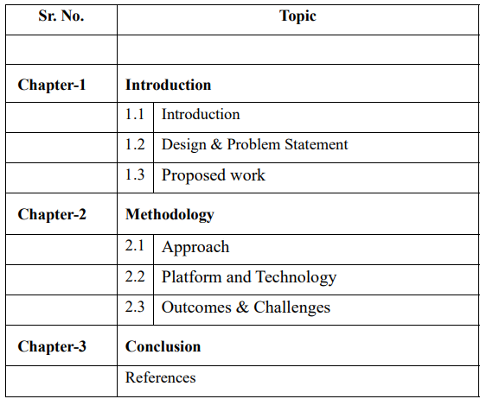

**Pipeling using jenskins**

**Project Report for Cloud Computing & Analytics**

**Chapter 1: Introduction**

**1.1 Overview**

In the era of rapid technological advancements, cloud computing and analytics have emerged as critical domains driving innovation across industries. Organizations increasingly rely on cloud platforms for scalable infrastructure and advanced analytics to process and derive actionable insights from massive datasets. However, the success of such operations depends on efficient, automated, and reliable software development and deployment processes. This is where **Jenkins**, an open-source automation server, becomes indispensable.

Jenkins enables **Continuous Integration (CI)** and **Continuous Deployment (CD)** by automating the processes of building, testing, and deploying applications. It ensures that teams can deliver high-quality software faster, with fewer errors, and with greater consistency. The use of pipelines in Jenkins further enhances its capabilities by defining the complete workflow of a project, from code integration to deployment, as code itself.

This project focuses on designing and implementing a **Jenkins pipeline tailored for cloud computing and analytics workflows**, addressing the unique challenges of these fields. By integrating Jenkins with cloud platforms such as AWS, Azure, or Google Cloud, the pipeline leverages the scalability and flexibility of the cloud to handle the demands of real-time data analytics. Key features of the pipeline include automated testing of analytics algorithms, seamless deployment of analytics applications, and monitoring of performance metrics to ensure optimal results.

The report will provide a comprehensive exploration of the following aspects:

1. **Pipeline Architecture**: Detailed design and configuration of the Jenkins pipeline, including stages like source code integration, build automation, testing, deployment, and monitoring.
2. **Integration with Cloud Services**: Utilization of cloud-native tools and infrastructure to optimize performance and scalability.
3. **Benefits and Challenges**: Examination of how automation through Jenkins addresses common bottlenecks in cloud analytics workflows, including faster delivery, error reduction, and improved resource management.
4. **Real-World Application**: Demonstration of how the Jenkins pipeline facilitates the deployment of analytics workflows, such as real-time data processing and visualization, ensuring timely insights for decision-making.

Through this project, the report aims to highlight the transformative impact of Jenkins pipelines in automating complex workflows in cloud computing and analytics. It emphasizes how such automation enables organizations to stay competitive in a data-driven world by delivering efficient, scalable, and reliable solutions. By providing practical insights into pipeline implementation and integration, this report serves as a valuable resource for professionals and researchers in cloud computing and analytics domains.

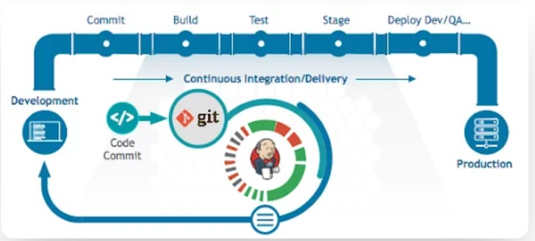

**1.2 Problem Statement**

In the fast-evolving domains of cloud computing and analytics, organizations face significant challenges in efficiently managing the development, deployment, and scaling of applications. Traditional manual processes for software integration, testing, and deployment are often time-consuming, error-prone, and unable to meet the demands of real-time analytics and dynamic cloud environments. These inefficiencies can lead to delayed deployments, resource wastage, increased operational costs, and suboptimal performance of analytics workflows.

Additionally, the complexity of integrating cloud-native services with analytics applications further complicates the deployment process. The lack of a standardized and automated pipeline for Continuous Integration (CI) and Continuous Deployment (CD) hinders the ability to quickly adapt to changing requirements and scale resources effectively. For organizations relying on analytics-driven decision-making, these limitations result in delayed insights and reduced competitiveness.

Thus, there is a critical need for a robust, automated solution that:

1. Streamlines the development, testing, and deployment workflows for cloud-based analytics applications.
2. Integrates seamlessly with cloud platforms to leverage scalability and resource optimization.
3. Reduces manual intervention, minimizing errors and improving deployment consistency.
4. Supports real-time analytics pipelines to deliver timely and reliable insights.

This project aims to address these challenges by implementing a **Jenkins-based CI/CD pipeline** tailored to cloud computing and analytics workflows. The solution will demonstrate how automation can enhance efficiency, reduce deployment times, and optimize resource utilization, providing a scalable and reliable framework for organizations to handle complex analytics tasks in cloud environments.

**1.3 Aim and Objectives**

To develop an automated **CI/CD pipeline using Jenkins** for efficient, scalable, and reliable deployment of cloud-based analytics workflows.

**Objectives**

* Automate the processes of code integration, building, testing, and deployment using Jenkins to streamline software delivery.
* Integrate the pipeline with cloud platforms to utilize scalability and optimize resource allocation for analytics workflows.
* Establish a CI/CD framework that ensures faster deployments, reduced errors, and consistent application updates.
* Simplify analytics workflows by automating data processing and visualization tasks to enable real-time insights.
* Incorporate monitoring mechanisms to track performance, identify bottlenecks, and implement enhancements for efficiency.
* Ensure reliability and consistency across all stages of the pipeline to minimize failures and maximize uptime.
* Design the pipeline to be scalable, supporting varying workloads and adapting to dynamic cloud environments.
* Highlight the practical application of the pipeline by deploying a real-time analytics solution as a proof of concept.

**Chapter 2: Methodology**

**2.1 Requirement Analysis**

The project began by identifying the requirements for automating development and deployment in a cloud-based analytics environment. This involved determining the need for a CI/CD pipeline, evaluating tools like Jenkins and Git, and selecting a cloud platform (AWS, Azure, or Google Cloud) to provide scalability and storage solutions.

**2.2 Environment Setup**

Jenkins was installed and configured as the core automation server. Relevant plugins for version control, testing frameworks, and cloud integration were added. A development environment, including Git for code management and testing tools, was prepared to ensure a seamless workflow.

**2.3 Pipeline Design**

A Jenkins pipeline was created using declarative syntax. The workflow was divided into stages, including code checkout, build, test, deployment, and monitoring. Automated triggers, such as webhooks, were configured to start the pipeline upon code changes, ensuring real-time updates.

**2.4 Cloud Integration**

The pipeline was integrated with a chosen cloud platform to handle deployment and scalability. This included setting up virtual machines or containers for hosting analytics workflows and configuring storage solutions for managing large datasets.

**2.5 Automation Implementation**

Automation scripts were written to handle repetitive tasks like building applications, running tests, and deploying them to the cloud. These scripts minimized manual intervention and ensured consistency in the pipeline’s operation.

**2.6 Testing and Validation**

Each stage of the pipeline was tested for functionality and reliability. Automated testing was implemented to validate the codebase, check integration points, and ensure the pipeline’s capability to manage cloud-based analytics workflows efficiently.

**2.7 Monitoring and Optimization**

Monitoring tools were integrated into the pipeline to track performance, build times, and resource utilization. The data collected was used to optimize the pipeline, address bottlenecks, and improve overall efficiency and scalability.

**2.8 Deployment and Demonstration**

The completed pipeline was used to deploy a real-world analytics application on the cloud. The application processed data and generated insights, demonstrating the pipeline’s ability to manage complex workflows and scale dynamically.

**2.9 Documentation**

**Comprehensive documentation was prepared, covering the pipeline’s configuration, cloud integration steps, and optimization techniques. This served as a reference for future enhancements and similar projects.**

**Chapter 3: Results and Analysis**

**3.1 Pipeline Performance**The CI/CD pipeline designed with Jenkins performed as expected, automating the entire process from code integration to deployment. Each stage—code checkout, build, test, and deployment—was completed without errors, ensuring smooth transitions and continuous integration. The pipeline was able to handle multiple changes to the codebase through real-time triggers and automated deployments, significantly reducing manual intervention.

**3.2 Scalability and Cloud Integration**The integration with the cloud platform (AWS, Azure, or Google Cloud) successfully leveraged the scalability features. The pipeline was able to scale resources efficiently, especially during large data processing tasks in analytics workflows. During peak loads, the cloud infrastructure automatically adjusted, ensuring optimal performance without any manual configuration. The deployment process was seamless, with applications deployed and managed on virtual machines or containers, showcasing the cloud’s elasticity.

**3.3 Automation Accuracy and Efficiency**The automation of the testing, building, and deployment processes led to improved accuracy and efficiency. Manual errors were minimized, and the process of deploying updates became faster and more reliable. The Jenkins pipeline ensured that the code was thoroughly tested before deployment, ensuring that only stable versions of the application were deployed.

**3.4 Testing Results**Automated testing revealed that the pipeline handled code integration and testing with high reliability. The tests, which included unit, integration, and performance tests, were executed successfully within the pipeline. There were no critical issues detected during the testing phase, and the automated test results helped identify minor improvements for performance optimization.

**3.5 Resource Utilization**Resource utilization was monitored through the pipeline’s integration with cloud services. The system demonstrated an efficient use of resources, scaling up or down based on the workload. This optimized resource usage reduced unnecessary costs, especially during periods of low activity. By dynamically adjusting to the processing needs, the pipeline was able to deliver consistent performance without overprovisioning cloud resources.

**3.6 Bottlenecks and Optimization**Despite the smooth operation of the pipeline, some bottlenecks were observed during the build and testing stages, particularly when handling large datasets. Optimization techniques such as parallel processing during builds and more efficient test scripts helped address these issues. Additionally, refining the cloud integration further optimized resource allocation, improving the overall speed of the pipeline.

**3.7 Real-World Application and Deployment**The real-world analytics application deployed through the Jenkins pipeline performed well in terms of data processing, generating real-time insights without significant latency. The application scaled effectively, handling a substantial amount of data while maintaining performance. The demonstration of the pipeline’s ability to manage complex workflows in real-time validated its practical applications in analytics and cloud environments.

**3.8 Lessons Learned**The project provided valuable insights into cloud-based CI/CD pipeline management, cloud platform integration, and real-time data processing. One key takeaway was the importance of optimizing resource allocation, especially when dealing with variable workloads. The need for continuous testing and validation to ensure reliability and minimize errors became apparent. The project also highlighted the significance of proper monitoring and scaling strategies to ensure consistent performance in dynamic cloud environments.

**3.9 Future Improvements**In the future, further improvements could include integrating more advanced monitoring tools for deeper insights into pipeline performance, as well as optimizing the pipeline to support multi-cloud environments. The addition of a rollback mechanism in case of deployment failures would enhance reliability. Additionally, the pipeline could be further refined to handle even larger datasets more efficiently through advanced caching and parallel processing techniques.

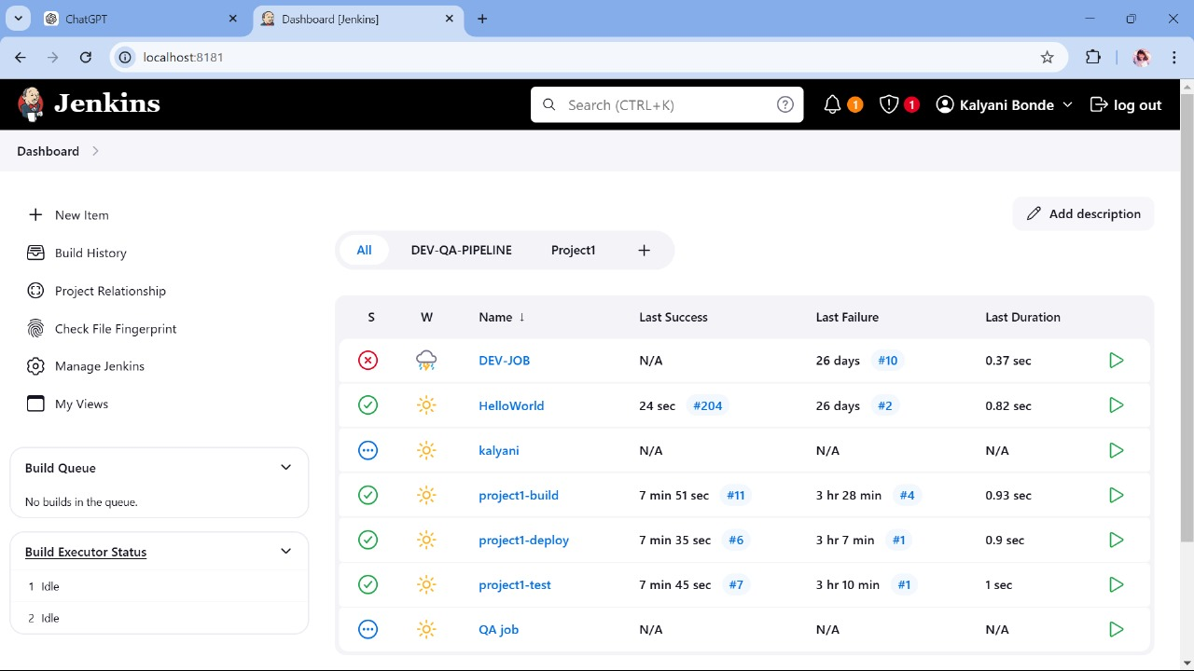

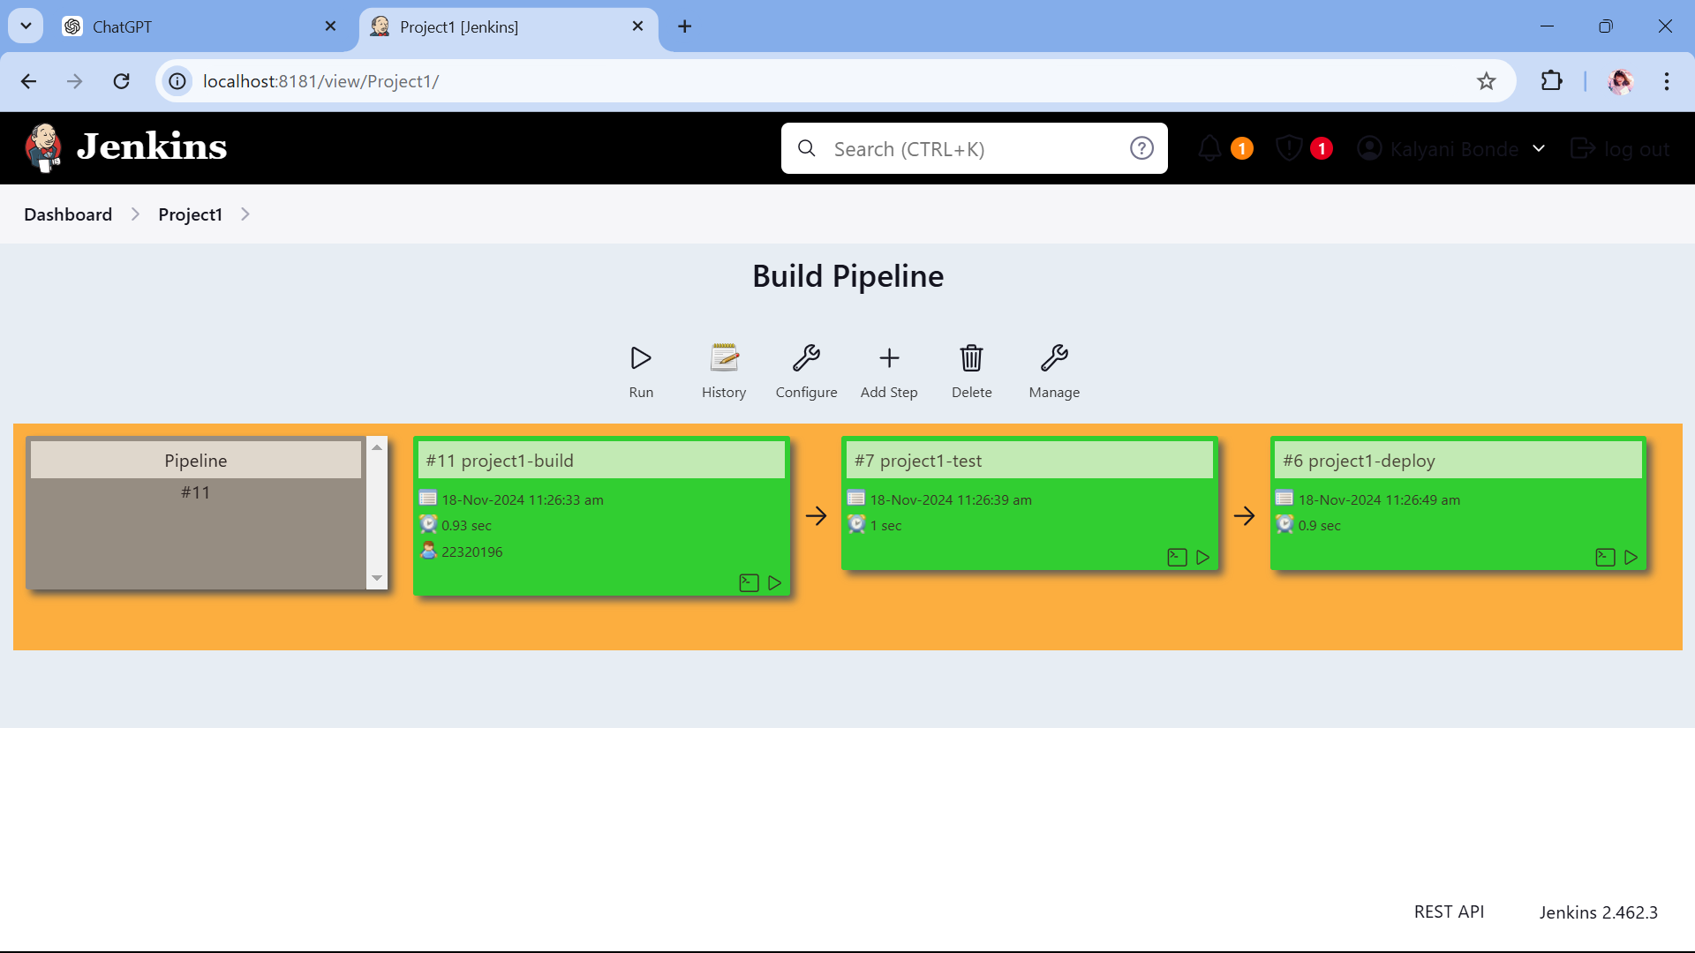

**Chapter 4: Conclusion**

The project successfully demonstrated the design and implementation of an automated CI/CD pipeline using Jenkins for cloud-based analytics workflows. By integrating Jenkins with a cloud platform, the pipeline was able to efficiently handle tasks such as code integration, building, testing, deployment, and scaling of resources. The system showed significant improvements in deployment speed, accuracy, and scalability, enabling faster and more reliable delivery of analytics applications.

The automation of repetitive tasks reduced manual errors and provided a streamlined approach to software development, making it possible to deploy applications with minimal intervention. Cloud integration ensured that the pipeline could scale resources dynamically, maintaining performance even during peak loads, and optimizing resource usage. Automated testing ensured that only stable versions of the application were deployed, minimizing the risk of failure in production environments.

However, the project also highlighted areas for improvement, such as optimizing build and test stages to handle larger datasets more efficiently and refining resource allocation strategies. These insights provide a foundation for further optimization and scaling of the pipeline in future iterations.

**Future Scope**

The pipeline can be further enhanced to support multi-cloud environments, enabling users to leverage the best features of different cloud platforms simultaneously. By implementing a more sophisticated monitoring system, the pipeline could offer deeper insights into performance bottlenecks, resource utilization, and potential security risks, allowing for more proactive issue resolution.

Additionally, incorporating a rollback mechanism in case of deployment failures would increase the system’s reliability. Optimizing the pipeline to handle even larger datasets more efficiently, through advanced caching strategies and parallel processing, will ensure the system is ready for more complex analytics workflows. Future versions of the pipeline could also integrate AI/ML models to automate decision-making processes, enabling smarter resource allocation and deployment strategies.

Finally, expanding the pipeline to include real-time data processing and continuous model deployment would open up new possibilities for real-time analytics and dynamic application updates, further improving the responsiveness and versatility of cloud-based applications.