**Identification of Currency by Image Processing Techniques and Artificial Intelligence**

**Abstract:**

Counterfeiting of paper currency is a major issue around the world. Almost every country has been severely impacted by this, which has escalated into a major issue. The major goal of this research is to identify Indian paper currency. We acquired a dataset of the currency notes for both original and fake notes of different denominations from internet. By using feature extraction method of front side of the currency to classify whether the currency is original or fake. In this paper we used the Support Vector Machine (SVM) algorithm for the classification. Perceive whether something is Original or fake. We have used the MATLAB image processing toolbox. Image processing is a method of enhancing an image's visual information for machine or hardware perception. And to classify the denomination of the note we used a CNN network and the average accuracy of the trained network is around 90% with minimal error.

**Keywords: -** Image Processing, Monetary Identification, Denomination, Currency Identification, Machine learning, SVM, Brisk Features, Convolutional Neural Network.

**Existing System:**

Several existing approaches for the identification of currency is developed in the recent times including the techniques like edge detection and image segmentation techniques.

Edge detection includes a variety of mathematical methods that aim at identifying edges, curves in a digital image at which the image brightness changes sharply or, more formally, has discontinuities. The same problem of finding discontinuities in one-dimensional signals is known as step detection and the problem of finding signal discontinuities over time is known as change detection. Edge detection is a fundamental tool in image processing, machine vision and computer vision, particularly in the areas of feature detection and feature extraction.

In digital image processing and computer vision, **image segmentation** is the process of partitioning a digital image into multiple segments (sets of pixels, also known as image objects). The goal of segmentation is to simplify and/or change the representation of an image into something that is more meaningful and easier to analyze. Image segmentation is typically used to locate objects and boundaries (lines, curves, etc.) in images. More precisely, image segmentation is the process of assigning a label to every pixel in an image such that pixels with the same label share certain characteristics.

The result of image segmentation is a set of segments that collectively cover the entire image, or a set of contours extracted from the image (see edge detection). Each of the pixels in a region are similar with respect to some characteristic or computed property, such as color, intensity, or texture. Adjacent regions are significantly different color respect to the same characteristic(s). When applied to a stack of images, typical in medical imaging, the resulting contours after image segmentation can be used to create 3D reconstructions with the help of interpolation algorithms like marching cubes.

**Disadvantages:**

* Edge detection will not work properly if the note is folded.
* Image segmentation will not work properly if the note is faded or folded.
* Computational time is higher.
* There’s a high chance for miss classification of the currency.

**Proposed System:**

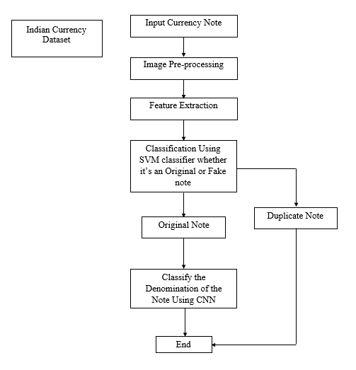

Figure 1:- Block diagram of proposed method

The BRISK algorithm is a feature point detection and description algorithm with scale invariance and rotation invariance. It constructs the feature descriptor of the local image through the gray scale relationship of random point pairs in the neighborhood of the local image, and obtains the binary feature descriptor.

The BRISK descriptor has a predefined sampling pattern as compared to BRIEF or ORB. Pixels are sampled over concentric rings. For each sampling point, a small patch is considered around it. Before starting the algorithm, the patch is smoothed using Gaussian smoothing.

Support vector machines (SVMs) are a set of supervised learning methods used for classification, regression and outliers detection. However, primarily, it is used for Classification problems in Machine Learning.

The goal of the SVM algorithm is to create the best line or decision boundary that can segregate n-dimensional space into classes so that we can easily put the new data point in the correct category in the future. This best decision boundary is called a hyperplane.

**CNN:**

When it comes to Machine Learning, artificial neural network performs really well. Artificial Neural Networks are used in various classification task like image, audio, words. Different types of Neural Networks are used for different purposes, for example for predicting the sequence of words we use Recurrent Neural Networks more precisely an LSTM, similarly for image classification we use Convolution Neural Network. In this we are going to build basic building block for CNN. A convolutional neural network can consist of one or multiple convolutional layers. The number of convolutional layers depends on the amount and complexity of the data.

Before diving into the Convolution Neural Network, let us first revisit some concepts of Neural Network. In a regular Neural Network, there are three types of layers:

**1. Input Layers:** It’s the layer in which we give input to our model. The number of neurons in this layer is equal to total number of features in our data (number of pixels in case of an image).

2.  **Hidden Layer:** The input from Input layer is then feed into the hidden layer. There can be many hidden layers depending upon our model and data size. Each hidden layer can have different numbers of neurons which are generally greater than the number of features. The output from each layer is computed by matrix multiplication of output of the previous layer with learnable weights of that layer and then by addition of learnable biases followed by activation function which makes the network nonlinear.

3**. Output Layer:** The output from the hidden layer is then fed into a logistic function like sigmoid or softmax which converts the output of each class into probability score of each class.

**Advantages:**

* BRISK features are highly robust as they can detect the feature even the image is scaled or rotated.
* Brisk increases the speed as well as the matching quality in applications where they are not needed.
* It might be affordable in a particular application.
* SVM works relatively well when there is a clear margin of separation between classes.

**Applications:**

* Monetary recognition whether it’s real or fake.
* Identifying the country of the currency.

**Software & Hardware Requirements:**

**Software:** Matlab 2020a or above

**Hardware:**

**Operating Systems:**

* Windows 10
* Windows 7 Service Pack 1
* Windows Server 2019
* Windows Server 2016

**Processors:**

Minimum: Any Intel or AMD x86-64 processor

Recommended: Any Intel or AMD x86-64 processor with four logical cores and AVX2 instruction set support

**Disk:**

Minimum: 2.9 GB of HDD space for MATLAB only, 5-8 GB for a typical installation

Recommended: An SSD is recommended A full installation of all MathWorks products may take up to 29 GB of disk space

**RAM:**

Minimum: 4 GB

Recommended: 8 GB

**Learning outcomes:**

* Introduction to Matlab
* How to start with MATLAB
* About Matlab language
* Matlab coding skills
* About tools & libraries
* Application Program Interface in Matlab
* About Matlab desktop
* How to use Matlab editor to create M-Files
* Features of Matlab
* Basics on Matlab
* What is an Image/pixel?
* About image formats
* Introduction to Image Processing
* How digital image is formed
* Importing the image via image acquisition tools
* Analyzing and manipulation of image.
* Phases of image processing:
* Acquisition
* Image enhancement
* Image restoration
* Color image processing
* Image compression
* Morphological processing
* Segmentation etc.,
* How to extend our work to another real time applications
* Project development Skills
* Problem analyzing skills
* Problem solving skills
* Creativity and imaginary skills
* Programming skills
* Deployment
* Testing skills
* Debugging skills
* Project presentation skills
* Thesis writing skills