**Laboratory work 4**

**We continue to work with the database from the previous laboratory works.**

**Take a full-page screenshot that covers the code and results of each task.**

**Tasks**:

1. Retrieve all airline names in uppercase.

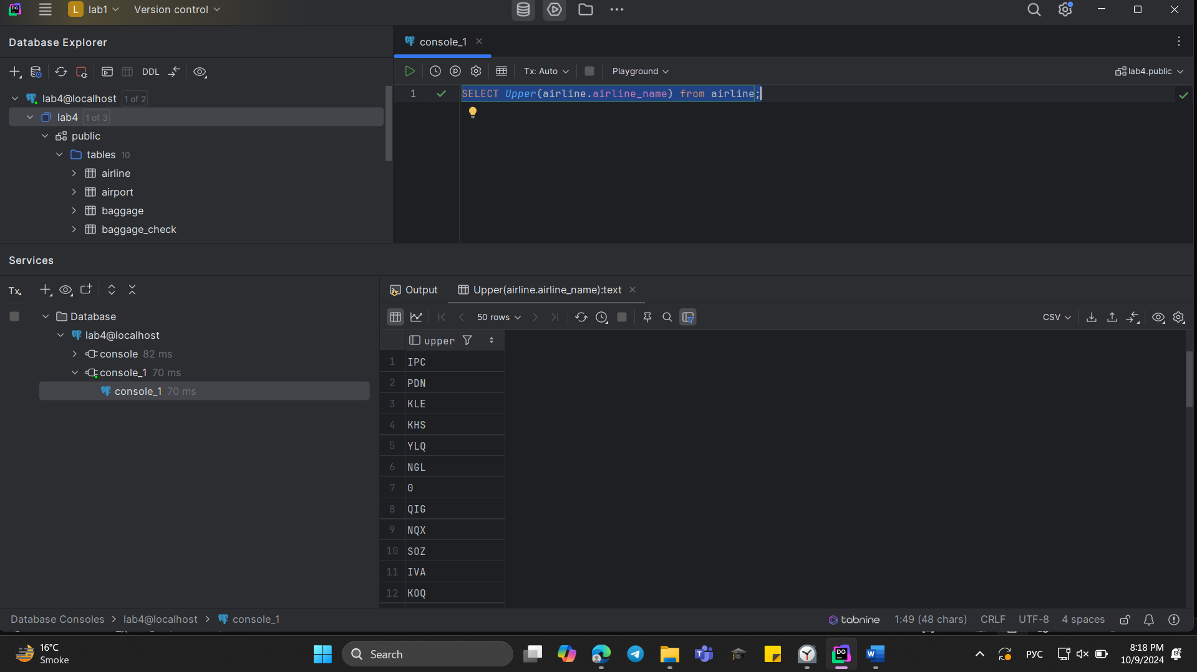

1. Replace any occurrence of the word "Air" in airline names with "Aero".

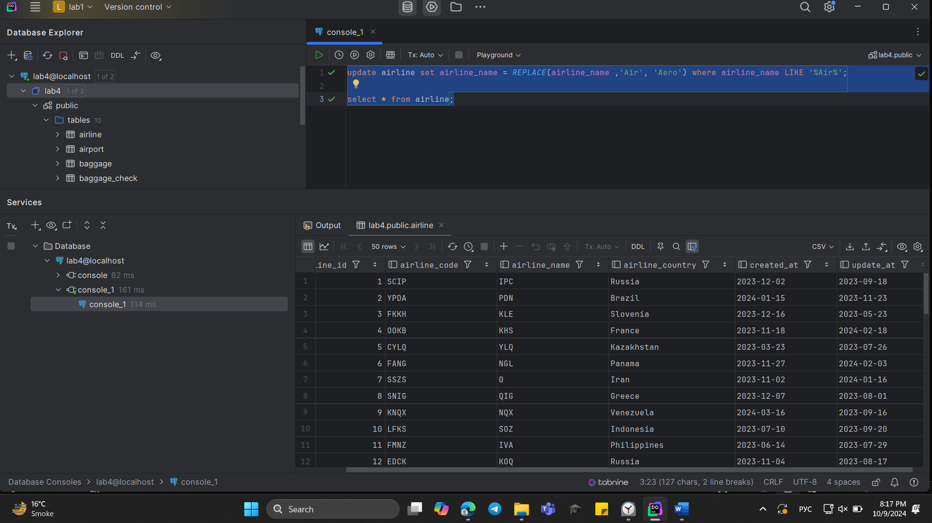

1. Fing all flight numbers that coordinates with both airline 1 and airline 2.  
   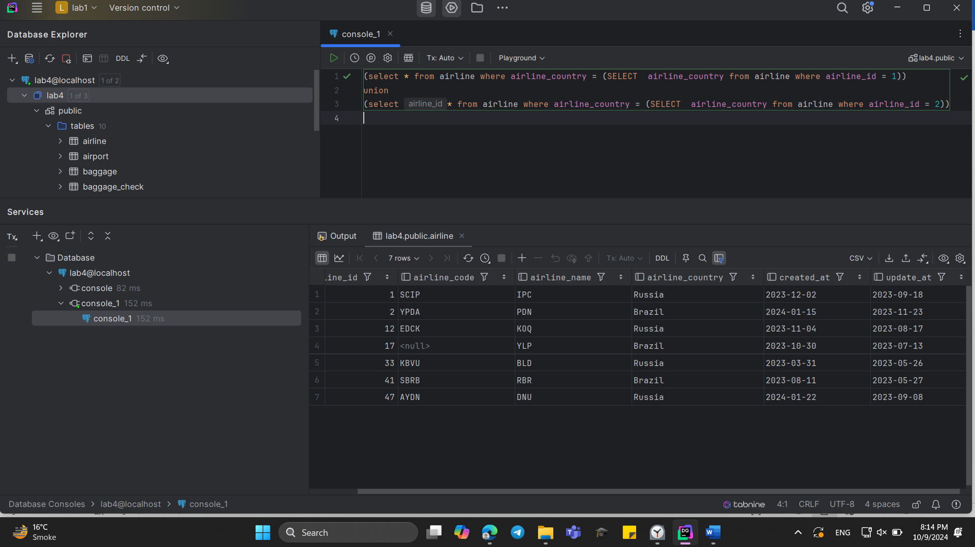
2. Retrieve airports that contain the word "Reginal" and "Air" in their names.

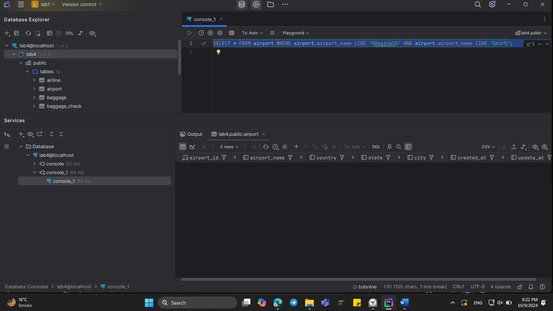

1. Retrieve passenger names and format their birth dates as 'Month DD, YYYY'.  
   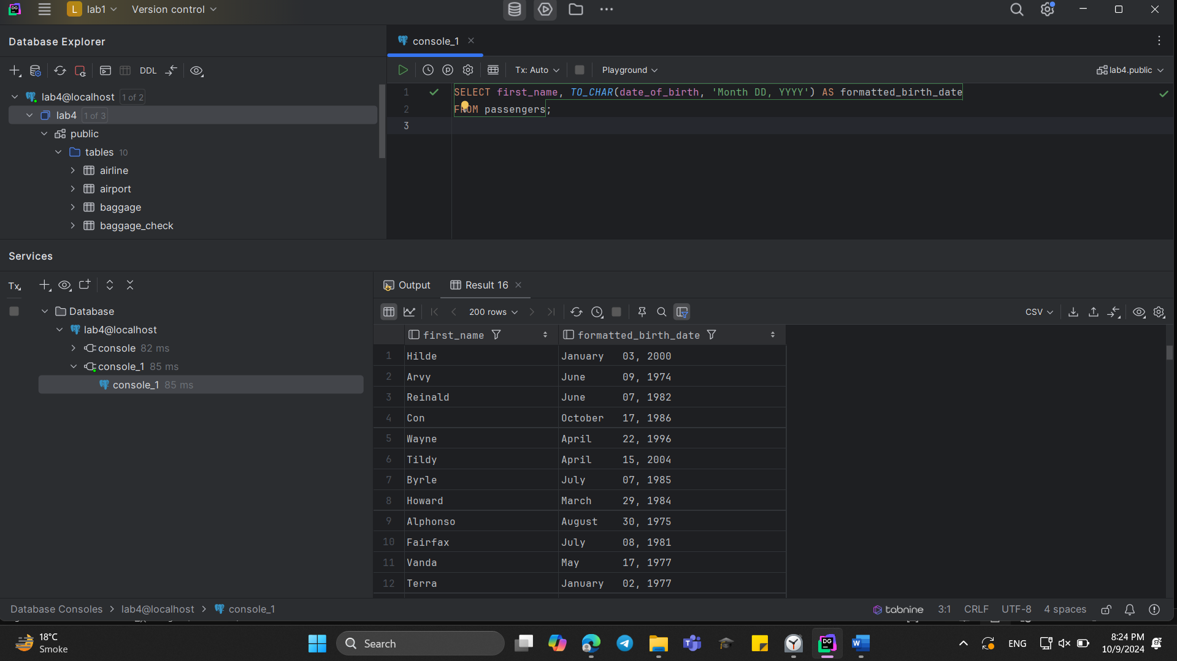
2. Find flight numbers that have been delayed based on the actual arrival time.  
   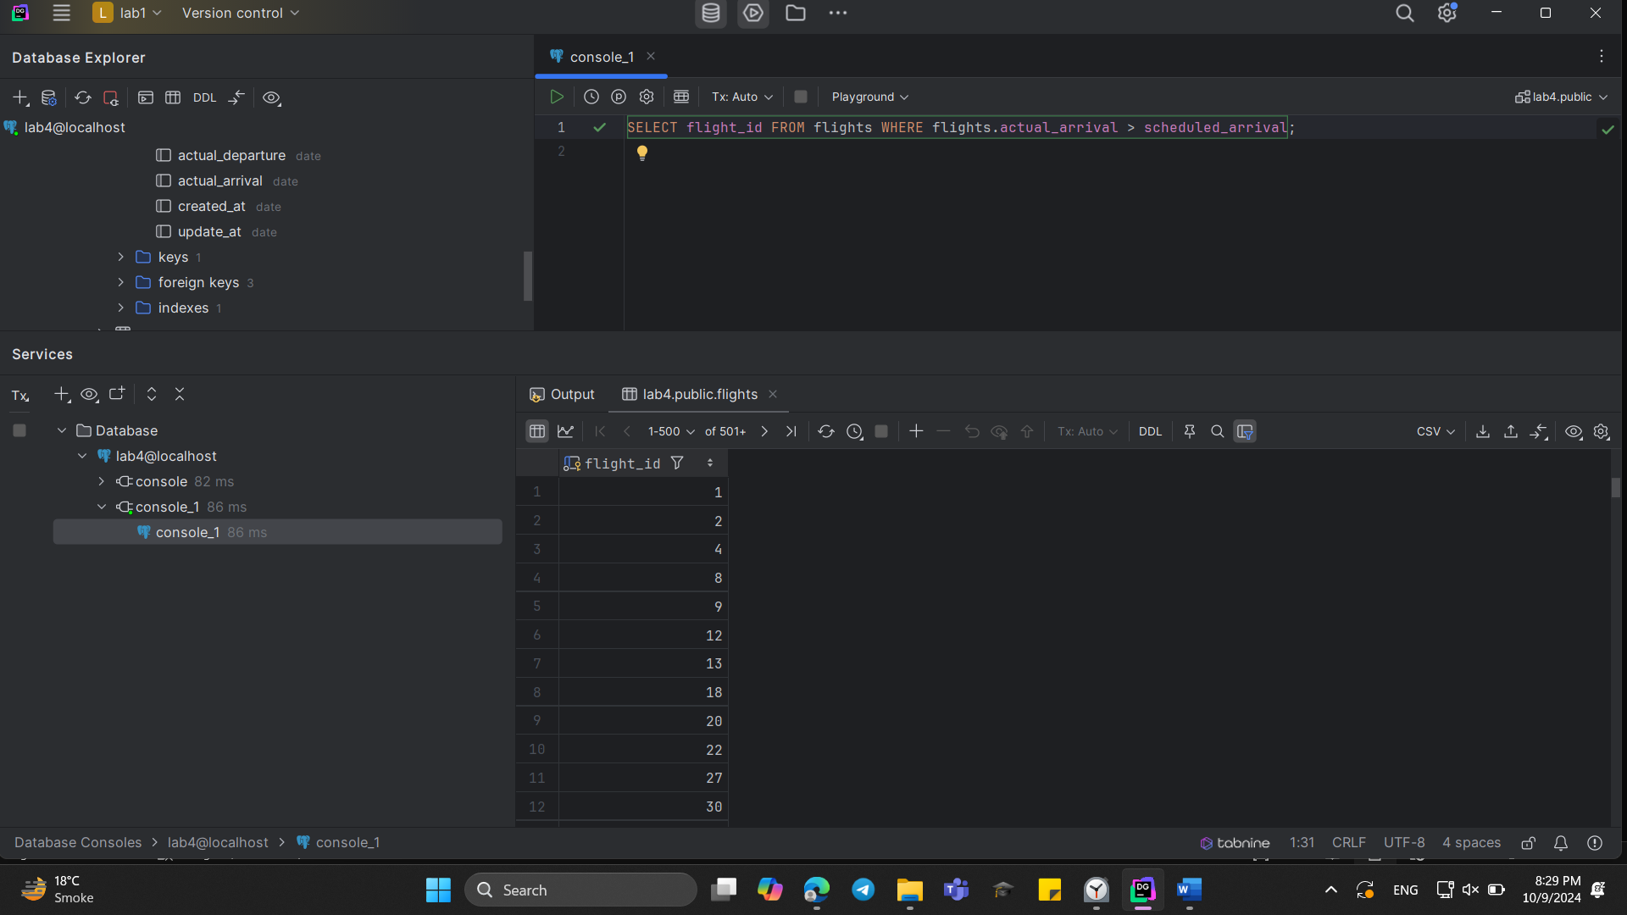
3. Create a query that divides passengers into age groups like ‘Young’ and ‘Adult’ based on their birth date. Young passengers age between 18 and 35, Adult passengers age between 36 and 55.

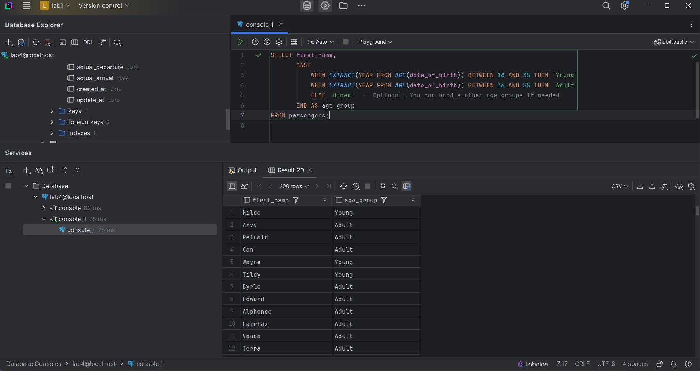

1. Create a query that categorizes ticket prices based on their price as "Cheap," "Medium" or "Expensive."

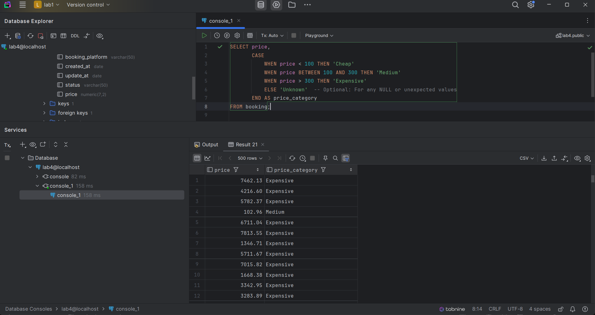

1. Find number of airline names in each airline country.

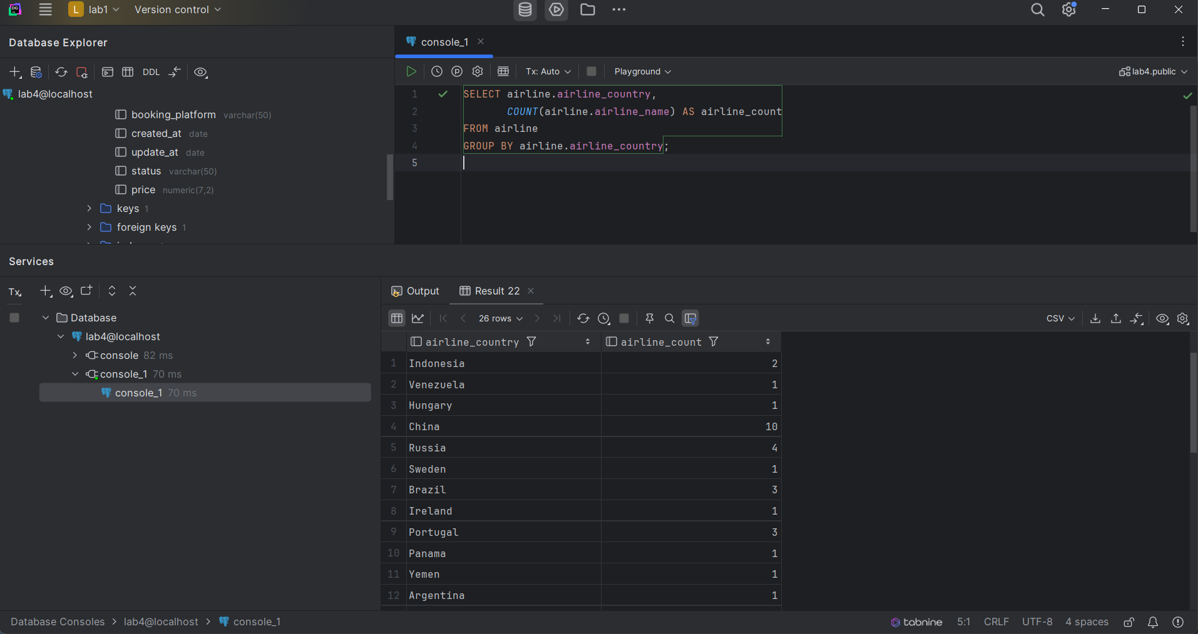

1. Find flights that arrived late according to their actual arrival time compared to the scheduled arrival time.  
   