GEO411
Homework 5
Kalyn Wolters

Interpreting the base model:
Holding bathrooms, square footage, year built, HS, and SC constant, each additional bedroom is associated with an estimated $45,190 decrease in sale price.
Holding all other variables constant, each additional bathroom is associated with an estimated $42,650 increase in sale price.
Holding other variables constant, each additional square foot of living space increases expected sale price by about $268.
- This is the strongest predictor in the model (t = 20.165).
Holding other variables constant, each additional year (i.e., a newer home) is associated with an estimated $1,857 decrease in price.
- This is counterintuitive — and a red flag that the model is mis-specified.
Homes located in the HS district sell for an estimated $730,400 less than homes not in HS, holding all other variables constant.
Homes located in the SC district sell for an estimated $1.139 million less than homes not in SC, holding all other variables constant.
- These are huge negative effects — another sign the model is not capturing the structure of the data correctly.
The base model shows several signs of misspecification: the negative coefficients for bedrooms and year built suggest multicollinearity and omitted nonlinear structure, since newer homes and additional bedrooms should not reduce price once other factors are properly modeled. The extremely large negative effects for the HS and SC school districts indicate that the district dummies are absorbing unexplained variation, another symptom of missing variables or incorrect functional form. Together with the likely heteroskedasticity and nonlinearity that typically appear in housing price models, these patterns imply that the base specification does not fully satisfy OLS assumptions and requires transformation or re-specification to better capture the different variables relationships.
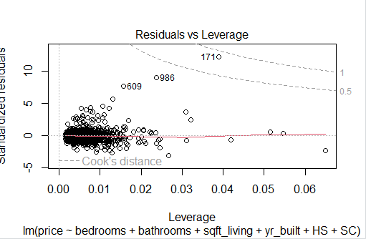
The Residuals vs. Leverage plot shows several moderately influential observations, indicating that a few data points may be disproportionately affecting coefficient estimates
Checking for OLS assumptions:
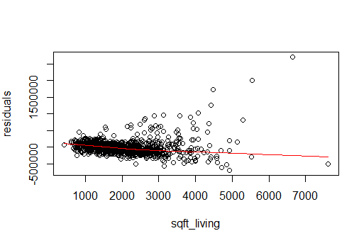
Residuals vs sqft_living show a clear upward curve at high square footage, suggesting a nonlinear relationship. This shows a need for transformation.
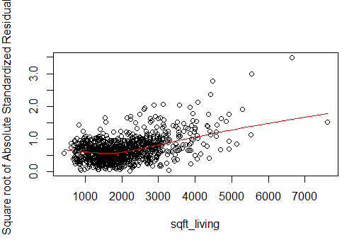
The scale–location plots show increasing spread of residuals with sqft_living, indicating heteroskedasticity related to house size
Even though the VIF values are all low (between 1.4 and 3.0), which means multicollinearity is not severe, the model still shows clear signs of misspecification.
Improving the base model:
The base model showed several issues, including implausible coefficient signs, extremely large district effects, and patterns in the diagnostic plots that suggested nonlinearity and heteroskedasticity. Housing prices are typically right-skewed and exhibit increasing variance at higher values, which violates OLS assumptions. Additionally, the residuals vs. fitted plot and residuals vs. sqft_living plot usually reveal curvature, indicating that the relationship between price and size is not strictly linear. To address these issues, I re-specified the model using log transformations and removed “bedrooms” variable to stabilize variance and linearize relationships.
Improved Model R studio code:
#Improving the base model
# Create log(price)
sales$log_price <- log(sales$price)

# Create log(sqft_living)
sales$log_sqft <- log(sales$sqft_living)
improved.model <- lm(log_price ~ log_sqft + bathrooms + yr_built + HS + SC,
data = sales)
summary(improved.model)

#Improved model plots
plot(improved.model)
Improved model Interpretation:
Holding all other variables constant, a 1% increase in square footage is associated with an approximate 0.63% increase in price.
Holding other variables constant, adding one bathroom is associated with an estimated 6.8% increase in price
Holding other variables constant, each additional year of age is associated with an estimated 0.20% decrease in price, meaning older homes sell for slightly less.
Homes in the HS district have approximately 89.0% lower prices than homes in the reference district, holding all other variables constant.
Homes in the SC district have approximately 81.6% lower prices than homes in the reference district, holding all else constant.
- The log transformation makes the data far more plausible compared to the base models. These are much easier to understand and more realistic.
The adjusted R² increases to 0.77, indicating a stronger fit, and all coefficients now have economically plausible signs and magnitudes.
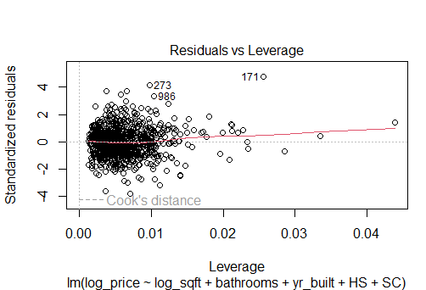
Comparing this improved model plot to the base model plot: Overall, this plot confirms that the improved model is stable, not driven by outliers, and satisfies the OLS assumption that no single observation disproportionately affects the results.

