GEO411 – Homework 4
Kalyn Wolters

- Is SAT score a good predictor of GPA? How do you know?
SAT score is a good predictor of GPA because the adjusted $R^{2}=0.7914$indicates that about 79–81% of the variation in GPA is explained by SAT score, and the overall F-test is highly significant $\left(F(1,9)=38.93,p=0.0001516\right)$
- What is the interpretation of the slope of the regression line, in terms of SAT scores and GPA?
The higher the SAT score, the higher the GPA and vice versa. (For every 100 point SAT score increase GPA increases about 0.35 GPA points.)
- Test the hypothesis that β=0.

Ho: There is no relationship between GPA and SAT test scores (β=0)
Ha: There is a relationship between GPA and SAT test scores (β ≠ 0)
Alpha = 0.05
Residual standard error: 0.2075 on 9 degrees of freedom
Multiple R-squared: 0.8122, Adjusted R-squared: 0.7914
F-statistic: 38.93 on 1 and 9 DF, p-value: 0.0001516
Since, 0.0001516<0.05
Reject the null hypothesis and conclude that β ≠ 0 (SAT score is a strong predictor for GPA)
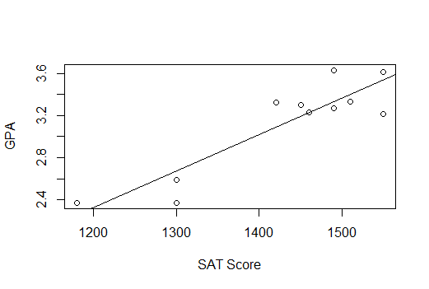

- Why is the intercept negative?
Because at the predicted line where SAT score is zero, GPA would be negative. (-1.8274795) Even though there is no SAT score of 0 in the real world.

- What percentage of GPA can be explained by SAT score?
Almost 80% of GPA can be explained by SAT score.

f. What is the interpretation of the slope of the regression line, in terms of development sites and pupae?
For every 1‑unit increase in DevelopmentSites, the predicted value of pupae increases by about 2.80 units.
- What is the percent change in the estimate of β between this model and the original model with all data points?
2.3536−2.79592/7959×100 = -15.8%
So, slope decreases about 15% when the outlier is removed.
h. Why does the t test statistic associated with β increase when the outlier is removed?
Because the outlier being incorporated causes the standard error to inflate. So, once the outlier is removed the model is more stable and shows the true relationship more clearly.
i. Compare the histogram of the raw pupae data with the transformed pupae data.
The histogram became much more symmetrical (bell shaped). Overall, after transformation the data is much better suited for hypothesis testing and regression analysis.
j. What is the interpretation of the slope of the regression line, in terms of development sites and pupae?
For every 1-unit increase in development sites, the predicted value of pupae increases by 0.016 units.
k. What is the interpretation of the slope of the log-log model, in terms of development sites and pupae?
For every 1% increase in development sites, the predicted value of pupae increases by 1.5009%

l. Test the hypothesis that ρ²=0 for the log-log model.

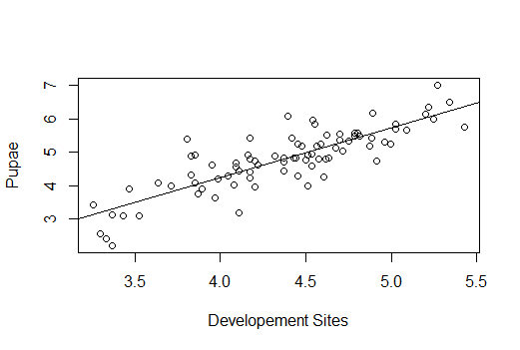
Ho: ρ²=0
Ha: ρ² ≠ 0
Alpha = 0.05
t=1.50090/1.074=13.981
p<0.05
Therefore, we reject the null hypothesis that ρ₂ = 0 and conclude that development sites have a statistically significant effect on the outcome in the log–log specification.

