

National Institute Of Electronic

And

Information Technology, Ajmer

|  |
| --- |
| Gamers web |
| GAMERS |
| In this site you are purchased online and offline games very cheep price |

Supervisor :- Submitted By:

Smt..Ankita Sharma Kamlesh Sharma

(Sr.Faculty) Reg.No.1653321

**index**

Topic :-

* Candidate
* Acnowlegemet
* Introduction
* Requirement’s

Coding :-

* HTML(HYPER TEXT MARKUP Language)
* CSS(CAST STYLE SEET)
* JAVA SCRIPT

Output :-

* Screenshots

CANDIDATE’S DECLARATION

I hereby declare that the work,which is being presented in the dissertation .“Gamers” in fulfillment for the award of diploma of NIELIT ‘O’ Level with specialization in software and submitted to be the training department of national institute of electronic & information technology , Ajmer center is a record of my own investigation carried under guidance of Mrs.ANKITA SHARMA(Sr.Faculty)

I have not submitted the matter presented in this report any ware for the award of any other diploma

(Name And Signature Of Candidate)

Kamlesh Sharma

Reg.no. 1653321

Counter Signed By

Ms.Anita Sharma Smt. Ankita Sharma

(Scientist E)

Acknowledgement

I would like to place on record my deep sence of gratitute to smt.ANKITA SHARMA(Sr.faculty) India for his generous, help and useful suggestions.

I express my since gratitude to Smt. Ankita Sharma (Sr. faculty) National Institute Of Electronic & Information Technology, Ajmer Center (Raj.) India for his stimulating guidance, Continues encouragement and supervision throughout the course of present work.

I am extremely thanks full to Dr. Sanjeev Kumar Gupta(Executive Director) and Anita Sharma (Scientist E) providing me infrastructure facilities to work in, without which this work would not have possible.

“ GAMERS”

GAMERS

MY GAMERS A FULLY ONLINE GAMES SELLING & GAMING TURNAMENT WEB PAGE WITH ADVANCE GAMES Features AND IT ’S PROVIDES A TRUELLY GAMES EXPERIENCE WITH MODERN AND INTUITIVE DESIGN .

* Responsive design for desktop and mobile devices
* Games and tournament
* Mostly useable for gamer

**Tech Stack**

* ReactJS
* Firebase
* Tailwind CSS
* CSS

**Installation**

Navigate to the project directory: CD GAMERS

Install the required dependencies: npm install or yarn install

Start the development server: npm start or yarn start

**Contributing**

Contributing are welcome! Please read the Contribution Guideline for more information

**License**

* GAMRS is open sourced software licensed under the MIT license

**Requirement’s:-**

Minimum Requirement’s -

Processor – P4 or higher version

Window – XP or higher version

Ram – 500MB or higher storage DDr3

HDD – 60GB or higher SATA/PATA/IDE

TFT – “21” or available

Actual Environment During the project

Processor – Intel® Core(TM) i7 – 477 CPU @ 3.40GHZ

Window – 10/11

Ram – 4GB/16GB

HDD – 512GB

**Layout**

**header**

Designing a Gamers header involves creating a layout that accommodates various elements such

as the logo, search bar, navigation links, and user-specific links. its need to provide easy access to numerous

categories, and functionalities in a user-friendly and accessible manner. Here’s a theoretical

layout focusing on key components and their organization:

### Structure of the Gamers Header

#### 1. Logo Section:

* The very left part of the header houses the Gamers logo, which also acts as a home button.

#### 2. Location Selector (optional):

* Next to the logo, Vishal book shop sometimes includes a delivery location selector, indicating where the user is shopping from or where items will be shipped.

#### 3. Search Bar:

* The search bar is a central element of the header, stretching across much of its length. It includes:
  + A dropdown menu on the left to filter searches by categories.
  + A large input field for text entry.
  + A submit button with a magnifying glass icon.

#### 4. Navigation Bar:

* To the right Coroner, there are several key navigation links/buttons, including:
  + Home:- Here you will be given a button through which you can join us.
  + games :- This is provided so that you can purchase and play the games provided
  + tournaments :- This is put in place so that you can follow the tournaments and join them as soon as they start.
  + Contact:-This has been installed so that if you face any kind of technical problem, you can contact us so that we can solve it
  + About:- Its use is that you can follow all our social media platforms so that you can get any kind of information..

### CSS Styling Considerations:

* Flexbox or Grid:

Use CSS Flexbox or Grid to structure the header, as they offer flexibility and

control in positioning elements.

* Responsive Design:

Employ media queries to ensure the header adjusts gracefully across different screen sizes,

keeping elements accessible on mobile devices.

* Iconography:

Use SVGs or font icons for scalable and visually consistent icons for the search button.

* Color Scheme and Typography:

Mirror Gamers color scheme and typography to maintain brand recognition. This usually involves a dark-colored background with neo green glow text for contrast effect.

### Accessibility and Interactivity:

* Aria-labels and Roles: Ensure interactive elements like the search bar and navigation links have appropriate Aria-labels and roles for screen readers and accessibility tools.
* Keyboard Navigation:

Make sure the header is navigable via keyboard, with focus states clearly indicated for

interactive elements.

### Implementation Notes:

While this theoretical layout provides a solid foundation for creating a Gamers header, it's

important to pay attention to the finer details like padding, margins, font sizes, and element sizes to

ensure a polished look. Additionally, testing across browsers and devices is crucial to ensure a

consistent and user-friendly experience.

**BODY**

Designing a body section for an Gaming site involves structuring a

complex layout that accommodates various elements aimed at enhancing

user experience, navigation, and showcasing effectivel the body section must be

organized, flexible, and scalable. Here's a theoretical layout that covers body

section:

### 1. Main Banner or Carousel:

* At the top, just below the header, a large banner or carousel often displays A Join Now button for coming in our Family . This dynamic element can rotate automatically or allow user interaction for navigation.

### 2. Primary Navigation or Category Listings:

* This area might include a sidebar or a horizontal menu that lists major categories available on the site, such as mobile and PC games etc., enabling

users to quickly navigate to areas of interest.

### 3. Deals:

* We have kept all the PC and Mobile games at equal price so that it becomes easy for everyone to buy these games.

### 4. Featured Recommendations:

* We have not been able to implement this feature on this website yet, but we will try to implement this feature on this website soon.
* 5. Product Grids or Lists:
* Core to the Amazon experience, these grids or lists display products with essential information such as the product image, name, price. Games can be organized based on various criteria, including new arrivals.

### 8. Footer Navigation:

* While technically not part of the body's main content, a comprehensive footer at the bottom of

the page includes links to customer service, company information, policies, social media, ensuring that essential navigation elements are accessible from anywhere on the site.

### Design and Layout Considerations:

* Grid Layouts and Flexbox:

Employ CSS Grid and Flexbox for responsive layouts that adjust seamlessly to different screen

sizes, ensuring that products and categories are displayed in an organized manner.

* Loading Performance:

Implement lazy loading for images and content sections that are not immediately visible to

improve page loading times and user experience.

* Accessibility:

Ensure all interactive elements are accessible, including proper alt texts for images, and that

the site is navigable via keyboard controls.

* Dynamic Content Loading:

Use AJAX or similar technologies to dynamically load content as the user scrolls or navigates

through categories, reducing initial load times and enhancing the browsing experience.

The body section of an Gamers needs to balance between functionality, performance, and

aesthetics, ensuring users can find and explore products effortlessly while also being exposed to new

deals, categories, and recommendations tailored to their interests.

CODING

HTML AND CSS , JAVASCRIPT

**HTML, which stands for HyperText Markup Language, is the standard language used to create**

**and design documents on the World Wide Web. It's the backbone of most web pages and**

**provides the structure for web content by using a system of tags and attributes.**

HTML documents consist of elements, which are surrounded by tags enclosed in angle brackets. These

tags define the structure and content of the web page. For example, <p> tags indicate a paragraph,

<h1> to <h6> tags represent headings of different levels, <a> tags create hyperlinks, and so on.

HTML is not a programming language but rather a markup language, meaning it defines the structure

and presentation of content rather than specifying how it functions. However, it often works in

conjunction with other technologies like CSS (Cascading Style Sheets) for styling and JavaScript for interactivity to create rich and dynamic web pages.

**CODING**

**<html>**

**<head>**

**<meta charset="UTF-8">**

**<meta name="viewport" content="width=device-width, initial-scale=1.0">**

**<title>Gaming Website</title>**

**<link rel="stylesheet" href="style.css">**

**<link href='https://unpkg.com/boxicons@2.1.4/css/boxicons.min.css' rel='stylesheet'>**

**</head>**

**<body>**

**<header>**

**<a href="#" class="logo ">Gamers</a>**

**<ul class="nav">**

**<li><a href="#home">Home</a></li>**

**<li><a href="#games">Games</a></li>**

**<li><a href="#tournaments">Tournaments</a></li>**

**<li><a href="#contact">Contact</a></li>**

**<li><a href="#about">About</a></li>**

**</ul>**

**<div class="action">**

**<div class="searchbx">**

**<a href="#"><i class='bx bx-search'></i></a>**

**<input type="text" placeholder="Search Games">**

**</div>**

**</div>**

**<div class="toggleMenu" onclick="toggleMenu();"></div>**

**</header>**

**<!--Home Banner -->**

**<div class="banner" id="home">**

**<div class="bg">**

**<div class="content">**

**<h2>A New Home for<br>**

**Game Lovers</h2>**

**<p>Lorem ipsum dolor, sit amet consectetur adipisicing elit. Aspernatur voluptatum. </p>**

**<a href="#" class="btn">Join Now</a>**

**</div>**

**<img src="pngegg.png">**

**</div>**

**</div>**

**`<!-- About -->**

**<div class="About" id="About">**

**<div class="contentBx">**

**<h2>About Us</h2>**

**<p>Lorem ipsum dolor sit amet consectetur adipisicing elit. Aliquam autem, reprehenderit architecto quos**

**nesciunt sunt, repellendus saepe laborum facere aut adipisci voluptates eligendi voluptatum et vitae minus**

**magni earum alias!**

**Lorem ipsum dolor sit, amet consectetur adipisicing elit. Ad fugit iure, neque placeat laboriosam, officiis**

**facilis excepturi similique sed ipsam dolores blanditiis aspernatur, eius ea. Quidem magni quae eos neque.**

**Lorem ipsum dolor sit amet consectetur adipisicing elit. Eveniet doloremque sed sequi iusto. Sapiente dolore**

**alias doloremque voluptate nam ut! Vero recusandae facilis placeat minima corrupti impedit, similique**

**assumenda rem?**

**</p>**

**<a href="#">Read more</a>**

**</div>**

**<img src="vr-gaming.png">**

**</div>**

**<!-- Games -->**

**<div class="games" id="games">**

**<h2>Popular Games</h2>**

**<ul>**

**<li class="list active" data-filter="all">All</li>**

**<li class="list" data-filter="pc">PC games</li>**

**<li class="list" data-filter="mobile">Mobile games</li>**

**</ul>**

**<div class="cardBx">**

**<div class="card" data-item="pc">**

**<img src="Grand_Theft_Auto_V.png">**

**<div class="content">**

**<h4>Grand Theft Auto V</h4>**

**<div class="progress-line"><span></span></div>**

**<div class="info">**

**<p>Pricing<br><span>$100</span></p>**

**<a href="#">Play Now</a>**

**</div>**

**</div>**

**</div>**

**<div class="card" data-item="pc">**

**<img src="Battleground_Mobile_India.webp.png">**

**<div class="content">**

**<h4>Battleground Mobile India</h4>**

**<div class="progress-line"><span></span></div>**

**<div class="info">**

**<p>Pricing<br><span>$100</span></p>**

**<a href="#">Play Now</a>**

**</div>**

**</div>**

**</div>**

**<div class="card" data-item="PC">**

**<img src="Red_Dead_Redemption_II.jpg">**

**<div class="content">**

**<h4>Red Dead Redemption II</h4>**

**<div class="progress-line"><span></span></div>**

**<div class="info">**

**<p>Pricing<br><span>$100</span></p>**

**<a href="#">Play Now</a>**

**</div>**

**</div>**

**</div>**

**<div class="card" data-item="PC">**

**<img src="hitmen.jpg">**

**<div class="content">**

**<h4>Hitmen</h4>**

**<div class="progress-line"><span></span></div>**

**<div class="info">**

**<p>Pricing<br><span>$100</span></p>**

**<a href="#">Play Now</a>**

**</div>**

**</div>**

**</div>**

**<div class="card" data-item="PC">**

**<img src="The Wwitcher 3.jpg">**

**<div class="content">**

**<h4>The Wwitcher 3</h4>**

**<div class="progress-line"><span></span></div>**

**<div class="info">**

**<p>Pricing<br><span>$100</span></p>**

**<a href="#">Play Now</a>**

**</div>**

**</div>**

**</div>**

**<div class="card" data-item="PC">**

**<img src="granny-.jpg">**

**<div class="content">**

**<h4>Granny</h4>**

**<div class="progress-line"><span></span></div>**

**<div class="info">**

**<p>Pricing<br><span>$100</span></p>**

**<a href="#">Play Now</a>**

**</div>**

**</div>**

**</div>**

**<div class="card" data-item="mobile">**

**<img src="subway surfers.png">**

**<div class="content">**

**<h4>Subway Surfers</h4>**

**<div class="progress-line"><span></span></div>**

**<div class="info">**

**<p>Pricing<br><span>$100</span></p>**

**<a href="#">Play Now</a>**

**</div>**

**</div>**

**</div>**

**<div class="card" data-item="mobile">**

**<img src="DR  DRIVING.png">**

**<div class="content">**

**<h4>DR DRIVING</h4>**

**<div class="progress-line"><span></span></div>**

**<div class="info">**

**<p>Pricing<br><span>$100</span></p>**

**<a href="#">Play Now</a>**

**</div>**

**</div>**

**</div>**

**<div class="card" data-item="mobile">**

**<img src="uno.png">**

**<div class="content">**

**<h4>UNO</h4>**

**<div class="progress-line"><span></span></div>**

**<div class="info">**

**<p>Pricing<br><span>$100</span></p>**

**<a href="#">Play Now</a>**

**</div>**

**</div>**

**</div>**

**<div class="card" data-item="mobile">**

**<img src="GTA SA.jpg">**

**<div class="content">**

**<h4>Grand Theft Auto san andrass</h4>**

**<div class="progress-line"><span></span></div>**

**<div class="info">**

**<p>Pricing<br><span>$100</span></p>**

**<a href="#">Play Now</a>**

**</div>**

**</div>**

**</div>**

**<div class="card" data-item="pc">**

**<img src="MINECRAFT.jpg">**

**<div class="content">**

**<h4>MINECRAFT</h4>**

**<div class="progress-line"><span></span></div>**

**<div class="info">**

**<p>Pricing<br><span>$100</span></p>**

**<a href="#">Play Now</a>**

**</div>**

**</div>**

**</div>**

**<div class="card" data-item="pc">**

**<img src="cyberpunk-2077.png">**

**<div class="content">**

**<h4>CYBER PUNK-2077</h4>**

**<div class="progress-line"><span></span></div>**

**<div class="info">**

**<p>Pricing<br><span>$100</span></p>**

**<a href="#">Play Now</a>**

**</div>**

**</div>**

**</div>**

**<div class="card" data-item="pc">**

**<img src="RFS Real Flight simulator.jpg">**

**<div class="content">**

**<h4>Real Flight Simulator</h4>**

**<div class="progress-line"><span></span></div>**

**<div class="info">**

**<p>Pricing<br><span>$100</span></p>**

**<a href="#">Play Now</a>**

**</div>**

**</div>**

**</div>**

**<div class="card" data-item="pc">**

**<img src="Super Mario.png">**

**<div class="content">**

**<h4>Super Mario</h4>**

**<div class="progress-line"><span></span></div>**

**<div class="info">**

**<p>Pricing<br><span>$100</span></p>**

**<a href="#">Play Now</a>**

**</div>**

**</div>**

**</div>**

**<div class="card" data-item="mobile">**

**<img src="CS GO.jpg">**

**<div class="content">**

**<h4>Counter strick</h4>**

**<div class="progress-line"><span></span></div>**

**<div class="info">**

**<p>Pricing<br><span>$100</span></p>**

**<a href="#">Play Now</a>**

**</div>**

**</div>**

**</div>**

**</div>**

**</div>**

**<!-- Tournaments -->**

**<div class="tournaments" id="tournaments">**

**<h2>Live tournaments</h2>**

**<div class="boxBx">**

**<div class="box">**

**<img src="turnament.jpeg">**

**<div class="content">**

**<h4><span>100</span>Matches in progress..</h4>**

**<p>DISCLIMER <BR>**

**Place your ui and pay 50$ for playing this turnament and coming on the time then you not coming we**

**will starting this turnamen.**

**</p>**

**<div class="btn">**

**<a href="#" class="watch">watch</a>**

**<a href="#" class="join">join now</a>**

**</div>**

**</div>**

**</div>**

**<div class="box">**

**<img src="turnament4.webp">**

**<div class="content">**

**<h4><span>100</span>Matches in progress..</h4>**

**<p>DISCLIMER <BR>**

**Place your ui and pay 50$ for playing this turnament and coming on the time then you not coming we**

**will starting this turnamen.**

**</p>**

**<div class="btn">**

**<a href="#" class="watch">watch</a>**

**<a href="#" class="join">join now</a>**

**</div>**

**</div>**

**</div>**

**<div class="box">**

**<img src="turnament3.jpg">**

**<div class="content">**

**<h4><span>50</span>Matches in progress..</h4>**

**<p>DISCLIMER <BR>**

**Place your ui and pay 50$ for playing this turnament and coming on the time then you not coming we**

**will starting this turnamen.**

**</p>**

**<div class="btn">**

**<a href="#" class="watch">watch</a>**

**<a href="#" class="join">join now</a>**

**</div>**

**</div>**

**</div>**

**<div class="box">**

**<img src="turnament2.jpg">**

**<div class="content">**

**<h4><span>100</span>Matches in progress..</h4>**

**<p>DISCLIMER <BR>**

**Place your ui and pay 50$ for playing this turnament and coming on the time then you not coming we**

**will starting this turnamen.**

**</p>**

**<div class="btn">**

**<a href="#" class="watch">watch</a>**

**<a href="#" class="join">join now</a>**

**</div>**

**</div>**

**</div>**

**<div class="box">**

**<img src="valorant.jpg">**

**<div class="content">**

**<h4><span>100</span>Matches in progress..</h4>**

**<p>DISCLIMER <BR>**

**Place your ui and pay 50$ for playing this turnament and coming on the time then you not coming we**

**will starting this turnamen.**

**</p>**

**<div class="btn">**

**<a href="#" class="watch">watch</a>**

**<a href="#" class="join">join now</a>**

**</div>**

**</div>**

**</div>**

**<div class="box">**

**<img src="fortnight.jpg">**

**<div class="content">**

**<h4><span>100</span>Matches in progress..</h4>**

**<p>DISCLIMER <BR>**

**Place your ui and pay 50$ for playing this turnament and coming on the time then you not coming we**

**will starting this turnamen.**

**</p>**

**<div class="btn">**

**<a href="#" class="watch">watch</a>**

**<a href="#" class="join">join now</a>**

**</div>**

**</div>**

**</div>**

**<div class="box">**

**<img src="call of duty.jpg">**

**<div class="content">**

**<h4><span>100</span>Matches in progress..</h4>**

**<p>DISCLIMER <BR>**

**Place your ui and pay 50$ for playing this turnament and coming on the time then you not coming we**

**will starting this turnamen.**

**</p>**

**<div class="btn">**

**<a href="#" class="watch">watch</a>**

**<a href="#" class="join">join now</a>**

**</div>**

**</div>**

**</div>**

**<div class="box">**

**<img src="dota2.jpg">**

**<div class="content">**

**<h4><span>100</span>Matches in progress..</h4>**

**<p>DISCLIMER <BR>**

**Place your ui and pay 50$ for playing this turnament and coming on the time then you not coming we**

**will starting this turnamen.**

**</p>**

**<div class="btn">**

**<a href="#" class="watch">watch</a>**

**<a href="#" class="join">join now</a>**

**</div>**

**</div>**

**</div>**

**<div class="box">**

**<img src="mobile legends.jpg">**

**<div class="content">**

**<h4><span>100</span>Matches in progress..</h4>**

**<p>DISCLIMER <BR>**

**Place your ui and pay 50$ for playing this turnament and coming on the time then you not coming we**

**will starting this turnamen.**

**</p>**

**<div class="btn">**

**<a href="#" class="watch">watch</a>**

**<a href="#" class="join">join now</a>**

**</div>**

**</div>**

**</div>**

**<div class="box">**

**<img src="chess.jpg">**

**<div class="content">**

**<h4><span>100</span>Matches in progress..</h4>**

**<p>DISCLIMER <BR>**

**Place your ui and pay 50$ for playing this turnament and coming on the time then you not coming we**

**will starting this turnamen.**

**</p>**

**<div class="btn">**

**<a href="#" class="watch">watch</a>**

**<a href="#" class="join">join now</a>**

**</div>**

**</div>**

**</div>**

**</div>**

**</div>**

**<!-- Testimonials -->**

**<div class="testimonials">**

**<h2>What Our Gamers Say</h2>**

**<div class="testimonial-card">**

**<p>"Great platform, excellent games, and a strong community!" - Player 1</p>**

**</div>**

**<div class="testimonial-card">**

**<p>"The best place to compete and improve your skills." - Player 2</p>**

**</div>**

**</div>**

**<!-- FAQ -->**

**<div class="faq">**

**<h2>Frequently Asked Questions</h2>**

**<div class="faq-item">**

**<h3>How do I join a tournament?</h3>**

**<p>You can join a tournament by signing up and paying the entry fee. Check the live tournaments section for available ones.</p>**

**</div>**

**<div class="faq-item">**

**<h3>What games can I play?</h3>**

**<p>We offer both PC and mobile games. Browse through the Popular Games section to explore them.</p>**

**</div>**

**</div>**

**<!-- Footer -->**

**<footer>**

**<div class="contact" id="contact">**

**<img src="contect us.jpg">**

**<div class="form">**

**<h1>Contact Us</h1>**

**<div class="inputBx">**

**<p>Enter Name</p>**

**<input type"text" placeholder="Full Name">**

**</div>**

**<div class="inputBx">**

**<p>Enter Email</p>**

**<input type"text" placeholder="Full Name">**

**</div>**

**<div class="inputBx">**

**<p>Message</p>**

**<textarea placeholder="Type here..."></textarea>**

**</div>**

**<div class="inputBx">**

**<input type="submit" name="submit">**

**</div>**

**</div>**

**</div>**

**<div class="info" id="about">**

**<a href="#" class="logo">Gamers</a>**

**<p><i class='bx bx-copyright'></i>2025 All rights reserved.</p>**

**<ul>**

**<li><a href="#"><i class='bx bxl-facebook-circle' ></i></a></li>**

**<li><a href="#"><i class='bx bxl-twitter'></i></a></li>**

**<li><a href="#"><i class='bx bxl-instagram'></i></a></li>**

**</ul>**

**</div>**

**</footer>**

**<script>**

**/* Sticky NavBar */**

**window.addEventListener('scroll', function () {**

**var header = document.querySelector('header');**

**header.classList.toggle('sticky', window.scrollY > 0);**

**});**

**/* Responsive NavBar */**

**function toggleMenu(){**

**const toggleMenu = document.querySelector('.toggleMenu');**

**const nav = document.querySelector('.nav');**

**toggleMenu.classList.toggle('active')**

**nav.classList.toggle('active')**

**}**

**/* Filterable Cards */**

**let list = document.querySelectorAll('.list');**

**let card = document.querySelectorAll('.card');**

**for (let i = 0; i < list.length; i++) {**

**list[i].addEventListener('click', function () {**

**for (let j = 0; j < list.length; j++) {**

**list[j].classList.remove('active');**

**}**

**this.classList.add('active');**

**let dataFilter = this.getafteribute('data-filter');**

**for (let k = 0; k.card.length; k++) {**

**card[k].classList.remove('active');**

**card[k].classList.add('hide');**

**if (card[k].getAttribute('data-item') == dataFilter || dataFilter) {**

**card[k].classList.remove('hide');**

**card[k].classList.add('active');**

**}**

**}**

**})**

**}**

**</script>**

**</body>**

**</html>**

**CSS**

CSS, which stands for Cascading Style Sheets, is a styling language used to describe the

presentation of a document written in HTML. It defines how HTML elements are to be displayed on

screen, in print, or in other media. CSS separates the content of a webpage from its design, allowing

developers to control the layout, colors, fonts, and other visual aspects of their web pages.

CSS works by targeting HTML elements and applying styling rules to them. These rules consist of

property-value pairs that define various aspects of the element's appearance. For example, CSS can

specify the font size, color, margin, padding, border, and positioning of elements on a webpage.

By using CSS, web developers can create visually appealing and consistent designs across their

websites, enhance user experience, and make their web pages more accessible and responsive across

different devices and screen sizes. CSS can be written directly within an HTML document using

inline styles, included within a <style> element in the document's <head> section, or stored in

external CSS files and linked to HTML documents using the <link> element.

**CODING**

**@import url('https://fonts.googleapis.com/css2?family=Poppins&display=swap');**

**\* {**

**margin: 0;**

**padding: 0;**

**box-sizing: border-box;**

**font-family: 'Poppins', sans-serif;**

**scroll-behavior: smooth;**

**}**

**body {**

**background: radial-gradient(circle, #0a1a2d, #050e2d);**

**color: #fff;**

**overflow-x: hidden;**

**}**

**/* Scroll Bar */**

**::-webkit-scrollbar {**

**width: 12px;**

**}**

**::-webkit-scrollbar-thumb {**

**background: linear-gradient(45deg, #1aeeef, #408eb8);**

**border-radius: 6px;**

**}**

**header {**

**position: fixed;**

**top: 0;**

**left: 0;**

**width: 100%;**

**padding: 10px 80px;**

**display: flex;**

**justify-content: space-between;**

**align-items: center;**

**background: rgba(0, 0, 0, 0.8); ;**

**transition: background 0.5s, box-shadow 0.5s;**

**z-index: 1000;**

**}**

**header.sticky {**

**background: rgba(64, 142, 184, 0.9);**

**box-shadow: 0 5px 20px rgba(0, 0, 0, 0.3);**

**}**

**header .logo {**

**position: relative;**

**color: #fff;**

**text-decoration: none;**

**font-size: 2em;**

**font-weight: 700;**

**transition: color 0.3s;transform: 0.3s;**

**}**

**header .logo:hover {**

**color: #1aeeef;**

**transform: scale(1.1);**

**}**

**header .nav {**

**display: flex;**

**justify-content: center;**

**align-items: center;**

**}**

**header ul li {**

**list-style: none;**

**margin: 10px;**

**}**

**header ul li a {**

**color: #fff;**

**text-decoration: none;**

**padding: 10px 20px;**

**border-radius: 5px;**

**transition: background 0.3s, color 0.3s, box-shadow 0.3s;**

**}**

**header ul li a:hover {**

**background: #1aeeef;**

**color: #050e2d;**

**box-shadow: 0 0 10px #1aeeef;**

**}**

**header .action .searchBx {**

**padding: 5px;**

**margin: 5px;**

**display: flex;**

**justify-content: center;**

**align-items: center;**

**background: rgba(255, 255, 255, 0.1);**

**border-radius: 5px;**

**transition: box-shadow 0.3s, background 0.3s;**

**}**

**header .action .searchBx:hover {**

**background: rgba(255, 255, 255, 0.2);**

**box-shadow: 0 0 10px #1aeeef;**

**}**

**header .action .searchBx i {**

**font-size: 1.4em;**

**margin: 5px;**

**color: #fff;**

**}**

**header .action .searchBx input {**

**outline: none;**

**border: none;**

**font-size: 1em;**

**color: #222;**

**background: transparent;**

**}**

**/* Home Banner */**

**.banner {**

**position: relative;**

**width: 100%;**

**min-height: 100vh;**

**padding: 0px 100px;**

**display: flex;**

**justify-content: center;**

**align-items: center;**

**overflow: hidden;**

**}**

**.banner .bg {**

**position: relative;**

**width: 100%;**

**min-height: 100vh;**

**display: flex;**

**justify-content: center;**

**align-items: center;**

**}**

**.banner .bg .content {**

**width: 50%;**

**height: 100%;**

**animation: fadeIn 1.5s ease-in-out;**

**}**

**.banner .bg .content h2 {**

**font-size: 4em;**

**color: #ffffff;**

**letter-spacing: 1px;**

**text-shadow: 0 0 10px #1aeeef;**

**}**

**.banner .bg .content p {**

**font-size: 1em;**

**color: #dbd9d9;**

**letter-spacing: 1px;**

**}**

**.banner .bg .content a {**

**display: inline-block;**

**padding: 10px 20px;**

**margin: 20px 0;**

**border: 1px solid #1aeeef;**

**text-decoration: none;**

**font-weight: 700;**

**border-radius: 5px;**

**color: #fff;**

**letter-spacing: 1px;**

**transition: background 0.3s, color 0.3s, box-shadow 0.3s;**

**}**

**.banner .bg .content a:hover {**

**background: #1aeeef;**

**border: none;**

**color: #050e2d;**

**box-shadow: 0 0 10px #1aeeef;**

**}**

**.banner .bg img {**

**width: 600px;**

**animation: float 3s ease-in-out infinite;**

**}**

**@keyframes float {**

**0%, 100% {**

**transform: translateY(0);**

**}**

**50% {**

**transform: translateY(-20px);**

**}**

**}**

**@keyframes fadeIn {**

**0% {**

**opacity: 0;**

**transform: translateY(20px);**

**}**

**100% {**

**opacity: 1;**

**transform: translateY(0);**

**}**

**}**

**/* about */**

**.about {**

**position: relative;**

**width: 100%;**

**min-height: 75vh;**

**padding: 0px 100px;**

**display: flex;**

**justify-content: space-between;**

**align-items: center;**

**}**

**.about .contentBx {**

**width: 50%;**

**margin: 20px;**

**animation: fadeInLeft 1.5s ease-in-out;**

**}**

**.about .contentBx h2 {**

**font-size: 3em;**

**font-weight: 700;**

**color: #fff;**

**text-shadow: 0 0 10px #1aeeef;**

**}**

**.about .contentBx p {**

**max-width: 600px;**

**text-align: justify;**

**color: #dbd9d9;**

**}**

**.about .contentBx a {**

**display: inline-block;**

**padding: 10px 20px;**

**margin: 20px 0;**

**border: 1px solid #1aeeef;**

**text-decoration: none;**

**font-weight: 700;**

**border-radius: 5px;**

**color: #fff;**

**letter-spacing: 1px;**

**transition: background 0.3s, color 0.3s, box-shadow 0.3s;**

**}**

**.about .contentBx a:hover {**

**background: #1aeeef;**

**border: none;**

**color: #050e2d;**

**box-shadow: 0 0 10px #1aeeef;**

**}**

**@keyframes fadeInLeft {**

**0% {**

**opacity: 0;**

**transform: translateX(-20px);**

**}**

**100% {**

**opacity: 1;**

**transform: translateX(0);**

**}**

**}**

**/* Games */**

**.games {**

**padding: 0px 100px;**

**width: 100%;**

**min-height: 100vh;**

**display: flex;**

**justify-content: center;**

**align-items: center;**

**flex-direction: column;**

**margin: 40px auto;**

**}**

**.games h2 {**

**color: #fff;**

**margin: 10px 0;**

**}**

**.games ul {**

**display: flex;**

**justify-content: center;**

**align-items: center;**

**flex-wrap: wrap;**

**margin-bottom: 20px;**

**}**

**.games ul li {**

**list-style: none;**

**padding: 10px 20px;**

**border-radius: 5px;**

**margin: 5px;**

**letter-spacing: 1px;**

**cursor: pointer;**

**color: #fff;**

**transition: background 0.3s, color 0.3s, box-shadow 0.3s;**

**}**

**.games ul li.active,**

**.games ul li:hover {**

**background: #1aeeef;**

**color: #050e2d;**

**box-shadow: 0 0 10px #1aeeef;**

**}**

**.games .cardBx {**

**width: 100%;**

**min-height: 100%;**

**display: flex;**

**flex-wrap: wrap;**

**justify-content: center;**

**align-items: center;**

**}**

**.games .cardBx .card {**

**width: 250px;**

**border-radius: 10px;**

**margin: 20px 40px;**

**background: rgba(72, 109, 98, 0.8);**

**overflow: hidden;**

**transition: transform 0.3s, box-shadow 0.3s;**

**}**

**.games .cardBx .card:hover {**

**transform: translateY(-10px);**

**box-shadow: 0 10px 20px rgba(0, 0, 0, 0.2);**

**}**

**.games .cardBx .card img {**

**width: 100%;**

**height: 250px;**

**object-fit: cover;**

**}**

**.games .cardBx .card .content {**

**padding: 10px;**

**}**

**.games .cardBx .card .content h4 {**

**color: #fff;**

**margin: 15px 0;**

**}**

**.games .cardBx .card .progrss-line {**

**position: relative;**

**height: 10px;**

**width: 100%;**

**background: #35407e;**

**margin-bottom: 15px;**

**border-radius: 10px;**

**transform: scaleX(0);**

**transform-origin: left;**

**animation: animate 1s cubic-bezier(1, 0, 0.5, 1) forwards;**

**}**

**.games .cardBx .card .progrss-line span {**

**position: absolute;**

**height: 100%;**

**width: 80%;**

**border-radius: 10px;**

**background: #1aeeef;**

**box-shadow: 0 0 10px #1aeeef;**

**transform: scaleX(0);**

**transform-origin: left;**

**animation: animate 1s cubic-bezier(1, 0, 0.5, 1) forwards;**

**}**

**@keyframes animate {**

**100% {**

**transform: scaleX(1);**

**}**

**}**

**.games .cardBx .card .info {**

**border-top: 2px solid #35407e;**

**padding: 5px;**

**display: flex;**

**justify-content: space-between;**

**align-items: center;**

**}**

**.games .cardBx .card .info p {**

**font-size: 1em;**

**color: #fff;**

**}**

**.games .cardBx .card .info p span {**

**color: #1aeeef;**

**}**

**.games .cardBx .card .info a {**

**display: inline-block;**

**padding: 10px 20px;**

**margin: 10px 0;**

**border: 1px solid #1aeeef;**

**text-decoration: none;**

**font-weight: 700;**

**border-radius: 5px;**

**color: #fff;**

**letter-spacing: 1px;**

**transition: background 0.3s, color 0.3s, box-shadow 0.3s;**

**}**

**.games .cardBx .card .info a:hover {**

**background: #1aeeef;**

**border: none;**

**color: #050e2d;**

**box-shadow: 0 0 10px #1aeeef;**

**}**

**.games .cardBx .card.hide {**

**display: none;**

**}**

**/* Tournaments */**

**.tournaments {**

**padding: 0px 100px;**

**width: 100%;**

**min-height: 100vh;**

**display: flex;**

**flex-direction: column;**

**justify-content: center;**

**align-items: center;**

**}**

**.tournaments h2 {**

**color: #fff;**

**margin: 10px 0;**

**text-shadow: 0 0 10px #1aeeef;**

**}**

**.tournaments .boxBx {**

**width: 100%;**

**min-height: 100%;**

**display: flex;**

**flex-wrap: wrap;**

**justify-content: center;**

**align-items: center;**

**}**

**.tournaments .boxBx .box {**

**width: 350px;**

**border-radius: 10px;**

**margin: 20px 40px;**

**background: #486d62;**

**overflow: hidden;**

**transition: transform 0.3s, box-shadow 0.3s;**

**}**

**.tournaments .boxBx .box:hover {**

**transform: translateY(-10px);**

**box-shadow: 0 10px 20px rgba(0, 0, 0, 0.2);**

**}**

**.tournaments .boxBx .box img {**

**width: 100%;**

**height: 300px;**

**object-fit: cover;**

**}**

**.tournaments .boxBx .box .content {**

**padding: 10px;**

**}**

**.tournaments .boxBx .box .content h4 {**

**color: #fff;**

**margin-top: 15px;**

**}**

**.tournaments .boxBx .box .content h4 span {**

**color: #1aeeef;**

**}**

**.tournaments .boxBx .box .content p {**

**text-align: justify;**

**color: #ffffff;**

**margin-top: 10px;**

**}**

**.tournaments .boxBx .box .content .btn {**

**display: flex;**

**justify-content: space-between;**

**}**

**.tournaments .boxBx .box .content .watch {**

**display: inline-block;**

**padding: 10px 20px;**

**margin: 20px 0;**

**background: #1aeeef;**

**text-decoration: none;**

**font-weight: 700;**

**border-radius: 5px;**

**color: #050e2d;**

**letter-spacing: 1px;**

**box-shadow: 0 0 10px #1aeeef;**

**transition: background 0.3s, color 0.3s, box-shadow 0.3s;**

**}**

**.tournaments .boxBx .box .content .watch:hover {**

**background: none;**

**border: 1px solid #1aeeef;**

**color: #fff;**

**box-shadow: none;**

**}**

**.tournaments .boxBx .box .content .join {**

**display: inline-block;**

**padding: 10px 20px;**

**margin: 20px 0;**

**border: 1px solid #1aeeef;**

**text-decoration: none;**

**font-weight: 700;**

**border-radius: 5px;**

**color: #fff;**

**letter-spacing: 1px;**

**transition: background 0.3s, color 0.3s, box-shadow 0.3s;**

**}**

**.tournaments .boxBx .box .content .join:hover {**

**background: #1aeeef;**

**border: none;**

**color: #050e2d;**

**box-shadow: 0 0 10px #1aeeef;**

**}**

**/* Contact */**

**.contact {**

**padding: 20px 100px;**

**width: 100%;**

**min-height: 50vh;**

**display: flex;**

**justify-content: center;**

**align-items: center;**

**}**

**.contact img {**

**height: 100%;**

**width: 50%;**

**object-fit: cover;**

**border-radius: 10px;**

**animation: fadeInRight 1.5s ease-in-out;**

**}**

**.contact .form {**

**width: 50%;**

**margin: 30px;**

**animation: fadeInLeft 1.5s ease-in-out;**

**}**

**.contact .form h1 {**

**color: #fff;**

**}**

**.contact .form .inputBx {**

**margin: 10px 0;**

**}**

**.contact .form .inputBx p {**

**color: #fff;**

**}**

**.contact .form .inputBx input,**

**.contact .form .inputBx textarea {**

**border: none;**

**outline: none;**

**padding: 10px;**

**width: 100%;**

**color: #fff;**

**background: #1b2141;**

**min-height: 15px;**

**font-size: 1.1em;**

**transition: border 0.3s, box-shadow 0.3s;**

**}**

**.contact .form .inputBx input:focus,**

**.contact .form .inputBx textarea:focus {**

**border: 1px solid #1aeeef;**

**box-shadow: 0 0 10px #1aeeef;**

**}**

**.contact .form .inputBx textarea {**

**height: 150px;**

**}**

**.contact .form .inputBx input[type="submit"] {**

**display: inline-block;**

**padding: 10px 20px;**

**margin: 15px 0;**

**outline: none;**

**background: transparent;**

**border: 1px solid #1aeeef;**

**text-decoration: none;**

**font-weight: 700;**

**width: 150px;**

**border-radius: 5px;**

**color: #fff;**

**letter-spacing: 1px;**

**transition: background 0.3s, color 0.3s, box-shadow 0.3s;**

**}**

**.contact .form .inputBx input[type="submit"]:hover {**

**background: #1aeeef;**

**color: #050e2d;**

**box-shadow: 0 0 10px #1aeeef;**

**}**

**footer{**

**padding: 10px 100px;**

**}**

**footer .info{**

**display: flex;**

**justify-content: space-between;**

**align-items: center;**

**}**

**footer .info .logo{**

**position: relative;**

**color: #fff;**

**text-decoration: none;**

**font-size: 2em;**

**font-weight: 700;**

**}**

**footer .info p{**

**color: #dbd9d9;**

**}**

**footer .info ul{**

**margin: 10px 0;**

**display: flex;**

**justify-content: center;**

**align-items: center;**

**}**

**footer .info ul li{**

**list-style: none;**

**height: 50px;**

**width: 50px;**

**margin: 5px;**

**border-radius: 50%;**

**display: flex;**

**justify-content: center;**

**align-items: center;**

**border: 1px solid #1aeeef;**

**}**

**footer .info ul li:hover{**

**background: #1aeeef;**

**border: none;**

**box-shadow: 0 0 10px #1aeeef;**

**}**

**footer .info ul li a i{**

**font-size: 1.5em;**

**color: #fff;**

**}**

**footer .info ul li:hover a i{**

**color: #050e2d;**

**}**

**/* Responsive design*/**

**@media (max-width: 991px)**

**{**

**header**

**{**

**padding: 15px 40px;**

**}**

**header .nav{**

**position: fixed;**

**top: 0;**

**left: 0;**

**right: 0;**

**bottom: 0;**

**background: #1b2141;**

**display: none;**

**justify-content: center;**

**align-items: center;**

**flex-direction: column;**

**z-index: 1000;**

**}**

**header .nav.active{**

**display: flex;**

**}**

**header .nav li{**

**margin: 20px 0;**

**}**

**header .nav li a{**

**font-size: 24px;**

**margin: 10px 0;**

**}**

**.toggleMenu{**

**position: relative;**

**width: 30px;**

**height: 30px;**

**background: url(menu.png);**

**background-position: center;**

**background-size: 30px;**

**background-repeat: no-repeat;**

**cursor: pointer;**

**z-index: 1001;**

**}**

**.toggleMenu.active{**

**background: url(close\ \(1\).png);**

**background-position: center;**

**background-size: 30px;**

**background-repeat: no-repeat;**

**}**

**.banner .bg img {**

**position: absolute;**

**}**

**}**

**@keyframes fadeInRight {**

**0% {**

**opacity: 0;**

**transform: translateX(20px);**

**}**

**100% {**

**opacity: 1;**

**transform: translateX(0);**

**}**

**}**

**SCREENSHOTS**

**1**

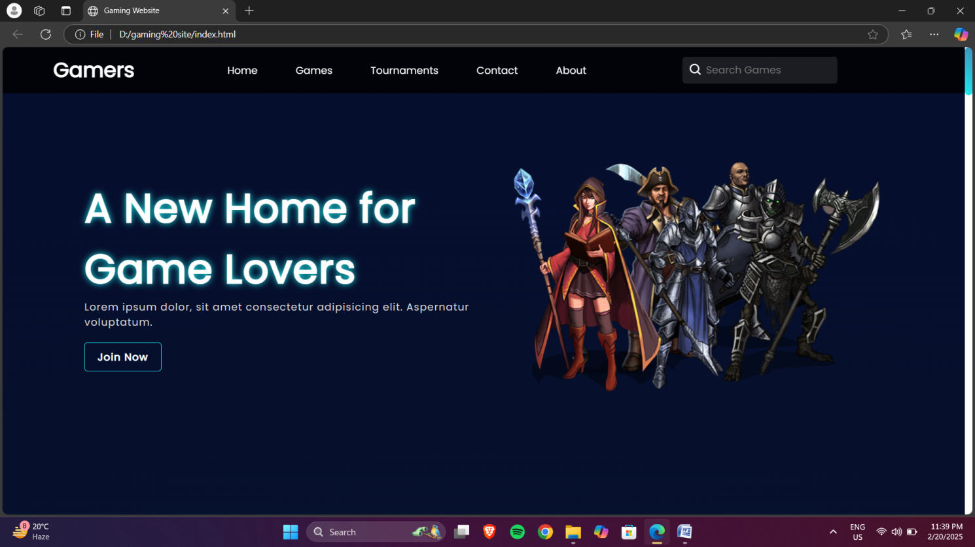

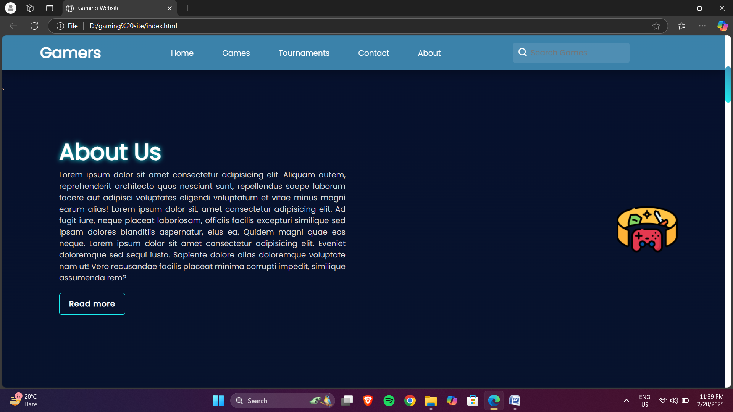

**2**

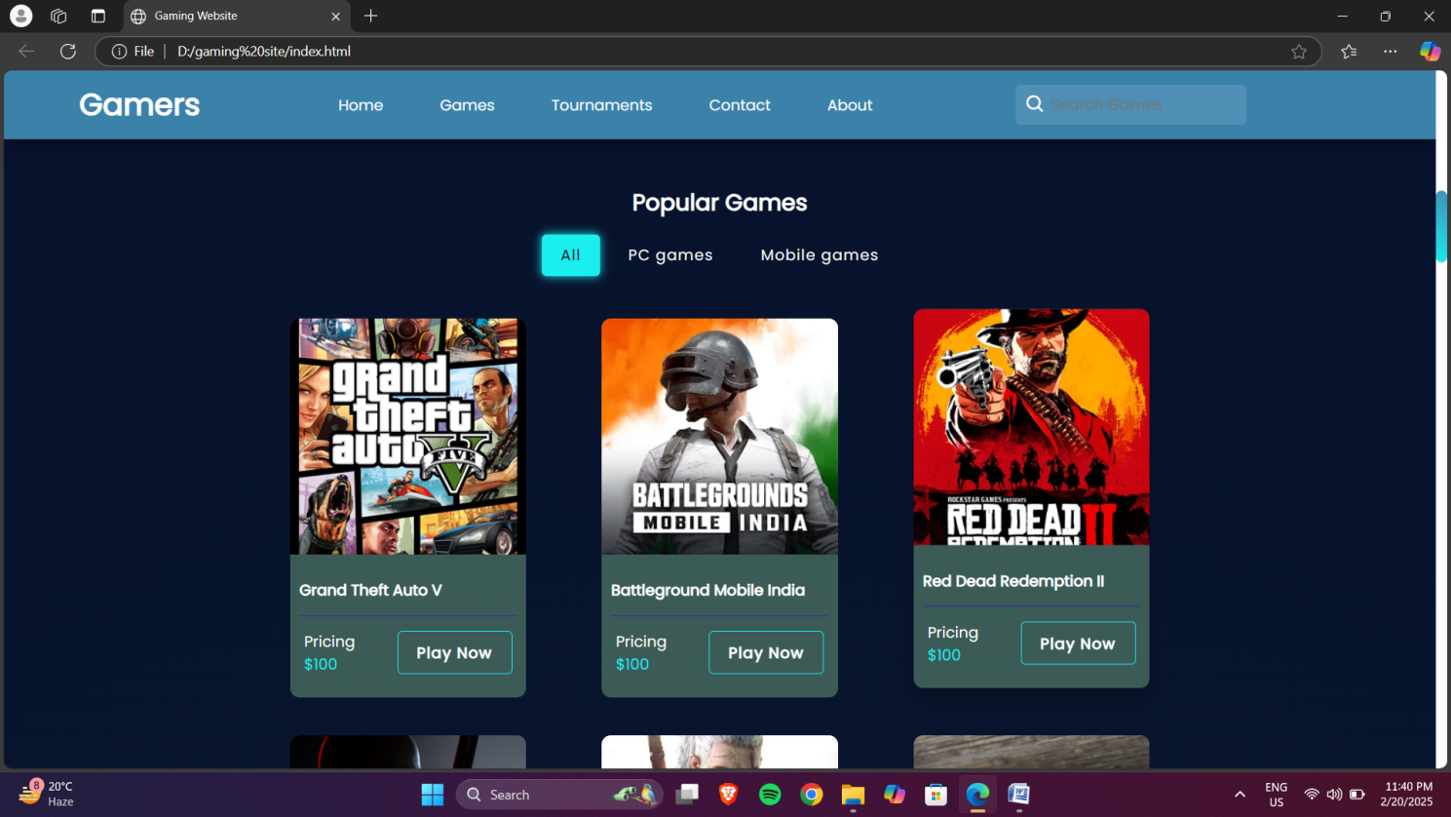

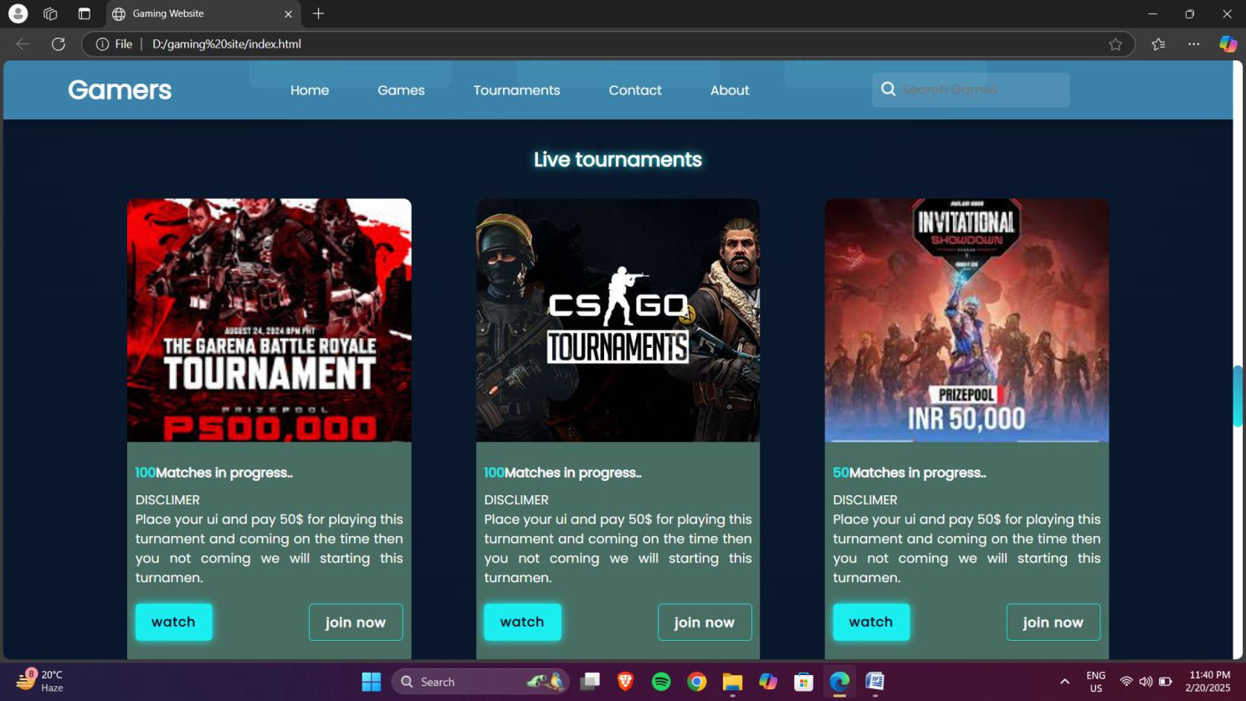

3

