**SOFTWARE MANAGEMENT PLAN**

**FOR**

**TRAINIA**

**MARCH 22, 2021**

**MEMBERS: PHUONG DINH NGUYEN, GIGI CALDAMO, MAMADOU NDIONG, TONGWA AKA, AND JONATHAN SCHIMPF**

**VERSION 2**

**PART 1: INTRODUCTION**

## 1.1 Project Overview

Congress has decided to allocate a generous budget to the DOE for a team of experts, given the popularity of “gaming”, to gamify some sort of engaging website for today’s teens in some type of subscription-based, online gaming system would be an ideal to educate them on fitness/nutrition. The technical process section will include the specifications of the technical models, tools, and techniques that will be used to develop the products and infrastructure.

The general purpose of the website would be to create a fun, interactive learning environment for teens to become more aware of what they should be doing to maximize their performance in a given sport.

## 1.2 Project Deliverables

All work deliverables will be provided online on the project homepage by March 31st, 2021 via internet.

The following items will be produced by the group 2:

* A **Software Project Management Plan** defining the technical and managerial processes necessary for the development and delivery by Group 2.
* **Sequence Diagrams** between client and developers, representing a contract between the client and the developers of what is going to be delivered.
* A **Component Diagram** describing the functional and global requirements of the system as well as 4 models - the use case model, the object model, the functional model and the dynamic model. This document is created in interaction with the application domain experts.
* A **System Design Document** describing the design goals, tradeoffs made between design goals, the high-level decomposition of the system, concurrency identification, software platforms/tools. This document forms the basis of the object design.

## 1.3 Evolution of the SPMP

The software project management plan is under version control. Proposed changes and new versions of the plan are announced in the submission links, repository meetings and announce and are made available to all the project members.

## 1.4 Reference Materials

* Complete list of materials referenced in SPMP

## 1.5 Definitions and acronyms

* API - Applications Programming Interface
* GUI - Graphical User Interface
* ODD - Object Design Document
* RAD - Requirements Analysis Document
* SDD - System Design Document
* SPMP - Software Project Management Plan
* UML - Unified Modeling Language

**PART 2: PROJECT ORGANIZATION**

## 2.1: Process Model

After reviewing the proposal, we have decided to adopt the Agile Development process model against all other models to best meet all client requirements. Taking into consideration the feasibility of this project scope, the proposed development process allows us to commence development as soon as possible while constantly communicating with the client allowing room for version iteration updates, and proper documentation of requirement updates throughout the development lifecycle.

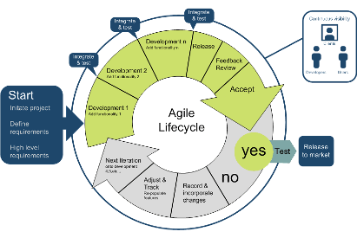

**Project milestones**:

* **Use Cases/ Sequence Diagrams**: With both diagrams being essential to commence project development and taking the first steps towards a working prototype, they both are set to start on week 3 and be ready by midweek 4. The rest of Week 4 is used for a QA session with the client before the parallel commencement of different phases of development on week 5.
* **System Testing**: System testing is integral to ensure a working prototype per the DOE’s request. A first test is done on week 7, allowing the following three weeks to be used for feedback implementation. Weeks 11 – 13 are ten used to derive a final prototype to be presented to the client.
* **Presentation**: A working prototype is expected to be ready by the start of week 14. At this stage, documentation, along with a presentation for the DOE, should be created for the end of week 15.

**Gantt Schedule**

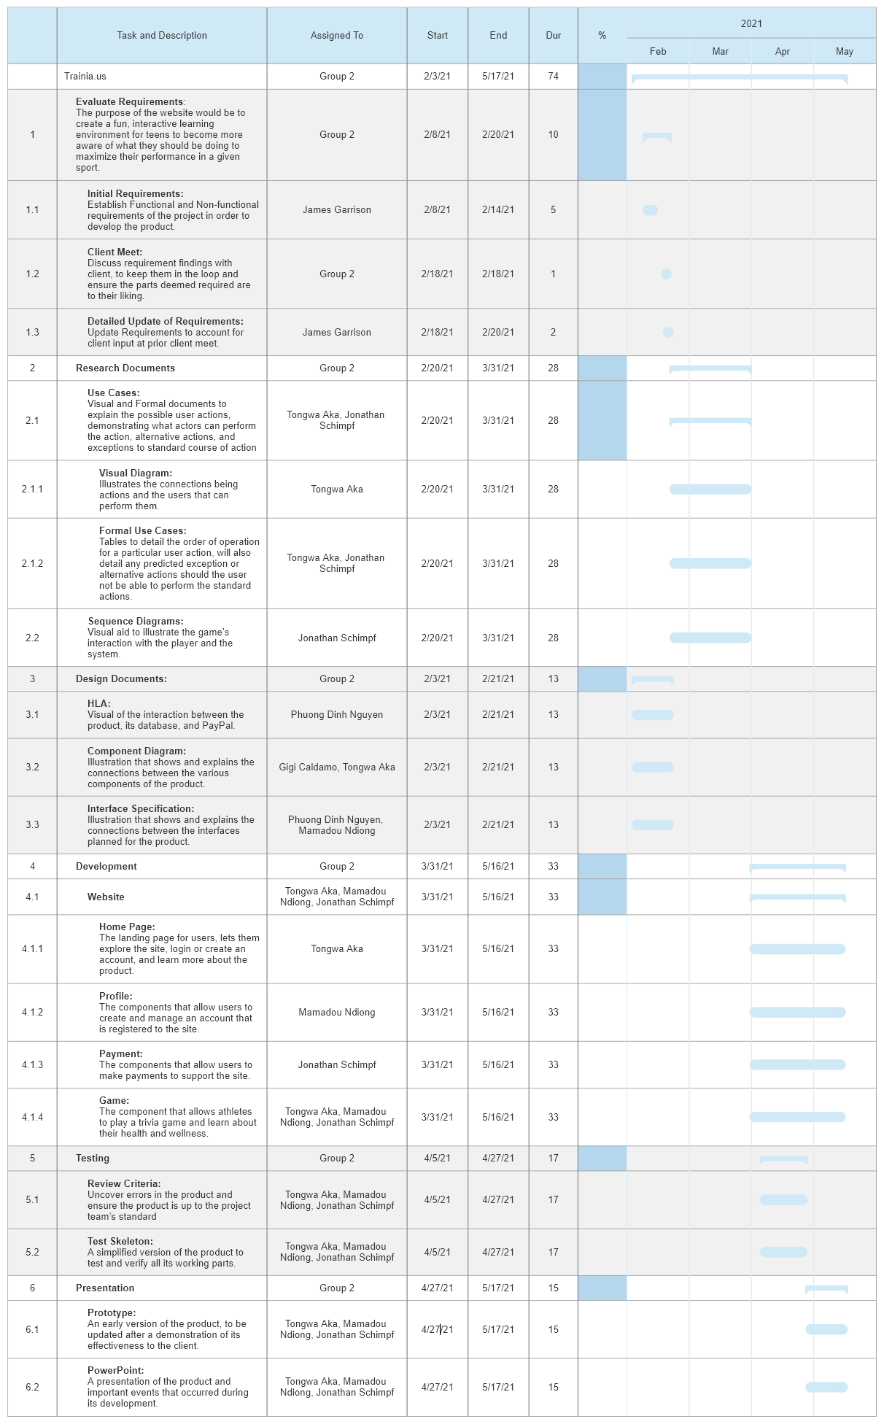

## 2.2: Organizational Structure

**Project roles**

* **Project Manager**: Lays out a blueprint for the whole project by planning, scheduling, budgeting, and overlooking the execution and delivery of the prototype.
* **Documentation**: Responsible for storing, cataloging, and retrieving all information related to the project making sure that all the feedback gathered from all QA sessions are annotated, and archived chronologically.
* **Developer**: Works with the design and the rest of the team to develop a working prototype per client’s proposal. Suggests tools/ plugins/ platforms to use towards the development of the project.
* **Designer**: Communicates with both the client and developers to create a prototype that represents the client’s requirements as much as the business value at a reasonable cost.
* **QAs**: Organizes weekly meetups with the DOE to discuss updates, and progress of development.

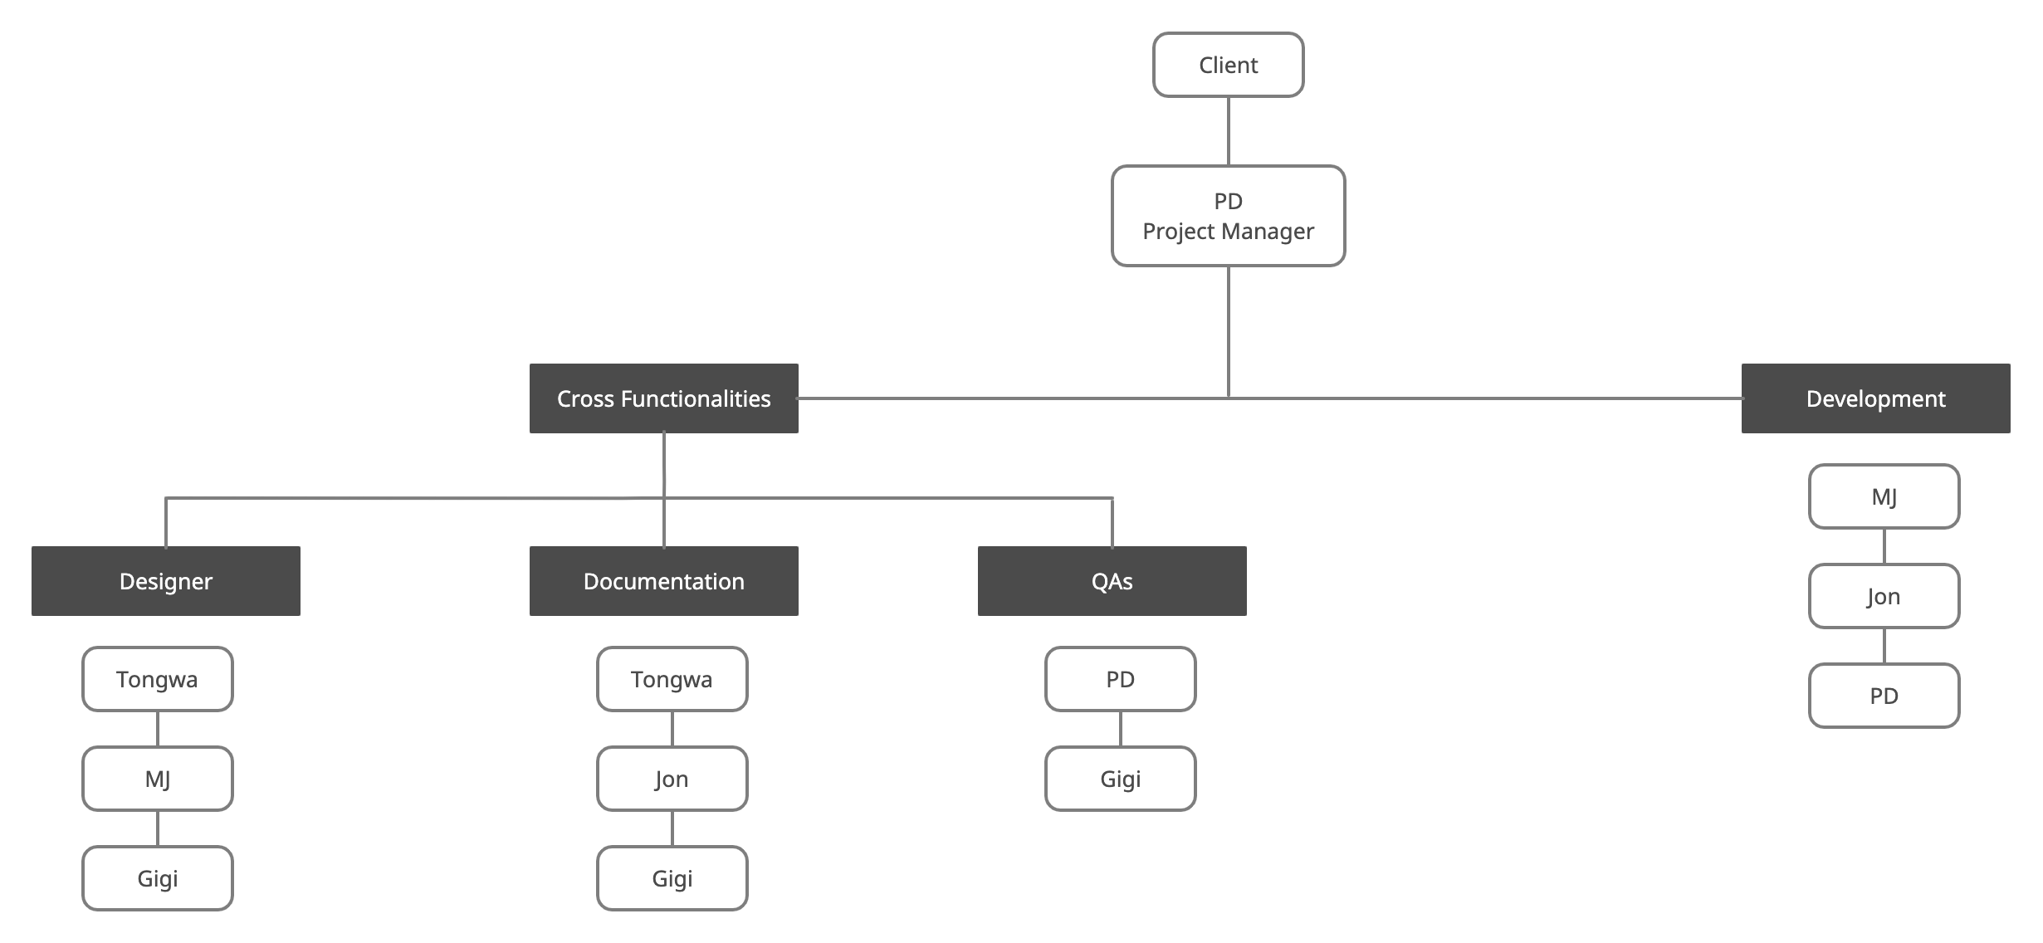

## 2.3: Organizational Interfaces

The client(s) for [website name] is (are): The DOE, schools who choose to adopt this new interactive learning environment, and the parents of children in said schools.

* The project manager is PD Nguyen.
* Those in charge of documentation are Tongwa Aka, Jonathan Schimpf, and Gigi Caldamo.
* The development team consists of MJ Mustafa, Jonathan Schimpf, and PD Nguyen.
* The design team consists of Tongwa Aka, MJ Mustafa, and Gigi Caldamo.
* QAs are carried out by PD Nguyen, and Gigi Caldamo.

## 2.4: Project Responsibilities

|  |  |  |  |  |  |
| --- | --- | --- | --- | --- | --- |
|  | Project  Manager | Documentation  Team | Development  Team | Design  Team | QAs |
| System Design | √ |  | √ | √ |  |
| Implementation | √ | √ | √ | √ | √ |
| Testing | √ | √ | √ | √ | √ |

**PART 3: MANAGERIAL PROCESS**

## 3.1: Management Objectives and Priorities

In order to complete the objectives and requirements for the website we need to incorporate a management philosophy that includes:

* Treating everyone on the team with respect.
* Providing an environment virtually that results in work efficiency.
* Managing time effectively to complete individual and collaborative tasks.
* Communicating with each other if any concerns arise.
* Working with the client to produce satisfactory results.

Prioritizing requirements is needed in order to decide what needs more focus as time is one of the constraints for every project. In order to do so, we must speak with the client to determine what is most important to them and if there is anything in particular that they want to see in the end product. This must be done before development begins so that there will not be additional issues as to what must be completed first. In terms of building a schedule, we must create a working prototype by May. Along the way, we have to set deadlines for ourselves when we have to finish certain tasks of the project including development, testing, modifying, and reporting.

## 3.2: Assumptions, Dependencies, and Constraints

As with every project, there are constraints that limit the efficacy of work development. Given the situation we are in, we are not able to collaborate in person to work on the product. Therefore, we need to work on our individual tasks as well as set up meetings as often as possible given we all have differing schedules. In addition, we need to make time to meet with the client to update them and to see if they have any additional requirements. This project also depends on deadlines and making sure we finish what we need to for the given week.

## 3.3: Risk Management

The risks of this website development include:

* **Member leave**
  + If a member leaves the team, work still has to get done
  + Workload must be evenly distributed amongst the rest of group members
* **Project is too large**
  + If this is the case, we need to speak with the client to let them know which requirements are not achievable
* **Not enough time**
  + We must again speak with the client to let them know what can be done with the time frame we are given
* **Client acceptance**
  + To try to avoid this issue, we need to show the client periodically what we have so far so that in the end there won’t be much to modify
* **Lack of contribution**
  + If a team member is not contributing much to the team, we must address the issue as a whole beforehand and if it occurs because at the end of the day, the work has to get done
* **Miscommunication**
  + We must constantly communicate with each other and the client to minimize this risk

## 3.4: Monitoring and Controlling Mechanisms

We need to document every step of the development and modification process. In addition, we need to report the results of our system testing to determine what needs to be modified and what was successful during the test. These reports and changes in documentation will be reported weekly to the rest of the project team.

## 3.5: Staffing Plan

The staff personnel are simply the members of the group. The project group size has been halved since development was started, so work must be distributed amongst the remaining members of the group.

**PART 4: TECHNICAL PROCESS**

## 4.1: Methods, Tools, and Techniques

The group will be using object-oriented methods in the development of the product.

The group has not made any final decisions on development tools at this point in time. When the group has reached a decision on the tools to be made, this section will be updated to detail the conclusion.

## 4.2: Software Documentation

A number of documents will be completed by the members of the project group over the lifetime of the project. The list of documents that will be created and maintained through the project include:

* Requirements specification: defines the functionality that the client requires
* Design specifications: defines the system structure
* Risk analysis reports: defines risk handling issues
* Test results: tests that are completed are to be recorded
* Reviews: review documents of the phases of the project

## 4.3: Project Support Functions

## 4.3.1: Quality Assurance Plan

The project team’s quality assurance plan is a part of a separate document, Group 2 Quality Assurance Plan, and will be maintained separately.

## 4.3.2: Configuration Management Plan

The project team’s configuration management plan is a part of a separate document, Group 2 Configuration Management Plan and it will be maintained as such.

## 4.3.3: Verification and Validation Plan

The SPMP shall contain the verification and validation plan for the software project and its tools, techniques and responsibilities for the verification and validation work activities. The verification and validation plan will be part of a separate document and will be separately maintained.

**PART 5: DESCRIPTION OF WORK PACKAGES**

Website Application

* Evaluate Requirements
  + Initial requirements - Week 3
  + Detailed requirements - Week 4
* Research
  + Use Cases - Weeks 3-4
  + Sequence Diagrams - Weeks 3-4
* Design
  + Design Documents - Week 4
    - HLA
    - Class/Component Diagram
    - Interface Specification
* Develop
  + Website
    - Coding the website
  + User Manual
* Test
  + System testing
  + Document and report test results
* Present
  + Prototype – Week 13-15
  + PowerPoint - Week 15

