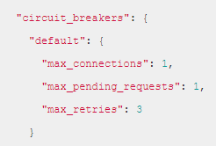Circuit breaker:

Bulkhead pattern:

* Prevents the entire system from failing when one part fails
* Similar idea is used for Hystrix and Envoy circuit breaker

Hystrix:

* Two approaches: Thread isolation and Semaphore Isolation
  + Thread Isolation: direct all request to a separate pool with a fixed number of threads
  + Semaphore: calls need to acquire a permit from the service they are calling before making request to that service, no permit means service is down and the call will be stopped

Envoy:

* Circuit breaker:
  + limited the number of connections and pending request
  + number of retries are defined
  + in practice, there are some leeway, this is not hard limits
* Outlier detection:
  + Detects services that are not working, or not reliable
  + Detect then eject the service from the cluster load balancing pool, for a period of time (sleep window).
    - By default, the ejected time = (# of consecutive fails * interval_ms)
  + During the duration of sleep window, the service is excluded from routing and load balancing
* Cluster Panic:
  + Too many host ejected by the outlier detection, panic threshold default is 50%
  + In panic mode, proxy will disregard all health condition of load-balancing pool and route to all hosts again
* Fault tolerance
  + Features in Istio includes retries/timeouts, circuit breaker, health checks, fault injection, connection pool control,