**DATA ANALYTICS FOR HEALTH CARE QUALITY**

Dr. M. Kamakshaiah

[kamakshaiah.m@gmail.com](mailto:kamakshaiah.m@gmail.com)

Health care quality is a level of value provided by any health care resource, as determined by some measurement. The goal of health care is to provide medical resources of high quality only to ensure good quality of life, to cure illnesses when possible, to extend life expectancy, and so on.

Researchers use a variety of quality measures to determine health care quality, which might include therapy's reduction, efficiency in medical diagnosis, preventive care, or a survey of health indicators for public health. Health care quality is the degree to which health care services increase the likelihood of desired health outcomes. Few approaches available for health care quality are as follows:

***1. Meta Analysis***

A meta-analysis is a statistical analysis that combines the results of multiple scientific studies. The basic tenet behind meta-analyses is that there is a common truth behind all conceptually similar scientific studies, but which has been measured with a certain error within individual studies. The aim then is to use approaches from statistics to derive a pooled estimate closest to the unknown common truth based on how this error is perceived. In essence, all existing methods yield a weighted average from the results of the individual studies and what differs is the manner in which these weights are allocated and also the manner in which the uncertainty is computed around the point estimate thus generated. In addition to providing an estimate of the unknown common truth, meta-analysis has the capacity to contrast results from different studies and identify patterns among study results, sources of disagreement among those results, or other interesting relationships that may come to light in the context of multiple studies.

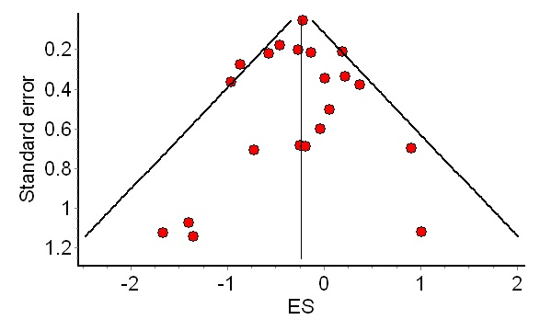

**Practice**: Patient safety

Referemce: <https://www.ncbi.nlm.nih.gov/pubmed/10689266>(Amlodipine)

***2. Donabedian model:***

a common framework for assessing health care quality and identifies three domains in which health care quality can be assessed: structure, process, and outcomes.

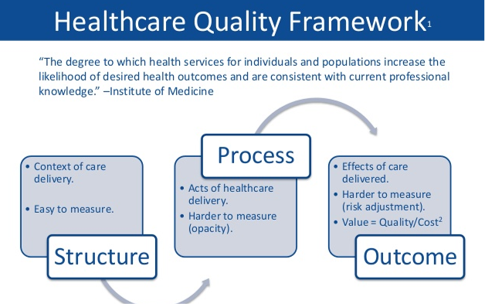

***3. Sixsigma:***

Six Sigma (6σ) is a set of techniques and tools for process improvement. A six sigma process is one in which 99.99966% of all opportunities to produce some feature of a part are statistically expected to be free of defects.

Six Sigma strategies seek to improve the quality of the output of a process by identifying and removing the causes of defects and minimizing variability in manufacturing and business processes. It uses a set of quality management methods, mainly empirical, statistical methods, and creates a special infrastructure of people within the organization who are experts in these methods. Each Six Sigma project carried out within an organization follows a defined sequence of steps and has specific value targets, for example: reduce process cycle time, reduce pollution, reduce costs, increase customer satisfaction, and increase profits.

***3.1. Methodologies***

* DMAIC - used for projects aimed at improving an existing business process.
* DMADV - used for projects aimed at creating new product or process designs.

***3.1. DMAIC***

***3.1.1. Pereto Chart***

A Pareto chart, named after Vilfredo Pareto, is a type of chart that contains both bars and a line graph, where individual values are represented in descending order by bars, and the cumulative total is represented by the line. The purpose of the Pareto chart is to highlight the most important among a (typically large) set of factors. In quality control, it often represents the most common sources of defects, the highest occurring type of defect, or the most frequent reasons for customer complaints, and so on.

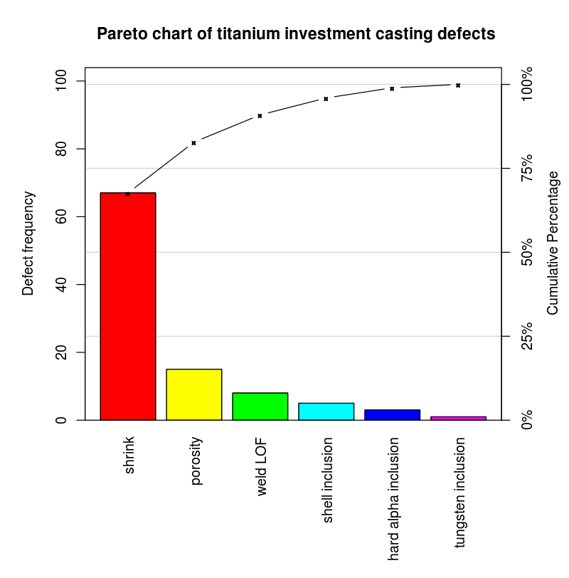

**Practice:** Health care error detection and rectification

***3.1.2. Gage Capability***

Measurement system analysis (MSA) is indispensable to quality management. Neither quality control nor quality improvement can be done without being able to take reliable measurements. In quality improvement projects it is standard practice to assess the reliability of measurements before doing any analyses. In particular, in the second phase of a Six Sigma project, the Measure phase, the measurement procedures need to be validated. A very important aspect of the quality of a measurement procedure is its precision, or the measurement variation.

The quality of measurements is determined by the accuracy and the precision of the measurement. The precision of a numerical measurement can be determined by a gage R&R experiment. The purpose of a gage R&R experiment is to estimate the measurement spread and to find out what part of the measurement spread is caused by repeatability and what part by reproducibility of the measurement system.

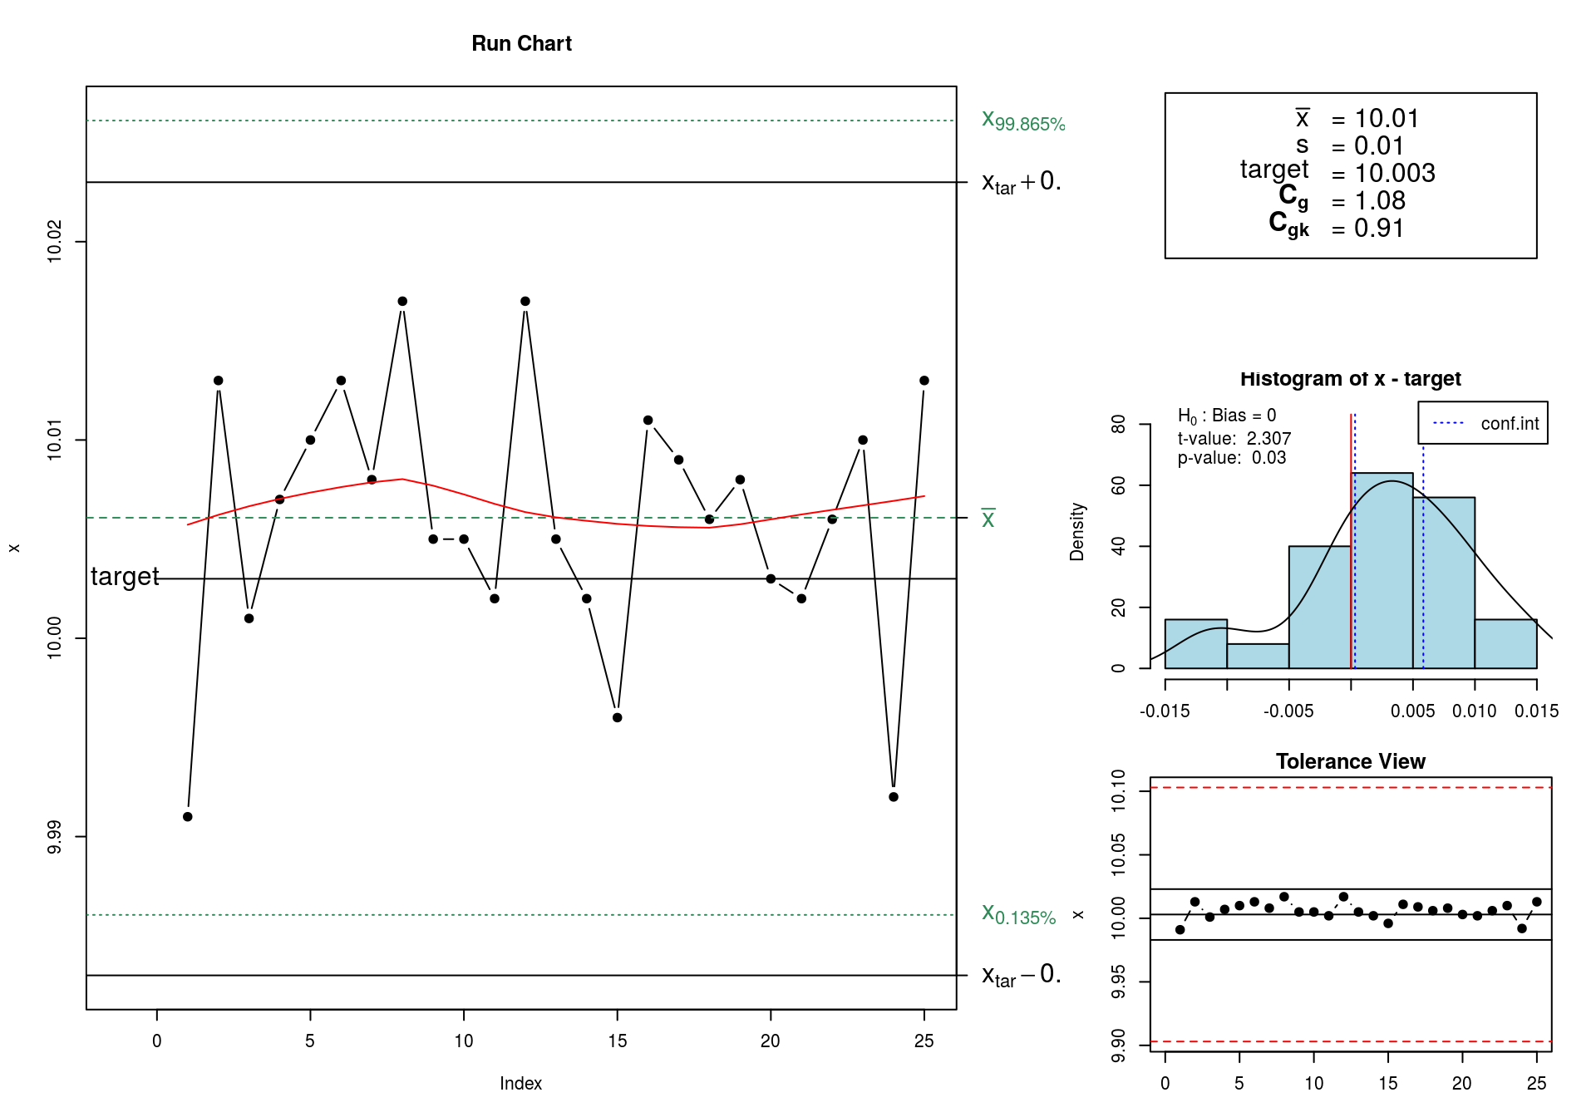

**Practice:** Patien’t body temperature

***3.1.3. Process Capability***

A process is a unique combination of tools, materials, methods, and people engaged in producing a measurable output; for example a manufacturing line for machine parts. All processes have inherent statistical variability which can be evaluated by statistical methods.

The process capability is a measurable property of a process to the specification, expressed as a process capability index (e.g., Cpk or Cpm) or as a process performance index (e.g., Ppk or Ppm). The output of this measurement is usually illustrated by a histogram and calculations that predict how many parts will be produced out of specification (OOS).

Two parts of process capability are: 1) measure the variability of the output of a process, and 2) compare that variability with a proposed specification or product tolerance.

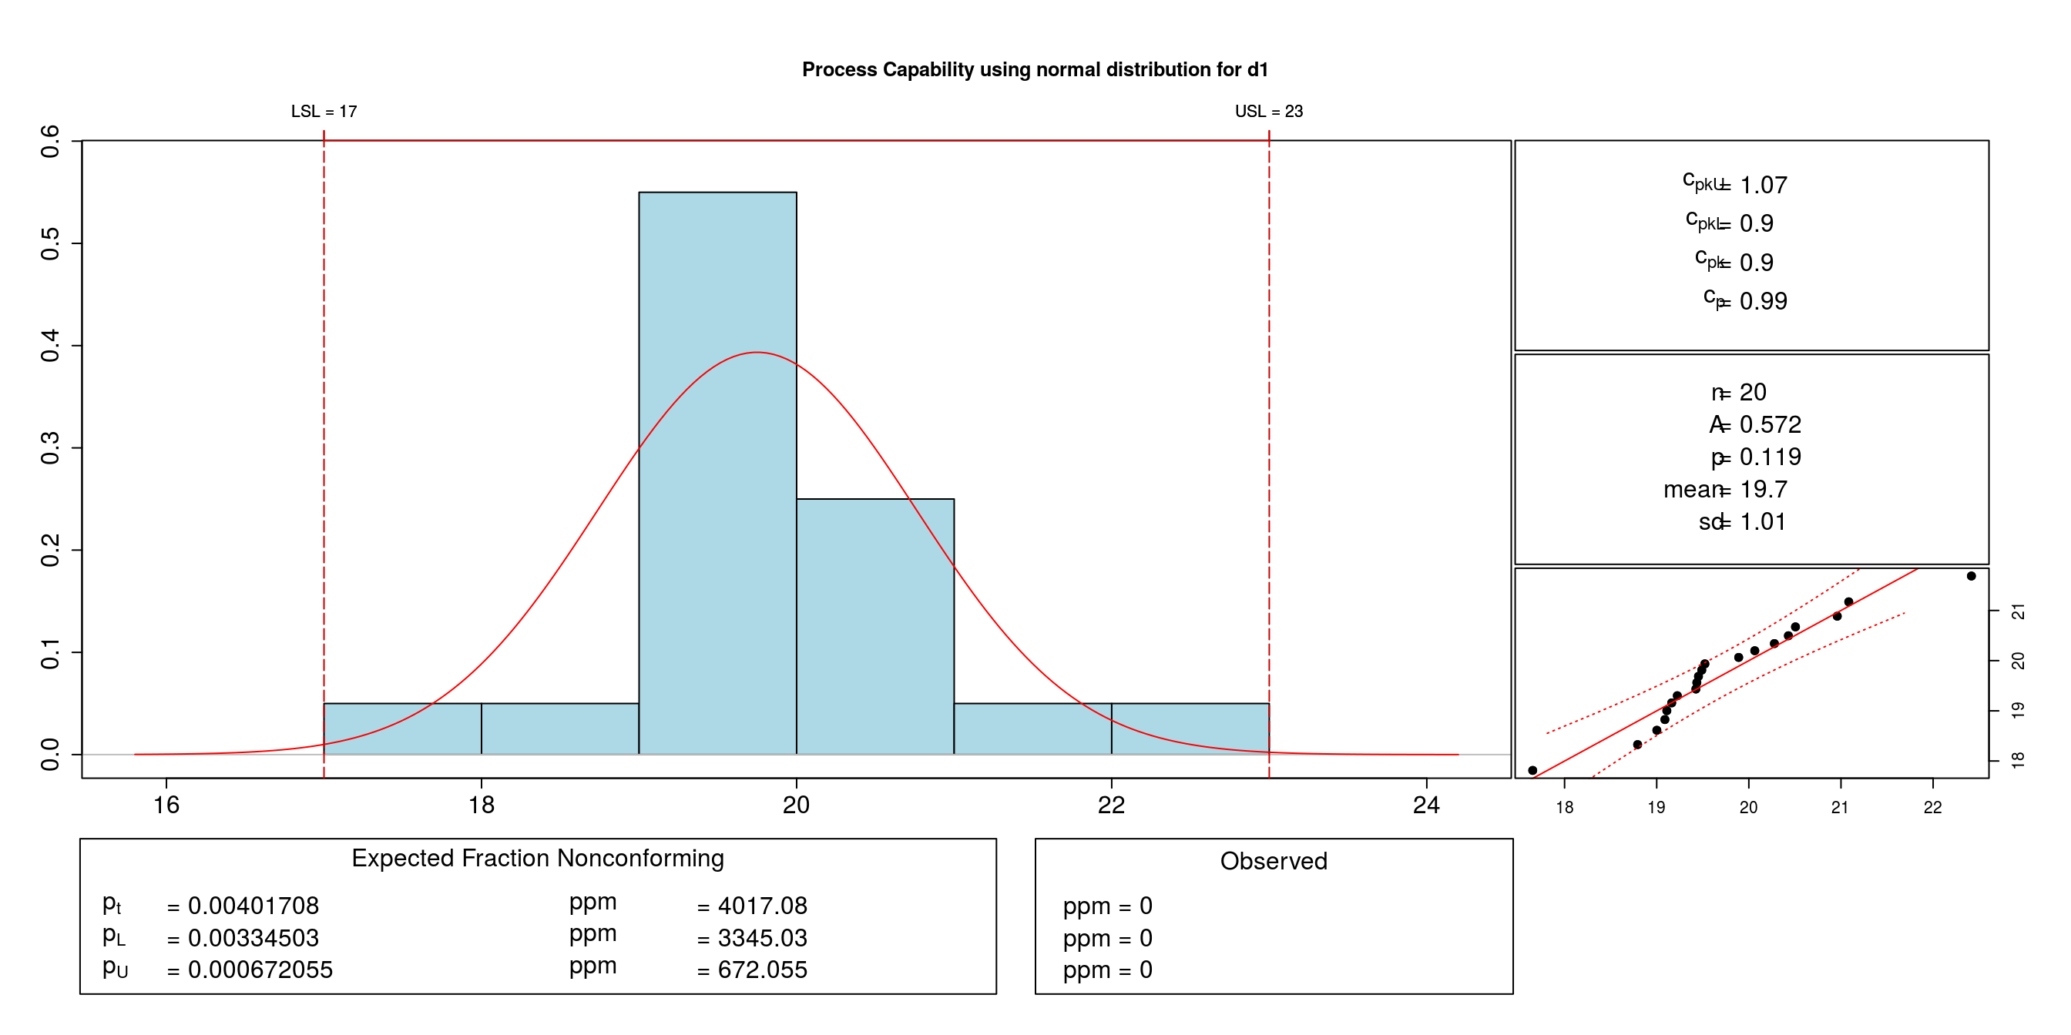

Process capability is one of the sought after techniques used in *clinical laboratories.* Undoubtedly clinical laboratories are the most important units of the healthcare sector, particularly in hospitals. Obviously, without accurate test results, physicians cannot make diagnoses or provide effective treatment. This is true even for experienced physicians. Currently, clinical laboratories affect 60~70% of all critical decisions.

**Practice**: Clinical laboratory quality

***3.1.4. Factorial Designs***

Randomised controlled trials provide the best quality evidence in medical research, but they require a large commitment of time and effort, certainly from the investigators and often from participants. As a result, trials can be expensive. For these reasons, investigators may consider evaluating more than one intervention in the same study. A factorial trial, where participants are allocated to receive neither intervention, one or the other, or both. There are number of factorial designs. The following are few methods widely used in healh care.

* 2k Factorial Designs
* 2k−p Fractional Factorial Designs
* Replicated Designs and Center Points
* Multiple Responses
* Moving to a process setting with an expected higher yield
* Response Surface Designs
* Using desirabilities together with designed experiments
* Mixture Designs
* Taguchi Designs

**Practice**: Asthma symptom study

***3.1.5. Statistical Process Controlling***

Statistical process control (SPC) is a method of quality control which employs statistical methods to monitor and control a process. This helps to ensure that the process operates efficiently, producing more specification-conforming products with less waste (rework or scrap). SPC can be applied to any process where the "conforming product" (product meeting specifications) output can be measured. Key tools used in SPC include run charts, control charts, a focus on continuous improvement, and the design of experiments. There are several methods implemented in this phase of DMAIC. Few of them are list below.

* Control charts variables: Xbar chart, R chart, S chart.
* Control charts atributes: p chart, np chart, c chart, u chart.
* Schewart control charts
* Operating characteristic function
* Cusum charts
* EWMA charts
* Cause-and-effect/Fishbone diagram.

**Practice**: Various examples with abstract data sets

***4. RfQASS***

RfQASS stands for R for Quality Analytics and Sixsigma which is server level web application meant for academics and industry practitioners engaging in quality analytics. The application right now serves DMAIC methodology of sixsigma. The methods are implemented using QualityTools package in R along with QCC. RfQASS doesn’t require any R programming knowledge. Implementation model of RfQASS is so simple viz., (1) Upload, (2) Perform and (3) Interpret.

While coming to methodology; The RfQASS package contains methods associated with the Define (M)easure (A)nalyze (I)mprove and Control (i. e. DMAIC) problem solving cycle of the Six Sigma Quality Management methodology. Usage of these methods is illustrated with the help of example datasets.



Visit <https://github.com/Kamakshaiah> to know more about RfQASS. RfQASS is open source project, so feel free to obtain, use, change and redistribute.