Best AI-powered architecture

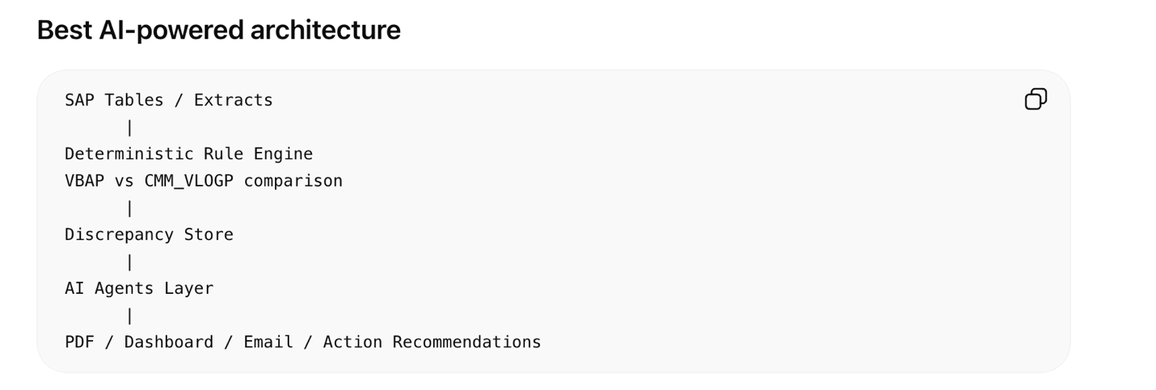

Where to create agents

1. Discrepancy Classification Agent
Purpose: classify each issue.
Examples:
Missing in CMM_VLOGP
Attribute mismatch
Possible qRFC failure
Possible sales order change issue
Possible duplicate/data integrity issue
No root cause found
This agent should not decide whether a discrepancy exists. The rule engine should do that. The agent explains and categorizes it.

2. qRFC Research Agent
Use for Scenario 1: missing in CMM_VLOGP.
Input:
VBELN
POSNR
QRFC_I_QIN_TOP result
QRFC_I_ERR_STATE result
Agent output:
Likely cause:
qRFC queue failed during commodity document creation.
Evidence:
Queue name matched sales order X.
UNIT_ID found.
Error message says Y.
Recommended action:
Reprocess qRFC queue or assign to SAP Basis / Commodity Management support.

3. Change History Agent
Use for Scenario 2: attribute mismatch.
Input:
VBAP value
CMM_VLOGP value
CDHDR/CDPOS changes
Agent output:
Likely cause:
Sales order schedule line was changed after commodity version was created.
Evidence:
CDPOS shows field X changed from old value to new value.
Recommended action:
Validate whether commodity version table should have been updated after this change.

4. Root Cause Summary Agent
Purpose: summarize all findings into business-friendly language.
Example output:
12 sales order items are commodity relevant but missing in CMM_VLOGP.
8 of these have matching qRFC errors, suggesting failed queue processing.
3 records show attribute mismatch after sales schedule changes.
1 record needs manual investigation because no qRFC or change document evidence was found.
This is very useful for the PDF summary section.

5. Action Recommendation Agent
Purpose: convert technical discrepancies into next steps.
Example:
Issue | Recommended Owner | Action
qRFC error found | SAP Basis | Reprocess failed queue
Attribute mismatch | SAP Commodity Team | Validate update logic
No CDPOS history | Functional Analyst | Review business process
Duplicate CMM_VLOGP | Data Team | Investigate duplicate creation

6. PDF Narrative Agent
Purpose: write the final PDF in a friendly format.
It can generate:
Executive Summary
What We Found
Why It Matters
Recommended Actions
Technical Appendix
This is where AI adds the most polish.

Agents I would avoid
Do not let AI directly decide:
Whether VBAP and CMM_VLOGP match
Whether an SAP record exists
Whether a field value is different
Those should be deterministic SQL / ABAP / Python rules.
AI should sit on top and explain:
What happened?
Why might it have happened?
Who should look at it?
What action should be taken?
How should this be written in the PDF?

Recommended Agent Design
Agent 1: Discrepancy Classifier
Agent 2: qRFC Investigator
Agent 3: Change History Investigator
Agent 4: Root Cause Summarizer
Agent 5: PDF Report Writer

