Wasselne Architecture Diagrams
Presents nine rendered architecture figures spanning the BRS, HLD and LLD. Each view identifies its requirement and design references so reviewers can connect the pictures to the written specifications.
Status For owner review
Word edition 0.2 | Source baseline 0.1 | 23 September 2026

Contents
BRS view business scope
HLD views logical responsibilities and runtime
LLD views offers records and critical workflows
Requirements traceability matrix
Figures D01 to D09 provide the business, component, deployment, sequence, state and data views.

BRS view business scope

D 01 People service and external responsibilities
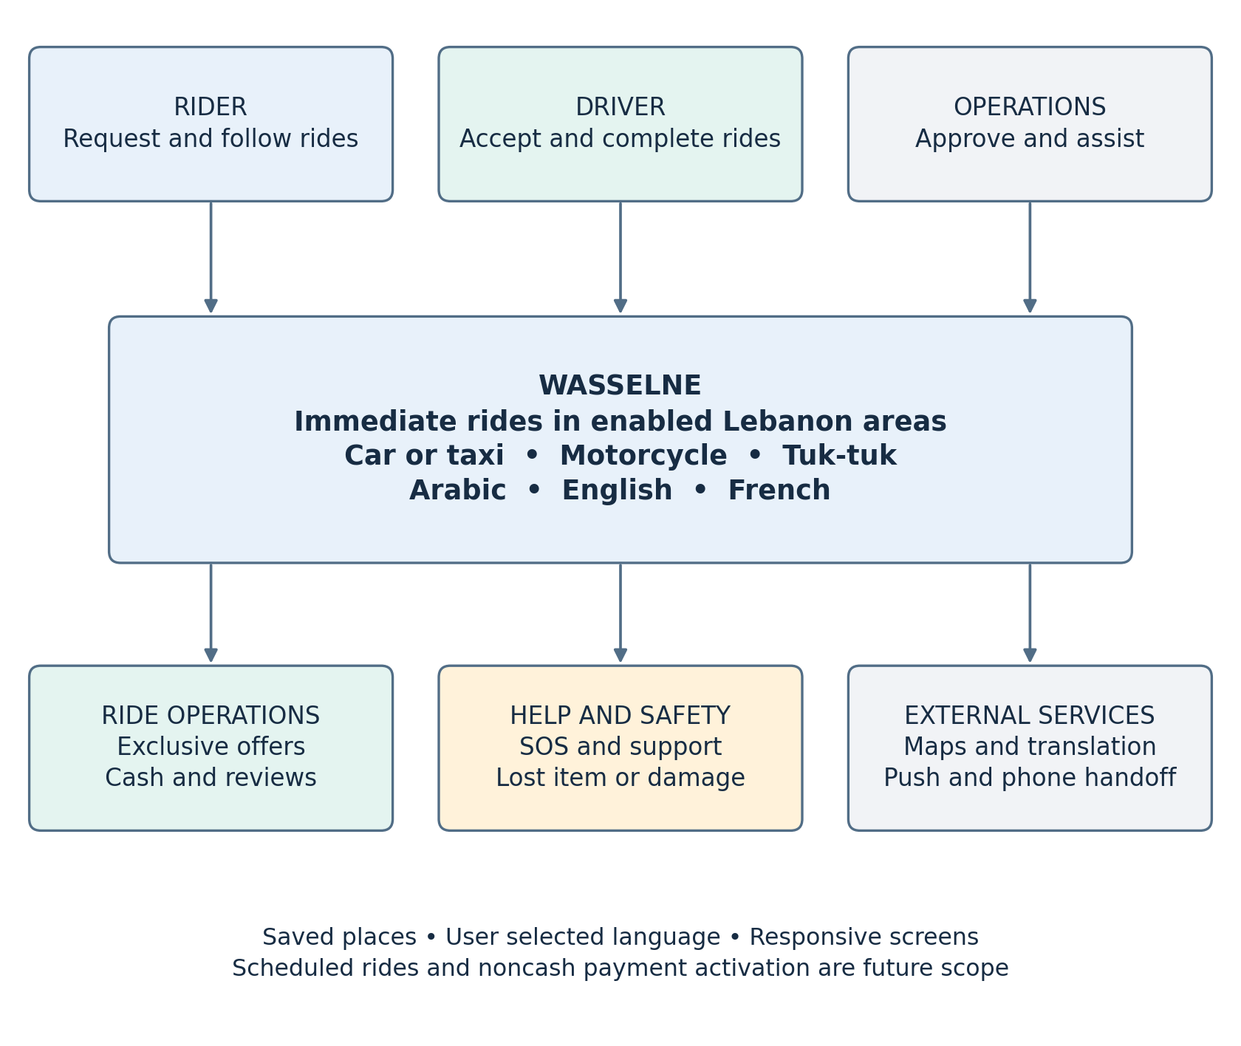
Scope within the platform: selected car/taxi, motorcycle and tuk-tuk categories; Arabic, English and French selection; saved places; CMS fares; one-driver-at-a-time offers; trip tracking; cash; post-confirmation ordinary calls; translated chat; configurable SOS; two-way reviews; and lost-item / vehicle mess or damage support. Staged city activation is controlled by approved area polygons. Scheduled booking and active OMT, Wish/Whish or bank payment are outside the enabled first-release flow. A public kiosk booking journey is TBD; adaptive screen layouts do not imply a live kiosk workflow.
Trace: BG-01–05; BR-01–49; NFR-06, NFR-10–11. D-01 identifies the business actors and boundaries; the diagrams below detail how specific requirements are fulfilled.

HLD views logical responsibilities and runtime

D 02 Booking location and dispatch components
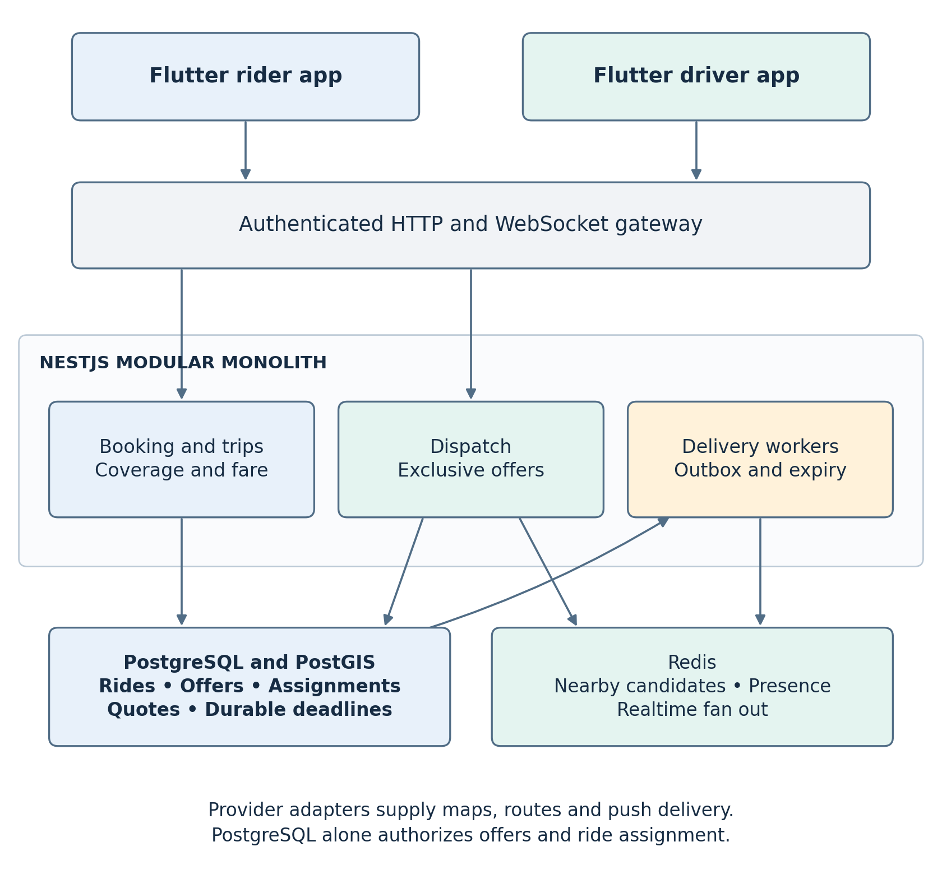
The backend checks live eligibility and database offer/assignment state after a Redis nearby-driver shortlist. Redis never decides whether an offer is valid or a ride is assigned. Maps provides routes and road ETA, not assignment authority. Workers recover from durable deadlines and outbox records. The driver app obtains the same CMS fare snapshot the rider saw; it has no price-entry flow.
Trace: HLD-01–02, HLD-04, HLD-07–14, HLD-19–20, HLD-22; LLD-01–02, LLD-04–07, LLD-09–10; BR-07–29, BR-45–46; NFR-01–03, NFR-07–08, NFR-12.

D 03 Operations communication and safety components
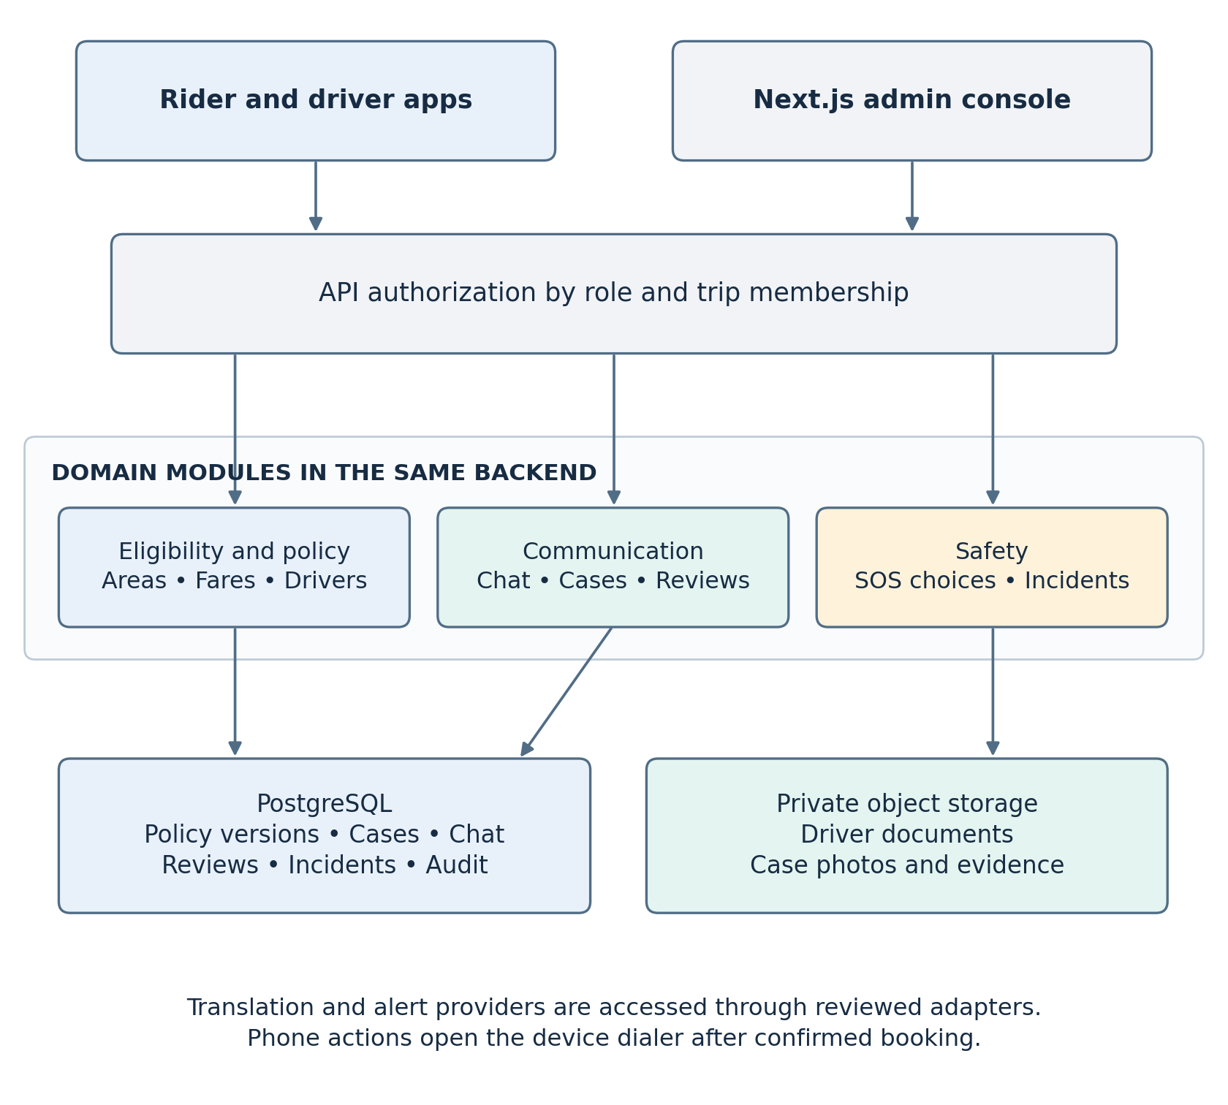
Staff publish versioned area, category, fare/currency and SOS policies under role-based permissions with an audit record. A ride preserves the agreed fare/currency version. Driver documents and case evidence remain private. Chat keeps the original text beside any translation. SOS reports the observed action status and requires an actual staffing and response policy before an alert choice is enabled. Ordinary telephone calls use the device dialer after confirmation; no phone masking is promised. Lost-item and driver damage reports create reviewable support cases, never an automatic rider charge.
Trace: HLD-01–07, HLD-11, HLD-14–18, HLD-19, HLD-21–23; LLD-01–05, LLD-07–10; BR-01–08, BR-14–16, BR-24–25, BR-30–49; NFR-04–07, NFR-09–11.

D 04 Deployment and failure boundaries
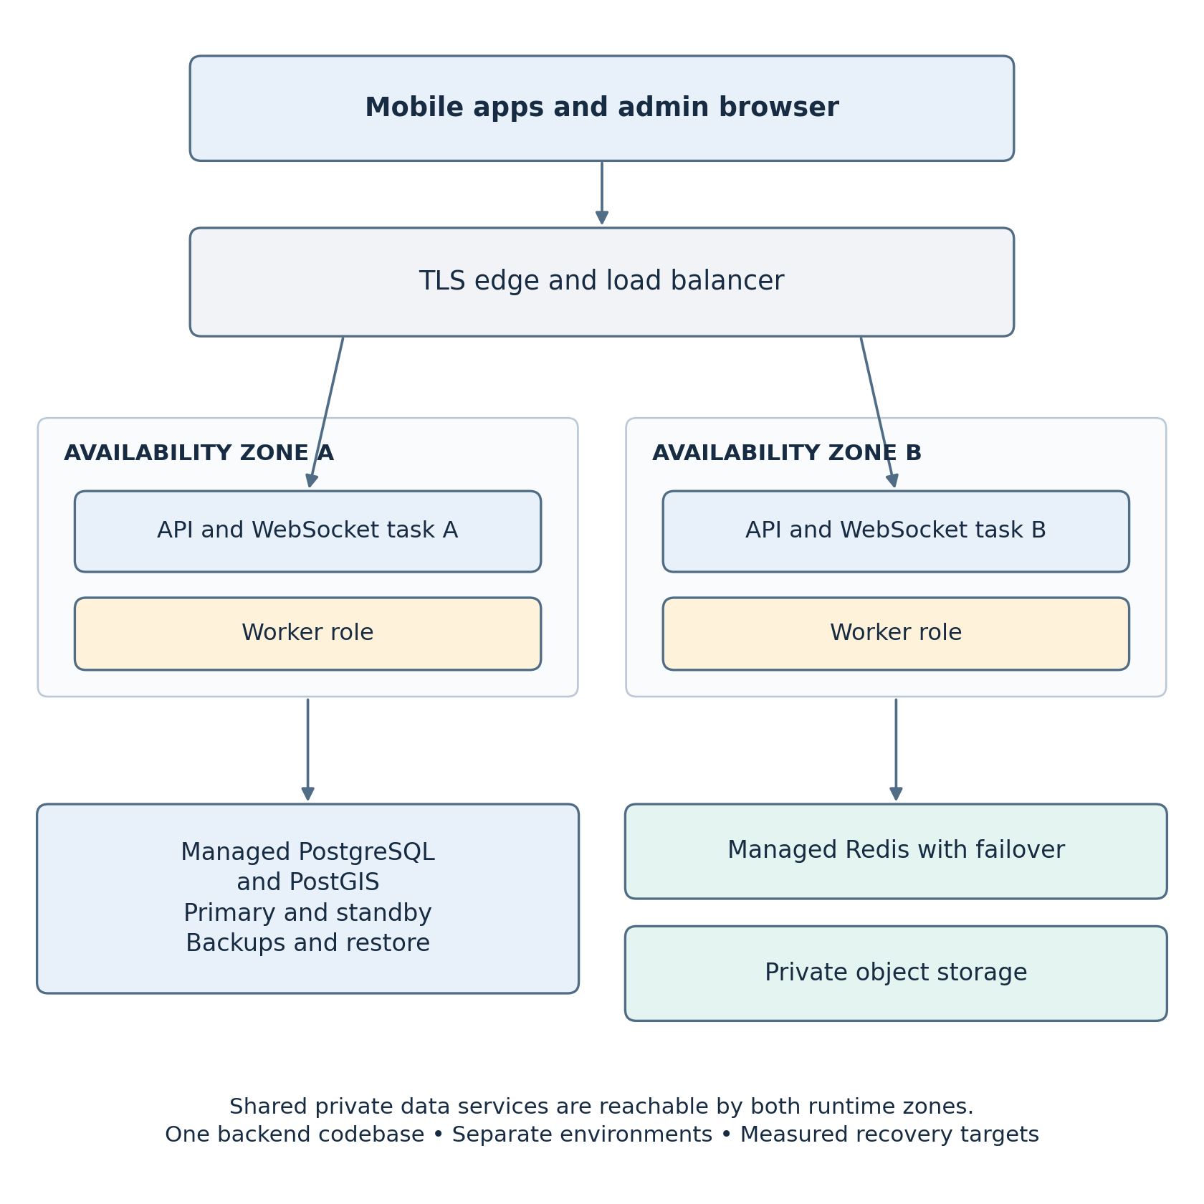
API/WebSocket processes and workers are deployment roles from one modular monolith. Production placement, cloud vendor, region, numerical availability targets, RPO/RTO and exact service sizing are TBD. DB failover can interrupt new acceptances; the system must not approve a ride from Redis during that interruption. Clients recover from server snapshots after reconnect. Development, staging, production, monitoring, backups, restoration exercises and controlled releases remain part of the platform plan.
Trace: HLD-04, HLD-08–10, HLD-14, HLD-19–24; LLD-04, LLD-06, LLD-09–10; BR-12–13, BR-17–22; NFR-01–05, NFR-07–08, NFR-12.

LLD views offers records and critical workflows

D 05 Exclusive offer and three second clock
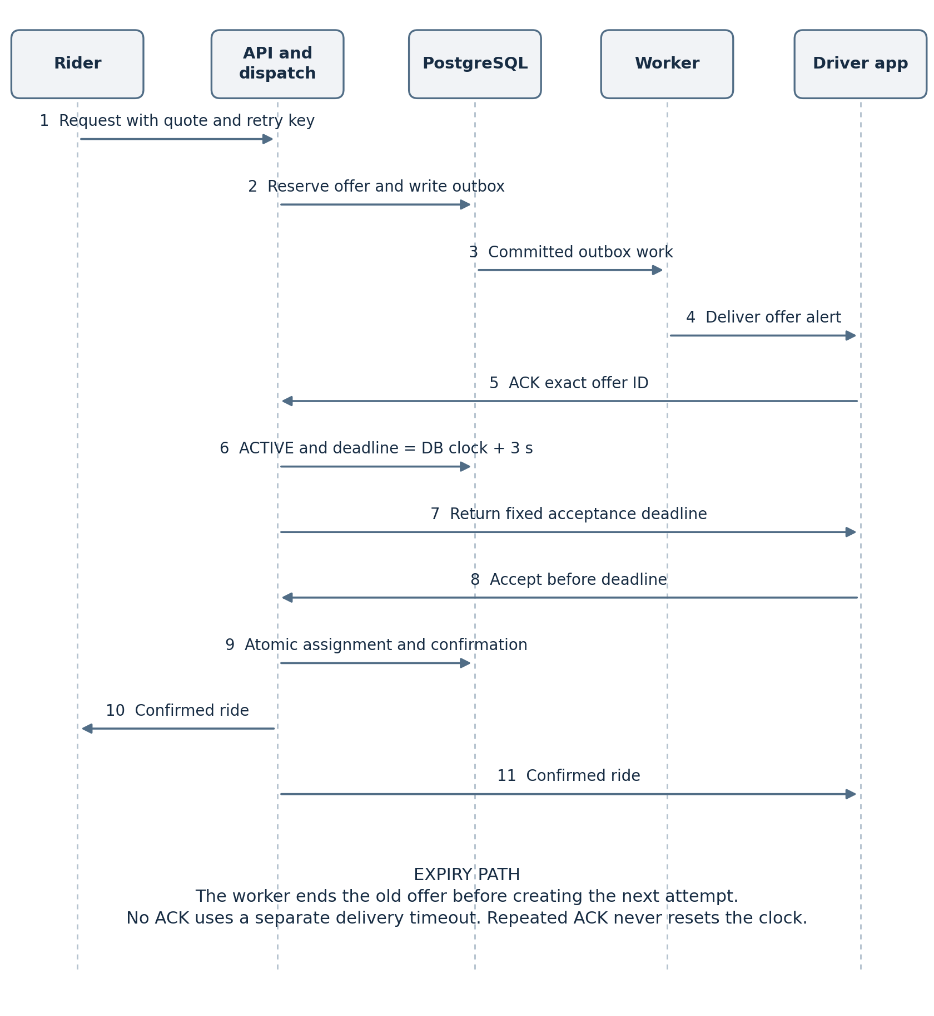
The worker-to-app arrow represents attempted delivery; it does not establish receipt or start the three seconds. An authenticated app ACK starts the three-second window from database time; repeated ACKs return the original deadline. Expired or late acceptances fail even if an old push arrives. Candidate lookup uses Redis GEOSEARCH before the first reservation transaction; the final eligibility, sole offer and sole assignment checks occur in PostgreSQL. Delivery-ACK timeout, reoffer cap, rider search limit and background-driver eligibility are TBD. When no other eligible driver remains, the same driver can receive a new offer ID under the eventual capped reoffer policy.
Trace: HLD-02, HLD-08–10, HLD-14, HLD-19–20, HLD-22; LLD-02, LLD-04, LLD-06–07, LLD-10; BR-09, BR-12–19, BR-22; NFR-01–03, NFR-07, NFR-12; VT-06–10, VT-17.

D 06 Offer state and database invariant
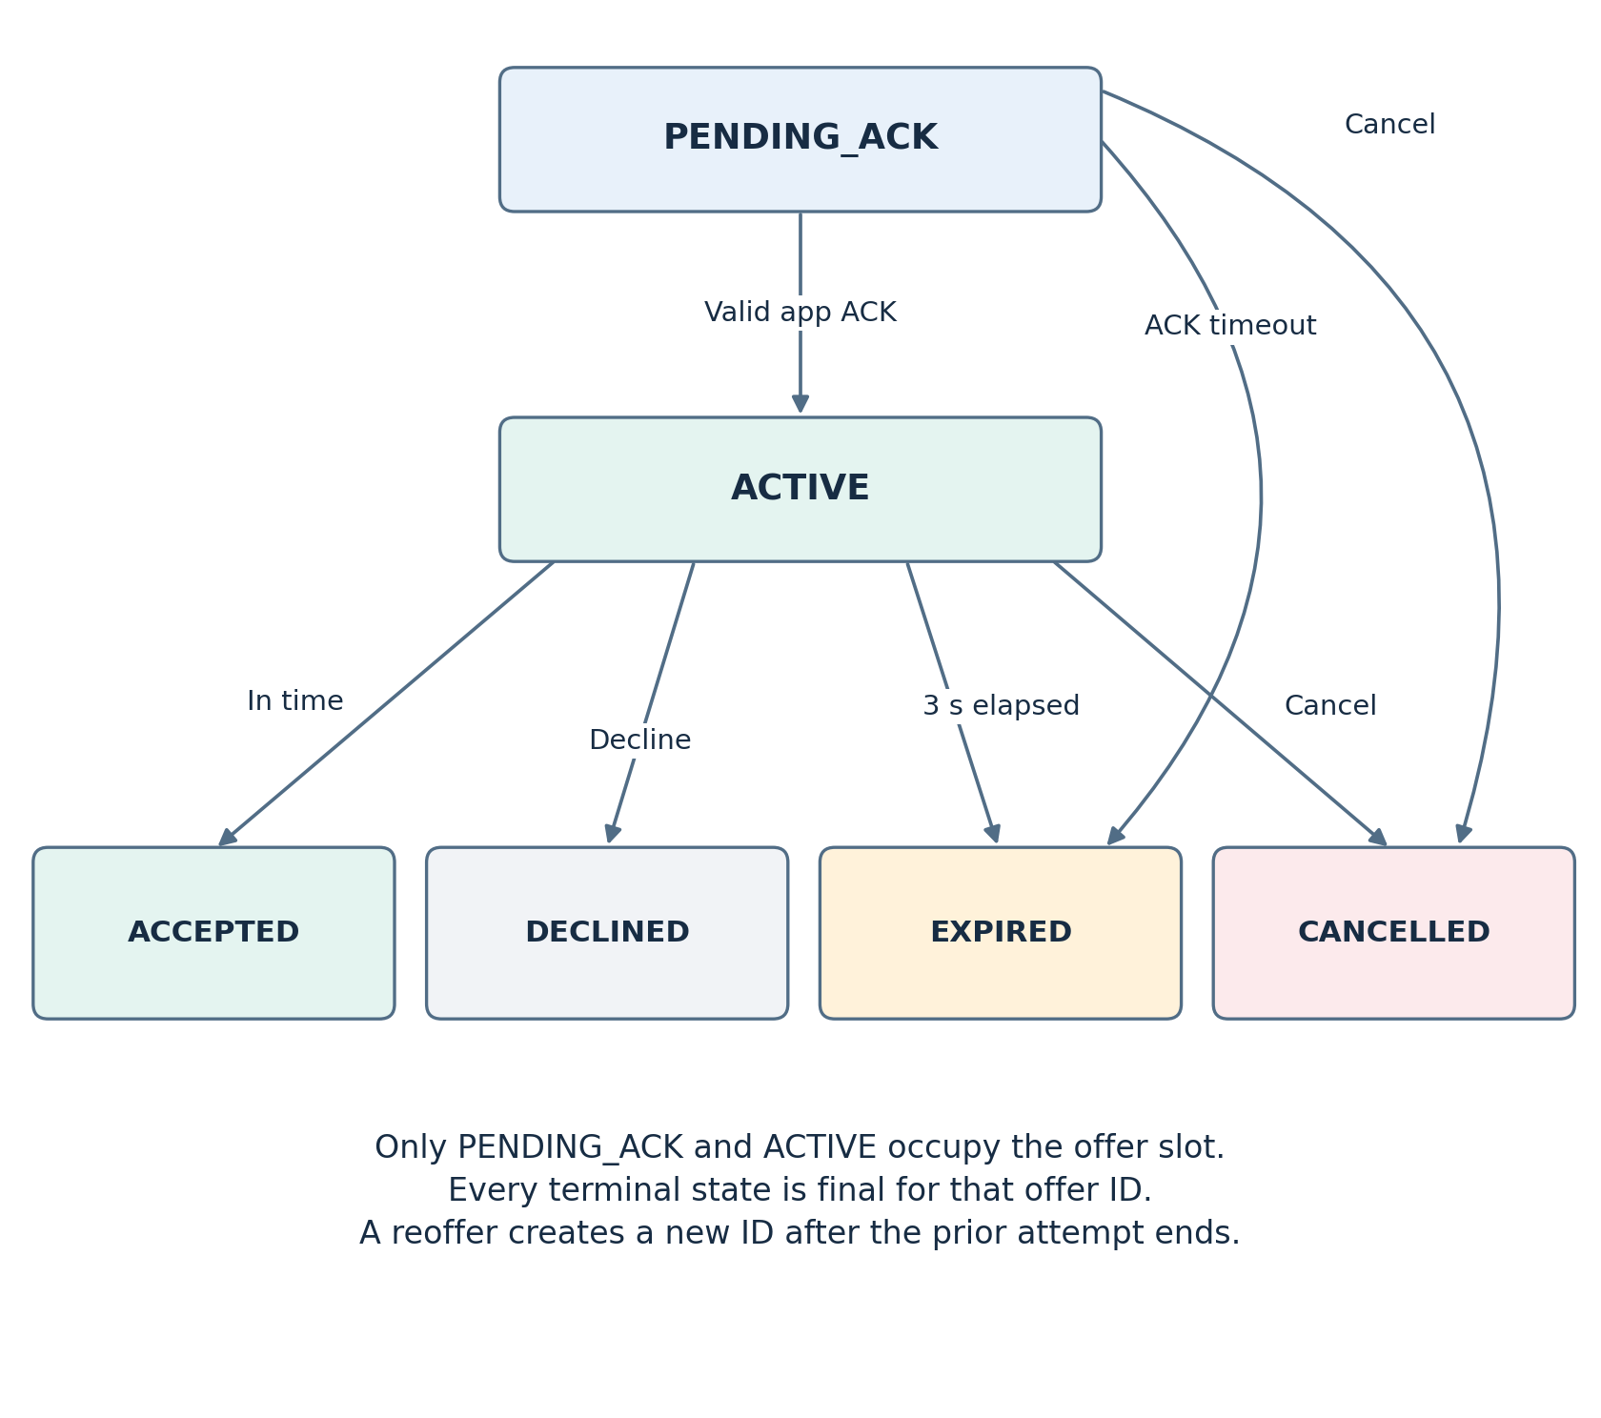
The same offer ID cannot leave a terminal state. Partial unique database indexes admit only one PENDING_​ACK or ACTIVE offer for each ride and each driver; separate partial unique indexes admit only one open assignment per ride and driver. Lock the parent ride during offer transitions, check driver eligibility and DB deadlines, and use idempotency keys for booking and acceptance. Driver acceptance itself moves the ride to CONFIRMED; no driver price proposal or second rider acceptance step exists. Push or WebSocket delivery does not override these database checks.
Trace: HLD-09–10, HLD-19, HLD-22; LLD-04, LLD-06–07, LLD-10; BR-12–13, BR-16–19, BR-22; NFR-02, NFR-12; VT-06–10.

D 07 Authoritative record and live data boundary
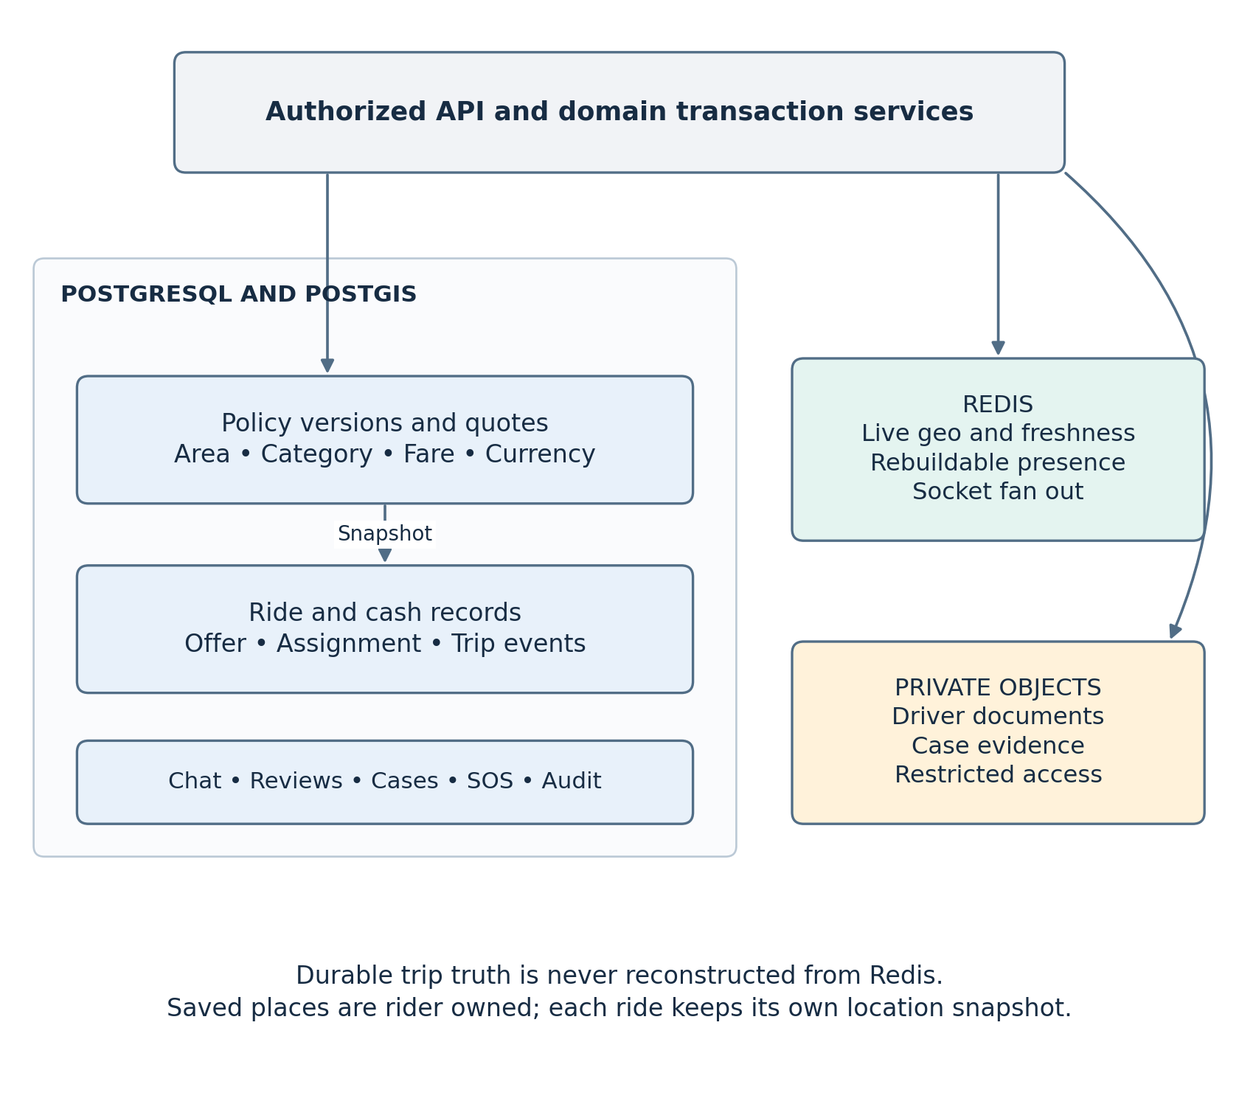
Each confirmed ride snapshots its quote's fare amount, currency and policy version. A saved place is owned by its rider and its coordinate is copied into the request; later edits never rewrite ride history. Redis GEO members must pass a separate freshness/accuracy/eligibility check; stale locations cannot produce offers. The driver and rider fetch an authoritative ride/offer snapshot on reconnect. Object bytes are accessed only through short-lived grants and ownership checks. No payment transaction is attempted for disabled OMT, Wish/Whish or bank methods. Cash collection is reported and reconcilable, not treated as externally verified settlement.
Trace: HLD-05–12, HLD-15–23; LLD-04–10; BR-05–29, BR-31–32, BR-34–49; NFR-02–05, NFR-07–09; VT-02–05, VT-10–16.

D 08 Safety support and post ride accountability
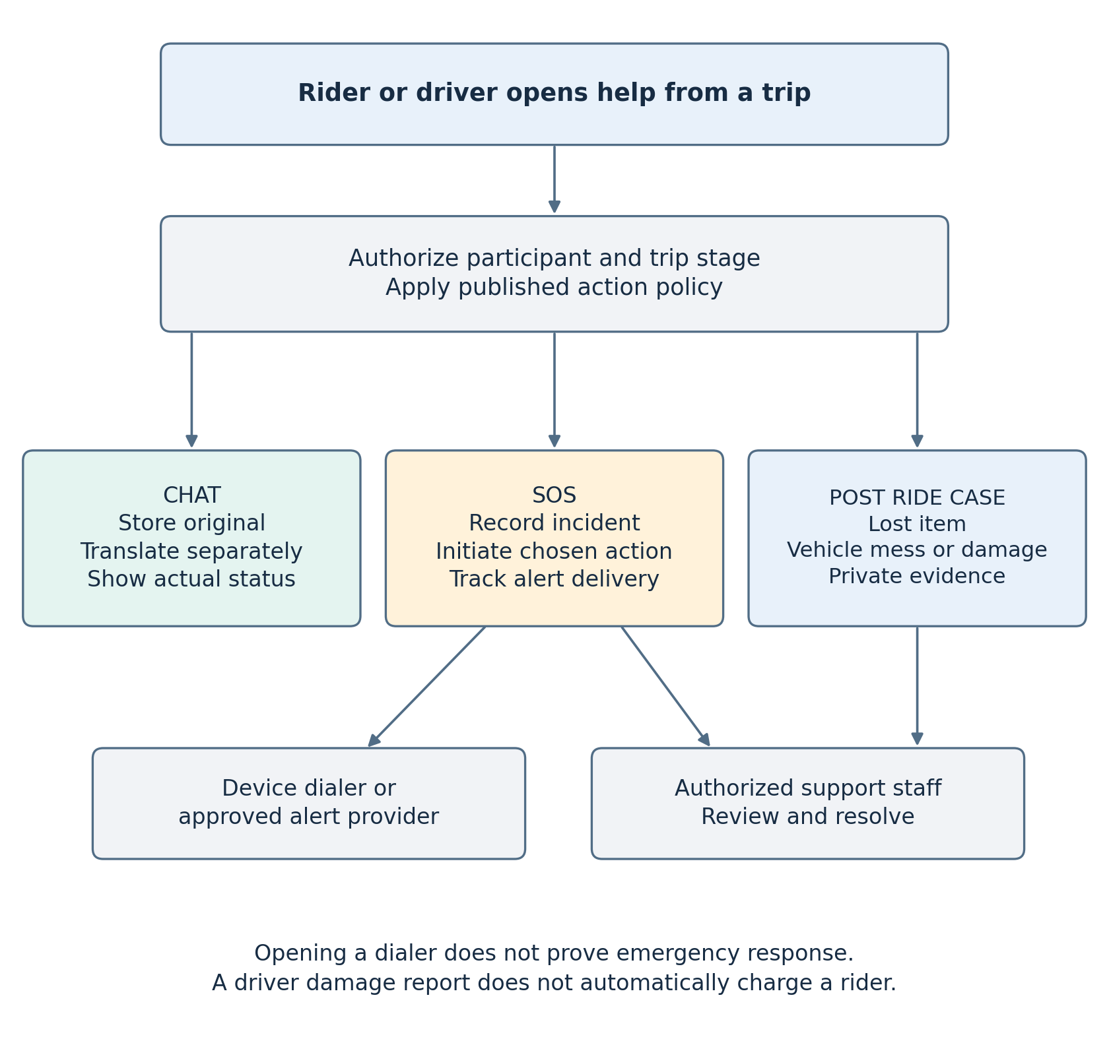
SOS choices are admin-published registered actions only. Opening an emergency dialer is not evidence that emergency services responded. Real alert options require a defined responder/channel and truthful delivery status. During the approved contact window after ride confirmation, a phone action opens the device dialer outside the app; caller IDs may be visible. After completion, rider and driver can each submit one trip-linked review of the other. A damage report opens a human-reviewed case with private evidence and no automatic rider charge. Response staffing, number exposure duration, review format and case remedies remain TBD.
Trace: HLD-14–18, HLD-19, HLD-21–23; LLD-02–04, LLD-08–10; BR-30–40, BR-42–43, BR-47–49; NFR-04–05, NFR-07, NFR-09; VT-13–16.

D 09 Core relational model
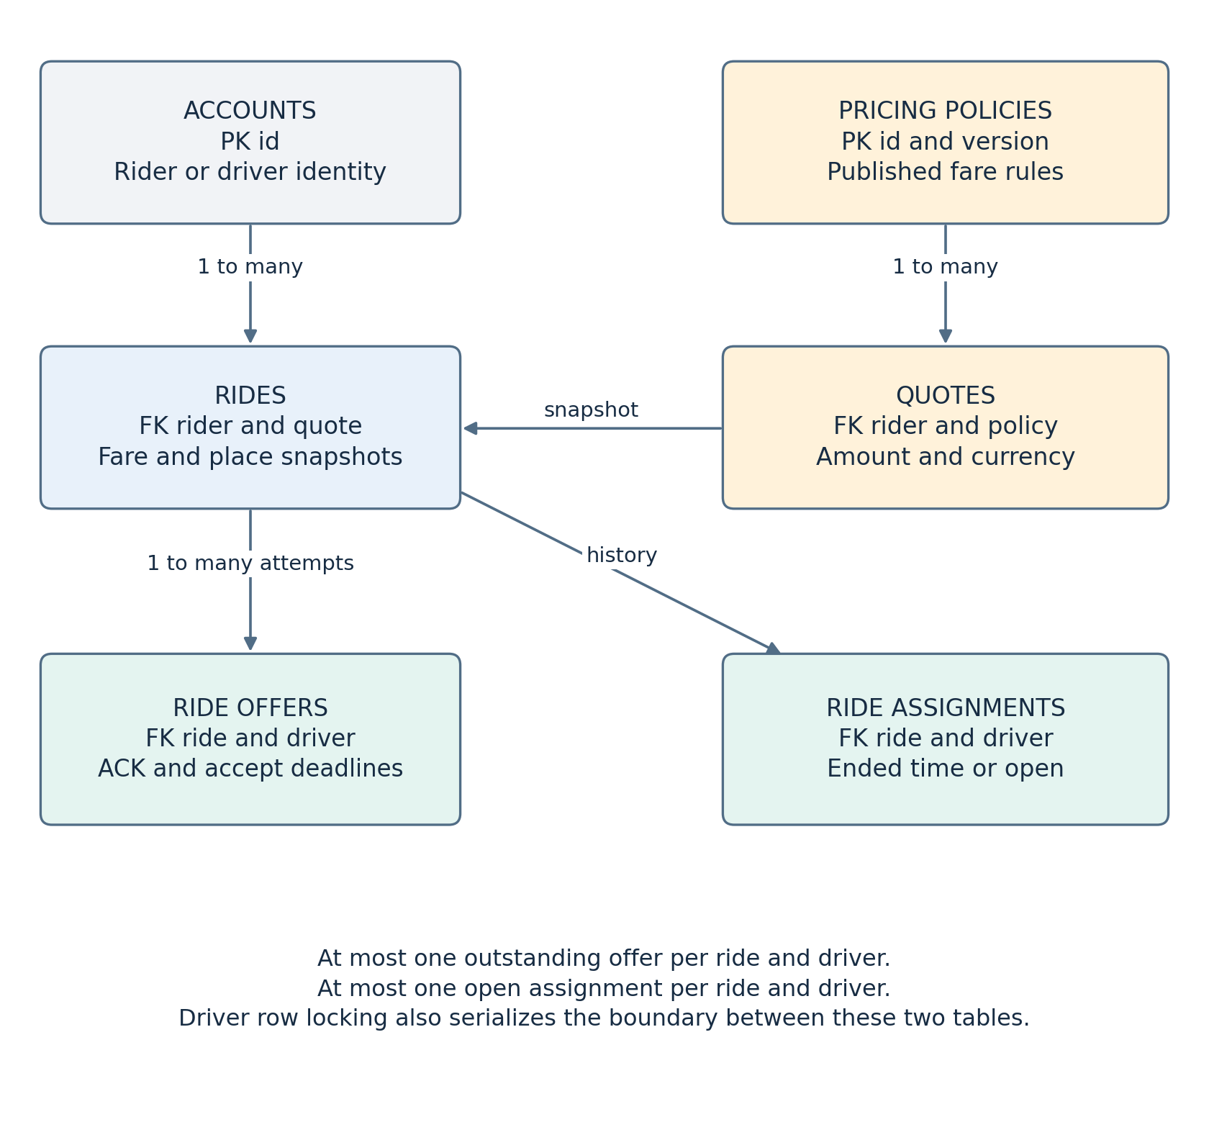
Accounts identify participants. A quote links a rider to an immutable published pricing version; the ride captures the accepted quote and location snapshot. Offer attempts and assignment history belong to the ride. The two partial unique offer indexes and two open-assignment indexes enforce their own table invariants. A stable driver-row lock serializes offer creation and conversion to an assignment across the tables. This focused model omits support and identity details already defined in the LLD persistent model.
Trace: BR-12–18, BR-24–26, BR-44; NFR-02; HLD-09–11, HLD-19, HLD-22; LLD-04, LLD-06–07, LLD-10; VT-06–11. PK means primary key; FK means foreign key. Relationship labels refer to possible historical rows; active rows are constrained separately.

Requirements traceability matrix
Each row covers the inclusive source-ID range shown; the diagram IDs identify where the behavior or architecture is represented, and the HLD/LLD IDs identify the design specification. D-01 provides business context for all functional requirements, while the additional diagram IDs below show the detailed relationships. VT are planned LLD verification scenarios, not test results.
Source requirements | Diagram IDs | Design IDs | Planned evidence
BR-01–04; NFR-06 | D-01, D-03, D-04 | HLD-01–05, HLD-23; LLD-01–04 | VT-01, VT-13
BR-05–08 | D-01–03, D-07 | HLD-02–03, HLD-05–06, HLD-08, HLD-19–21; LLD-02–06, LLD-09 | VT-02, VT-05
BR-09–11 | D-01–02, D-05, D-07 | HLD-01, HLD-07–10, HLD-13, HLD-19–20; LLD-01, LLD-05–07, LLD-09 | VT-03–05, VT-11
BR-12–13; NFR-12 | D-02, D-04–07, D-09 | HLD-02, HLD-09, HLD-14, HLD-19, HLD-22–23; LLD-02, LLD-04, LLD-06, LLD-10 | VT-06–09, VT-17
BR-14–16; BR-24–26 | D-01–03, D-05, D-07, D-09 | HLD-01–03, HLD-09–11, HLD-19; LLD-01–03, LLD-06–07 | VT-06, VT-11
BR-17–18 | D-02, D-04–07, D-09 | HLD-04, HLD-09–10, HLD-19, HLD-22; LLD-04, LLD-06–07, LLD-10 | VT-08, VT-10
BR-19–23; NFR-02–03 | D-01–02, D-04–07 | HLD-01–02, HLD-08–10, HLD-13–14, HLD-19–20; LLD-01–02, LLD-04, LLD-06–07, LLD-09 | VT-05, VT-10, VT-17
BR-27–29 | D-01, D-02, D-07 | HLD-11–12, HLD-19; LLD-07, LLD-09 | VT-12
BR-30–32 | D-01, D-03, D-08 | HLD-01–02, HLD-14–15, HLD-19; LLD-01–02, LLD-04, LLD-08–09 | VT-13
BR-33–37 | D-01, D-03, D-07–08 | HLD-01–03, HLD-14, HLD-16–17, HLD-19, HLD-22; LLD-01–03, LLD-08–10 | VT-14, VT-16
BR-38–40 | D-01, D-03, D-07–08 | HLD-01–03, HLD-18–19; LLD-01–03, LLD-08 | VT-15
BR-41–44 | D-01, D-03, D-07–08 | HLD-03, HLD-06–07, HLD-11, HLD-17, HLD-19, HLD-23; LLD-03, LLD-05, LLD-07–08, LLD-10 | VT-02–03, VT-11, VT-14
BR-45 | D-01–03, D-07 | HLD-03, HLD-07, HLD-19; LLD-03, LLD-05 | VT-03
BR-46 | D-01–02, D-07 | HLD-01, HLD-07, HLD-13, HLD-19; LLD-01, LLD-05, LLD-09 | VT-04
BR-47–49 | D-01, D-03, D-07–08 | HLD-01–03, HLD-16, HLD-19, HLD-21–22; LLD-01–03, LLD-08–10 | VT-16
NFR-01 | D-02, D-04–06 | HLD-04, HLD-08–09, HLD-13–14, HLD-20, HLD-23–24; LLD-04, LLD-06, LLD-09–10 | VT-08, VT-17
NFR-04–05 | D-03–04, D-07–08 | HLD-01–06, HLD-15–19, HLD-21, HLD-23–24; LLD-01–05, LLD-08–10 | VT-02, VT-13–16
NFR-07–08 | D-02, D-04–07, D-09 | HLD-09–12, HLD-14, HLD-17, HLD-19, HLD-22–24; LLD-06–08, LLD-10 | VT-07–08, VT-14, VT-17
NFR-09–10 | D-01, D-03–04, D-07–08 | HLD-03, HLD-05–07, HLD-11, HLD-17, HLD-23–24; LLD-03–05, LLD-07–10 | VT-02–03, VT-11, VT-14
NFR-11 | D-01, D-03–04 | HLD-01–03, HLD-23; LLD-01–03 | VT-01

Open decisions inherited from the source documents: exact initial area polygons/order and eligible documents; fare formula/rates, quote validity, USD↔LBP/cash treatment and commission; ACK timeout, background-driver eligibility and bounded reoffers; sign-in, phone visibility, retention and targets; SOS staffing/channels, review/case policy and kiosk operating model. The only agreed offer acceptance window is three seconds after app ACK. See BRS OD-01–16 and LLD section 14 for the decision owners and implementation dependencies.
Review boundary: These diagrams provide the requested visual reference to the approved BRS and HLD and the LLD draft. LLD and diagram approval remain pending. It does not resolve TBD business policy or authorize implementation, payment activation or production launch.

