Wasselne Low Level Design
Specifies the data model, offer state machine, transaction rules, API and event contracts, client behavior and verification cases for the approved Wasselne architecture. Open business policy values remain visible in the decision register.
Status For owner review
Word edition 0.2 | Source baseline 0.1 | 23 September 2026

Contents
1 Scope and notation
2 Module boundaries and dependencies
3 Persistent model and database invariants
4 Dispatch state machine and transactions
5 HTTP contracts and error semantics
6 Realtime event contract and client synchronization
7 Location coverage routes and saved places
8 CMS fares currency cash and disabled methods
9 Files communication safety reviews and post ride support
10 Admin localization and device adaptation
11 Workers observability and operations
12 Verification cases and acceptance evidence
13 Requirements and design traceability matrix
14 Decisions still required and approval gate
Appendix A Architecture views

1 Scope and notation
This document specifies data structures, state transitions, API/event contracts, transaction boundaries, client behavior, background jobs, authorization checks, and verification cases. It is a design artifact, not implemented code, a migration, an executed test, or a deployed system. Contract names and fields here are proposals to be frozen at LLD approval. Business amounts, exact locations, providers, timeout policy values other than the approved three seconds, legal obligations, and operational staff arrangements remain TBD rather than being fabricated.
The first release covers immediate rides for enabled car/taxi, motorcycle, and tuk-tuk categories in configured pilot areas of Lebanon; rider/driver/Admin experiences; Arabic/English/French; saved rider places; CMS-set USD fare with a CMS LBP option; cash collection recording; direct phone calls after confirmed assignment; translated chat; SOS and support; and reciprocal reviews. Scheduled rides and OMT, Wish/Whish, and bank payments remain inactive.
Identifiers: BR-* and NFR-* are BRS requirements; HLD-* are approved high-level components; LLD-* are design elements in this document; VT-* are proposed verification cases. UUIDs, UTC timestamps, and money in integer minor units are design choices pending code review. Human display of dates/times and money follows selected locale and the approved currency rules.
Policy parameters that must be supplied before implementation/configuration: DELIVERY_​ACK_​TIMEOUT, MAX_​OFFER_​ATTEMPTS, MAX_​RIDER_​SEARCH_​DURATION, PRESENCE_​FRESHNESS, LOCATION_​ACCURACY_​LIMIT, allowed GPS update policy, quote expiration, fare formula/rounding, coverage polygons, SOS channels, review format/moderation, case/evidence retention, and backup/recovery targets. ACCEPT_​WINDOW = 3 seconds is fixed by the owner. Reject invalid or absent critical production configuration at startup rather than silently guessing a value.

2 Module boundaries and dependencies
LLD ID | Component and responsibility | Maps to HLD / BRS
LLD-01 | apps/​rider, Flutter  Screens, localization, API/WebSocket client, saved places, trip snapshot; no local authority over acceptance/fare. | HLD-01; BR-01–04, BR-09–11, BR-14–15, BR-19–23, BR-25–38, BR-46–47, NFR-02, NFR-06, NFR-11
LLD-02 | apps/​driver, Flutter plus platform code  GPS/push lifecycle, acknowledgment, countdown, accept/decline, registration, trip and help; read-only fare display. | HLD-02; BR-01–08, BR-12–13, BR-16–23, BR-30–39, BR-48, NFR-02–03, NFR-06, NFR-11–12
LLD-03 | apps/​admin, Next.js  Role-aware operations screens, review queue, published settings, cases and audit. | HLD-03; BR-06, BR-14, BR-24–25, BR-35, BR-40–45, BR-49, NFR-09, NFR-11
LLD-04 | api, NestJS HTTP/WebSocket adapters  Authentication, DTO validation, authorization, rate limits, error mapping, snapshot delivery; calls domain services. | HLD-04–05, HLD-14; BR-02, BR-17–22, BR-30–36, NFR-01–04
LLD-05 | domain/​eligibility, domain/​places  Driver/vehicle review; active geofences; private saved places. | HLD-06–07, HLD-19, HLD-21; BR-05–11, BR-41, BR-45–46, NFR-04–05, NFR-10
LLD-06 | domain/​presence, domain/​dispatch  Fresh Redis location; one outstanding offer; ACK then three-second deadline; sole assignment. | HLD-08–09, HLD-19–20, HLD-22; BR-07–08, BR-11–13, BR-16–18, BR-21–22, NFR-01–03, NFR-12
LLD-07 | domain/​trip, domain/​pricing, domain/​cash  Trip transitions; CMS fare/version snapshots; cash report and disabled future methods. | HLD-10–12, HLD-19; BR-09, BR-14–29, BR-41, BR-44, NFR-07–08
LLD-08 | domain/​communication, domain/​support, domain/​sos, domain/​review  Scoped chat/translation/calling; post-trip cases; supported SOS actions; reciprocal reviews. | HLD-15–18, HLD-21–22; BR-30–40, BR-43, BR-47–49, NFR-04–05, NFR-07, NFR-09
LLD-09 | integrations  Provider interfaces for maps, push, translation, object storage, identity/telephony; disabled payment interfaces. | HLD-13–15, HLD-21; BR-02, BR-05, BR-11, BR-21, BR-28–32, BR-37, BR-46, NFR-03–05
LLD-10 | worker, platform/​observability, platform/​deploy  Durable outbox, offer timeout recovery, retry, audit, metrics, secrets, health, backups. | HLD-22–24; BR-12–13, BR-18–22, BR-32–37, BR-41–44, BR-47–49, NFR-01–02, NFR-05, NFR-07–10, NFR-12

Shared model definitions are versioned contracts, not database entities imported directly into mobile clients. A module may access its own data repository and call another domain module's public service; cross-module SQL writes require an explicit transaction coordinator in the booking workflow. No external broker is assumed. HTTP/API tasks and worker tasks are separate process roles from the same codebase.

3 Persistent model and database invariants
The table below is the proposed logical SQL schema. Columns are illustrative but intentionally precise enough for migrations. Every table has id, creation/update timestamps where relevant, and a migration-managed version; sensitive columns are encrypted or otherwise protected according to the selected provider/platform. Exact field limits and retention are TBD.
Entity | Key fields and relationships | Required integrity/index behavior
accounts, sessions, role_​grants | account ID, role, language ar/​en/​fr, verified contact, auth provider ref; session revocation | Unique identity/provider mapping; admin scopes checked server-side; no plaintext OTP/passwords.
drivers, vehicles, driver_​documents | account ID, category, verification state; vehicle ID/plate; private object key, document type, expiry/review state | FK owner; indexed eligibility/category; approval history immutable; document object not publicly readable.
service_​area_​versions, category_​area_​rules | versioned PostGIS multipolygon, activation status/effective time, category enablement | Spatial GiST index; mutually coherent published versions; explicit area priority for overlaps. No coverage implied by city-name text.
saved_​places | rider ID, user-selected name, coordinates/address descriptor | Owner FK; list/edit/delete scoped to rider; no global uniqueness requirement on personal names.
pricing_​policy_​versions | area/category scope, fare currency, structured validated rates, status and effective time, publisher | Published version immutable; currency and supported rate schema validation; formula/values TBD.
quotes | rider, pickup/destination snapshot, category, pricing version, amount/currency, expiry | Immutable fare snapshot for request; idempotent quote/request flow; reject stale policy according to TBD quote-expiry rule.
rides | rider, pickup/destination snapshot, category, quote/pricing version, fare/currency snapshot, status, current assignment ID, request idempotency key | Unique (rider_​id, request_​idempotency_​key); optimistic version counter; status transition validation.
ride_​offers | ride ID, driver ID, attempt number, PENDING_​ACK/​ACTIVE/​ACCEPTED/​DECLINED/​EXPIRED/​CANCELLED, ack_​deadline_​at, acknowledged_​at, accept_​deadline_​at, offer token/id | Unique outstanding offer per ride and per driver for PENDING_​ACK/ACTIVE; indexed expiry; a new attempt gets a new ID.
ride_​assignments | ride ID, driver ID, vehicle ID, assigned time, ended time, outcome | Partial unique open assignment per ride and driver (ended_​at IS NULL); ended rows preserve history if reassignment is later approved.
trip_​events | ride ID, transition, actor, timestamp, reason, prior/new status | Append-only evidence; server-authorized transition; outbox event in same transaction.
cash_​collections, financial_​events | ride ID, expected amount/currency, report actor/time/status, reconciliation entries | No card charge; immutable correction event rather than editing history; commission/settlement policy TBD.
chat_​messages, chat_​translations | ride ID, sender, original text/language, message sequence, translated language/text/status | Participant access, unique per-sender client message ID for retry; original preserved if translation fails.
reviews | trip, reviewer, reviewee, rating/payload under approved schema, status | Unique (ride_​id, reviewer_​id); only completed-trip participants; format/moderation TBD.
support_​cases, case_​events, case_​evidence | ride ID, type LOST_​ITEM/VEHICLE_​MESS_​DAMAGE/other help, reporter, status, evidence object refs | Reporter role and trip membership validated; no automatic rider debit; audit evidence access.
sos_​policy_​versions, sos_​incidents, trusted_​contacts | allowlisted action types/config, publisher, incident actor/ride/status, contact owner/consent | Policy version captured per activation; only published supported actions executable; no arbitrary code/URL from admin input.
outbox_​events, delivery_​attempts, admin_​audit | aggregate/event IDs, status/attempts, actor/action/target, timestamps | Unique business event key; retry safe; append-only audit with restricted read.

Database constraint sketch (design, not an executed migration):
CREATE UNIQUE INDEX one_outstanding_offer_per_ride
ON ride_offers (ride_id)
WHERE state IN ('PENDING_ACK', 'ACTIVE');
CREATE UNIQUE INDEX one_outstanding_offer_per_driver
ON ride_offers (driver_id)
WHERE state IN ('PENDING_ACK', 'ACTIVE');
CREATE UNIQUE INDEX one_open_assignment_per_ride
ON ride_assignments (ride_id) WHERE ended_at IS NULL;
CREATE UNIQUE INDEX one_open_assignment_per_driver
ON ride_assignments (driver_id) WHERE ended_at IS NULL;

All offer-state writes go through a transaction that locks the parent ride row first, then the stable driver row and offer row in that order. This avoids relying on Redis locks and ensures a late acceptance cannot outrun an expiry or a second driver. PostgreSQL partial unique indexes support uniqueness limited to specified states; the final migration and isolation/locking order will be validated against the chosen PostgreSQL version. PostgreSQL partial index documentation.
The 3-second window is checked using database time against accept_​deadline_​at, not the phone clock. All provider monetary amounts use currency-tagged integer minor units, never floating-point fare totals. No LBP conversion rate, USD/LBP rounding, tax, or commission is hard-coded before business approval.

4 Dispatch state machine and transactions
Ride states (first release): REQUESTED → SEARCHING → CONFIRMED → DRIVER_​ARRIVING → AT_​PICKUP → IN_​PROGRESS → COMPLETED. SEARCHING may end as NO_​DRIVER, CANCELLED, or EXPIRED; a confirmed/in-progress ride may move to an approved terminal cancellation state only under a policy still TBD. This is a proposed transition set, not permission to impose unapproved cancellation fees. Every transition checks actor/role, expected prior state and ride version in PostgreSQL.
Offer states: PENDING_​ACK → ACTIVE → ACCEPTED, with PENDING_​ACK → EXPIRED, ACTIVE → EXPIRED, ACTIVE → DECLINED, or PENDING_​ACK/​ACTIVE → CANCELLED when the request is cancelled or driver becomes ineligible. ACCEPTED, DECLINED, EXPIRED, and CANCELLED are terminal for that offer ID. A second attempt, even to the same driver, is a new row and ID. PENDING_​ACK reserves the sole offer slot even though the three-second window has not begun.
Transition | Transactional checks and side effects | Result on retry/race
SEARCHING → PENDING_​ACK | Lock ride; check no outstanding offer; recheck candidate eligibility and no outstanding offer/open assignment; create offer/ack_​deadline_​at; append outbox delivery event; commit. | Unique indexes reject overlapping attempts; retry reads existing outstanding offer.
PENDING_​ACK → ACTIVE | Authenticate exact driver and offer ID; lock ride + offer; require database time before ack_​deadline_​at; set acknowledged_​at = DB now and accept_​deadline_​at = DB now + 3 seconds; emit activation event; commit. | Duplicate ACK returns same accept_​deadline_​at, never restarts three seconds. Late ACK gets OFFER_​EXPIRED.
ACTIVE → ACCEPTED, ride → CONFIRMED | Lock ride + offer, check driver/vehicle approved and offer deadline strictly later than DB now; create one open assignment, snapshot CMS fare/currency, update ride; outbox events; commit. | Duplicate accept by winner returns confirmed snapshot; other/late accept gets non-success conflict.
PENDING_​ACK/​ACTIVE → EXPIRED | Worker locks ride + offer, checks relevant deadline with DB time, changes old offer to terminal state, releases candidate's offer slot, records event; selects next candidate after old state has ended, possibly in same transaction. | Multiple workers contend on same ride; one transition wins; no overlap.
ACTIVE → DECLINED | Authenticate intended driver; lock ride + offer; end attempt and request next candidate only after terminal transition. | Replayed decline on terminal offer does not revoke another driver's current offer.

ACK policy: The driver app sends an authenticated ACK for the received offer; a push delivery receipt from a provider, WebSocket server write, or notification tap does not count as an app acknowledgment. ACK timeout is an independent, bounded configuration value DELIVERY_​ACK_​TIMEOUT = TBD. If no ACK, end the PENDING_​ACK attempt and move on. If app ACK succeeds but response is lost, its retry must fetch the original deadline. Acknowledgment means the app processed the offer, not that a human read it; measure the human-visible time on real devices.
Search and reoffer: Candidate list comes from Redis GEOSEARCH then filters current heartbeat, location quality, approved vehicle/category, area, outstanding offer, and open assignment; road ETA may reorder a shortlist. The attempt ledger tracks candidate/round history in PostgreSQL. If a driver declines or times out, try another candidate. If no other eligible driver remains, a previous candidate can receive a fresh offer, but MAX_​OFFER_​ATTEMPTS and MAX_​RIDER_​SEARCH_​DURATION are TBD. Production configuration must cap both, with a rider-visible failure state when exhausted. The scheduler can be woken by an event, but authoritative expiration also runs from indexed DB deadlines so process restarts do not strand a request.
Concurrency and delivery limits: An API instance cannot promise when an OS push arrives; it can promise that only one driver has an outstanding, actionable offer. A late push for a terminal offer may be visible briefly. Push payload contains only an opaque offer ID and short expiration metadata; the app retrieves current state before exposing Accept. Use a provider-supported short message lifespan relative to the ACK deadline and suppress stale UI. Expired push delivery is a known platform behavior to test; it cannot be treated as another active offer. FCM message lifespan documentation.

4 1 Lock and deadline implementation rules
All offer creation, acknowledgment, acceptance, cancellation and expiry paths acquire locks in the same order: parent ride row, stable driver row, then offer row. A transaction involving several driver rows orders those driver IDs consistently. Suspension and vehicle eligibility changes also serialize on the affected driver row before changing dispatch eligibility. New offer creation checks both outstanding offers and open assignments while holding the driver row lock. The partial unique indexes protect each table; the shared driver row lock protects the cross-table transition from an offer into an assignment. Direct writes that bypass the coordinator are prohibited.
Deadline checks use a fresh clock_​timestamp() after the required locks have been obtained. PostgreSQL now() represents the transaction start time and must not be used for an acceptance decision that may have waited on a row lock. An offer is timely only when that fresh instant is strictly earlier than its deadline. The ACK transition stores one clock sample as acknowledged_​at and adds exactly three seconds for accept_​deadline_​at. A repeated ACK returns that stored deadline. A valid acceptance is decided under the lock; the UI shows confirmation only after commit. Transactions perform no remote provider calls while holding these locks. PostgreSQL date and time functions.
Expiry workers discover candidate ride IDs from indexed deadlines without first taking an offer-row lock. They then lock the ride, driver and offer in the normal order and recheck the deadline and state. A locked or changed candidate is skipped or retried. This avoids an offer-first worker deadlocking with a ride-first acceptance. Outbox workers may separately claim work using SKIP LOCKED; committing the claim must precede a network call, with a recoverable processing lease for worker failure.
An idempotency record is scoped to actor, operation and client key and stores the canonical request hash and committed response reference. Reusing a key with a different payload returns a conflict. A repeated successful acceptance returns the original assignment even when the current clock is later than the original deadline. Unknown outcomes are resolved by a state read or a retry with the same key. Outbox consumers tolerate at-least-once delivery using stable event IDs.
Trace: BR-12–13, BR-17–18, BR-22; NFR-02, NFR-07, NFR-12; HLD-09–10, HLD-19, HLD-22; LLD-04, LLD-06–07, LLD-10; VT-06–10, VT-17. These are implementation clarifications for the existing integrity requirements, not new business policies.

5 HTTP contracts and error semantics
Illustrative /​v1 paths below establish boundaries; exact OpenAPI DTOs, field limits and authentication method are finalized during implementation. Every mutation authenticates actor, checks ownership/role, validates a request body, returns a correlation ID, and uses an idempotency key where retry could cause a duplicate record/action. Pagination is mandatory for histories/admin lists.
Method/path | Request → successful result | Authorization, idempotency, important failure | Trace
POST /​v1/​auth/​... | Selected sign-in provider exchange → session | Provider and abuse-control policy TBD; no production stub login. | BR-02, NFR-04
GET/​PATCH /​v1/​me/​preferences | language: ar/​en/​fr → saved preference | Self only; updates client RTL/rendering. | BR-03–04
GET/​POST/​PATCH/​DELETE /​v1/​me/​places | Named place and coordinates → place/success | Rider self only; saved place revalidated on booking. | BR-46
POST /​v1/​drivers/​onboarding, POST /​v1/​uploads/​authorize | Registration metadata/private object authorization → review state/signed upload | Driver owner; allowed MIME/size, object validation; exact docs TBD. | BR-05–07
POST /​v1/​drivers/​availability, POST /​v1/​drivers/​locations | Online flag / coordinates, accuracy, capture time → accepted/stale status | Approved driver only; stale/out-of-order GPS rejected. | BR-07–08, BR-21
GET /​v1/​service-areas, GET /​v1/​nearby | Active categories/availability for pickup → coarse view | Rate-limited; no arbitrary access to drivers' precise positions. | BR-09–11, BR-45
POST /​v1/​quotes | Pickup/destination/category → CMS fare snapshot, currency, policy version, quote ID/expiry | Area/category validity; price formula TBD; no driver-entered amount. | BR-14–16, BR-24–26
POST /​v1/​rides | Quote ID, request ID, pickup/destination → SEARCHING ride ID | Rider; Idempotency-Key scoped to rider; repeat returns same ride. | BR-09, BR-17–18
GET /​v1/​rides/​{id}, GET /​v1/​me/​active-ride | Authoritative trip/offer-visible snapshot, event version and server time | Rider/assigned driver/authorized staff; driver sees only their actionable offer. | BR-19–23
GET /​v1/​driver/​offers/​current | Intended current offer ID, CMS fare, ACK/accept status and server deadline | Driver self; no other driver's offer disclosed. | BR-12–13, BR-16
POST /​v1/​driver/​offers/​{id}/​ack | Offer ID → ACTIVE, server_​now, accept_​deadline_​at | Intended driver only; duplicate returns same deadline; late ACK fails. | BR-12–13, NFR-12
POST /​v1/​driver/​offers/​{id}/​accept | Offer ID, idempotency key → confirmed ride snapshot | Intended driver; atomic sole assignment; 409/410 on stale/expired. | BR-12–18
POST /​v1/​driver/​offers/​{id}/​decline | Offer ID → terminal offer state | Intended driver; no effect on a later offer. | BR-12–13
POST /​v1/​rides/​{id}/​transitions | Requested allowed state/reason + expected version → new trip state | Party/role and transition checks; fee/no-show rules TBD. | BR-19–20
GET/​POST /​v1/​rides/​{id}/​messages | Trip-scoped original content → message ID/status; translated view follows | Participant/approved staff; sender message key prevents duplicate. | BR-31–32
GET /​v1/​rides/​{id}/​call-eligibility | Eligible phone contact information/action → OS dialer handoff | Confirmed trip and time window; number disclosure policy TBD. | BR-30
GET/​POST /​v1/​rides/​{id}/​reviews | Eligible participant review → review record | Completed ride, one review per participant/ride; format TBD. | BR-38–40
POST /​v1/​support/​cases, GET /​v1/​support/​cases/​{id} | Trip-linked lost-item/damage/help case → status/history | Rider or driver with ride membership, evidence private; no automatic charge. | BR-33, BR-47–49
GET /​v1/​sos/​options, POST /​v1/​sos/​incidents | Published choices; chosen action → incident ID and actual initiation/delivery status | Trip stage and actor authorization; action-specific response policy TBD. | BR-34–37
/​v1/​admin/​... | Driver review, geofence, category, fare/currency, SOS publication, support/review decisions, audit reads | Explicit role grant and auditable versioned mutation; no direct raw DB admin UI. | BR-06, BR-24–25, BR-35, BR-40–45, BR-49, NFR-09

Errors: stable machine code plus human-localized explanation; examples OUTSIDE_​SERVICE_​AREA, CATEGORY_​UNAVAILABLE, DRIVER_​NOT_​ELIGIBLE, OFFER_​NOT_​FOR_​DRIVER, OFFER_​NOT_​ACKNOWLEDGED, OFFER_​EXPIRED, OFFER_​ALREADY_​RESOLVED, RIDE_​ALREADY_​ASSIGNED, INVALID_​TRIP_​TRANSITION, QUOTE_​STALE, PAYMENT_​METHOD_​DISABLED, SOS_​ACTION_​DISABLED, NOT_​AUTHORIZED, PROVIDER_​TEMPORARY_​FAILURE. A retryable timeout must not be converted into a new booking. Use HTTP conflict for stale state and an explicit terminal-expiry code; exact HTTP status mapping is part of the OpenAPI review.

6 Realtime event contract and client synchronization
WebSocket is a delivery channel, not storage. Authorized channels are per account and per ride; joining an arbitrary ride room requires server-side membership validation. Cross-instance fan-out may use Redis, but a missed message is recovered by HTTP snapshot and event version. Define a common event envelope:
{
"event_id": "uuid",
"type": "offer.pending_ack | offer.active | offer.terminal | ride.changed | chat.created | sos.updated",
"aggregate_id": "uuid",
"aggregate_version": 7,
"occurred_at": "UTC timestamp",
"server_now": "UTC timestamp",
"payload": "role-filtered, minimal fields"
}

The driver offer.pending_​ack event includes opaque offer ID and CMS fare/currency snapshot, plus an ACK deadline; the driver app calls /​ack and receives the authoritative three-second accept deadline. Do not emit a countdown based solely on push creation time. ride.changed includes current state/version, no unapproved other-party data. Clients discard older aggregate versions, tolerate duplicates, and fetch a fresh snapshot on reconnect, version gap, authentication refresh, or app resume. Chat persistence precedes a chat.created event; translated may arrive later and must not replace original text.
Push is an alert that tells a device to check a particular offer/ride; provider delivery receipt is not the app ACK. Use a provider-supported short lifespan for offer pushes and never send sensitive pickup/phone/document details in the push payload. Background notification handling and ACK availability depend on OS behavior and must be measured on real phones. The exact policy for treating a background driver as offer-eligible is TBD.

7 Location coverage routes and saved places
Operation | Detailed behavior | Failure/permission handling
Driver online | Verify approved driver/vehicle/category and allowed location permission; set online_​requested; only a fresh qualifying location yields dispatch_​eligible. | Loss of location/permission/heartbeat removes eligibility; do not fabricate location.
Driver position update | Validate latitude/longitude, reported accuracy, captured timestamp, monotonic sequence; reject implausible/stale/out-of-order updates; update Redis GEO member and separate expiring presence metadata. | Redis geo membership has no per-driver TTL; lookup checks fresh metadata and sweeper removes stale members. Thresholds TBD.
Nearby candidates | Redis GEOSEARCH radius/box from pickup; apply freshness, service area, approved category, and current offer/assignment checks; shortlist for road ETA. | Redis unavailable ⇒ pause/degrade matching with clear rider state. No assignment from last-known cache alone.
Area check | Published PostGIS zone version and category rule for pickup and service policy for destination. | Names such as Zgharta or Koura do not define polygons; admin must approve geometries.
Route/ETA | Adapter requests suitable route/ETA for a small shortlist and after assignment, with quota and request timeout; mobile renders current position with time of last update. | If provider fails, show unavailability instead of a fabricated route or a guaranteed ETA. Category-specific route suitability validated locally.
Saved place | Rider stores label/address/point, later resolves to current pickup/destination snapshot and revalidates coverage. | Editing/deleting saved place does not rewrite past rides; only owner has routine access.

Use ST_​Covers or reviewed equivalent so the area-edge rule is explicit; use a spatial index. Candidate straight-line distance is a coarse search, not the trip fare distance or road ETA. Location update cadence, rider map refresh, sampled trip trail, and retention are configurable policies needing device and legal review. PostGIS spatial query guidance, Redis GEOSEARCH.

8 CMS fares currency cash and disabled methods
1. Admin creates a draft typed pricing policy: currency (USD initially, optionally LBP), category/area scope, kilometre rate and any additional components approved later. Validate a complete policy and preview example journeys before publishing an immutable version. A quote stores (pricing_​version, route inputs/​measurement basis, amount_​minor, currency, expiry) and the ride stores the quote snapshot accepted by the rider. The exact formula, time/waiting, minimum, tax, cancellation, and quote TTL are TBD; no executable production formula may be guessed.
2. Driver offer carries the same fare/currency snapshot as the rider's request. Driver sees and accepts/declines within three seconds after ACK. No fare input field, negotiation command, or driver-origin price mutation exists in driver app/API.
3. Admin switching from USD to LBP publishes a new, valid currency-specific policy effective for new quotes. A prior quote or accepted ride stays in its original currency. Whether conversion uses a manually approved rate or separate tariffs, and cash tender/rounding rules, remain TBD; the CMS must refuse a currency switch with missing required configuration.
4. The first-release payment selector exposes Cash as enabled. OMT, Wish/Whish, and bank choices remain disabled; their labels may be shown as disabled only under approved UX. No payment token, capture, webhook, or charge path exists for disabled methods. cash_​collections distinguishes driver-reported collection from confirmed reconciliation; disputes and correction entries are preserved. Commission/payout policy is TBD and must not be silently calculated.

9 Files communication safety reviews and post ride support
Private uploads: driver onboarding and case evidence use a short-lived object upload authorization scoped to account/case, object key, MIME type and size. Completion endpoint verifies object metadata and processing status before review. A private download authorization requires explicit viewer permission, is short-lived, and is audited for sensitive evidence. Scan/quarantine policy and retention are TBD. Presigned URLs grant temporary access to the specified object without handing cloud credentials to the mobile client. S3 documentation.
Chat/translation: A message persists as original text and source language; worker or provider adapter translates only for authorized recipient locale, stores a separate translation version/status, and never overwrites the original. UI offers original/translated toggle and retry on failure. Server validates chat window and trip membership; message retry key prevents duplicate posts. Exact translation provider, retention and abuse controls need approval.
Phone: call-eligibility responds only after a confirmed driver assignment, within the approved contact window. The app opens the OS dialer; the call happens outside Wasselne. Without a masked calling provider, ordinary phone numbers/caller ID may be exposed and cannot be unshared later. Access-expiry policy remains TBD; this design does not claim to mask calls.
SOS: Admin can enable any subset of registered supported actions: open emergency dialer, initiate a durable Wasselne support incident/alert, notify an owner-approved trusted contact through a selected channel, and a separately reviewed extra action type. The UI states what was initiated and distinguishes DIALER_​OPENED, ALERT_​QUEUED, DELIVERED, FAILED, and RESPONDER_​ACKNOWLEDGED when those states are observable. A dialer opening is not an emergency-service acknowledgment. Server creates an incident record before dispatching any backend alert, uses idempotent delivery jobs, and records actor/ride/location-share consent and actual delivery status. Admin configuration accepts typed allowlisted actions only; no arbitrary script/webhook/URL text becomes executable. Escalation staff, local number, contact channel, coverage hours and consent are TBD and must be supplied before the corresponding choice is enabled.
Reviews: POST review requires completed ride, authenticated participant and the other party as reviewee; unique index rejects repeated same-side reviews. Rider→driver and driver→rider are independent. Rating scale, free text, visibility, edit window, moderation and appeal policy are TBD; API/UI schema remains versioned until chosen.
Post-ride cases: a rider opens LOST_​ITEM with trip identification and optional private description/evidence; a driver opens VEHICLE_​MESS_​DAMAGE with description and private photos. Case event trail records submission, staff assignment, communication, evidence, response, outcome and appeal when approved. Relevant party access is scoped to its own case; staff evidence access is audited. No automatic fee or rider penalty is generated from a driver's report. Claim deadlines, remedies, return contact process and appeals are TBD.

10 Admin localization and device adaptation
Admin roles (proposed RBAC grants, names subject to operations review): driver reviewer (approve/suspend), area manager (publish coverage/categories), pricing manager (publish rates/currency), safety manager (publish SOS options), support agent (assigned cases/incidents), auditor (read audit), and administrator (grant/revoke roles). A user can hold multiple grants. Every mutation validates role plus scope, requires a reason where policy demands it, and produces an append-only audit record with actor, target, previous/new version, and timestamp. Do not render placeholder numbers as live operational metrics.
Responsive clients: rider and driver Flutter layouts reflow for supported phones and tablets/pads. Next.js admin layouts reflow from compact to large displays. A kiosk-sized layout must preserve legibility and essential actions; whether a public kiosk runs a rider booking flow, staffed booking, or another mode remains TBD (BRS OD-14). Public kiosk sessions would need a defined sign-out/inactivity/PII clearing policy before enabling a live account. Driver GPS functionality cannot be promised on arbitrary kiosk hardware without a supported platform and permission model. RTL tests cover map controls, form order, numerals/currency and Arabic accessibility labels; English and French remain selectable regardless of device language.

11 Workers observability and operations
Worker/job | Trigger, idempotency, and recovery
Offer delivery | Committed outbox event for PENDING_​ACK; send WebSocket and optional push; record each delivery attempt, never advance offer state on provider's delivery report. App ACK is separate.
Offer timeout | Indexed ack_​deadline_​at and accept_​deadline_​at; concurrent workers claim due rows/ride locks, end old attempt, pick next only after old is terminal. Restart scans overdue rows.
Notifications/translation/SOS | Outbox event with stable event ID; retry bounded transient failures; dead-letter/manual escalation path for unrecoverable safety/support events.
Geo cleanup | Expiring presence metadata plus sweep of old GEO members; never use an unverified old member for dispatch.
Audit/retention/backup | Append secure audit records; deletion/retention and backup restore run under approved policies.

Queue workers may use PostgreSQL FOR UPDATE SKIP LOCKED to distribute outbox/expiry work, but correctness still comes from ride-row locking and constraints. SKIP LOCKED is suitable for queue-like consumers and is not a consistent read for general business state. PostgreSQL documentation.
Metrics and alerts: offers_​pending_​ack, ACK timeout rate, ACK-to-accept latency, offer accept/expiry rate, stale/late accept rejects, more-than-one-outstanding invariant violations (must remain zero), driver geo freshness, reconnect/snapshot recovery, map/translation errors and spend, cash disputes, support case age, SOS delivery/acknowledgment failures, DB/Redis health, outbox lag, restore-test results. Structured logs use correlation ID, ride/offer pseudonymous IDs and server timestamps; exclude raw phone numbers, precise address text, chat, documents and tokens. SLO thresholds remain TBD and should be established from load/device tests rather than asserted here.
Deployment: separate dev/staging/production secrets and data; at least two stateless API/WebSocket instances across availability zones and independently scaled worker tasks; private managed PostgreSQL/PostGIS, Redis and object storage; health/readiness, migrations with rollback plan, tested backups and failover. A DB outage blocks new acceptances instead of failing over to a Redis guess. Public deployment and live payment activation need separate owner authorization.

12 Verification cases and acceptance evidence
The following are planned tests, not tests executed by this document. Test fixtures use synthetic identities, coordinates, prices and documents. Business policy values are supplied only after approval.
ID | Test/scenario | Key expected result
VT-01 | Arabic/English/French on rider and driver phones/tablets; admin and kiosk-sized responsive review | User can change language, Arabic RTL works, essential actions fit supported screens; kiosk flow waits for OD-14.
VT-02 | Unapproved/suspended/expired-document driver online and in candidate list | No new actionable offer; admin decision and audit visible.
VT-03 | Activate a named pilot-area polygon and category; book at inside, boundary and outside coordinates | Only published category/area accepts requests; exact geometry and edge policy verified.
VT-04 | Save Home/Work, edit, delete, and reuse as pickup/destination | Only owner can access; historic ride snapshots unaffected; coverage rechecked.
VT-05 | Driver location stale/low accuracy/out of order; Redis geo member left behind | Not dispatch-eligible or falsely shown current; cleanup succeeds.
VT-06 | One driver ACKs exclusive offer, duplicate ACK and slow ACK response | Exactly one ACK starts the three seconds; duplicate returns same deadline; no reset.
VT-07 | No app ACK before configured timeout; delayed push then next candidate | Old attempt ends before next begins; late ACK/accept rejected; at most one actionable offer.
VT-08 | Two workers/instances race on expiry, acceptance and next offer at exact boundary | Exactly one terminal transition and at most one assigned driver; DB invariants hold.
VT-09 | Only one eligible driver; offer expires and a fresh offer is attempted | New offer ID/ACK/window; old offer stays terminal; retry cap and rider wait policy respected.
VT-10 | Duplicate rider request, accept retries after lost response, app reconnect | Same ride/assignment returned; snapshot repairs missed WebSocket events.
VT-11 | CMS fare changed while quote/offer/ride active; currency switched from USD to LBP for new quotes | Rider/driver see matching fare, old ride stays in old currency/rule version; missing LBP tariff blocks publish.
VT-12 | Cash trip and attempts to invoke OMT, Wish/Whish or bank path | Cash reported and auditable; disabled methods cannot charge or be selected.
VT-13 | Contact before/after confirmation, cross-trip chat, translated/original message | Call access only in authorized window; chat scoped; original remains on translation failure.
VT-14 | SOS option change, support/trusted contact success and delivery failure, emergency dialer handoff | Only published supported actions visible; incident/audit and actual status accurate; failed delivery escalated per approved policy.
VT-15 | Both directions of completed-trip review, duplicate, cancellation, unauthorized reviewer | One review each side only for completed shared ride; moderation access scoped.
VT-16 | Rider forgotten item and driver mess/damage claim with evidence and dispute | Separate trip-linked cases, private evidence, human resolution, no automatic rider charge.
VT-17 | Load, app background/resume, network loss, DB failover, Redis flush, restore | Measured agreed SLOs, safe degraded behavior, reconstructed presence, durable rides/cases/cash and documented recovery.

13 Requirements and design traceability matrix
This matrix maps every approved BR/NFR to an HLD component, LLD element, and planned verification case. The module catalogue at section 2 gives a parent requirement for every LLD-01–LLD-10. Actual test results, code paths and release sign-off are future evidence.
BRS requirement IDs | HLD elements | LLD elements / section | Proposed verification
BR-01–04, NFR-06 | HLD-01–05, HLD-23 | LLD-01–04; sections 5, 10 | VT-01, VT-13
BR-05–08 | HLD-02–03, HLD-05–06, HLD-08, HLD-19–21 | LLD-02–06, LLD-09; sections 3, 7, 9–10 | VT-02, VT-05
BR-09–11 | HLD-01, HLD-07–10, HLD-13, HLD-19–20 | LLD-01, LLD-05–07, LLD-09; sections 3–5, 7 | VT-03–05, VT-11
BR-12–13, NFR-12 | HLD-02, HLD-09, HLD-14, HLD-19, HLD-22–23 | LLD-02, LLD-04, LLD-06, LLD-10; sections 3–6, 11 | VT-06–09, VT-17
BR-14–16, BR-24–26 | HLD-01–03, HLD-09–11, HLD-19 | LLD-01–03, LLD-06–07; sections 3–5, 8 | VT-06, VT-11
BR-17–18 | HLD-04, HLD-09–10, HLD-19, HLD-22 | LLD-04, LLD-06–07, LLD-10; sections 3–5, 11 | VT-08, VT-10
BR-19–23, NFR-02–03 | HLD-01–02, HLD-08–10, HLD-13–14, HLD-19–20 | LLD-01–02, LLD-04, LLD-06–07, LLD-09; sections 4–7 | VT-05, VT-10, VT-17
BR-27–29 | HLD-11–12, HLD-19 | LLD-07, LLD-09; sections 3, 5, 8 | VT-12
BR-30–32 | HLD-01–02, HLD-14–15, HLD-19 | LLD-01–02, LLD-04, LLD-08–09; sections 5–6, 9 | VT-13
BR-33–37 | HLD-01–03, HLD-14, HLD-16–17, HLD-19, HLD-22 | LLD-01–03, LLD-08–10; sections 3, 5–6, 9–11 | VT-14, VT-16
BR-38–40 | HLD-01–03, HLD-18–19 | LLD-01–03, LLD-08; sections 3, 5, 9–10 | VT-15
BR-41–44 | HLD-03, HLD-06–07, HLD-11, HLD-17, HLD-19, HLD-23 | LLD-03, LLD-05, LLD-07–08, LLD-10; sections 3, 8–11 | VT-02–03, VT-11, VT-14
BR-45 | HLD-03, HLD-07, HLD-19 | LLD-03, LLD-05; sections 3, 7, 10 | VT-03
BR-46 | HLD-01, HLD-07, HLD-13, HLD-19 | LLD-01, LLD-05, LLD-09; sections 3, 5, 7 | VT-04
BR-47–49 | HLD-01–03, HLD-16, HLD-19, HLD-21–22 | LLD-01–03, LLD-08–10; sections 3, 5, 9 | VT-16
NFR-01 | HLD-04, HLD-08–09, HLD-13–14, HLD-20, HLD-23–24 | LLD-04, LLD-06, LLD-09–10; sections 4, 7, 11 | VT-08, VT-17
NFR-04–05 | HLD-01–06, HLD-15–19, HLD-21, HLD-23–24 | LLD-01–05, LLD-08–10; sections 3, 5, 9–11 | VT-02, VT-13–16
NFR-07–08 | HLD-09–12, HLD-14, HLD-17, HLD-19, HLD-22–24 | LLD-06–08, LLD-10; sections 3–4, 8–11 | VT-07–08, VT-14, VT-17
NFR-09–10 | HLD-03, HLD-05–07, HLD-11, HLD-17, HLD-23–24 | LLD-03–05, LLD-07–10; sections 8–11 | VT-02–03, VT-11, VT-14
NFR-11 | HLD-01–03, HLD-23 | LLD-01–03; section 10 | VT-01

Coverage check: BR-01–BR-49, NFR-01–NFR-12, HLD-01–HLD-24, and LLD-01–LLD-10 are all represented. This is a trace map; it does not imply tests ran.

14 Decisions still required and approval gate
Decision (source) | What the LLD can specify now | What must be resolved before implementation/release
ACK timeout and background eligibility (OD-16) | PENDING_​ACK, authenticated app ACK and a separate deadline; three seconds start at ACK. | Actual ACK timeout, app background eligibility and max acceptable push delay from real-device tests.
Reoffer bounds (OD-13) | New ID and deadline for each attempt, old attempt terminal, no overlap. | Maximum attempts and rider-visible search cutoff.
Fare and currency (OD-03, OD-05–06) | CMS-only versioned price/currency and read-only driver display; immutable ride snapshot. | Formula, rates, quote expiry, USD/LBP method, cash tender/rounding, commission and reconciliation.
Service and driver rules (OD-01–02) | Versioned area polygons, category eligibility and document-review states. | Exact pilot polygons/order, approved categories/documents/licensing.
Authentication and privacy (OD-08, OD-11) | Provider abstraction, trip-based call/chat access, owner-scoped data. | Sign-in method, phone exposure duration, retention and admin language policy.
SOS/cases/reviews (OD-09–10, OD-15) | Typed action/case/review records and auditable staff workflows. | Responder staffing, notification routes, claim/remedy deadlines, rating schema, moderation and appeals.
Kiosk and targets (OD-14, OD-11) | Adaptive layout contracts and secure-session design seam; metric names. | Supported kiosk journey/hardware, SLO values, recovery/backup goals.

Owner review requested: validate the ACK-gated three-second offer state machine, CMS-only fare data flow, record/endpoint boundaries, privacy controls, traceability, and open decision list. The LLD and its companion diagrams are presented together for owner review as requested. Approving the document does not resolve the open business policy values listed above. It does not itself authorize coding, live service operation, payment activation, or public deployment.

Appendix A Architecture views
The following rendered figures share their identifiers with the companion architecture diagram document.

D 05 Exclusive offer and acceptance sequence
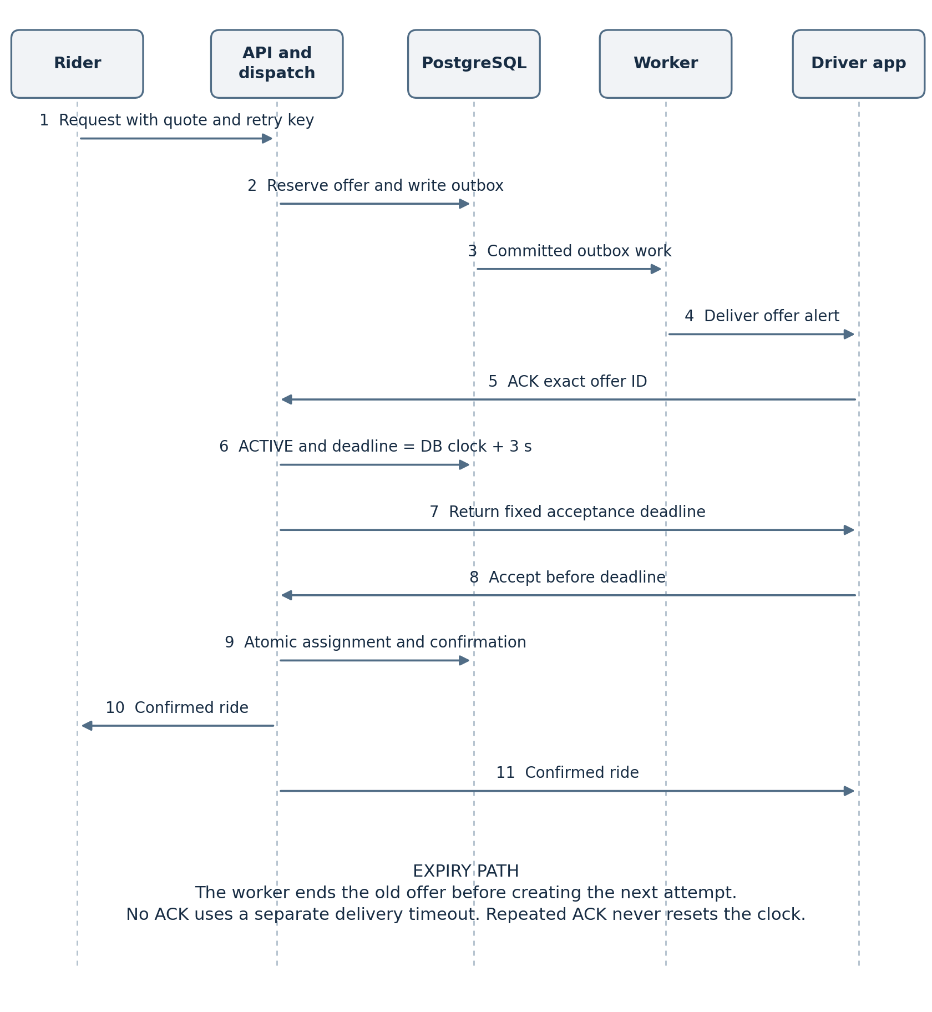
App acknowledgment begins the three-second server window. BR-12–18; LLD-04, LLD-06, LLD-10; VT-06–10.

D 06 Offer state transitions
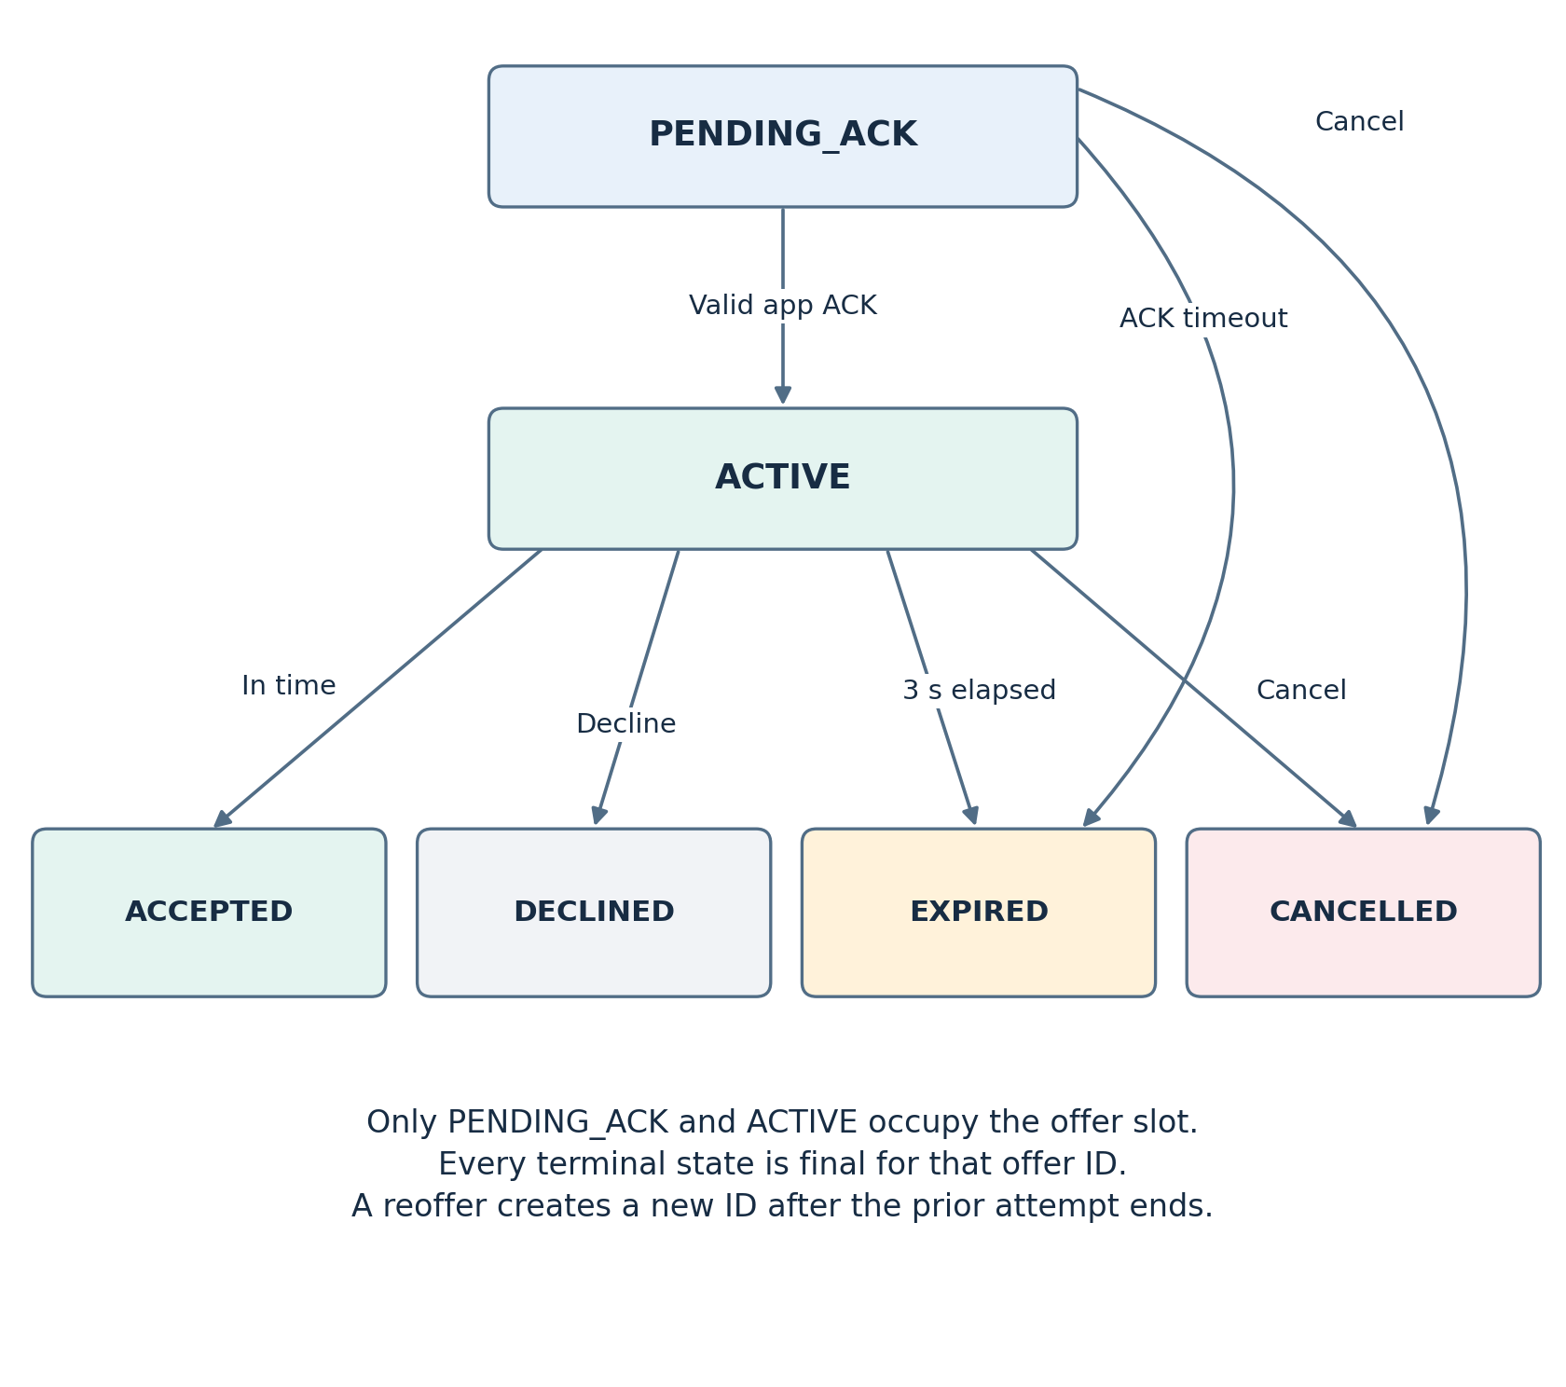
One outstanding attempt and irreversible terminal offer states. BR-12–13, BR-17–19; LLD-06.

D 09 Core relational model
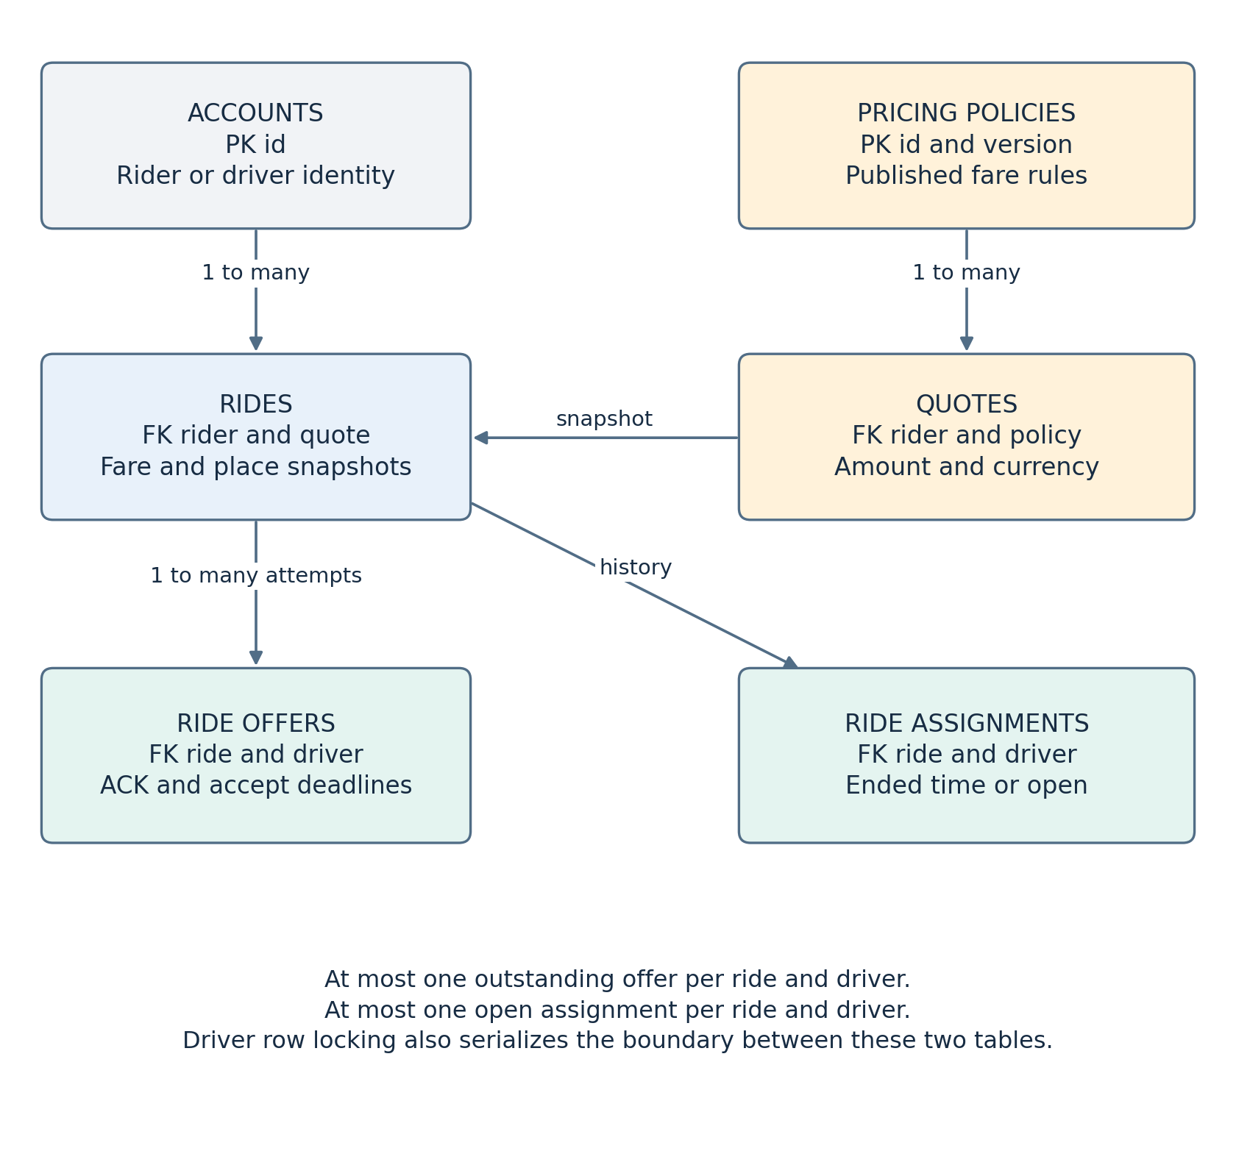
Ride, quote, offer and assignment relationships. BR-12–18, BR-24–26, BR-44; LLD-04, LLD-06–07.

D 07 Durable and live data boundaries
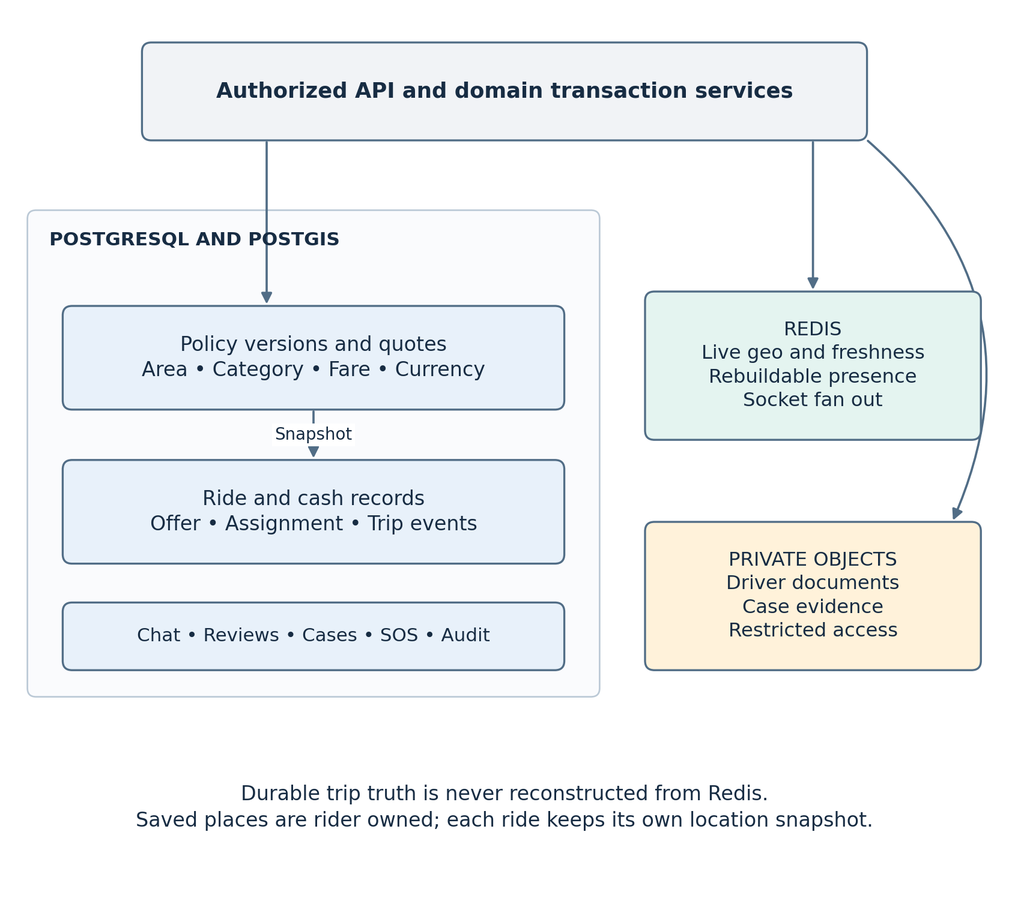
Authoritative transactional records, rebuildable presence and private objects. HLD-19–21; LLD-05–09.

D 08 Safety support and post ride help
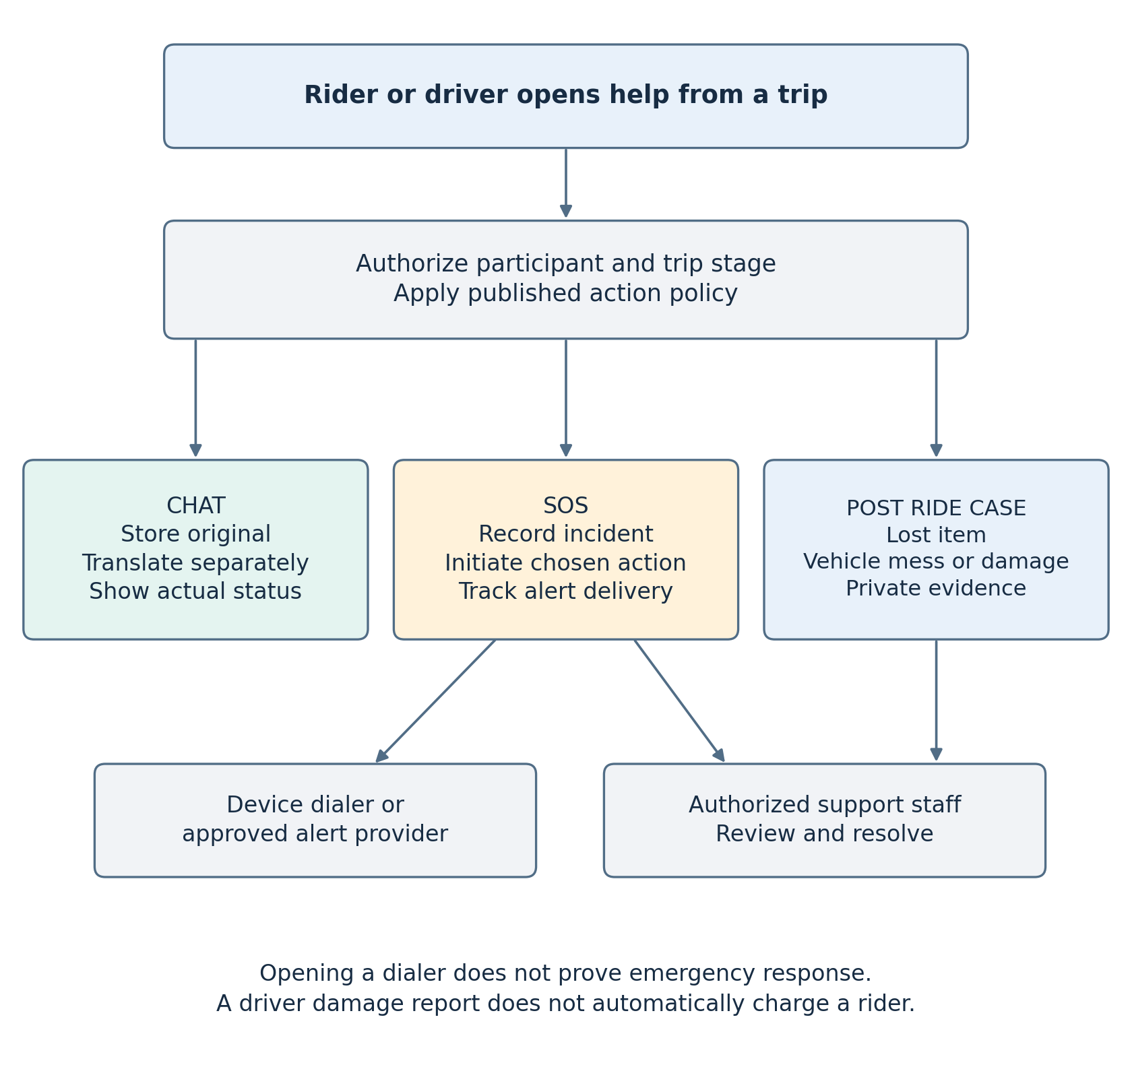
Separate communication, SOS and human-reviewed case workflows. BR-30–40, BR-47–49; LLD-08.

