Agniveer Morning Training Routine (Repeat Weekly)
Designed for running speed, stamina, pull-ups, and recovery.

Monday – Speed + Pull-Ups
1.6 km fast run, 4×200 m sprints, Pull-ups 5 sets (max reps), Push-ups 4×12, Plank 3×45 sec.

Tuesday – Stamina + Legs
3–4 km easy run, Squats 4×20, Lunges 3×30 both legs, Calf Raises 3×25, Leg Raises 3×15.

Wednesday – Intervals + Pull-Ups
400 m fast + 200 m walk ×5, Pull-ups 4 sets, Dead Hangs 3×30 sec, Plank 3×1 min.

Thursday – Recovery
2–3 km easy jog, stretches (Butterfly, Toe touch), Dead Hangs 3×30 sec, Scapular Pull-Ups 3×12.

Friday – Army Test Day
Timed 1.6 km run, 2×300 m sprints, Pull-up max test, Push-ups 3 sets.

Saturday – Full Body Conditioning
2km easy run, 3 rounds: Pull-ups (max), Push-ups 12, Squats 20, Burpees 15, Mountain Climbers 30 sec.

Sunday – Active Recovery
1–2 km easy jog or walk, stretching, 2 easy sets of pull-ups.

Pictures which helps to understand exercises:
Take a look on pictures.

Planks


Squats
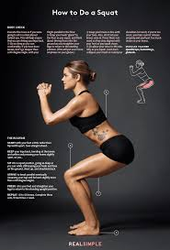

Lunges
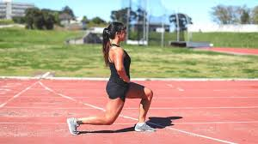

Calf raises


Leg raises
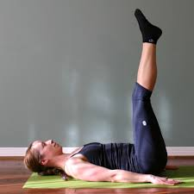

Burpees


