3D-CNN and Autoencoder-Based Gas Detection in Hyperspectral Images

From past one century world has made tremendous progress in industrial sector but the waste produce by this sector is harming natural environment and now it’s become necessary to identify gas emission levels from such industrial sector to make environment free from pollution. In propose paper author employing 3 Dimensional Convolution Neural Network (3D-CNN) based auto encoder decoder model to predict different gas emission. Author using Hypersectral (images take from drone or satellite) images taken from industrial gas leakage and then employing SAM (spectral angle mapper) distance formula on images which help in calculating different gas leak present in the images. SAM.

SAM will give has distance values of the pixels and NIST database contains details of each gas mapping to distance values. So by giving SAM distance we can get presence of gas in the image.

Author has generated his own dataset and then calculated labels of present gases to train 3D-CNN algorithm but not publish dataset on internet. So we used available methane and sulphur leak dataset from below website

<https://studio.edgeimpulse.com/public/158034/latest>

Above website has given spectral features of methane and sulphur gas leak in NUMPY format and we can see parse that dataset to get features. This website has inbuilt features to obtained Hypersectral images and then calculate presence of gas. In NUMPY data we will be using spectral image features and presence of gas label for training. In below screen we are showing website screen with dataset details

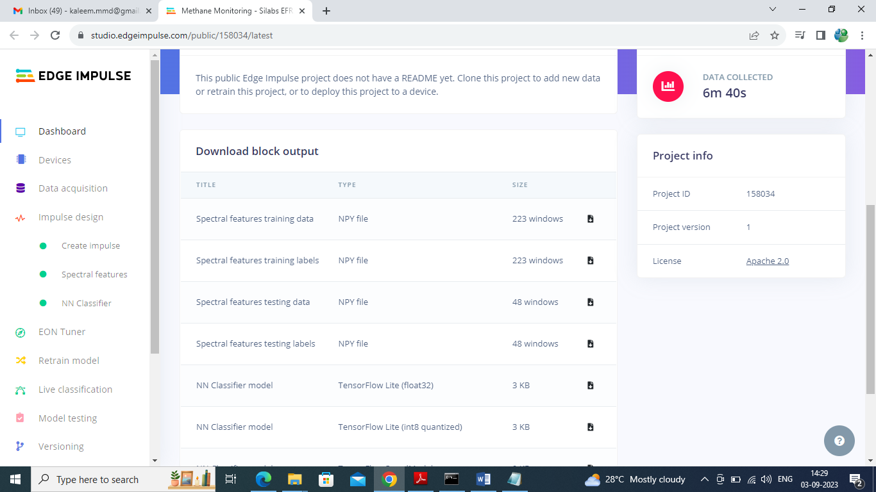

In above dataset page we have spectral features and labels for testing and by using above features we are training and test performance of propose 3D-CNN model. 3D-CNN models work on 4 dimension images as all Hypersectral images contains 4 dimension array where 1st dimension contains BAND values and other 3 dimension contains RGB values. So for 4 dimension data author has employed 3D-CNN model.

Extension Concept

In propose 3D-CNN algorithm author has not applied any features enhancement or ensemble technique so as extension we have experimented with 3 different algorithms such as CNN + Bi-directional + GRU to form a new model called Ensemble model. Input features will be optimized or process by 3 different algorithms which may help in better prediction accuracy.

NOTE: in propose work author has used images but we don’t have such images so we are using those images features given by Methane Monitoring website which I describe above.

SCREEN SHOTS

We have coded this project using JUPYTER NOTEBOOK and below are the code and output screens with blue colour comments

Author is interested only in GAS detection so he has not given any performance metrics but we have calculated and compare this metrics between propose and extension models.

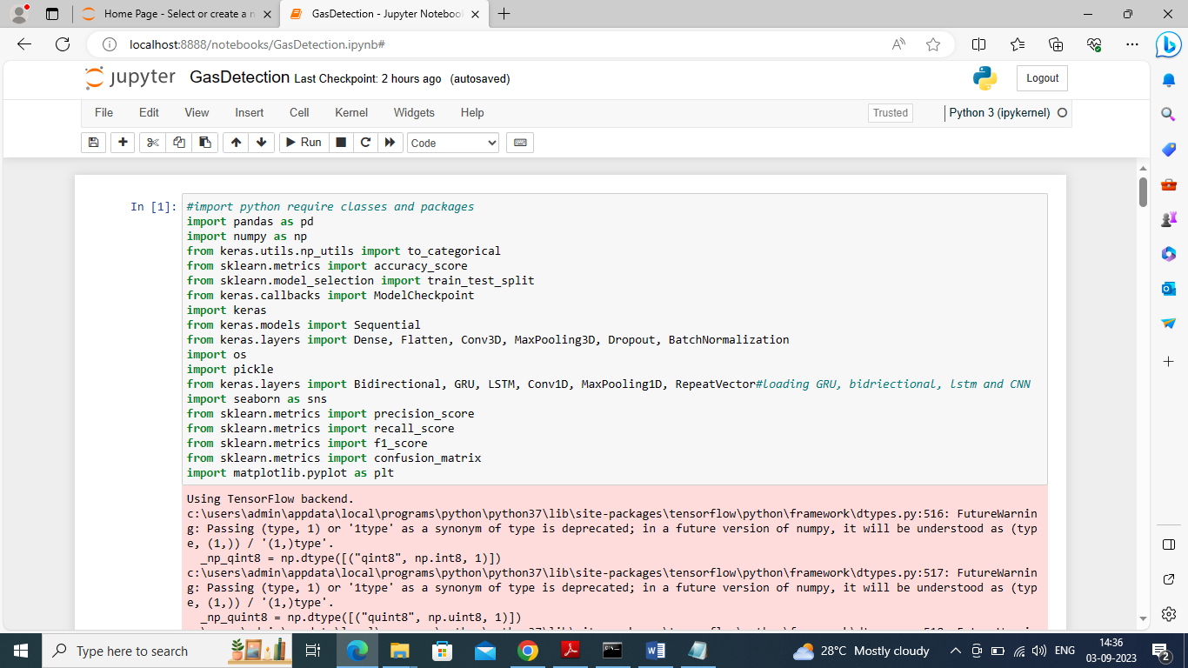

In above screen importing requited python classes and packages

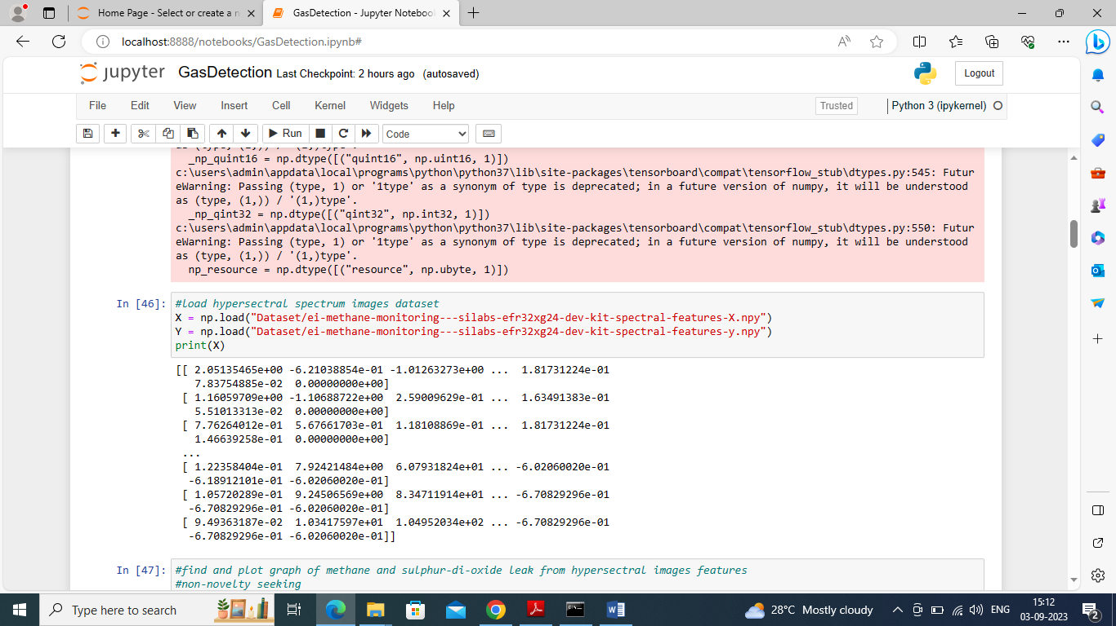

In above screen loading NPY (NUMPY) format X training features and Y label features and then displaying features extracted from dataset

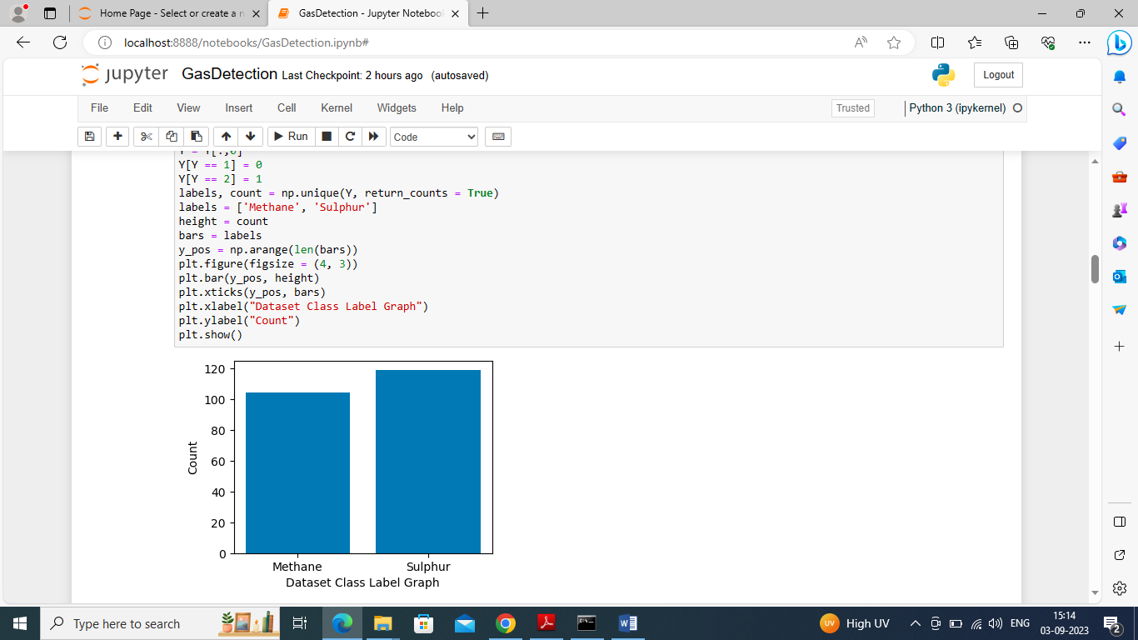

In above screen finding and plotting graph of different gases emission found in dataset where x-axis contains gas names and y-axis contains count of those gas leaks found in dataset

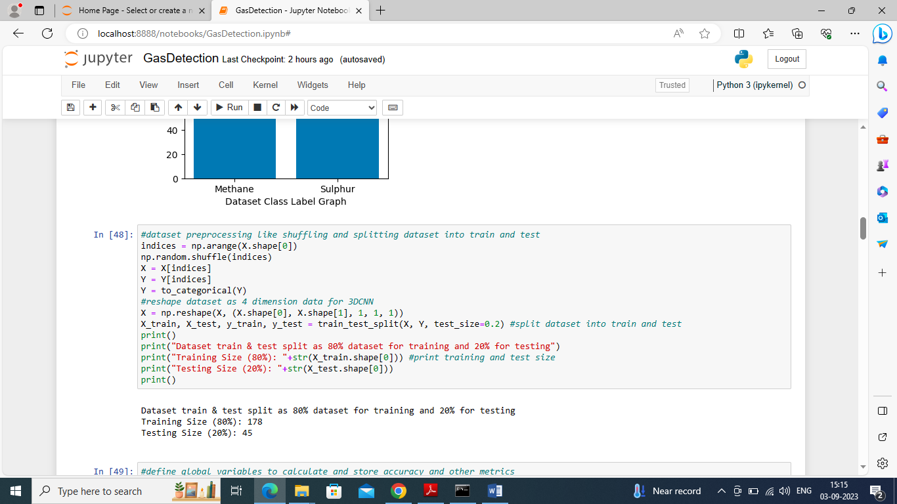

In above screen shuffling and splitting dataset into train and test where application using 80% dataset for training and 20% for testing

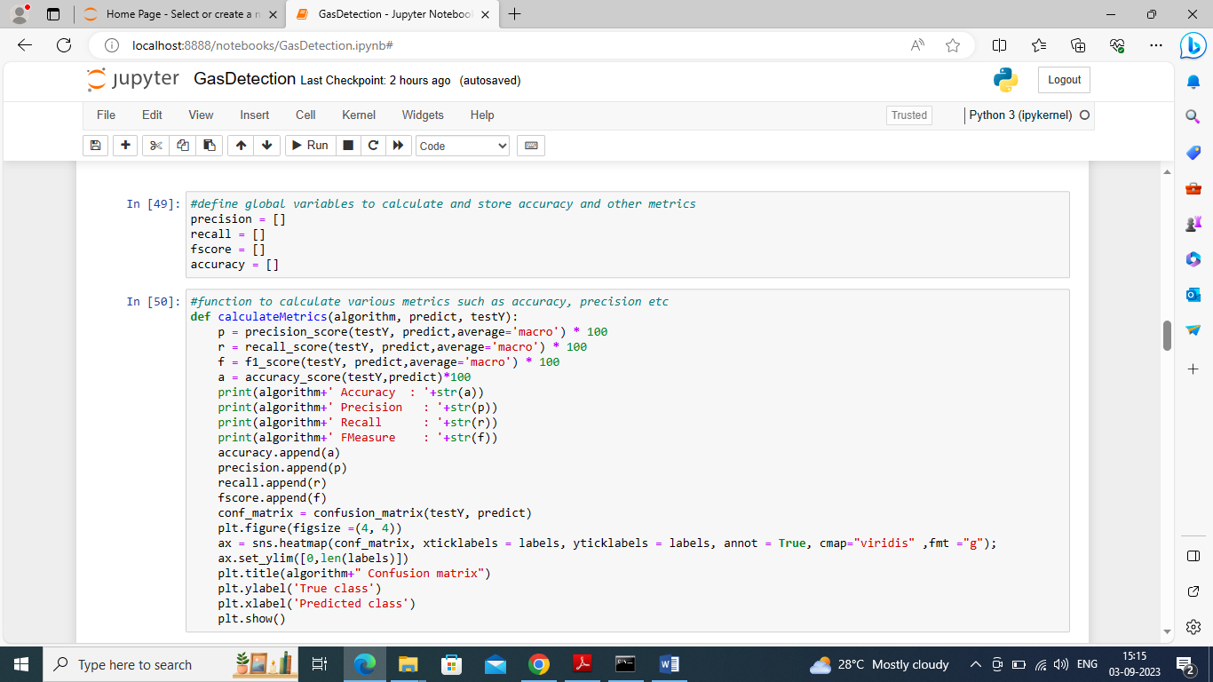

In above screen defining function to calculate accuracy and other metrics

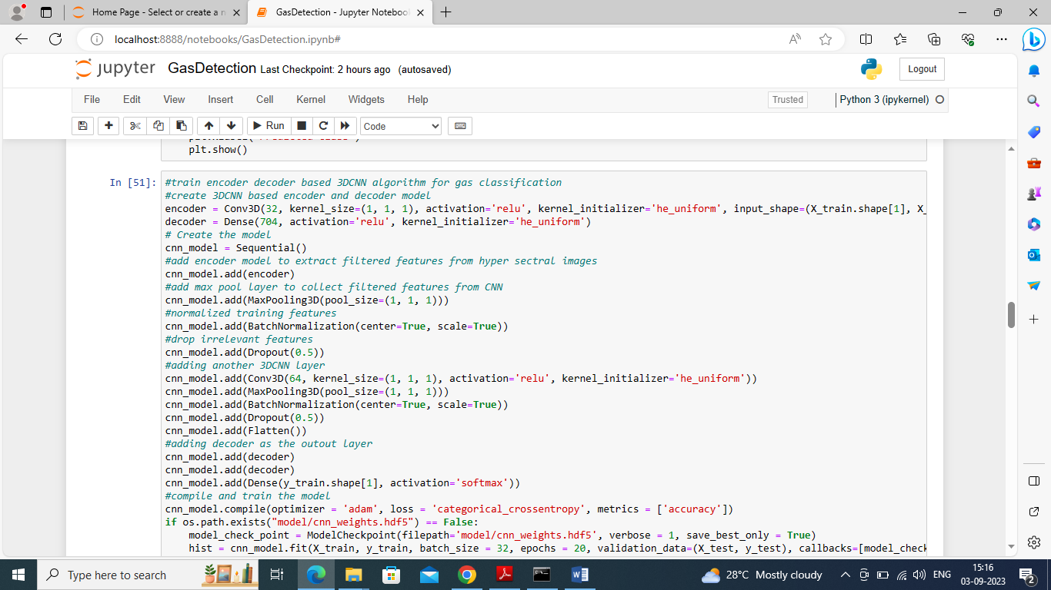

In above screen create 3D-CNN layer with auto encoder and decoder model and then passing GAS values as input features and after training model will get below output

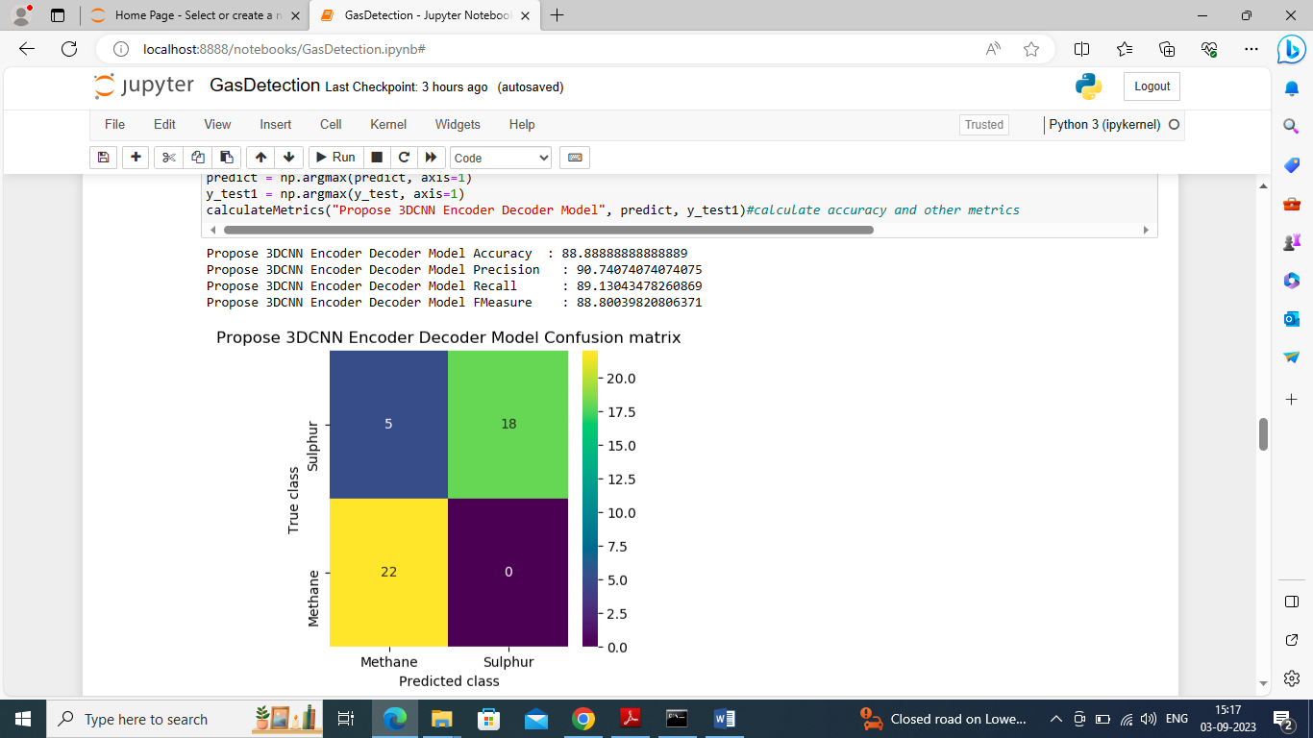

In above screen propose 3DCNN got 88% accuracy and can see other metrics also and in confusion matrix graph x-axis represents Predicted Labels and y-axis represents True Labels. Yellow and green boxes contains correct prediction count and blue boxes contains incorrect prediction count.

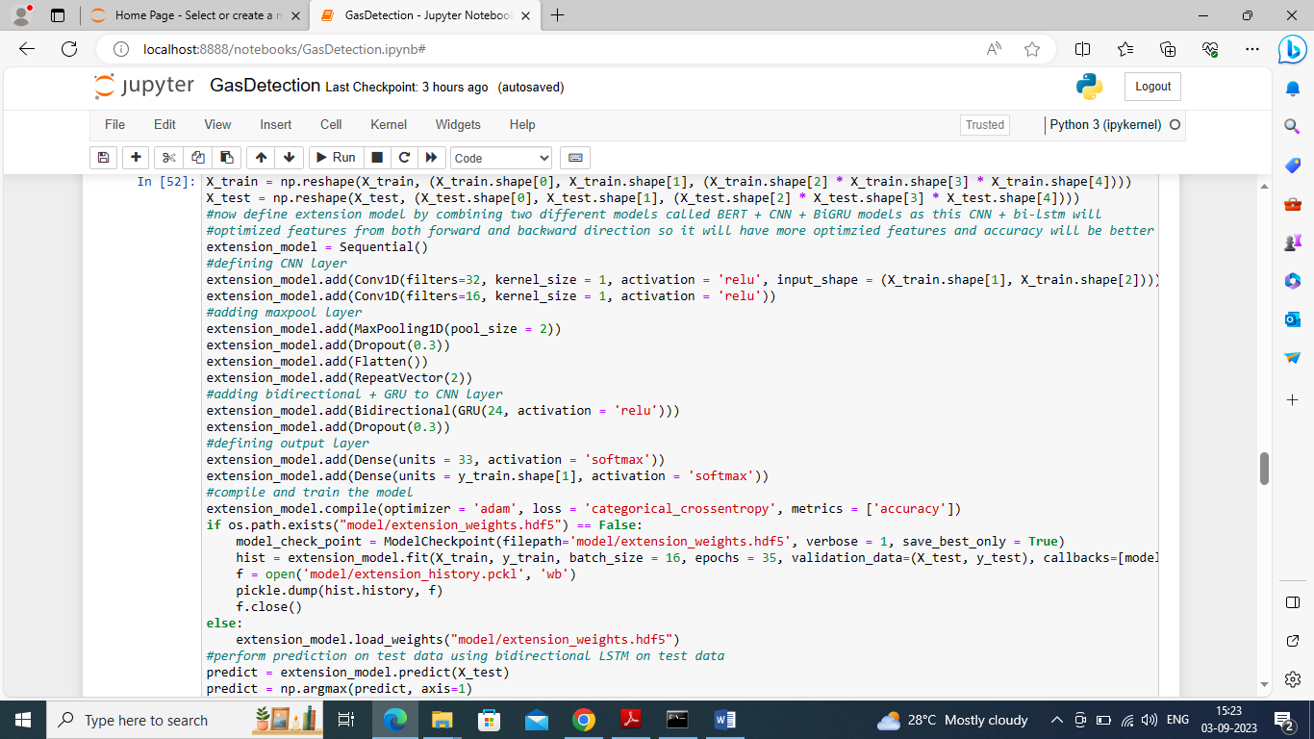

In above screen training extension model by combining 3 different algorithms such as CNN + Bidirectional and GRU and after executing above block will get below output

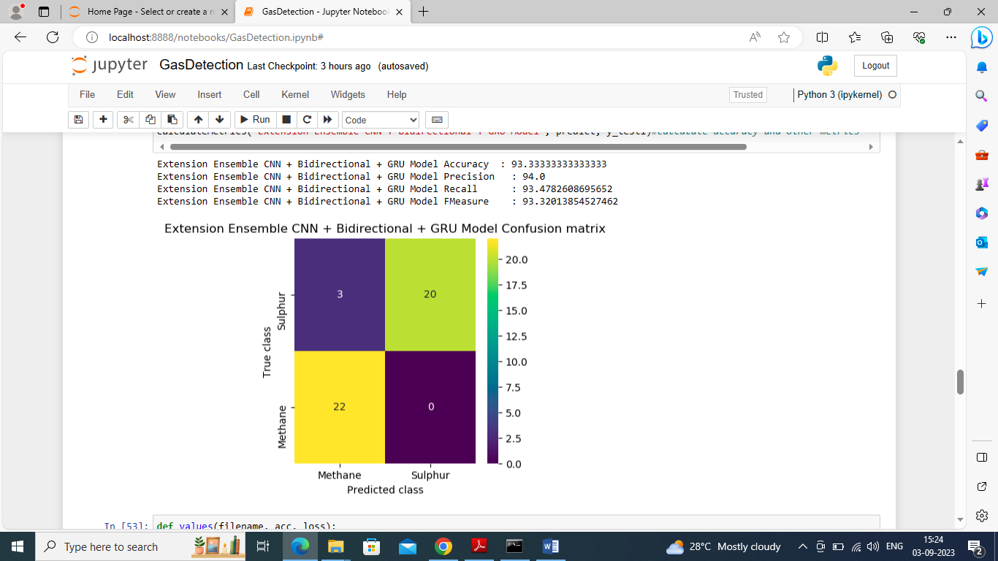

In above screen extension model got 93% accuracy and can see other outputs

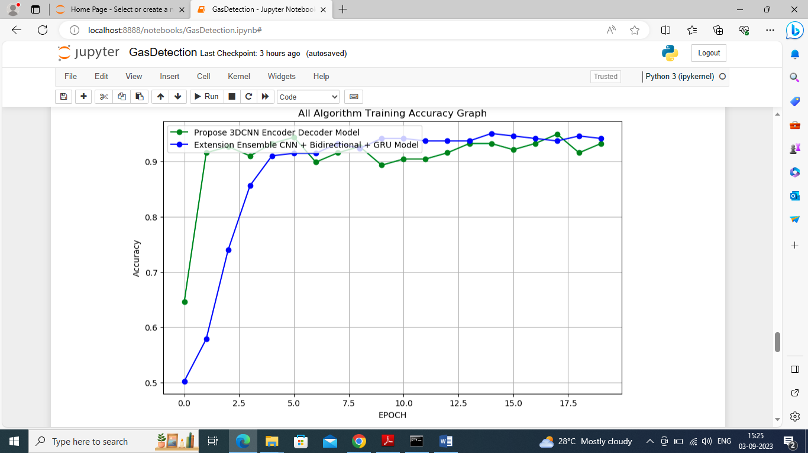

In above graph x-axis represents training epoch and y-axis represents accuracy and green line represents propose algorithm and blue line extension training accuracy where extension got high accuracy

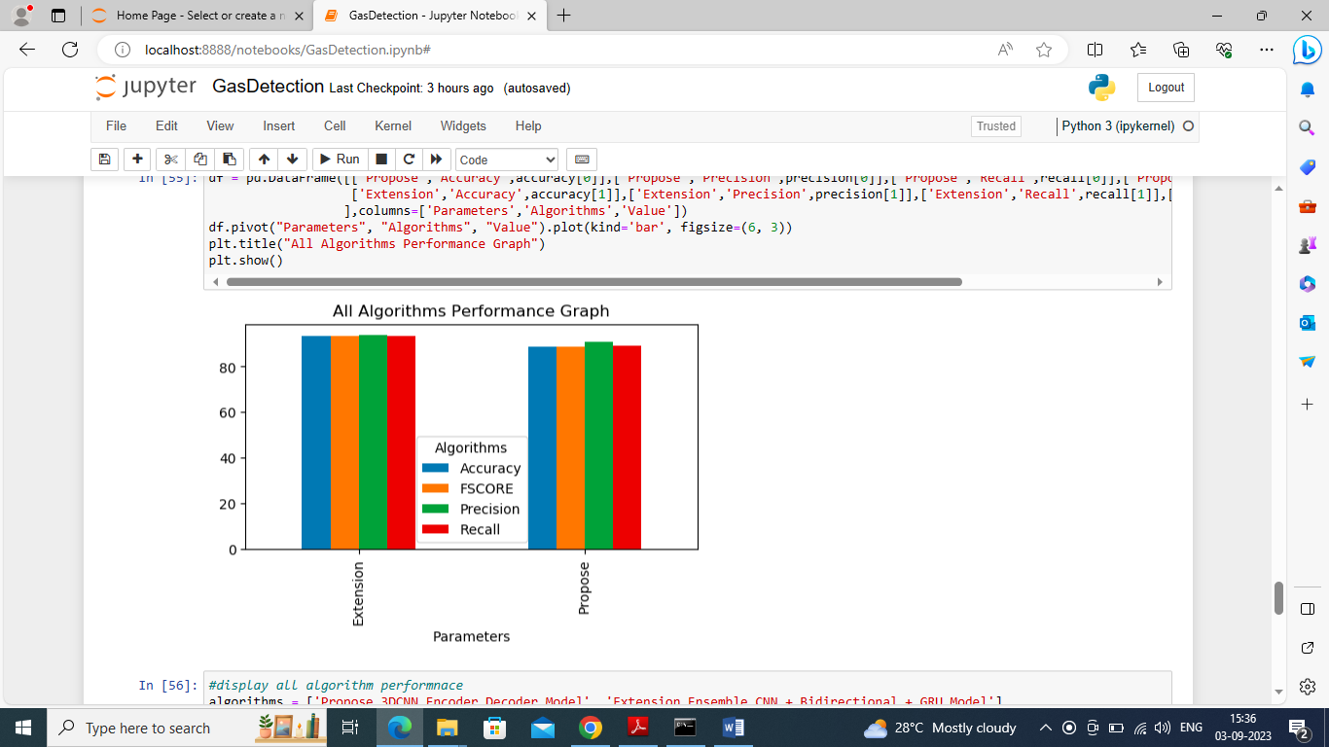

In above screen displaying both algorithm performance in tabular format where x-axis represents algorithm names and y-axis represents accuracy and other metrics in different colour bars

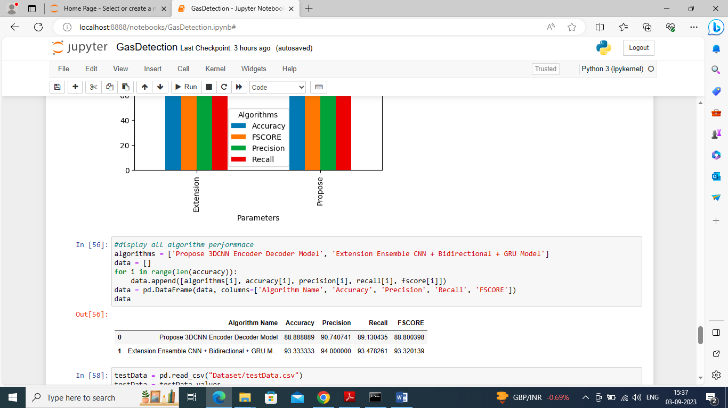

In above screen displaying both algorithm performance in tabular format

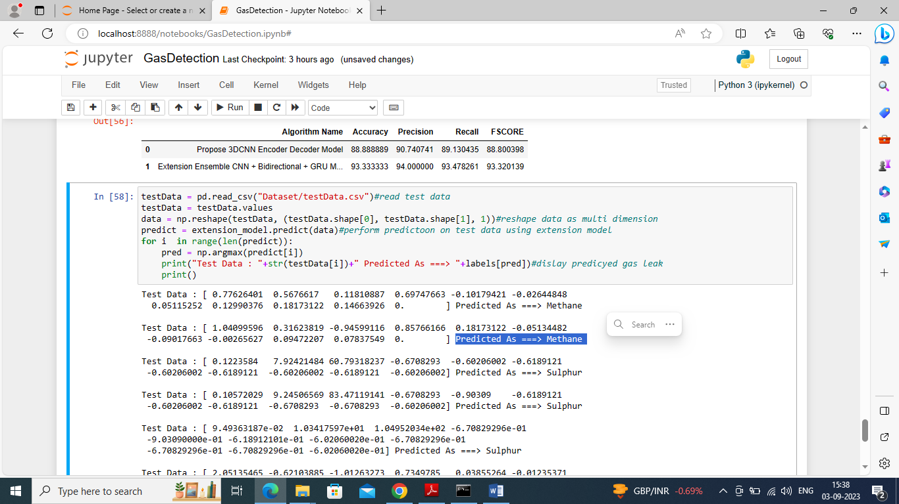

In above screen reading test data and then using extension model predicting type of gas presents in leak where square brackets contains Test Data and after arrow symbol we can see predicted and identified Gas Leak Names