**PRODUCT DEMAND PREDICTION WITH**

**MACHINE LEARNING**

**Dataset and its detail Explanation :**

**Product ID :**

**This is a unique identifier assigned to each product in a store or inventory system. It ensures that every product can be specifically identified and differentiated from all other products.**

**Store ID :**

**Just as products have a unique identifier, so do stores. This is especially relevant for businesses with multiple branches or franchises.**

**Total Price at Which Product Was Sold :**

**This is the final selling price of the product to the customer. It may include any discounts, promotions, or additional charges applied.**

**Base Price at Which Product Was Sold :**

**This is the initial or listed price of the product before any discounts, promotions, or additional charges. It’s the standard price at which the product is typically sold when no promotions are in effect.**

**Units Sold (Quantity Demanded) :**

**This refers to the number of individual units of a product that were sold during a specific period.**

**Begin building the project by load the dataset :**

**Importing the packages:**

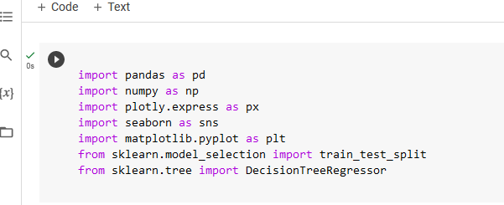

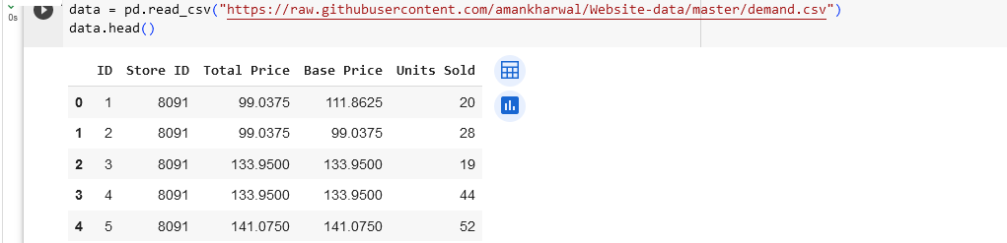

**Preprocess Dataset :**

**Now lets have a look at whether this dataset contains any null values or not.**

