Project: Securing an S3 bucket, configuring IAM access, and ensuring HTTPS for a cloud-native website hosted on ECS or EC2.

* 1. EC2 Instance Details – Showing information about your EC2 instance (Public IPv4 Address, Instance Type, IAM Role).

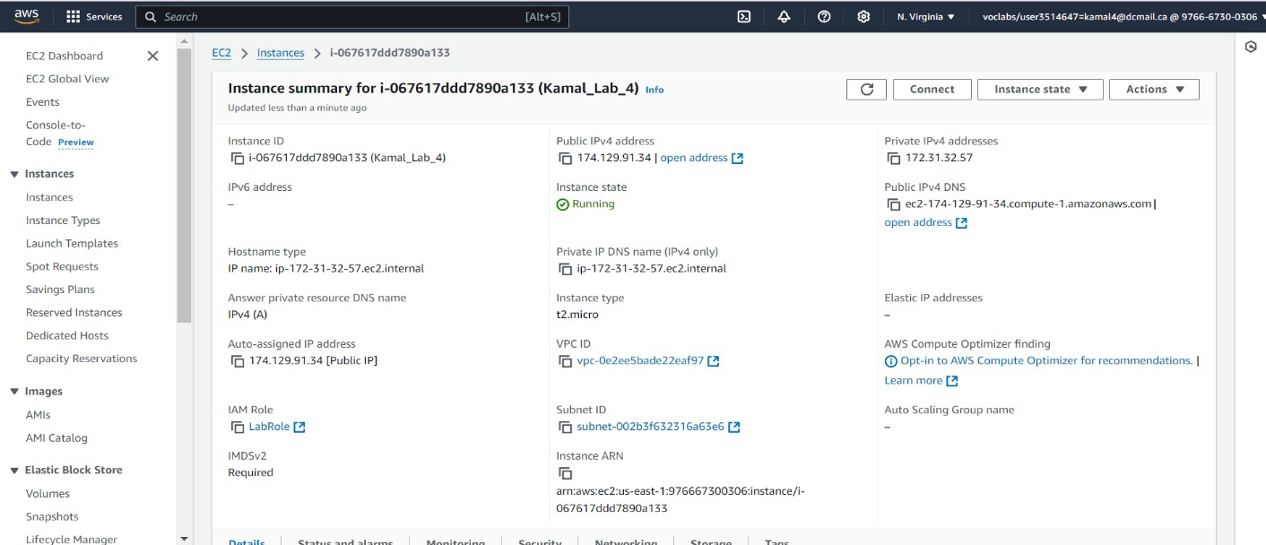

* 1. EBS Size after increasing – showing the EBS volume details with the increased size to 25GB

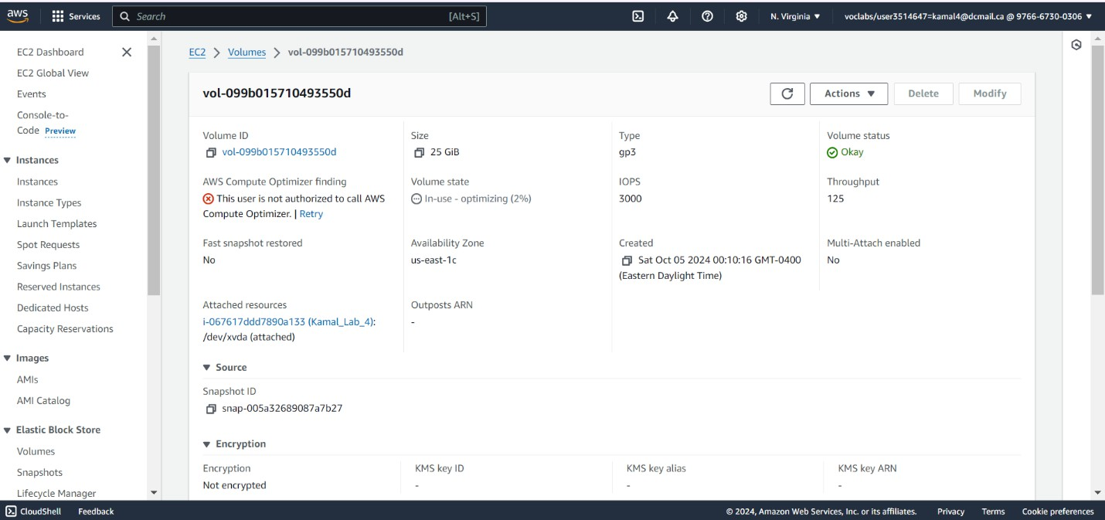

* 1. 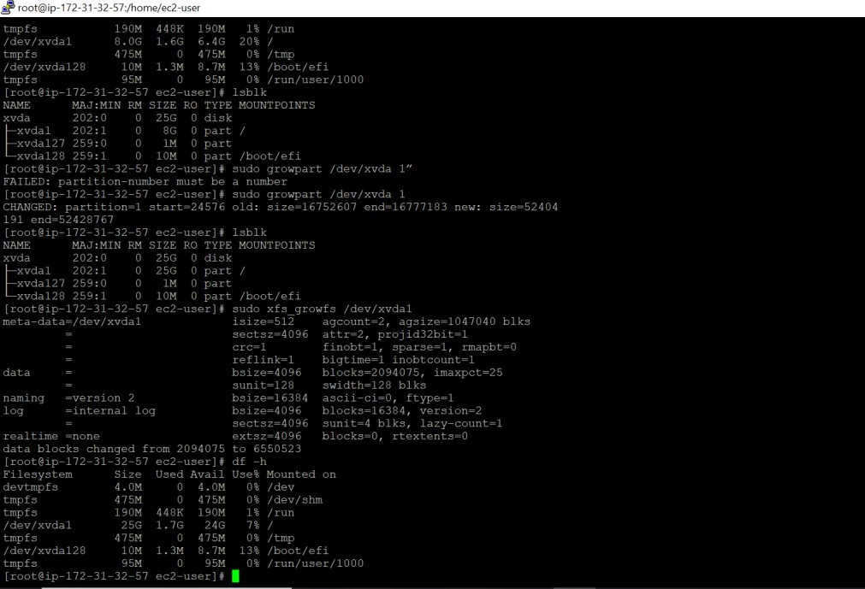df -h output after increasing the filesystem – showing the file system increased to 25GB from 8GB
  2. 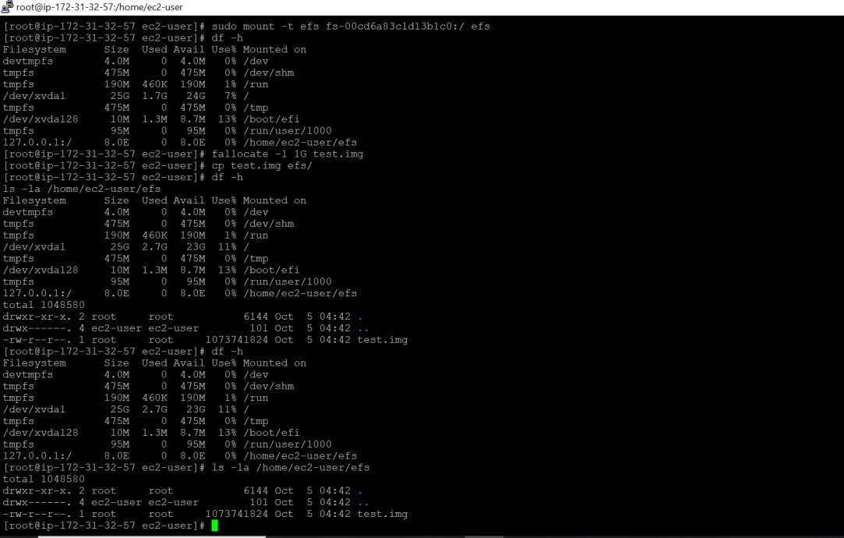EFS summary – showing the EFS filesystem mounted to the EC2 instance and available in output of df -h
  3. Take a screenshot of the Review and Createscreen showing policy name and permissions.

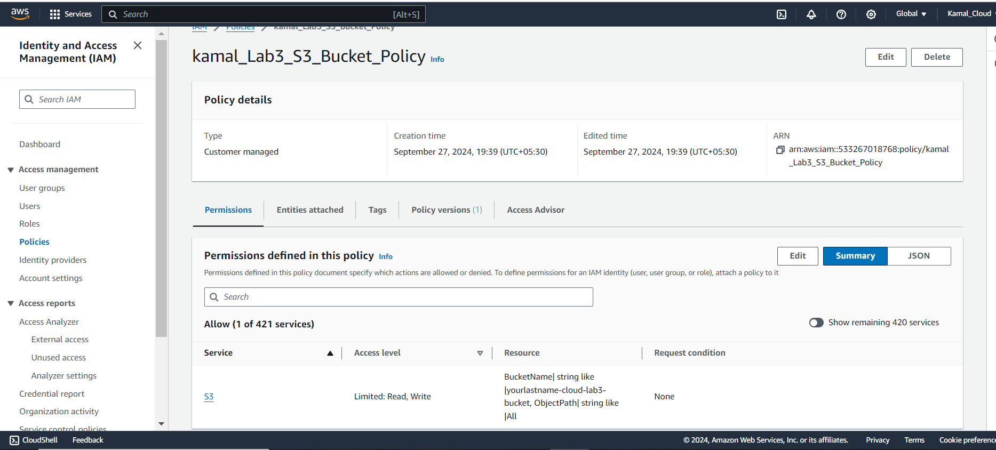

* 1. Take a screenshot of the Review screen demonstration you have created the role and assigned the policy to it.

