TechAssist Hub - Your Personal Tech Support Companion

TechAssist Hub is a personal web application project developed using React.js, Material-UI, and React Router DOM. It serves as your dedicated tech support companion, designed to provide you with a seamless and organized experience while exploring various tech topics.

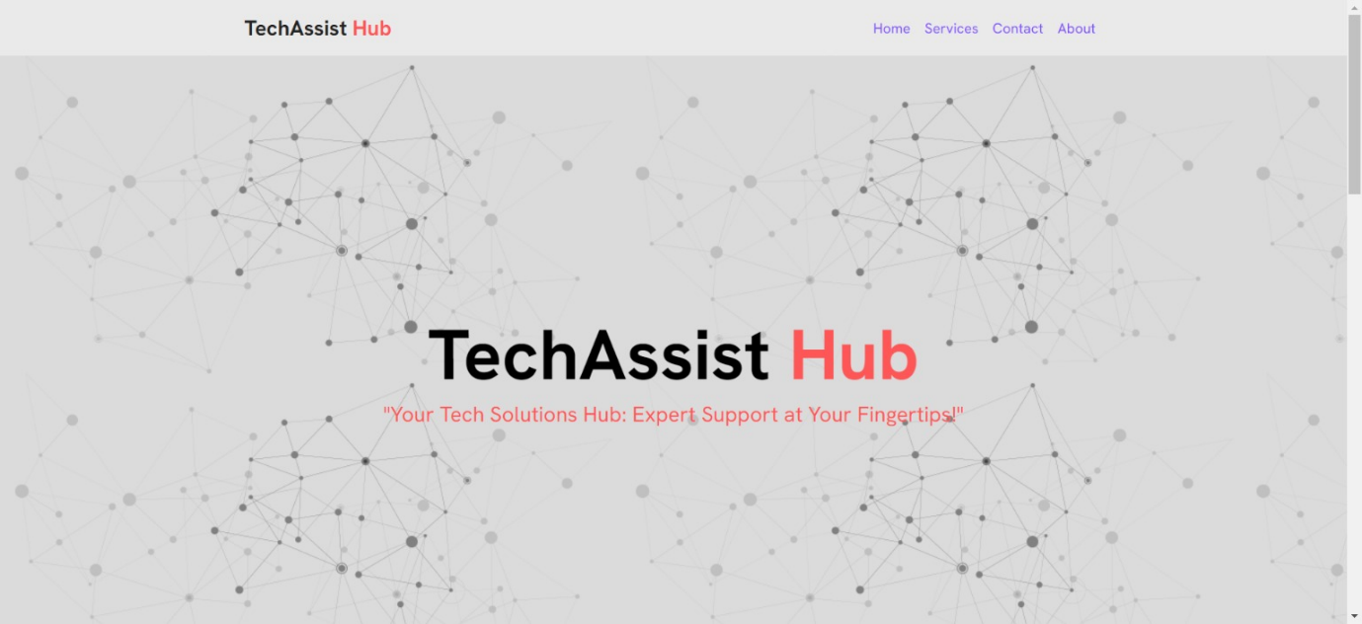

## Introduction

TechAssist Hub is a passion project aimed at creating a personalized tech support hub. This project demonstrates the utilization of modern web development tools and libraries to build a functional and visually appealing web application.

## Features

- **Resourceful Content:** Access a collection of articles, guides, and tutorials related to your favorite tech subjects.

- **Intuitive Navigation:** Utilize the power of React Router DOM to navigate between different sections of the app.

- **Responsive Design:** Enjoy a consistent experience across different devices, thanks to the responsive design principles applied.

- **Material-UI Styling:** The application is styled using Material-UI components, providing an elegant and user-friendly interface.

## Installation

1. Clone the repository: `git clone https://github.com/your-username/techassist-hub.git`

2. Navigate to the project directory: `cd techassist-hub`

3. Install dependencies: `npm install`

## Usage

1. Start the development server: `npm start`

2. Open your preferred web browser and visit: `http://localhost:3000`

## Technologies Used

- React.js: A JavaScript library for building user interfaces.

- Material-UI: A popular React UI framework that offers pre-designed components and styling.

- React Router DOM: Declarative routing for React applications, enabling dynamic navigation.

## Contribution

As a personal project, TechAssist Hub is not open to external contributions. However, if you find inspiration from this project, feel free to create your own version and explore innovative features!

## Contact

Feel free to connect with me if you have any questions or just want to chat about technology. You can reach me at kamaljoshi1511@gmail.com

---

Thank you for exploring TechAssist Hub, my personal endeavor to combine my love for technology and web development. I hope this project serves as an inspiration for your own creative journey!