**Topics: Normal distribution, Functions of Random Variables**

1. The time required for servicing transmissions is normally distributed with *μ* = 45 minutes and *σ* = 8 minutes. The service manager plans to have work begin on the transmission of a customer’s car 10 minutes after the car is dropped off and the customer is told that the car will be ready within 1 hour from drop-off. What is the probability that the service manager cannot meet his commitment?
2. 0.3875
3. 0.2676
4. 0.5
5. 0.6987

**Ans:**

The service manager told to ready the car within 1 hour.

But will start their work after 10 min from drop-off.

So they actually have 50 min to finish their work.

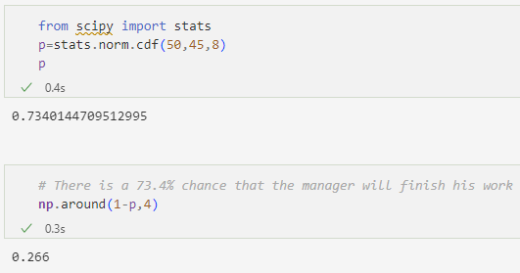

There is a probability of **0.266** that they will not finish their work before the specified time

1. The current age (in years) of 400 clerical employees at an insurance claims processing center is normally distributed with mean *μ* = 38 and Standard deviation *σ* =6. For each statement below, please specify True/False. If false, briefly explain why.
2. More employees at the processing center are older than 44 than between 38 and 44.
3. A training program for employees under the age of 30 at the center would be expected to attract about 36 employees.

**Ans: A.**

n = 400

*μ* = 38

*σ* =6

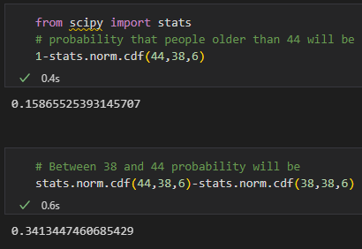

As we can see there is a high probability that employees aged in between 44 and 38.

So the statement is **False**.

**B .**

If we multiply the probability of people less than 30 and total no of people, then we will get how many peoples are there under the age 30

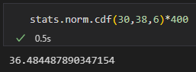

So it’s **True**

1. If *X1* ~ *N*(μ, σ2) and *X*2 ~ *N*(μ, σ2) are *iid* normal random variables, then what is the difference between 2 *X*1 and *X*1 + *X*2? Discuss both their distributions and parameters.

**Ans:**

If we multiply X1 with 2, then μ will change to 2μ and σ2 will change to 4σ2

So **2*X1***~ *N*( **2μ, 4σ2**)

For *X*1 + *X*2

Mean will sum of both means i.e, 2 μ

But variance will sum of both variances

So ***X*1 + *X*2** ~ *N*( **2μ, 2σ2**)

In case of 2*X*1 – (*X*1 + *X*2)

The mean will be 2μ-( μ+ μ) =0

But for var, it’s 4σ2 +( σ2+ σ2) = 6 σ2

i.e ***2X1 – ( X1 + X2*** *)* ~ *N*( **0, 6σ2**)

1. Let X ~ N(100, 202). Find two values, *a* and *b*, symmetric about the mean, such that the probability of the random variable taking a value between them is 0.99.
2. 90.5, 105.9
3. 80.2, 119.8
4. 22, 78
5. 48.5, 151.5
6. 90.1, 109.9

**Ans:**

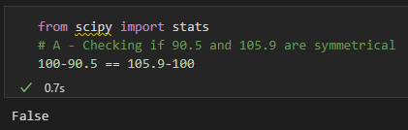

90.5 and 105.9 are not symmetrical from the mean.

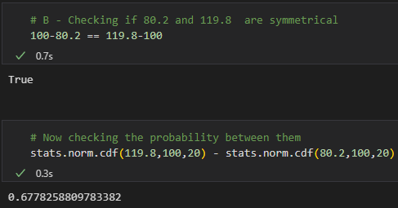

Probability between them is not 0.99

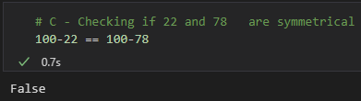

They are not symmetrical to mean

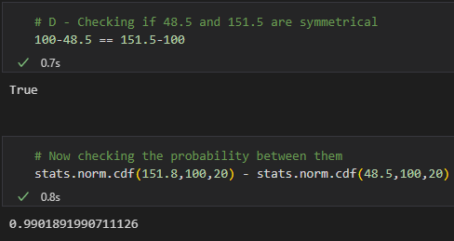

**48.5 and 151.5** points are symmetrical from the mean and also probability between them is 0.99

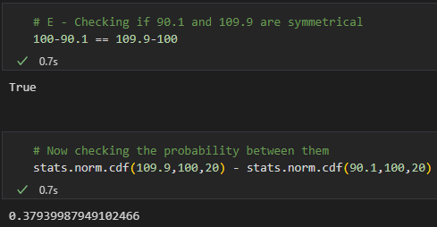

The probability does not match the requirement.

**Option D** is correct

1. Consider a company that has two different divisions. The annual profits from the two divisions are independent and have distributions Profit1 ~ N(5, 32) and Profit2 ~ N(7, 42) respectively. Both the profits are in $ Million. Answer the following questions about the total profit of the company in Rupees. Assume that $1 = Rs. 45
2. Specify a Rupee range (centered on the mean) such that it contains 95% probability for the annual profit of the company.
3. Specify the 5th percentile of profit (in Rupees) for the company
4. Which of the two divisions has a larger probability of making a loss in a given year?

**Ans:**

**A.**

Companies have Profit1 ~ N(5, 32) and Profit2 ~ N(7, 42)

So in total profit will be

Profit ~ N(5+7 , 32 + 42 )

~ N(12 , 52)

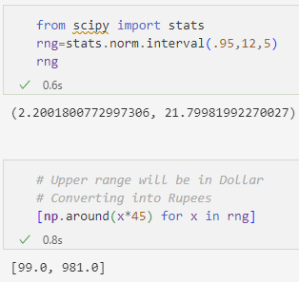

Between ₹**99** million to ₹**981** million there is a 0.95 probability that annual profit will lie.

**B.**

For 5th percentile probability will be 0.05

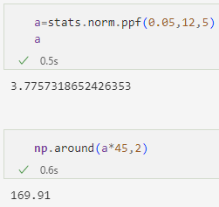

5th percentile will be around ₹170 million

**C.**

For loss we will calculate cdf where profit<0

Probability of division 1 making loss will be

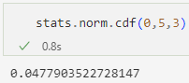

Now probability that division 2 will make loss

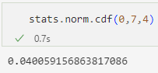

We can see division **1** has a larger probability of making loss