Babatye Mobile App for Barcode Reader

27 AUGUST 2020

Product Owner: Kamal Pun (30371365)

Scrum Master: Riaz Qadir (30364968)

Team: Roshan Dhital (30361962)

Jashandeep (30362218)

Haque Mohammad (30379834)

Initial Project Plan

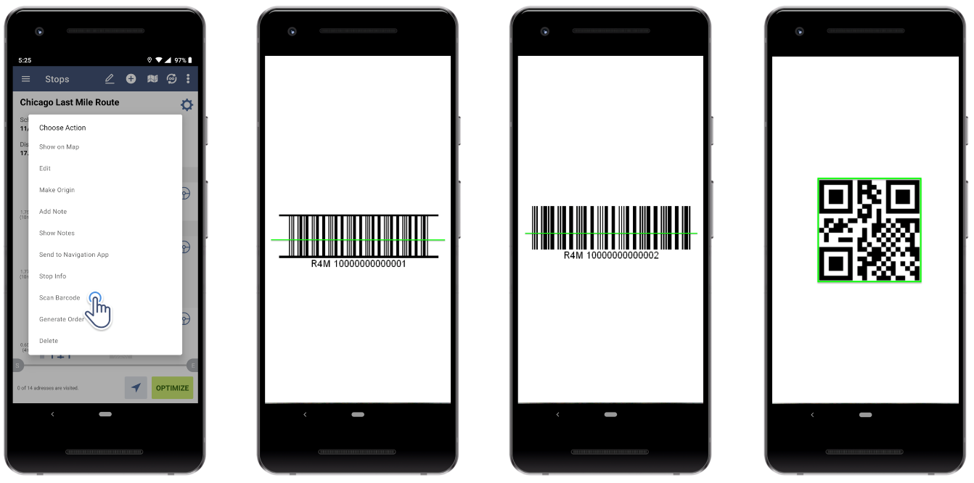

Contents

**Initial Project Plan** 2

**Organization** 2

1.1 Process Model 2

1.2 Organizational Structure 3

1.3 Organizational Boundaries and Interfaces 3

1.4 Project Responsibilities 4

**Managerial Process** 4

2.1 Managing Application’s Aspects 4

*2.1.1 Prototyping* 4

*2.1.2UX/UI Design* 4

*2.1.3Testing* 4

2.2 Resource Acquisition Plan 4

*2.2.1 Development Resources* 4

*2.2.2 Test Resources* 5

2.3 Work Plan 5

*2.3.1 Data Control Plan* 5

*2.3.2 Communication, Tracking and Reporting Plan* 6

***Technical Process*** 6

3.1 Methods, Tools and Techniques 6

3.2 Software Documentation 8

**Non-functional Requirements** 9

4.1 Platform 9

4.2 Communication 9

4.3 Performance 9

4.4 Security 9

4.5 Usability 9

4.6 Audience 9

4.7 Reliability 10

4.8 Modifiability 10

4.9 Economic 10

4.10 Standards 10

# **Initial Project Plan**

# **Organization**

## Process Model

*The first stage for this project has already begun, we as a team divided out tasks among ourselves and have chosen the project manager and scrum master. Project manager will be taking care of the project so that everything is going well, if there is any hurdle then the Project manager will take care of it. While on the other hand, Scrum master will be taking care of meetings held every week with the client and supervisor. Everyone is accompanied with their desired tasks and has already begun to start working after the meeting with our client.*

*This is the rough breakdown of activities which we will be doing to succeed in this project.*

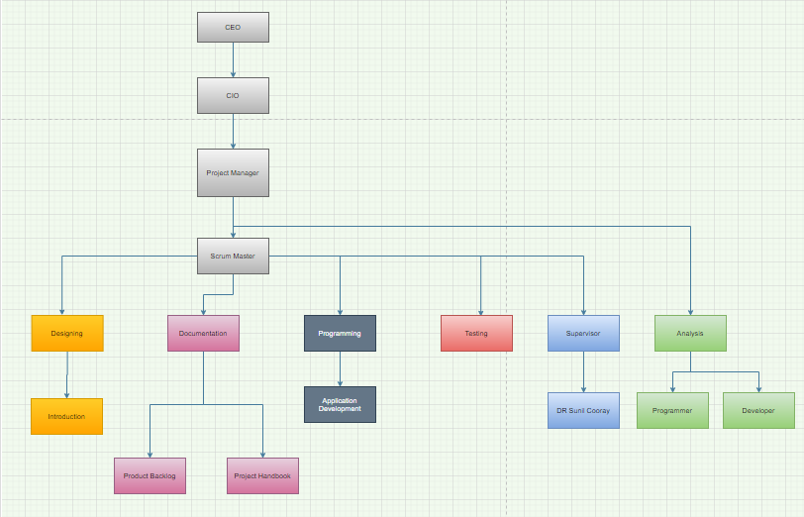

*We will be having meetings every week with our client as well as supervisor and will be keeping them updated on the work time to time. The platform chosen for meeting with our client is zoom, as suggested by the client with her feasibility. We have chosen a day and time to have a virtual meeting with the client and supervisor and have created a group on WhatsApp in case of any changes in the plan.*

## Organizational Structure

*The structure for this is that we will be doing this project in two parts. The initial part which is Sprint 1: this will be the documentation part where we will be analysing and designing the system whereas the second part will be Sprint 2: where we will be developing a Design for the app.*

*There are three basic roles for scrum:*

*1. Product Owner*

*2. Scrum Master*

*3. Team Member*

*We have divided the roles among us and will vary each week as everyone will be having an opportunity to show their managerial and leadership skills. This week’s Product Owner and Scrum Master are:*

|  |  |
| --- | --- |
| **Product Owner** | *Kamal Pun* |
| **Scrum Master** | *Riaz Qadir* |

## Organizational Boundaries and Interfaces

*As the project is divided into two parts Sprint 1: (documentation part) and sprint 2: (Design part). In the start things really were not in our favour, Our team was the only team who did not have a meeting with the client for a bit long due to some issues, while the other teams already had their few meetings. But finally, we sorted out our issues and had a meeting with a client on zoom video call. This was the first meeting where we had no experience of how to present ourselves in the professional industry, but things really went well as the client went happily from us and fixed the date for the next meeting too.*

*The roles which we have decided till now are the roles of Scrum Master and Product Owner. These two roles will be rotating among team members every week.*

*The mode of communication chosen by our client and us is, zoom video call where our client will be creating a room and we will be getting the link via email or through WhatsApp as preferred by the client. Scrum master will be responsible for the communications as it is the role of the Scrum Master to take care of communications with client and supervisor.*

## Project Responsibilities

*The responsibilities are divided among each of us by their own choice as per their interests towards this project.*

|  |  |  |  |  |  |
| --- | --- | --- | --- | --- | --- |
|  | *Riaz Qadir* | *Kamal Pun* | *Mohammad*  *Haque* | *Roshan*  *Dhital* | *Jashandeep*  *Singh* |
| *Design* | *A* | *A* | *C* | *R* | *I* |
| *Document* |  | *R* |  | *I* | *A* |
| *Program* | *R* | *I* | *R* |  | *C* |
| *Test* | *C* |  | *I* | *A* |  |

# **Managerial Process**

## 2.1 Managing Application’s Aspects

*The focus of our team is to give such platform that can lead the application’s required features with respect to business aspects and to meet our client’s requirements as well with ERP diagrams , we will be managing our application throughout their lifecycle.*

### *2.1.1 Prototyping*

*As prototyping can be helpful in managing and understanding the business process or IOS and Android apps platforms, we will consult with a professional UX/UI designer.*

### *2.1.2UX/UI Design*

*Our vision for user interface and user experience design is that it should be designed and managed in such a way that will maximum comfort and benefit to the user.*

### *2.1.3Testing*

*As Quality Assurance is a key part of the development cycle. via QA we will make sure our app will work as it should and will not crash upon performing its task.*

## 2.2 Resource Acquisition Plan

### *2.2.1 Development Resources*

*We will be using roughly 3 software and hardware tools that will be required by us for executing our application the project*

*Software- Ms project etc*

*Hardware- windows 10 etc*

### *2.2.2 Test Resources*

*For quality assurance testing resources of our barcode scanning system, which we will be using are-*

***For programming***

*Google dev tools https://developers.google.com/web/tools/chrome-devtools/open*

***For java code testing***

*Jsfiddle* [*https://jsfiddle.net/sibeeshvenu/upnxe8jp/4/*](https://jsfiddle.net/sibeeshvenu/upnxe8jp/4/)

## 2.3 Work Plan

### *2.3.1 Data Control Plan*

*There will be set of activities for barcode scanners, as we discussed earlier in our vision document , current barcode scanners do not allow editing data in real-time thus, client/users have to scan the barcodes physically in the stores at physical place in the facility.*

*Thus, the scanned barcode data will be transferred to the system’s database or ERP system*

*For effective management and convenience for the users. Application will display information regarding-*

*· Restocking Information*

*· Lot Number*

*· Further Updates.*

### *2.3.2 Communication, Tracking and Reporting Plan*

|  |  |  |  |  |
| --- | --- | --- | --- | --- |
| **Type of Communication** | **Communication Schedule** | **Typical Communication Mechanism** | **Who Initiates** | **Recipient** |
| **Status Report** | *Tuesday* | ***email*** | *Roshan* | *Team members* |
| **Schedule and Effort Tracking Report** | *Weekly* | *Voice call/Facetime* | *Kamal* | ***Team Members*** |
| **Project Review** | *Every 10 days* | ***Skype*** *meeting* | *Jashandeep* | *Team members* |
| **Risk Mitigation Status** | *On mitigation actions completion* | *email* | *Riaz and Mohmmad* | *Team members* |
| **Requirement Changes** | *As changes are approved* | *email and change control tool* | ***Client or supervisor*** | *Team members* |

# ***Technical Process***

## 3.1 Methods, Tools and Techniques

*To do work with the members of our team we use WhatsApp to communicate. When we need to massage someone about something, we use this application which is handy and can be used anywhere any time. So, for documentation we did use the google doc online. It is very easy to use and can be used both from a mobile phone or laptop, not need very high graphic or technology to use it and whenever we need to add something everyone can see the work and change whenever they need.*

*We are a team of five members who need to divide all the tasks in a very responsible way so they can work based on that and can be reached in the goal without delaying the process. Here is our scrum framework we will be working based on throughout the semester.*

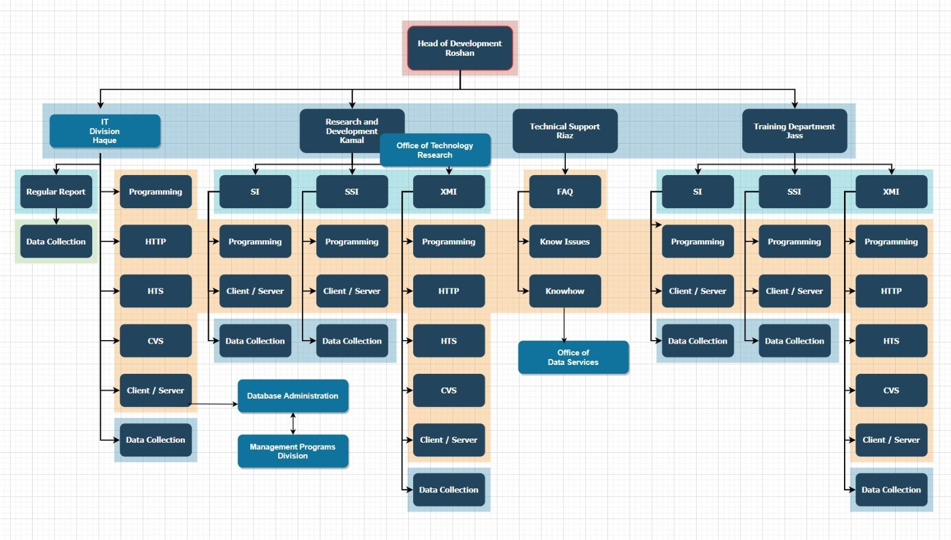

*For software design we use draw.io which is online based and completely free. We can draw the diagram and chart very easily over there. ERD diagram, UML diagram, crow foot notation and many more diagrams we will design throughout developing our project.*

*For document and code management we will be using GitHub and Microsoft excel and access which we have default in our laptop but for GitHub we just need to create an account to use. We do not use the account for coding yet, this is just the evidence we are using:*

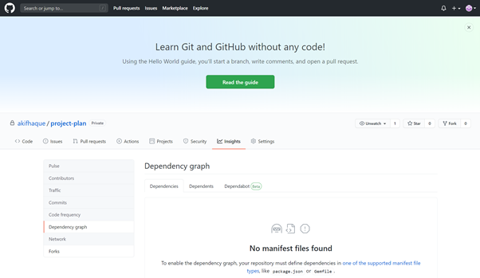

## 3.2 Software Documentation

*Technical documentation helps an intended audience use our product, understand our processes, and get unstuck. Whether that audience is end-users, administrators, colleagues, or technicians does not really matter. What does matter is that it is clear, searchable, and helpful for them.*

*Every technical writing project starts with research. It might sound obvious, but knowing the purpose and scope the technical documentation beforehand will save us a ton of time and energy (and headaches)*

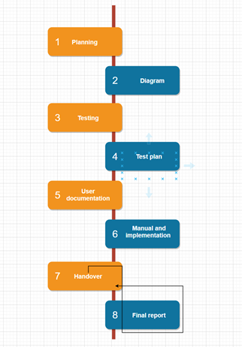

*Existing resources will help updating or merging current resources or starting from scratch. This Will help to find anything and everything that will make sure the accuracy of our work and effort.*

*Style guides are mandatory for documentation. This project requires us to write technical documentation in a specific way which has a style guide that explains what language to use, how to talk to users, and even grammatical styles*

# **Non-functional Requirements**

*Non-functional requirements are basically meant as the process of judgement of entire operating system regarding various aspects to ensure that the conditions are met successfully. Explicitly stating the qualities of execution such as platform, usability, safety, security, etc., this part paves the way of system development serving certain constraints and restriction while designing. Some of the applicable non-functional requirements are briefly explained below:*

## 4.1 Platform

*The application to scan barcodes will be built with the help of Google Developer tool that will allow the developers to have access to a range of built-in functionalities. Also, it gives a user version control and a provision to view and edit the open source code while developing the application.*

## 4.2 Communication

*The designed application needs to communicate with the data repository with the help of scanned barcode of a product and giving information about the colour, size, care instructions, material, etc.*

## 4.3 Performance

*This application is desired to maintain the expected level of service allowing the users to instantly retrieve information and perform activities based on that. So, the built application will not be complex resulting in a smooth and better performance and it can perform the same way even in peak hours.*

## 4.4 Security

*To secure the application, its main users are specified by the administrator where supplier and other members of a team have access to login to the application. The system needs to have a robust backup and recovery system of data and information stored in the repository should be in a highly secured location so that the attackers do not breach the system and have access to the confidential information.*

## 4.5 Usability

*As the application design is simple, it does not have complex functions making the users capable enough to use an application by following simple steps or making assumptions to perform certain activities. Application will be developed with proper use of colour, font size and type, simple texts which are understandable.*

## 4.6 Audience

*Application is targeted for the supplier teams of a clothing store. Using an application require the ability to view the screen, to understand English language, read and write, making changes such as giving input to the quantity of product left, restock information and so on.*

## 4.7 Reliability

*While considering the reliability of an application, it will have the system able to perform without any defect while scanning the code and retrieving information.*

## 4.8 Modifiability

For any of the unforeseen bugs or to make any changes on the application, the designed application will be developed in such a way that the developers get recommendation from the users or audience and make changes to ensure the reliability of an application.

## 4.9 Economic

Development of application with the assigned platform may require premium membership requiring some cost to gain access to a required functionality of an application. The data repository on the other side acts as the storage to all the information of products and keeping it in a secured location becomes costly.

## 4.10 Standards

Designed application will be accessible to use both on android and iOS system as the application will be created targeting both of the operating system users.