Babatye Mobile App for Barcode Reader

27 AUGUST 2020

Product Owner: Kamal Pun (30371365)

Team: Roshan Dhital (30361962)

Jashandeep (30362218)

Riaz Qadir (30364968)

Haque Mohammad (30379834)

Initial Product Backlog

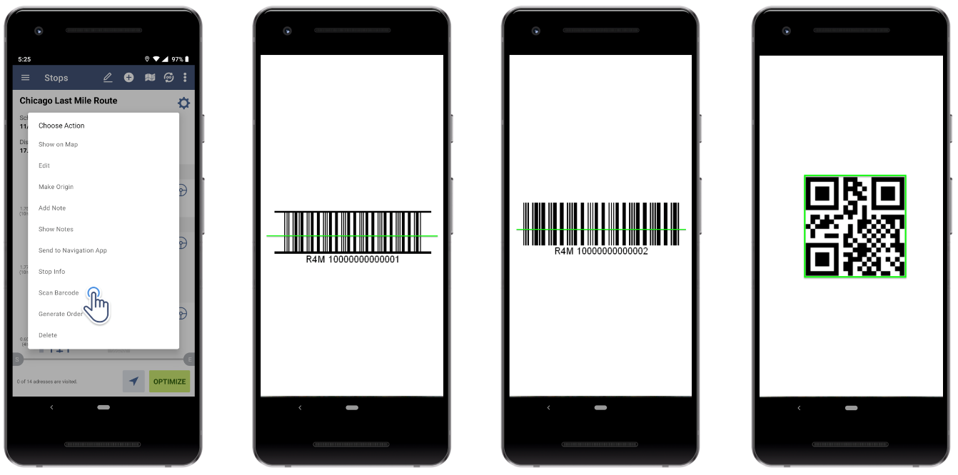

Contents

**Babatye Mobile App for Barcode Reader** 2

**Project Overview** 2

**Brief Description** 2

**Associated Problem** 2

**Envisioned Solution** 2

**Definition of Key Terms** 2

**Users** 2

**Product Backlog Items** 3

# **Babatye Mobile App for Barcode Reader**

# **Project Overview**

## **Brief Description**

*Babatye is a Melbourne, Australia based online clothing brand launched in 2018. It is a local business with global presence bringing fashions to you at the click of a button. Babatye works with external suppliers for their cloths.*

## **Associated Problem**

*Babatye has been manually storing information of their cloths form suppliers into their data repository which is very time consuming and unproductive.*

## **Envisioned Solution**

*Transfer into a more flexible system based on mobile that will let them to scan the barcodes of cloths received from suppliers at the time of delivery. And the scanned data should be stored into their data repository where the information should be correct and unique.*

# **Definition of Key Terms**

|  |  |
| --- | --- |
| **Key Terms** | **Definition** |
| **Data Repository** | *Place where data is hold, made available and organized in a logical manner.* |
| **Barcode** | *Number that is like a fingerprint for products.* |
| **Information** | *Stored data in data repository.* |

# **Users**

**Administrator Our client who is responsible for administration of the system.**

**User Employees of the company.**

**Supplier Providers of cloth.**

# **Product Backlog Items**

|  |  |
| --- | --- |
| **Requirement** | **Conditions of satisfaction** |
| **US1** As a user, I want to scan barcode of cloths so that I can save time. | Mobile scanner app can scan barcode of cloths from suppliers. |
| **US2** As a user, I want to store scanned barcode data into data repository so that I can organise all information. | Scanned data from barcode is stored into data repository. |
| **US3** As a user, I want to retrieve information according to category, type, weight, size, and colour of the product so that I can check stock availability. | Database shows product accordingly and items left in stock. |
| **US4** As a user, I want the system to be flexible so that any additional data included in the barcode may be retrieved. | Database should include new information included in barcode such as material. |
| **US5** As a user, I want to store each data in barcode in individual columns into the database so that I can retrieve information individually. | Database has individual columns for different data included in barcode. |
| **US6** As a user, I want all stored information to have unique identifier so that it can be identified easily and quickly with that identifier. | All information stored in database have unique identifier and can be searched. |